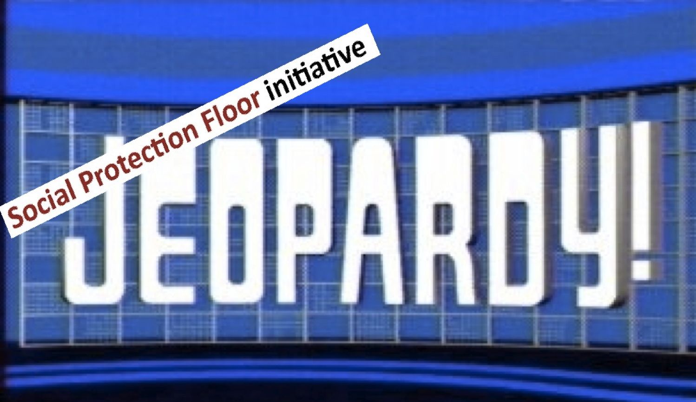

Instructions:

- Form some teams of equal members.
- Each round, each team select a team reresentative.
- The representative chooses a number from the board (slide 3 of the presentation). Behind the number, there is a question.
- The representative read the corresponsing question to the team.
- The team needs to consult with each other and gives the answer within 1 minute.
- If the answer is correct, the team will recieve the budget money to implement Social Protection Provisions!

Durations: 1.5-2 hours

