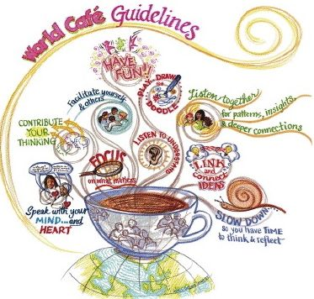

Instructions:

- Form 4 teams of equal numbers.
- Assign one person from each team to become a coffee manager.
- Each coffee manager works at their own cafe.
- There are 4 cafe with different themes: health, working age population, children, and elderly and disabled.
- Each team stays for 30 minutes at each cafe to discuss about the theme with these questions:
- What are the existing policies and schemes? Who do they cover? How effective & adequate is the coverage?
- What are the policy gaps and implementation issues?
- Which recommendations would you make to reach at least the SPF?
      - Extension of coverage to uncovered groups
      - New Social protection provisions to be introduced
- After each group finished their discussion in all 4 cafe, the coffee manager will give a full report of the discussion in their cafe. (see slide 8 of the presentation)
- Validate together the scenerios to be costed.

Duration: 3.5 hours

