

fP
nsurance for the Poor
a world bank program
Mission Statement
‘Developing sustainable and scalable programs for the provision of insurance and related services that can help the poor protect themselves against threats to life cycle management and the maintenance of adequate livelihoods.’
Why is insurance for the poor so important?
Insurance offers a way to help the working poor deal with the risks they face every day. Together with other risk management mechanisms, such as savings and credit, insurance helps prevent low-income families from falling below the poverty line. Not having to fear large unexpected expenses, people can make more long-term oriented and profitable investments.
Insurance and insurance-related services:
- Help prevent the poor from falling or slipping back into poverty;
- Protect families in times of economic crises so that children do not need to be pulled out of school to work;
- Enable people to take more long-term consumption and investment decisions.
There is a strong need to develop sound solutions to provide insurance against the most common risks people face in developing countries and to overcome the many challenges in providing insurance for the poor. The World Bank has recognized this need and is offering assistance in dealing with technical, operational, and institutional challenges through its recently established Insurance for the Poor (IfP) program within the Financial and Private Sector Development Vice Presidency.
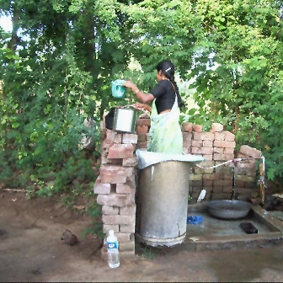
 A Senegalese farmer hoes his potato field. Other crops offer a higher expected yield than potato but would expose the farmer to significant risk of total crop loss. By offering protection against risk, insurance can support the poor in making risky investments with high expected yields, helping them to grow out of poverty.
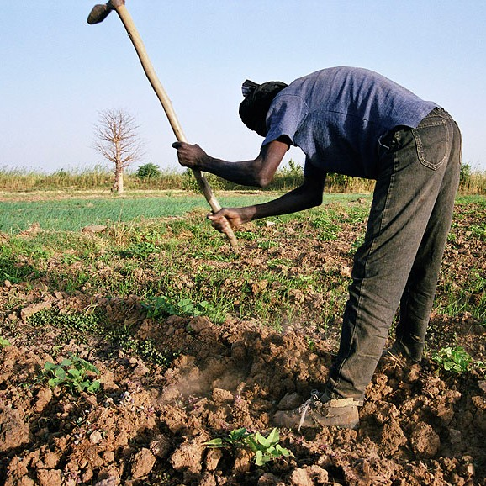
 A woman from a northern Indian village who, despite hard and relentless work, is not able to save more than fifty cents each month. Large unexpected expenses could wipe out those savings and perpetuate poverty. Insurance can help the poor cope with shocks, such as large unforeseen expenses or loss of the main source of income.

“Every day, I am afraid of the next.”
A youth in Russia, quoted in Voices of the Poor (World Bank 2000)
The poor are particularly vulnerable to risk. Any unexpected event can disrupt their lives. After the need to generate income, managing risk is the largest preoccupation of the poor. Insurance can help people to manage risk, yet very little insurance is available for the poor around the world. The World Bank is committed to changing that. This brochure explores the issues surrounding insurance for the poor in a series of questions and answers. It describes the World Bank approach and provides examples of recent World Bank-supported initiatives.
? What risks commonly affect the poor?
- Health: illness, surgery, accident
- Income: Unemployment, crop loss, economic fluctuations, death of a breadwinner
- Property loss: fire, flooding, other natural disasters, death of livestock, crime
- Public policy: taxation, property rights
- Other: surviving to old age, violence, exclusion
? Why do risks matter to the poor?
- The poor are particularly vulnerable to risk. The poor find it difficult to protect themselves against many shocks, such as large unexpected health expenses or death of the primary breadwinner. Without protection, routine shocks can have a substantial adverse effect on the lives of the poor. This is true even in countries or regions experiencing high economic growth, such as India or China.
- Shocks can lead to (deeper) poverty. Large shocks can cause families living above the poverty line to fall (back) into poverty.
- Risk can cause people to produce and consume in a less efficient way. Unable to protect themselves against bad outcomes, the poor may forego opportunities with high expected returns where there is a possibility of very low returns.
- Risk can reduce economic growth. By foregoing opportunities that have high expected return, households reduce expected future income.

? How do the poor manage risks?
- Most poor people manage risk primarily through informal mechanisms, such as borrowing from friends and relatives, and self-insurance, such as investing in assets that can be sold in hard times.
- However, the poor traditionally do not have access to instruments that offer protection against life-cycle shocks, large shocks or shocks that affect a whole family, community or region.
? What special characteristics are needed for insurance for the poor?
To serve poor people, insurance needs to:
- Match poor people’s priority needs for risk protection
- Be easy to understand
- Be affordable, and
- Be trusted.
? What are typical insurance products for the poor?
- Health insurance (linked with health savings and loan products)
- Term life and accidental death and disability (ADD) insurance
- Livestock insurance
- Crop insurance (including index-based insurance such as rainfall indexed insurance)
- Property insurance (such as a housing and fire insurance)
- Natural disaster insurance.
? What factors have so far limited the provision of insurance to the poor?
Less than 3 percent of the low-income population worldwide is covered by some form of formal insurance. Poor people in less developed countries have very limited access to insurance products that fit their needs for several reasons:
- The private sector tends to concentrate on the formally employed (such as civil servants or employees of public or larger private companies). This limits investments in product research and development to service less affluent segments of the population.
- Government-sponsored social protection schemes also mainly target those in the formal sector.
- There are technical, operational and institutional challenges specific to providing insurance to the poor. These include lack of data needed to design and price insurance products, limitations of existing distribution channels, and weak after-sales service of the insured.
? What are the key challenges for improving access to insurance for the poor?

Technical challenges
- Specialized knowledge and capacity
- Limited availability of reliable data about the informal or unorganized sector, where most of the poor work
- Weak risk assessment and difficulty of pricing insurance products with poor data
Operational challenges
- Lack of consumer education
- Need to strengthen intermediaries, such as self-help initiatives and microfinance institutions
- Need for appropriate distribution channels that can handle small transactions in a cost-effective manner and in convenient locations
- Effective after-sales service: timely and fair processing and settlement of claims
Institutional challenges
- Lack of an enabling environment and legislation that requires insurers to behave prudently without stifling innovation in the provision of access to insurance for the poor.
? What kind of insurance solutions does the World Bank support?
The Insurance for the Poor (IfP) Program follows a market enhancement approach, recognizing that market failures can create sub-optimal wealth allocation and that private sector coordination is not always effective. Its main objective is to support insurance solutions that:
- Are effective
- Respond to the priority needs for risk protection of the poor
- Are affordable and financially viable at the same time
- Can be included in a comprehensive financial strategy (savings, credit, insurance)
- Can be scaled up by using synergy effects (such as public-private partnerships)
- Create financially sustainable systems without heavy public intervention
- Either directly benefit the target group or indirectly help the poor by working with intermediaries, such as insurance companies or governments (for example, disaster insurance).
? What kind of support does the World Bank offer?
- Investments in building distribution and service channels for the low-income segment
- Technical assistance in new product development, including actuarial calculations
- Guidance in the development of an enabling environment favoring access to reliable insurance for the poor
- Integration of insurance projects into broader livelihood and social protection programs
- Facilitation of linkages with other financial services, such as savings and loans
? What partners does the World Bank work with in promoting access to insurance for the poor?
- Governments
- Insurance and reinsurance industry
- Development partners
- Communities
- Research institutes and associations
- Others
? What is the World Bank’s role in increasing access to insurance for the poor?

Convening power: The World Bank has in-depth country knowledge and extensive relationships with donors. The IfP team can play a catalytic role in facilitating efficient partnerships between countries, donors, and private markets in developing insurance solutions for the poor.
- In-house technical expertise: The World Bank is among the few international institutions and donors with the in-house experience to design, supervise, and provide technical input to insurance-related projects. The World Bank has international insurance experts knowledgeable in health insurance, life insurance, property insurance, agricultural insurance, and natural disaster insurance.

Operational experience: The IfP Team can make use of experience of both the World Bank and its private sector arm, the International Finance Corporation (IFC), in designing and implementing insurance operations all over the world. The World Bank has a broad project portfolio in the area of insurance for the poor (see below).

Some Insurance Initiatives Supported by the World Bank
The examples that follow illustrate the wide range of initiatives supported by the World Bank. Some directly benefit the target group (examples 1–4). Others work on the country level and indirectly help the poor (examples 5–6).
↓ Expanding Life Insurance in Rural India
Since 2001, the World Bank has supported a life insurance program in Andhra Pradesh, in which community-based organizations and commercial insurance companies work side by side to provide life insurance to the poor. The program has resulted in a rapid expansion of the rural life insurance market. In the fourth year since its inauguration, the program has covered 3.5 million people in 22 districts of Andhra Pradesh.
↓ Piloting Health Savings Accounts with Catastrophic Health Insurance in Uganda
The World Bank is supporting a pilot health financing model that enables poor households to open a health savings account and get catastrophic health insurance as an add-on. Poor households can use their health savings accounts to finance “high frequency, low severity” events and are covered by catastrophic health insurance for the case of high cost, low frequency health events, such as hospitalization. The product will be offered by Ugandan micro savings institutions, in partnership with a Ugandan health insurance provider.
↓ Introducing an Innovative Livestock Insurance Program in Mongolia
To insure livestock losses of herders in Mongolia, the World Bank assisted the government in introducing an innovative index-based livestock insurance program that uses mortality rates by species and geographic area. The program supports a public-private partnership that offers insurance coverage that is attractive to herders; involves the domestic insurance market, while protecting it against catastrophic losses; and limits the government’s budget exposure to natural disasters. At the end of 2007, 13 percent of herders in the project area were covered and about 600,000 animals were insured.

The World Bank
2121 Pennsylvania Ave., NW
Washington, DC 20433 USA
Contact Information
Olivier Mahul, Program Manager, Insurance for the Poor
Email: omahul@worldbank.org Tel: (+1) 202 458-8955
Vijaysekar Kalavakonda
Email: vkalavak@worldbank.org Tel: (+1) 202 458-4624
Fatou Assah
Email: fassah@worldbank.org
↓ Stimulating Crop Insurance in India
With the aim of assisting poor farmers in India, the World Bank provides technical assistance to the Agriculture Insurance Company of India. AICI had developed one of the world’s largest area yield index crop insurance programs (covering around 18 million farmers in 2007). While the program is technically sound, it faces operational challenges such as delays in claims settlement and entails an open-ended fiscal exposure for the government. The World Bank assists AICI in improving its existing program to make it more attractive to the farmers, while providing support to the design and implementation of a new weather index insurance program. This initiative determines crop losses on the basis of rainfall measured at public weather stations, and today insures over 600,000 farmers, generating more than USD30 million premium volume.
↓ Promoting Sovereign Catastrophe Insurance in the Caribbean
The World Bank together with other partners helped Caribbean governments to establish the first ever regional catastrophic insurance facility in the world, the Caribbean Catastrophic Risk Insurance Facility (CCRIF). The CCRIF provides participating governments from the region with immediate access to liquidity if hit by a hurricane or earthquake, which will ultimately also benefit affected poor households. In total 16 countries participate in the insurance initiative, which raised a total premium volume of USD 20 million.
↓ Supporting Legislation to Expand Insurance to the Poor in Cambodia
The Cambodian government recently established a microinsurance department within the Ministry of Economy and Finance and is in the process of drafting a microinsurance sub-decree. Together with other international experts, IfP is advising the ministry on the content of this decree.

