ILO Pre-course Questionnaire
Name: Stephen Smith
Country: South Africa
_________________________________________________________________________________________________

- The present situation and future government plans in social protection in your country.

- What are at present the main issues of the debate on social protection? Expansion – limitation – financing – good governance- compliance – how to encompass the informal sector in social protection and so on. Explain briefly?
Government released a policy discussion paper in November 2016 entitled, Comprehensive social security in South Africa Discussion document” to the National Economic Development and Labour Council (Nedlac). Nedlac has formed a task team to prepare a response and recommendation that will inform a policy paper for approval by Cabinet. The release of the paper follows a protracted period of anticipated policy reform dating back to 2002.
A White Paper on National Health Insurance was issued in June 2017 for health care reform and universal coverage under a new National Health Insurance Scheme.
The areas of debate at Nedlac are not about the objectives, but rather the fiscal and operational means to implement the reforms.

- What are the objectives/plans of your government to develop social protection for the next 5 years, and which accents are the most important? (for example: introduction – expansion of pension plans , introduction of health care for all ; etc. ) and explain briefly .
Health care reform has a timeline to 2025. Broader social security has no timeline as yet. Broader Social Protection is being discussed by the National Planning Commission (NPC).
Accents are as follows:
- Basic income subsidy for unemployed between ages 18-59 years;
- Introduction of a mandatory Pillar 2 retirement fund for the formal sector;
- Coverage for the informal sector;
- Default benefit arrangements for workers;
- Consolidation and alignment across social insurance funds;
- Consolidation of political leadership under a new Ministry and department;
- Universal health care by 2025:
  - All South Africans should have equitable access to quality, affordable healthcare.
  - During 2017/18 government intends to establish a national health insurance fund.
  - Its initial focus will be to expand access to a common set of maternal health services and make hearing aids and spectacles available through school health programmes.
  - It will offer improved psychiatric care, and services for people with disabilities and the elderly.
  - The service package, delivered through public and private medical practitioners, will be progressively expanded.
  - The fund will be established through a combination of re-organisation and legislative amendments.
  - Government is exploring a small reduction in the tax credit on medical scheme contributions to provide initial resources for the fund.
  - During 2017/18, the National Treasury and the Department of Health will work with a wide range of stakeholders to publish the final national health insurance white paper, refine the draft implementation plan and revise cost estimates.
- How is the financing situation of social protection interventions?
  - Financing is the most vulnerable aspect of the proposed policy. No recent demography, financing or sustainability modeling has been done.

- Please retrieve the following indicators?
Total public social expenditure in percentage of GDP ($294.8bn or : 11%. Spending on this priority is set to rise from R164.9 billion in 2016/17 to R209.1 billion by 2019/20, growing at an annual average of 8.2 per cent over the medium term.

Total Public health expenditures in percentage of GDP: 12%. Spending in this function will grow from R170.9 billion in 2016/17 to R217.1 billion in 2019/20.
Health expenditure growth is mainly driven by expanded provision of antiretroviral treatment, which now reaches 3.5 million people. Health expenditure has grown in real terms by about 1.3 per cent between
2012/13 and 2018/19.

Public social protection expenditure on benefits for children as a percentage of GDP R12.3bn or 0.3%

People living below national poverty lines. No official poverty line. Per StatsSA:
The proportion of the population living in poverty declined from 66,6% (31,6 million persons) in 2006 to 53,2% (27,3 million) in 2011, but increased to 55,5% (30,4 million) in 2015. The number of persons living in extreme poverty (i.e. persons living below the 2015 Food Poverty Line of R441 per person per month) in South Africa increased by 2,8 million, from 11 million in 2011 to 13,8 million in 2015. However, this is lower than in 2009 when persons living in extreme poverty were 16,7 million, this is according to the Poverty Trends in South Africa: An examination of absolute poverty between 2006 and 2015 report released by Statistics South Africa.
The report shows that the most vulnerable to poverty in our society are children (aged 17 or younger), females, Black Africans, people living in rural areas, those residing in Eastern Cape and Limpopo, and persons with little or no education.
The income per capita Gini coefficient (income inequality) has declined from 0,72% in 2006 to 0,68% in 2015; however, there are notable variations amongst various population groups.
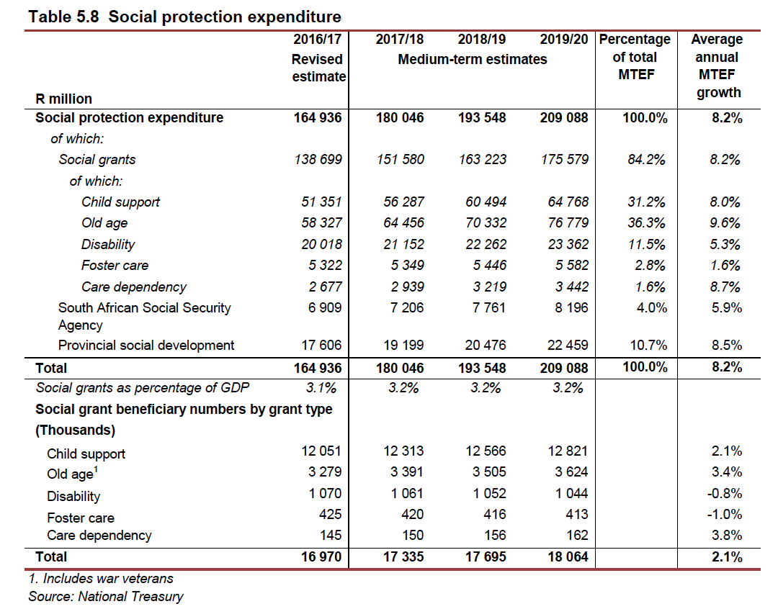

If you do not have national statistics, some data can be retrieved at http://www.ilo.org/dyn/ilossi/ssimain.home?p_lang=en

- Your EO’s positions (contents wise) towards social protection policies?

- Did you develop a general vision on what your country should do in the next 5 years, and how it can afford it? If so, explain the major lines.
  - Yes. Numerous studies undertaken on aspects of the reform. Major focus on retirement and risk coverage for vulnerable workers in the context of a minimum wage settlement as there are at least 5 million workers in this category. Incentives for low-income workers, optimum scale and fiscal sustainability other themes.

- Do you have specific positions on certain specific programmes or branches of social protection (for example public works programme , health care, conditionality in social protection etc etc. )? Explain the main lines.
No. There is often too much conditionality imposed on policy instruments causing complexity and failure.

- Did you develop concrete positions or ideas on social protection for the informal sector (coverage, contribution, compliance systems and so on) If so, explain.
  - I spent many years work-shopping ideas with Labour, did a study trip with Labour to Kenya and tested various proposals with business and Labour on coverage. Also commissioned a study on intersection with minimum wage limit in SA. Did fair amount of research and wrote paper on tax incentives and co-contributions. Also explored the concept of a digital platform for systems and multi-stakeholder groups.

- Do you have specific views on the relation between (multinational) company practices in social security and national social protection policies? No.

- How do you as EO influence your national social protection policies?

- First basic question: is the theme of social protection in any way present in your policy influence activities. If not, why? Yes. I represent Business Unity SA, which is the apex structure for business in the country.

- If you use advocacy and lobbying as a method: what did you do concretely and how? Please bring examples of your position papers

  - I have listed some examples above for informal workers. I have a team of actuaries and professionals drawn from members who support the advocacy, research and development of perspective. We are not keen on position taking, but prefer common research questions, good analytic work and pragmatic dialogue. We have spent many years engaging and participating with government and Labour on the topic and are currently in a national task team at Nedlac debating reform.
.
- What are your main challenges in lobbying and advocacy on social protection: internally (eg little expertise, little support of members) and externally (government does not inform, and so on) Explain, also how you deal with it. Don't have many challenges internally. The process with government has been protracted and lacks empirical support, which makes engagement very difficult. We have agreed at Nedlac to table certain agreed topics for research to inform the policy position.

- Do you have at the national level a social dialogue with trade unions (bipartite) or with trade unions and the government (tripartite) on social protection policies in general, and specifically on the main branches – programmes ? If yes, see further ; if not : why not ? Explain . As mentioned above, we use Nedlac for this type of interaction. I have also spent a lot of time informally with government and Labour.

- If you do have social dialogue (or bipartite or tripartite , and please specify) what are the main themes and results (e.g. global understanding or agreement on the pace of progress in social spending and coverage, e.g. expanded pension system; e.g. certain additional conditions for certain social protection programmes etc ? Explain. There has been little progress until we started meeting again 5 months ago.

- What are the main challenges in this dialogue , internally within the EO and externally, from the other partners ./( e.g. Little interest of members, etc. )( e.g. government does not inform or listen , trade unions are extreme ; etc etc. ) Explain .

  - Government has divergent views within itself leading to extensive delays and lack of sustainable engagement. Business is overwhelmed by change, policy uncertainty and low growth. We have had a good relationship with Labour and government and are optimistic. However, contributory capacity and fiscal space is very limited.

- Joint management of certain social security branches: are you represented in such management boards and in which one’s? No.

- Do you use this representation to influence social protection policies and implementation and what do you do exactly (eg in pension board, in health board, e.g. In other boards you are represented in) ? Explain

- Some good and bad practices

- Explain at least one good practice where you were successful in exerting influence on social protection policies and what the key factors were to ensure your success. This can be in relation to social protection in general ; to its financing by the private sector, its conditionality ; it can also be related to 1 specific part of social protection ( pensions, health, children, work injury etc etc. ). Explain the good practice(s).
  - I critiqued the social security document for the National Planning Commission in 2012, for its inclusion in the National Development Plan as part of a committee chaired by Prof. Viviene Taylor. One of my central criticisms were the absence of a substantive and integrated coverage strategy for informal workers. I recently again made a presentation to Nedlac explaining the need for an integrated strategy. Government has issued a tender for this work to be done.

- Idem for a so-called bad practice. Maybe you have had a case where you were unable to influence social protection policies whilst your members were much concerned . Explain why it went wrong.
  - I was invited to present a strategy for coverage to Labour in 2010. The home work had been done with a team of actuaries and EB professionals. Labour rejected the proposal because it had been conceived without their involvement and found that presumptuous.

- Finally : any original approaches in your country on social protection in and for the informal sector. Explain if anything meaningful happened in your country in that respect. Busy with this as explained above.

A legislative forum where government business and Labour debate policy and new legislation before it goes to parliament.

