- Overview of national social security systems in Asia
 |  |  |  | Number of policy areas covered by at least one programne |  |  |  | Existence of a statutory programme
 | Country |  |  | Number of policy areas covered by at least one programme | Number of social security policy areas covered by a statutory programme |  |  | Sickness (cash) | Maternity (cash)¹ |  | Old age² | Employment injury ³ | Invalidity | Survivors | Family allowances | Unemployment⁴
Asia
 | Afghanistan |  |  | … | … |  |  | … | ❐ |  | … | … | … | … | … | None
 | Australia |  |  | 8 | Comprehensive scope | 8 |  |  |  |  |  |  |  |  |  |  | 
 | Bangladesh |  |  | 4 | Very limited scope | 1 to 4 |  |  |  |  |  |  |  | None | None | None | ❐
 | Brunei Darussalam |  |  | 4 | Very limited scope | 1 to 4 |  |  | ❒ | ❐ |  |  |  |  |  | None | None
 | Cambodia |  |  | … | … |  |  | … | ❐ |  | … | … | … | … | … | ❐
 | China |  |  | 8 | Comprehensive scope | 8 |  |  |  |  |  |  |  |  |  |  | 
 | India |  |  | 7 | Semi-comprehensive scope | 7 |  |  |  |  |  |  |  |  |  | None | 
 | Indonesia |  |  | 4 | Very limited scope | 1 to 4 |  |  | ❒ | ❐ |  |  |  |  |  | None | ❐
 | Iran, Islamic Rep. of |  |  | 8 | Comprehensive scope | 8 |  |  |  |  |  |  |  |  |  |  | 
 | Japan |  |  | 8 | Comprehensive scope | 8 |  |  |  |  |  |  |  |  |  |  | 
 | Korea, Republic of |  |  | 5 | Limited scope | 5 to 6 |  |  | ❒ | ❐ |  |  |  |  |  | None | 
 | Lao People's Dem. Rep. |  |  | 6 | Limited scope | 5 to 6 |  |  |  |  |  |  |  |  |  | None | None
 | Malaysia |  |  | 4 | Very limited scope | 1 to 4 |  |  | ❒ | ❐ |  |  |  |  |  | None | ❐
 | Maldives |  |  | … | … |  |  | ❒ | … |  |  | … |  |  | … | None
 | Mongolia |  |  | 8 | Comprehensive scope | 8 |  |  |  |  |  |  |  |  |  |  | 
 | Myanmar ¹ |  |  | 3 | Very limited scope | 1 to 4 |  |  |  |  |  | ❐ |  | ❐ | ❐ | Not yet | Not yet
 | Nepal |  |  | 4 | Very limited scope | 1 to 4 |  |  | ❐ | ❐ |  |  |  |  |  | None | ❐
 | New Zealand |  |  | 8 | Comprehensive scope | 8 |  |  |  |  |  |  |  |  |  |  | 
 | Pakistan |  |  | 6 | Limited scope | 5 to 6 |  |  |  |  |  |  |  |  |  | None | ❐
 | Papua New Guinea |  |  | 4 | Very limited scope | 1 to 4 |  |  | ❐ | None |  |  |  |  |  | None | None
 | Philippines |  |  | 6 | Limited scope | 5 to 6 |  |  |  |  |  |  |  |  |  | None | ❐
 | Singapore |  |  | 7 | Semi-comprehensive scope | 7 |  |  |  |  |  |  |  |  |  |  | None
 | Sri Lanka |  |  | 5 | Limited scope | 5 to 6 |  |  | ❒ | ❐ |  |  |  |  |  |  | ❐
 | Thailand |  |  | 8 | Comprehensive scope | 8 |  |  |  |  |  |  |  |  |  |  | 
 | Timor-Leste |  |  | … | … |  |  | … | ❐ |  |  | … | … | … | None | None
 | Viet Nam |  |  | 7 | Semi-comprehensive scope | 7 |  |  |  |  |  |  |  |  |  | None | 
 |  |  |  |  |  |  |  | ▪ |  |  | ▪ | ▪ | ▪ | ▪
Pacific Island countries |  |  |  |  |  | ▪ |  |  |  | ▪
 | Fiji |  |  | 5 | Limited scope | 5 to 6 |  |  | None | ❐ |  |  |  |  |  |  | None
 | Kiribati |  |  | 4 | Very limited scope | 1 to 4 |  |  | None | ❐ |  |  |  |  |  | None | None
 | Marshall Islands |  |  | 3 | Very limited scope | 1 to 4 |  |  | ❒ | ❒ |  |  | None |  |  | None | None
 | Palau Islands |  |  | 3 | Very limited scope | 1 to 4 |  |  | None | None |  |  | None |  |  | None | None
 | Samoa |  |  | … | No information |  |  | … | … |  |  |  |  |  | … | None
 | Solomon Islands |  |  | 5 | Limited scope | 5 to 6 |  |  | None | None |  |  |  |  |  | None | X
 | Tuvalu |  |  | … | No information |  |  | … | … |  |  |  |  |  | … | None
 | Vanuatu |  |  | 3 | Very limited scope | 1 to 4 |  |  | ❐ | ❐ |  |  | None |  |  | None | ❐
Sources
SSA/ISSA. 2012. Social Security Programs Throughout the World (Washington, DC and Geneva): Asia and the Pacific, 2012, ILO Normlex and national legislation.
 |  | Notes
 |  | …: | Not available
 |  | Symbols
 |  |  | One statutory programme at least
 |  |  | Legislation not yet implemented
 |  | ❐ | Limited provision (e.g. labour code only)
 |  | ❒ | Only benefit in kind (e.g. medical benefit)
 |  | ▪
 |  | ¹ | Myanmar has enacted its social security law in 2012. The laws includes provisions for most social security branches including old age, survivors, disability, family benefits, unemployment insurance benefit (section 37) but the country is at the stage of drafting the regulations and provisions are not yet being implemented.
 |  | ▪
 |  | Definitions
The scope of coverage is measured by the number of social security policy areas provided for by law. This indicator can take the value 0 to 8 according to the total number of social security policy areas (or branches) with a programme anchored in national legislation.
The eight following branches are taken into consideration: sickness, maternity, old age, survivors, invalidity, family allowances, employment injury and unemployment.
 |  | The number of branches covered by at least one programme provides an overview of the scope of legal social security provision.
- Towards comprehensive social security systems in Asia:
from 1900 to 2012 (basis 34 countries)

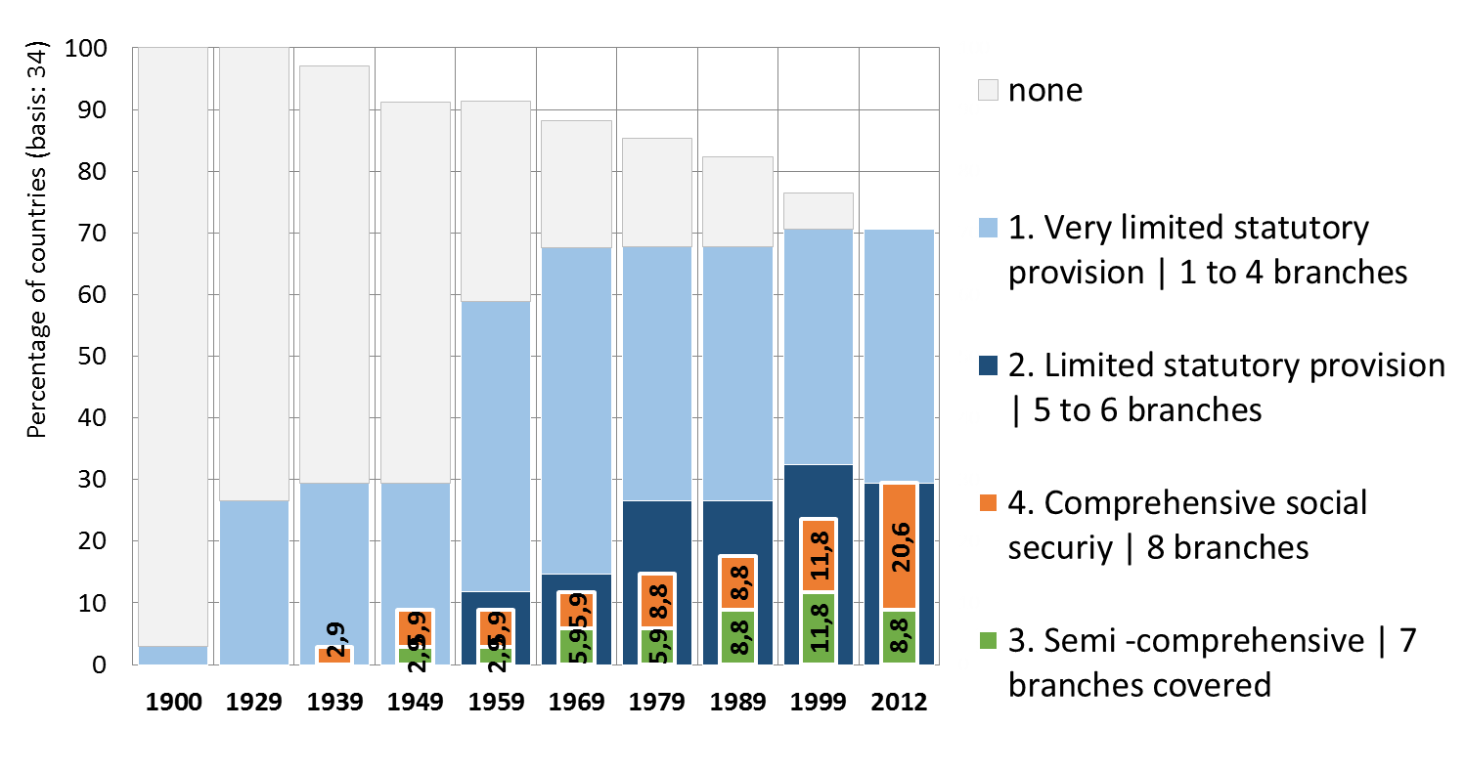
Sources: ILO based on SSA/ISSA Social security programs throughout the world, Asia 2012, ILO Normlex and national legislation (detailed sources available online: http://www.social-protection.org/gimi/gess/RessourceDownload.action?ressource.ressourceId=44777)
- Public social protection expenditure as a percentage of GDP in Asia (levels and composition), latest available year
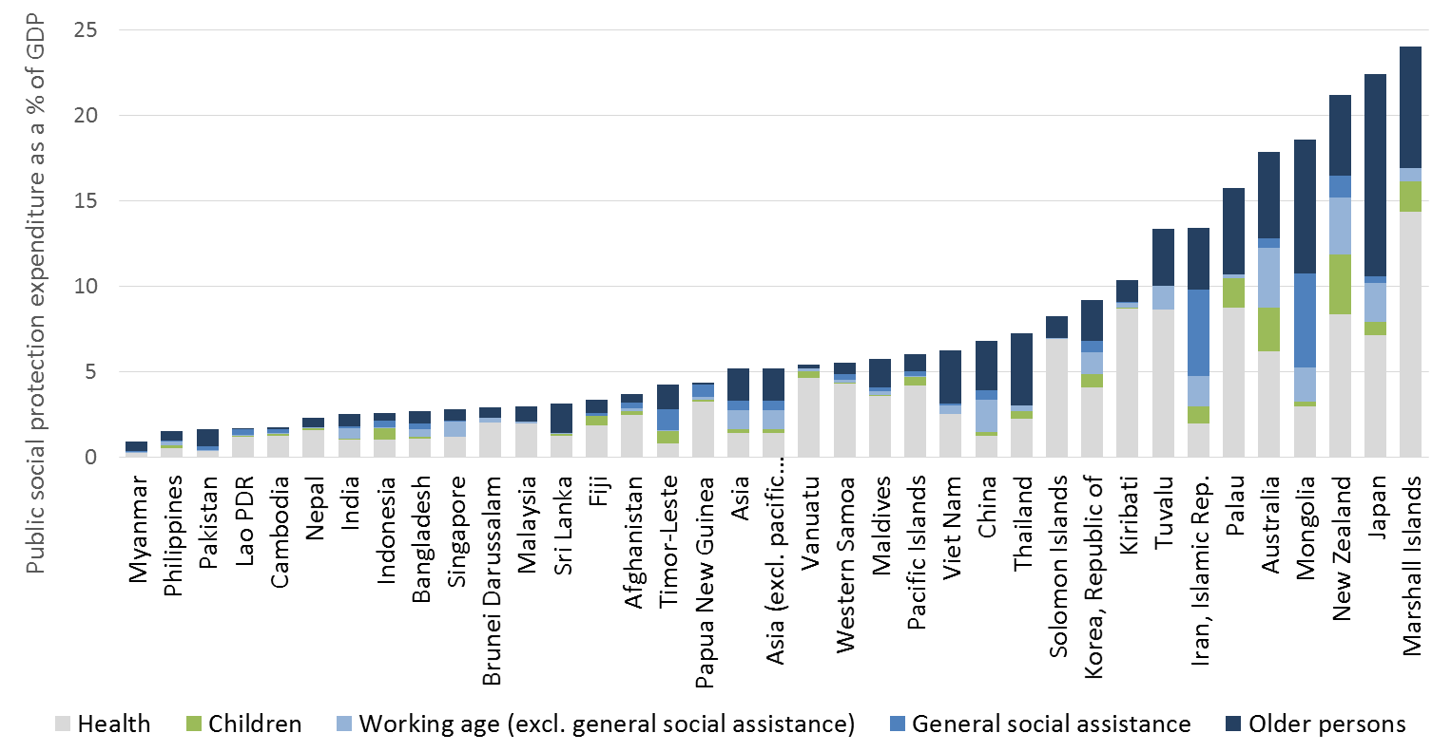
Sources: ILO social security inquiry database, ADB, IMF, WHO and national sources (detailed sources available online: http://www.social-protection.org/gimi/gess/RessourceDownload.action?ressource.ressourceId=44778 )

Alternative
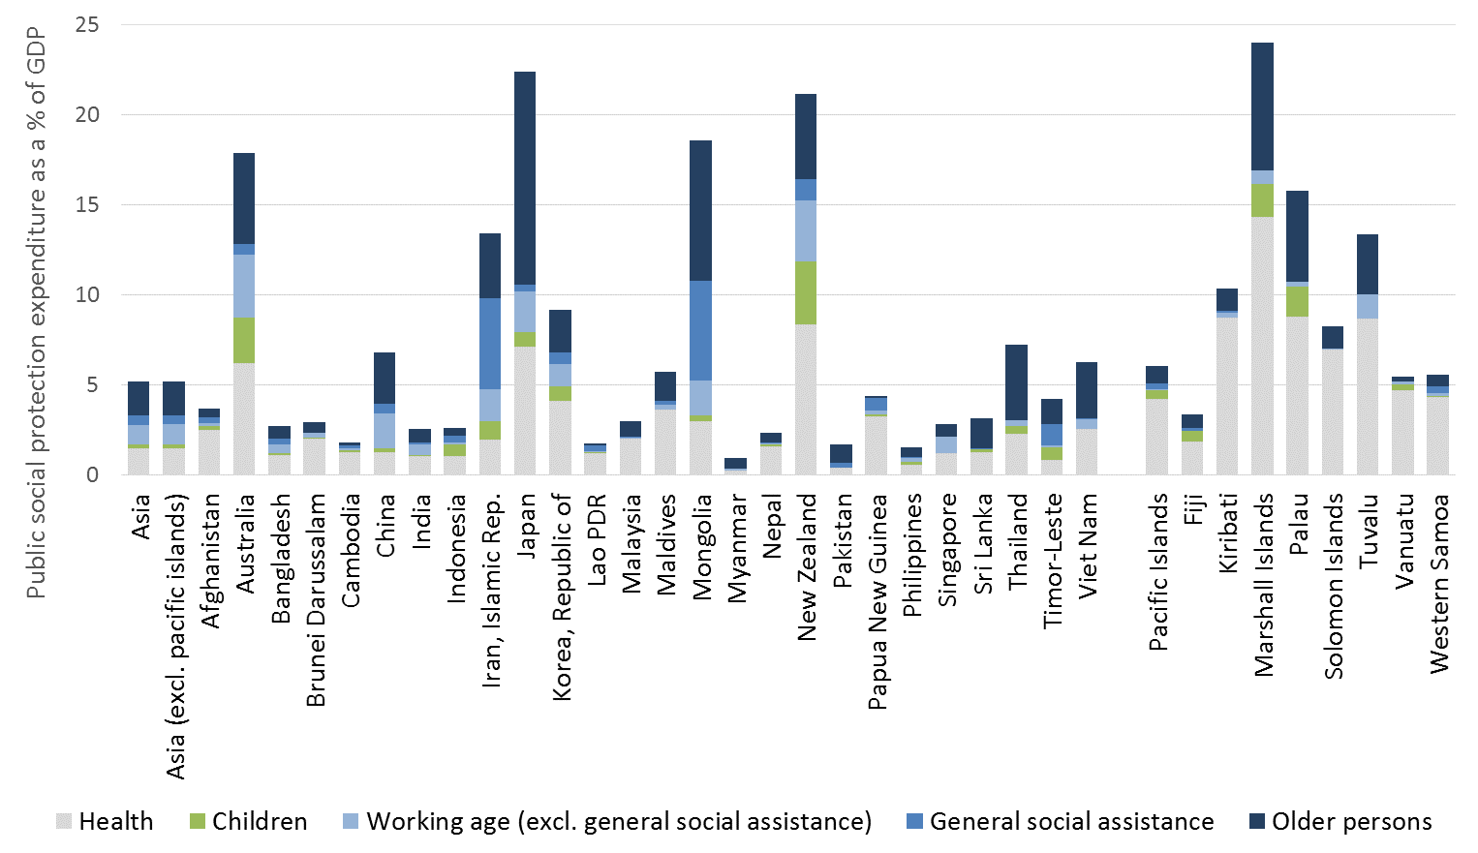
Sources: ILO social security inquiry database, ADB, IMF, WHO and national sources (detailed sources available online: http://www.social-protection.org/gimi/gess/RessourceDownload.action?ressource.ressourceId=44778 )

- Health coverage as a percentage of total population (members of health insurance or free access to health care services provided by the State)
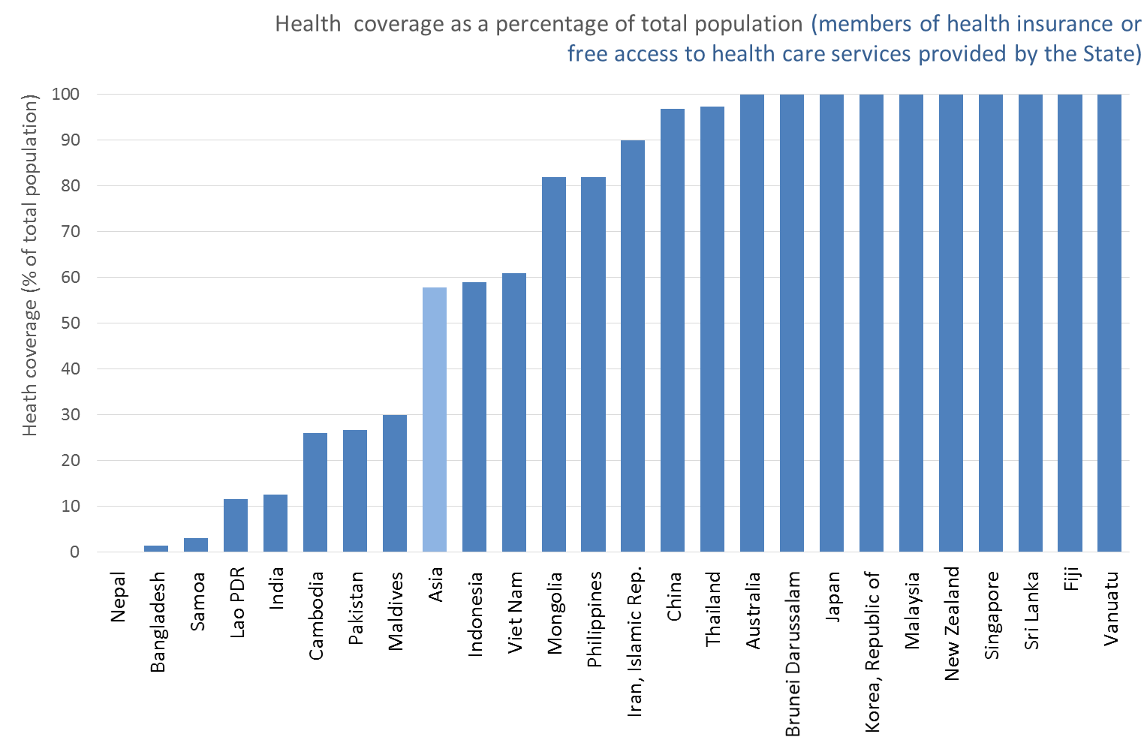
Sources: detailed national sources available at: http://www.social-protection.org/gimi/gess/RessourceDownload.action?ressource.ressourceId=44797
- Unemployed receiving unemployment benefits (percentage)
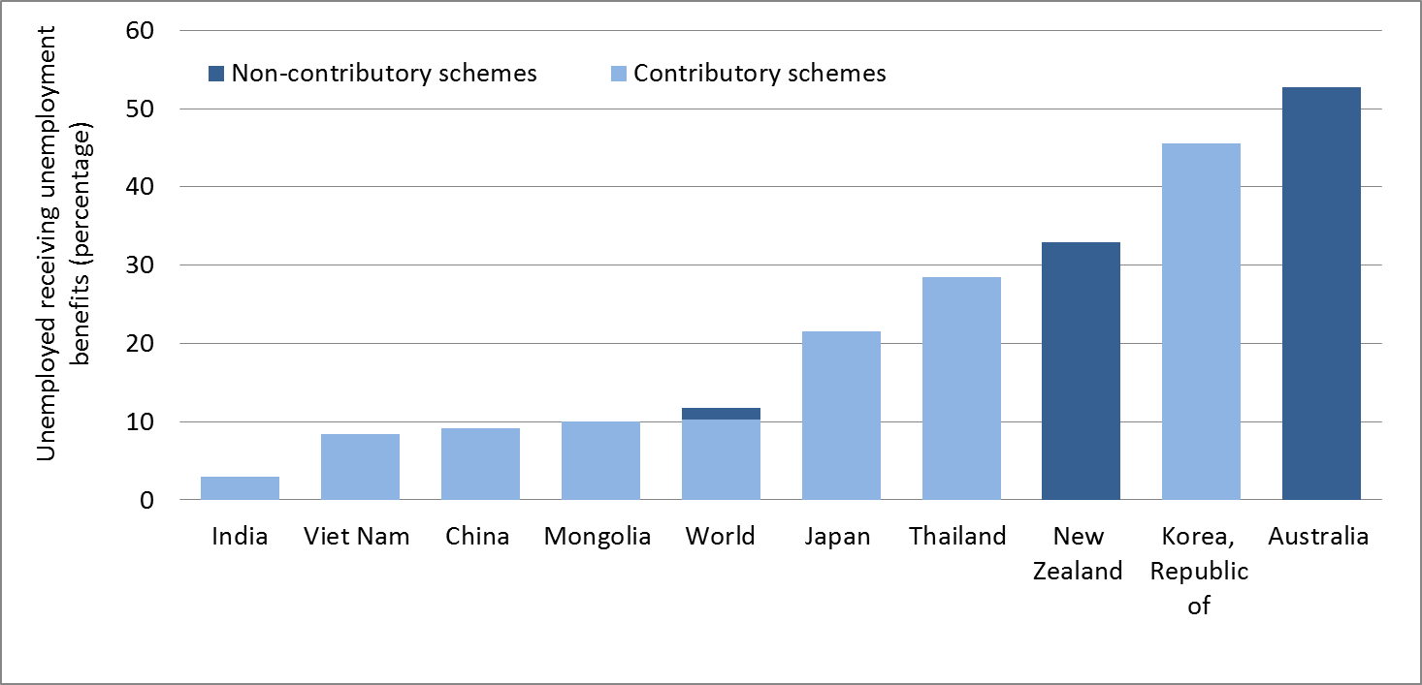
Note: consult detailed information by country (existence or not of unemployment benefits anchored in legislation, type of programme and data for 2000 to latest available year in the table below also available at: http://www.social-protection.org/gimi/gess/RessourceDownload.action?ressource.ressourceId=44798.
Sources: ILO social security inquiry and detailed national sources available at: http://www.social-protection.org/gimi/gess/RessourceDownload.action?ressource.ressourceId=44798
- Percentage of unemployed receiving unemployment benefits
 | 2000 |  | 2007 |  | 2009 |  | 2010 |  | 2011 |  | 2012
Major area, region or country | Contributory and non-contributory schemes | Real year | Contributory and non-contributory schemes | Real year | Contributory and non-contributory schemes | Real year | Contributory and non-contributory schemes | Real year | Contributory and non-contributory schemes | Real year | Contributory schemes | Non-contributory schemes | Contributory and non-contributory schemes | Male | Female | Latest Year | Exsistence of unemployment programme anchored in legislation and type of programme
World | 11,2 |  | 13,9 |  | 13,8 |  | 11,6 |  | 11,3 |  | 10,2 | 1,5 | 11,7
… without China | 11,6 |  | 12,8 |  | 13,8 |  | 12,5 |  | 12,1 |  | 10,6 | 2,0 | 12,6
Asia |  |  |  |  |  |  | 4,1 |  | 4,0 |  | 4,4 | 1,4 | 5,8
Afghanistan | n.a. | … | n.a. | … | n.a. | … | n.a. | … | n.a. | … | n.a. | n.a. | n.a. | n.a. | n.a. | 2013 | No programme anchored in legislation
Australia ³ | 73,4 | 2000 | 62,4 | 2007 | 58,2 | 2009 | 51,3 | 2010 | 51,4 | 2011 | 0,0 | 52,7 | 52,7 | 60,0 | 44,4 | 2012 | Social assistance
Bangladesh ^{2, 4} | n.a. | … | n.a. | … | n.a. | … | n.a. | … | n.a. | … | n.a. | n.a. | n.a. | n.a. | n.a. | 2013 | Severance payment ª
Brunei Darussalam | n.a. | … | n.a. | … | n.a. | … | n.a. | … | n.a. | … | n.a. | n.a. | n.a. | n.a. | n.a. | 2013 | No programme anchored in legislation
Cambodia ^{2, 5} | n.a. | … | n.a. | … | n.a. | … | n.a. | … | n.a. | … | n.a. | n.a. | n.a. | n.a. | n.a. | 2013 | Severance payment ª
China ⁶ | 9,9 | 2000 | 17,1 | 2007 | 14,0 | 2009 | 9,2 | 2010 | 9,1 | 2011 | 9,1 | 0,0 | 9,1 | … | … | 2011 | Local government-administered social insurance programs
India ⁷ | n.a. | … | n.a. | … | n.a. | … | n.a. | … | n.a. | … | 3,0 | 0,0 | 3,0 | … | … | 2008 | Social insurance and social assistance (public employment guarantee scheme)
Indonesia ^{2,8} | n.a. | … | n.a. | … | n.a. | … | n.a. | … | n.a. | … | n.a. | n.a. | n.a. | n.a. | n.a. | 2013 | Severance payment ª
Iran, Islamic Rep. Of | … | … | … | … | … | … | … | … | … | … | … | … | … | … | … |  | Social insurance
Japan ⁹ | 32,5 | 2001 | 22,1 | 2007 | 25,4 | 2009 | 19,6 | 2010 | 21,5 | 2011 | 21,5 | 0,0 | 21,5 | … | … | 2011 | Social insurance
Korea, Republic of ¹⁰ | 25,1 | 2004 | 34,9 | 2007 | 39,2 | 2009 | 36,0 | 2010 | 35,8 | 2011 | 45,5 | 0,0 | 45,5 | … | … | 2012 | Social insurance
Lao People's Dem. Rep. | n.a. | … | n.a. | … | n.a. | … | n.a. | … | n.a. | … | n.a. | n.a. | n.a. | n.a. | n.a. | 2013 | No programme anchored in legislation
Malaysia ^{2,11} | n.a. | … | n.a. | … | n.a. | … | n.a. | … | n.a. | … | n.a. | n.a. | n.a. | n.a. | n.a. | 2013 | Severance payment ª
Maldives | n.a. | … | n.a. | … | n.a. | … | n.a. | … | n.a. | … | n.a. | n.a. | n.a. | n.a. | n.a. | 2013 | No programme anchored in legislation
Mongolia ¹² | 18,0 | 2003 | … | … | 9,0 | 2009 | 10,0 | 2010 | … | … | 10,0 | 0,0 | 10,0 | … | … | 2010 | Social insurance
Myanmar ¹³ | n.a. | … | n.a. | … | n.a. | … | n.a. | … | n.a. | … | n.a. | n.a. | n.a. | n.a. | n.a. | 2013 | Unemployment insurance as part of social security law (August 2012, not yet implemented)
Nepal ^{2,14} | n.a. | … | n.a. | … | n.a. | … | n.a. | … | n.a. | … | n.a. | n.a. | n.a. | n.a. | n.a. | 2013 | Severance payment ª
New Zealand ¹⁵ | … | … | 28,0 | 2007 | 35,8 | 2009 | 41,8 | 2010 | 37,5 | 2011 | 0,0 | 32,9 | 32,9 | 45,8 | 20,6 | 2013 | Social assistance
Pakistan ^{2,16} | n.a. | … | n.a. | … | n.a. | … | n.a. | … | n.a. | … | n.a. | n.a. | n.a. | n.a. | n.a. | 2013 | Severance payment ª
Papua New Guinea | n.a. | … | n.a. | … | n.a. | … | n.a. | … | n.a. | … | n.a. | n.a. | n.a. | n.a. | n.a. | 2013 | No programme anchored in legislation
Philippines ^{2,17} | n.a. | … | n.a. | … | n.a. | … | n.a. | … | n.a. | … | n.a. | n.a. | n.a. | n.a. | n.a. | 2013 | Severance payment ª
Singapore | n.a. | … | n.a. | … | n.a. | … | n.a. | … | n.a. | … | n.a. | n.a. | n.a. | n.a. | n.a. | 2013 | No programme anchored in legislation
Sri Lanka ^{2,18} | n.a. | … | n.a. | … | n.a. | … | n.a. | … | n.a. | … | n.a. | n.a. | n.a. | n.a. | n.a. | 2013 | Severance payment ª
Thailand ¹⁹ | n.a. | 2000 | 11,1 | 2007 | 24,3 | 2009 | 22,4 | 2010 | 37,1 | 2011 | 28,5 | 0,0 | 28,5 | … | … | 2012 | Social insurance
Timor-Leste | n.a. | … | n.a. | … | n.a. | … | n.a. | … | n.a. | … | n.a. | n.a. | n.a. | n.a. | n.a. | 2013 | No programme anchored in legislation
Viet Nam ²⁰ | n.a. | 2000 | n.a. | 2007 | 0,7 | 2009 | 10,8 | 2010 | 9,5 | 2011 | 8,4 | 0,0 | 8,4 | … | … | 2012 | Social insurance
Pacific Islands
Fiji | n.a. | … | n.a. | … | n.a. | … | n.a. | … | n.a. | … | n.a. | n.a. | n.a. | n.a. | n.a. | 2013 | No programme anchored in legislation
Kiribati | n.a. | … | n.a. | … | n.a. | … | n.a. | … | n.a. | … | n.a. | n.a. | n.a. | n.a. | n.a. | 2013 | No programme anchored in legislation
Marshall Islands | n.a. | … | n.a. | … | n.a. | … | n.a. | … | n.a. | … | n.a. | n.a. | n.a. | n.a. | n.a. | 2013 | No programme anchored in legislation
Palau Islands | n.a. | … | n.a. | … | n.a. | … | n.a. | … | n.a. | … | n.a. | n.a. | n.a. | n.a. | n.a. | 2013 | No programme anchored in legislation
Samoa | n.a. | … | n.a. | … | n.a. | … | n.a. | … | n.a. | … | n.a. | n.a. | n.a. | n.a. | n.a. | 2013 | No programme anchored in legislation
Solomon Islands | n.a. | … | n.a. | … | n.a. | … | n.a. | … | n.a. | … | n.a. | n.a. | n.a. | n.a. | n.a. | 2013 | Withdraw from provident fund
Tuvalu | n.a. | … | n.a. | … | n.a. | … | n.a. | … | n.a. | … | n.a. | n.a. | n.a. | n.a. | n.a. | 2013 | Severance payment ª
Vanuatu ²¹ | n.a. | … | n.a. | … | n.a. | … | n.a. | … | n.a. | … | n.a. | n.a. | n.a. | n.a. | n.a. | 2013 | Severance payment ª

- Old age coverage indicators: contributors as a percentage of the working age and old age people as a percentage of the population above statutory pensionable age
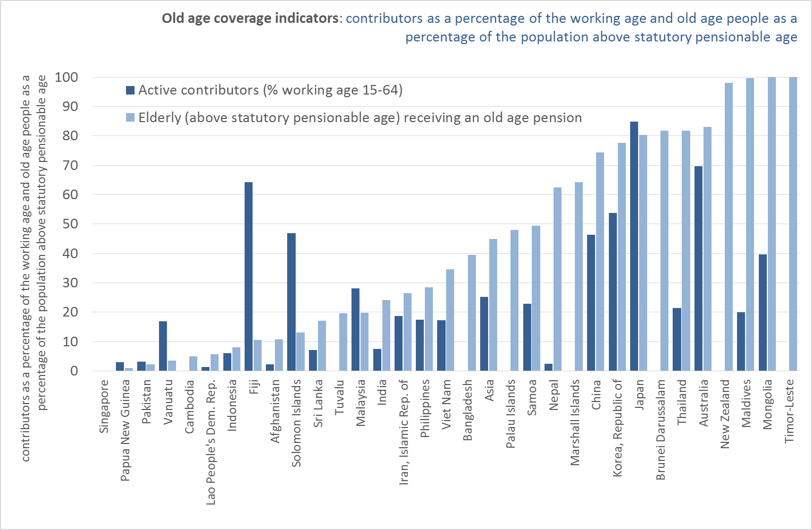
Sources: ILO social security inquiry and detailed national sources available at: http://www.social-protection.org/gimi/gess/RessourceDownload.action?ressource.ressourceId=44817
Alternative
