 | 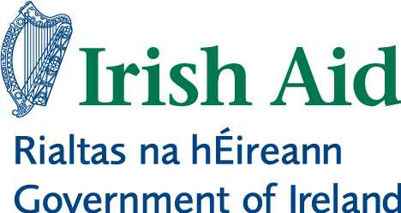

Workplan – 2015
Building National Floors of Social Protection in Southern Africa

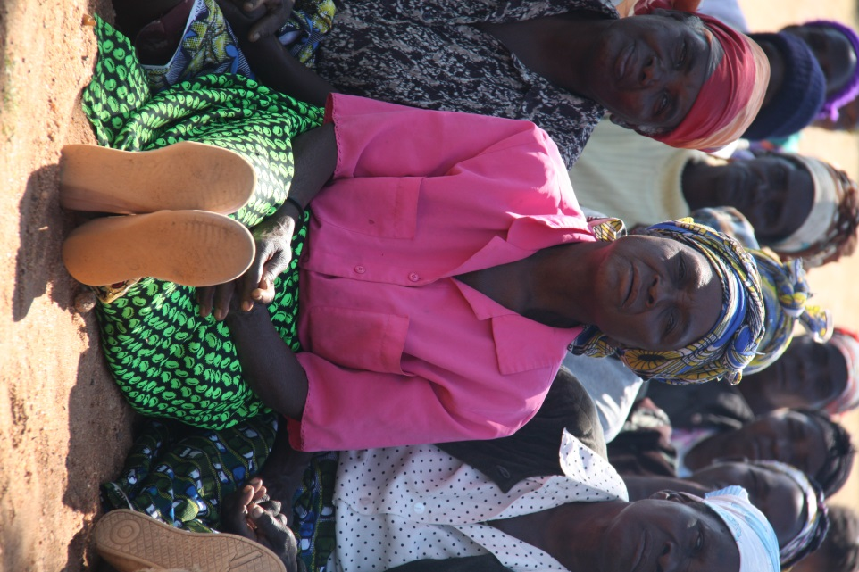 | 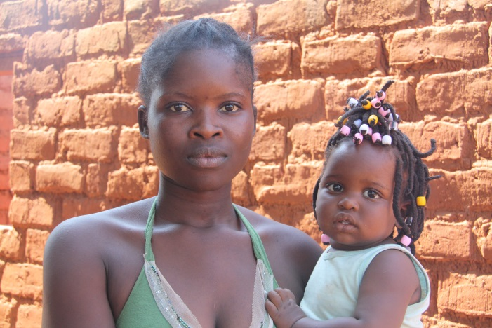
 | 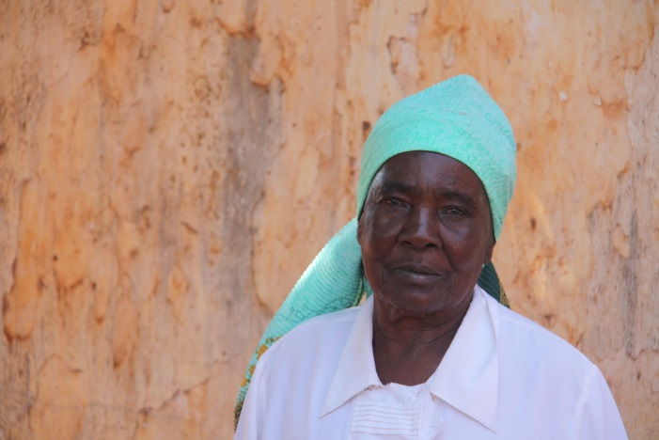

Lusaka, 19th February 2015
1. Introduction
This document serves to present the Project “Building National Floors of Social Protection in Southern Africa” work-plan for 2015. It includes a brief introduction of the current context that frames the Project interventions and a description of the main activities, whilst allowing for an understanding and appreciation of the detailed work-plans highlighted for each of the three countries and the regional component, guided by the Project Document logical framework.

2. Background
The Project will continue to focus on the same principles that guided the interventions in the first year. The main efforts will be focused towards continuing activities that were already started or at least planned with the partners in 2014.
An increased focus will be given to regional activities, through the organization of a high level learning peer to peer event and the finalization of regional products.
Following the Strategy proposed in the Project Document, and in order to increase its potential impact, the Project will maintainits strategy around the use of partnerships to increase its impact and additionally focus on leveraging resources from ILO internal and external sources to complement the actions planned.
Though the Project has not had significant context change since October 2014, when the Project prepared a “brief update report”, some common challenges and opportunities, which still remain relevant to the Project strategy have, however, been identified and are listed below:
- The need to keep promoting broad national consensus around the developmental role of Social Protection;
- The need to innovate in the processes of policy design and the potential offered by participatory approaches using the concept of Social Protection Floors Assessment Based National Dialogues
- The lack of systematic knowledge/expertise on how to deal with the design and implementation of SP operational systems, particularly for Social Assistance schemes;
- The existing risk of having countries in the region using safety nets approach for the development of their systems at the expense of grounding their system development on a comprehensive vision of SP systems based on a rights based approach as stated in Social Protection Floor Recommendation (R202)
- Very good collaborative environment between development partners, including bilateral donors, as well as UN agencies
- The existence of gaps in terms of communication and knowledge sharing in the region
- The need to improve linkages between SP and agriculture
The proposed work-plan was developed in consultation with government counterparts and development partners working at the country level in SP.

3. Project key activities
3.1 Regional
One of the key activities planned for 2015 under the Regional component is a “High level peer dialogue and learning event on institutionalizing and administering non-contributory national social protection programs” that should take place in April 2015.” The intended peer to peer dialogue, study tour and training seminar is crafted around the idea of strengthening exchange of information founded on experiences of different countries in the region regarding implementation of social protection. Basically, it will try to build a dialogue process around solutions that different countries would require in addressing challenges that SP systems are facing in the region. It is also expected that participating countries will benefit from technical expertise within the collaboratve framework aligned to the development of the technical modules.
The event will be organized in Nairobi (Kenya) following the expression of interest from participating countries in acquainting themselves and thereby fostering knowledge enhancement emanating from Kenya’s experience sharing(particularly its Single Registry of Harmonized Management and Information system and Social Protection Coordination/Legal framework). In addition to high level participation of government officials from the 3 countries, directly assisted by the Project, the event envisages also the participation of Lesotho and Namibia.
The organization of the retreat will be possible due to the resources that ILO was able to leverage from internal funds (RBSA funds allocated to the Area of Critical Importance 3 - Social Protection Floors). Additionally, UNICEF has also shown interest in co-financing the initiative due to its relevance to the region.
The innovation of this training event will be at two levels. The first has to do with the pedagogical methodology that will be proposed, drawing on I-P-K experience in the promotion of high level dialogues, building on initial collaborations at country level from 2014. The advancement of SP agenda in the region implies working towards a change in mind-sets and perceptions around SP. The need to therefore innovate and “push” decision-makers to think “out of the box” is an imperative and not alternative.
A second innovation has to do with the themes and the training materials. The identification of the themes was premised on Project experience at country level, including but not limited to, requests from government officials but also discussions with cooperating partners involved in assisting locally the development of social protection systems.
The event will allow to undertake preliminary training on the regional modules developed, which include; Legal framework, Coordination, Management Information System, Institutional and Administrative Arrangements and Social Protection Budgeting and Financing.
It is expected that in addition to the regional high level government officials’ event, a final day will be used to jointly explore and plan around the development of the regional innovative training guideline. This component will build on the lessons from the first days, and will bring together the experts involved in module development including ILO and UNICEF specialists, as the intention is to make it a UN tool. The ILO specialists (from HQ) involved in the development of global tools will be expected to participate as the regional tool to be developed will be an important source of information for the development of Global training tools. The participation of Irish Aid would be highly appreciated as this guideline should be a key deliverable from the Project.
A second key deliverable that is expected in 2015 is a first version of the Training package/guideline on Governance and Administration of Social Protection Floors in Southern Africa. The first drafts of the contents for the following four modules were already developed in 2014: Legal framework; Coordination; Management Information System and Institutional and Administrative Arrangements. In 2015 there are plans to develop at least the following 2 modules: Social Protection Floors Budgeting and Financing and Identification and Selection of Beneficiaries. The meeting in Nairobi will provide indications on the need/interest in developing additional modules and obtain consensus on the format that the training package/guideline will assume. Related, the above has been necessitated by ILO’s ability to mobilize internal resources to cover the development of these modules. Further, the ILO is in discussions for a possible partnership with UNICEF to extend the scope of the training package. In addition, the ILO is also working on the development of Global Training packages in similar thematic areas and it is expected that the regional package will also be one of the components of this global initiative.
It is also expected that in 2015 a regional study on the relation between Agriculture and Social Protection will be prepared. The study should bring together experiences in testing forms of intervention that brings together agriculture and social protection and based on concrete demands and on-going processes at country level. The study will be a compilation of individual researches to be carried out in Malawi, Zambia and Lesotho. In Malawi and Lesotho the work will be done in collaboration with FAO and in Zambia in collaboration with the Ministry of Health. The idea is to have joint ILO/FAO guidelines/recommendations at the end of the Project to link with the Regional Inter Agency Group on Agriculture and Social Protection coordinated by African Union. Actually, through a partnership with FAO, ILO has recently become a member of this group.
The experience at country level in the use of participatory processes in the definition of social protection, through the development of country adapted Social Protection Floors Assessment Based National Dialogues (ABND) will feed the development of a Global Guide on ABDN. The Project has been investing in the adaption of current methodologies to the regional context and needs in order to increase its effectiveness in influencing policies and promoting the extension of SP coverage. Meanwhile, virtual working spaces for each of the countries will be created to allow sharing the different steps and methodologies used. The experience of the Project will also be shared in a South-South Social Protection event in China.
Finally, a Guide on Good Collaboration Practices in the Region will be finalized. Cases like the joint work in Mozambique and Zambia will be especially highlighted in order to influence other countries to ensure more effective country support, by increased and improved collaboration. Indeed, it is possible to observe increase in the number of UN Joint Programs and Funds in this area in countries like Tanzania and Ethiopia. It is therefore expected that this study will impact the quality of UN and bilateral partners support to the country in the post 2015 delivery of social protection floor targets under the Sustainable Development Goals. This Guide is also funded by ILO internal resources.

3.2 Mozambique
Until 2014 the main support provided by ILO in the area of Social Protection to Mozambique was funded by the UN Joint Program funded by SIDA. The Program closed in December 2014. However, it was possible to extend the component funded under the UN One fund, which will allow ensuring in part the continuity the activities and staff in at least the first half of 2015. This situation requires an additional involvement of the Irish Aid Project as will be described further in sector 4 compared with 2014.

The main focus of the intervention will be on the draft of the new National Basic Social Security Strategy that will replace the current Strategy. ILO supported the evaluation of the current strategy through a participatory approach engaging policy-makers, national and provincial directors, civil society representatives, donors and UN agencies. The goal was the development of a common framework for the analysis of vulnerability, and to initiate a broaden discussion about the role of basic social security in the country economic and social development. In 2015, ILO will support a costing exercise and a process of national dialogue towards the design of the new Strategy that is expected to lead to the approval by the Council of Ministers of the new programmatic document for the area of Basic Social Security.

Following last year activities, the current discussion includes the possibility of extending the coverage benefits, through the provision of an Infant Grant. However, the discussion did not reach yet the level of decision makers. Indeed, ILO was requested to support the Ministry with the provision of Short Policy Briefs/Videos that can help improving the political space for the acceptance of the revised policy proposals. This sensitization process will also include training to high level officials in the Ministry (Consultative Council) as part of the design of the new Strategy.

In addition, ILO is supporting advocacy efforts for increased state funding to basic social protection through research on fiscal space, technical assistance in budget analysis, trainings with decision-makers and workshops with journalists. A partnership established with the IMF and the Mozambican Civil Society Platform for Social Protection, has proven effective in successfully advocating for increased budget allocations to the sector. The increase in budget allocations to the sector has allowed for the further expansion of INAS programmes and a continued increase in the value of the transfers.
The activities will be mainly funded by the remaining resources from the UN One Fund, but Irish Aid Project staff will be directly involved in the activities.

3.3 Zambia
Following the launch of the National Social Protection Policy in December 2014, the Project work-plan for Zambian is envisaged to have a prime focus on the development of an integrated social protection framework that would give a clearer roadmap for the operationalization of the National Social Protection Policy (NSPP). Though the policy is inclusive of an implementation plan, it is imperative that a structured framework, creating a nexus amongst the five pillars and systematic implementation plan is put in place. The main exercise for Zambia’s work-plan will therefore focus on the development of this exercise which will, in practice, make use of the ILO Assessment Based National Dialogue tool for formulation of an integrated framework.
This activity follows a concrete request from the Government during the join Government/Cooperating Partners mission in July 2014. The delays in the official launch of the NSPP pushed the commencement of the above into 2015.
The above exercise is therefore highlighted for the whole of 2015 as a result of the different activities which need to be undertaken within this space. Related workshops, research studies and literature review exercises will define this process through-out 2015. The key partner under this activity will be the MCDMCH. However, ILO will also work with other cooperating partners, particularly UNICEF.
The rest of the activities to be undertaken for the year will include capacity building trainings targeted at trade union representatives and media, building on initial trainings that had been undertaken with the civil society organisations, towards the tail-end of 2014. Within the civil society framework, the project intends to build on the capacity building trainings undertaken earlier in 2014. The project envisages working with the Churches Council of Zambia, an organisation that has strategic operations underpinning social protection interventions at implementation levels. Parliamentarian trainings on SP will be a strategic advocacy tool which will also help in giving “voices” towards the need to widen the scope for funding. It is therefore expected that the above actions will feed into the process of dialogue around the National Social Protection Policy toward the development of the integrated framework.
Technical support will also be provided to the Ministry of Health and Ministry of Labour on the Social Health Insurance and Pension Reform processes. In the case of Health the Project is supporting the assessment of the feasibility of using Health Savings as a source of funding for the foreseen National Health Insurance. This component is done in strong articulation with the UN Zambian Green Jobs Program that is also supporting the extension of Health Protection to workers in the construction sector.
In addition, ILO will also support the Ministry of Health in assessing the potential role of Agricultural Value Chains to organize contributions to the National Health Insurance. This will be done in collaboration with the ILO Project on Rural Employment and the research will be funded by ILO internal resources.
In 2015, the Project will finalize the working paper looking at the impact of the Zambian Child Grant and the Farmer Input Subsidy.
Depending on government requests, the ILO is also available to provide juridical support to the development of the Social Protection Law (currently in the form of a draft, but yet available for circulation) and to the development of the Social Assistance Act.
One of the strategies of the Project in Zambia is to provide assistance in a broad range of themes. Taking into consideration that other agencies/partners are mainly focusing in Social Assistance, and after dialogue with other partners, this decision should contribute to a more balanced development of a comprehensive SP system.
Briefs and communication tools will be produced for Zambia in a bid to promote Project information circulation and raise visibility profile.

3.4 Malawi
The strategy of ILO in Malawi is to reinforce the collaboration of the Project with other partners and together increase the effectiveness of provided support through better alignment based on the joint work plan between the Government of Malawi and Social Protection partners. The process is coordinated by the Ministry of Finance, Economic Planning and Development (MoFEPD), which is responsible for designing Malawi’s Social Protection policy.
The main highlights of ILO intervention for 2015 will be the finalization of the Assessment and Costing Report on the Social Protection System in Malawi. A first component of the report, which covers the assessment of currently implemented Social Protection programmes and includes recommendations collected from a Social Protection stakeholder workshop in November 2014 it is expected to be shared in the first quarter of 2015. The second component of the report, assessing the cost of a variety of potential extensions of social protection coverage, is planned to be finalized by the end of the first quarter of 2015. This report should be an analytical contribution supporting the review of the National Social Support Policy that will take place in 2015 and 2016.
In addition, the ILO will support the harmonization of programme implementation, which is key in improving the effectiveness and efficiency of Malawi’s Social Protection. ILO will work in close collaboration with other partners (particularly UNICEF and FAO) in supporting the development and implementation of the Single Household Registry. In a first step, ILO and UNICEF will facilitate the mission of a technical expert in the area (Richard Chirchir) to advise the MoFEPD on the advantages and disadvantages of various forms of Management and Information Systems (MIS). The consultant will analyse the Malawian Social Protection context and provide advice based on the country’s requirements and capacity as well as international best practices. This mission will enable national stakeholders to increase their knowledge on MIS and help foster a common understanding of the options and challenges countries face when designing a MIS for Social Protection. The training module that ILO developed on MIS and Single Registries for Social Protection can be used in a short training session as previously done in Zambia.
Furthermore, the ILO will support the MoFEPD’s initiative to improve programme harmonization in close collaboration with FAO, focussing on better understanding and fostering linkages between Social Protection and Agriculture, a very important issue in a country, in which the vast majority of people work in subsistence agriculture. The proposed FAO/ILO cooperation would build heavily on the FAO’s work on harmonization in Phalombe district. The ILO’s contribution would primarily revolve around conducting additional analysis of the Social Protection situation in the Phalombe district as part of the ILO’s ongoing Social Protection assessment in Malawi. The ILO could also asses and cost in how far the FAO's work on harmonization could be a viable option for nationwide scale-up as part of the national costing exercise to inform future policy decisions. Further discussions with the FAO and other partners are still needed to accurately define the nature and scope of the ILO’s contribution. This activity will benefit from ILO internal funding and will feed the regional Guide on Social Protection and Agriculture.
ILO will also collaborate with other development partners, particularly UNICEF and FAO, in joint advocacy efforts to increase the visibility and prioritization of social protection during the budget formulation and approval processes. Building on good practices from the region, a joint Budget Brief can be produced, bringing together information on Malawi’s budget and expenditure but also presenting information on social protection investments taken by other countries in the region.

4. Risks and Coping Strategies
The main risk associated with the implementation of the proposed work-plan is related to the pace of national processes due to the political complexity of some of these processes. As most of the activities are related with policy processes, the capacity of the Project to deliver in the proposed work-plan will depend on the Project ability to deal with this risk.
One of the strategies will be to keep monitoring closely the situation and invest in close support to the government, allowing the identification of possible barriers and assisting national partners in overcoming them. An additional option is to keep a margin to adapt the work-plan during the year to best fit governments’ own pace and potential needs.
The second risk relates with the fact that the design of the Project strategy was based on the assumption that it would be possible to complement the Project funds with additional funding. As part of the Project strategy presented in the PRODOC “The ILO will complement project activities and on-going or future ILO activities in the area of social protection in these three countries (….) funded by ILO regular resources, to ensure the maximum of synergies and maximization of the inputs, including staff to provide technical assistance. Local resources may be mobilized to complement seed funding from this project to national level activities”.
The Project foresees the funding of two National Project Officers (NPOs) based in Zambia and Malawi on the assumption that Project staff in Mozambique would be funded by the UN Joint Program. However, bilateral partners’ preference in Mozambique to design a new UN Joint Program following the approval of the new Strategy creates an additional constraint in the capacity to fund ILO staff in Mozambique with locally mobilized resources.
Looking at the current workload in Zambia, Malawi and Mozambique and the important moment in terms of policy decisions in Mozambique, ILO approach would be to keep the fully funded position in Zambia and split the funding for the other NPOs between the two countries, allowing the coverage of 50% of the position in Mozambique and 50% in Malawi. Meanwhile, it is looking at local funding options to cover the remaining 50% in Mozambique (possible USAID funding), as that will, together with other UN Agencies, assess the options for keeping the external consultant who has been locally in charge of the assessment and costing exercise in Malawi after July, functioning also as Project liaison element.
The Project has been simultaneously undertaking and successfully mobilized internal resources, a case in point being resources that ILO made available to interventions related with the Area of Critical Importance – Social Protection Floors. Around 295’000 Usd was mobilized through this source and was used to support the Ministry of Health in Zambia in the design of the National Health Insurance and the remaining was allocated to the development of the Regional Training Tool (including the regional retreat) and work on the theme Social Protection and Agriculture.
At country level, ILO is involved in the design of a Joint Program in Zambia that will most likely bring together DFID, Irish Aid, Finland, SIDA and the UN and is expected to finance the implementation of the National Social Protection Policy between 2016-2018. The original idea is that this Project will replace the current support from partners to the Cash Transfer Program, whilst reinforcing the support for a more comprehensive assistance to Social Protection, including National Health Insurance, Disabilities and the Policy Coordination.
In Mozambique the Project is finalizing negotiations for a 12 months Project with USAID that if confirmed, will bring additional capacity locally. This is very important, as the current demand received by ILO (together with other UN Agencies) in Mozambique is significant, due to the importance and dimension of several on-going support processes. The fact that the former main donor depends on the approval of the new Strategy to engage in a new phase of the Joint Program creates a risk of disruption in the assistance provided to the government by the UN. Other alternatives have also been analysed by the UN team and diligences are taking place to try and avoid any reduction in the level of technical assistance offered to the government in such a key moment.

5. Regional and Countries detailed workplans
5.1 Regional

 |  | When |  |  |  |  |  |  |  |  |  |  |  |  |  |  |  |  |  |  |  |  |  |  |  | Who |  |  |  | Estimated costs |  | Obs.
 |  | January-December 2015 |  |  |  |  |  |  |  |  |  |  |  |  |  |  |  |  |  |  |  |  |  |  |  | Responsibility |  |  | Agency/  partner | Total USD
 |  | Jan |  | Feb |  | Mar |  | April |  | May |  | Jun |  | Jul |  | Aug |  | Sept |  | Oct |  | Nov |  | Dec
Immediate Outcome 2: Improved legal, administrative and governance frameworks for the extension of Social protection (including budget planning and national monitoring systems) are designed in line with international social security standards
Output 2.4 | National constituents trained on financial and administrative governance of social protection
REG2.4..1 | International high level learning retreat in Nairobi |  |  |  |  |  |  |  |  |  |  |  |  |  |  |  |  |  |  |  |  |  |  |  |  |  | Proj. Team and Pretoria DWT SS Specialist | UNICEF |  |  | 10’000 |  | To be funded mainly with internal ILO resources
Immediate Outcome 3: Improved legal, administrative and governance frameworks for the extension of Social protection (including budget planning and national monitoring systems) are designed in line with international social security standards
Output 3.1 | Studies packaged and short policy briefs produced with key messages linked to Evidence, in order to generate wider dissemination of findings
REG3.2.1 | Guide on international practices in improving linkages between Agriculture and Social Protection |  |  |  |  |  |  |  |  |  |  |  |  |  |  |  |  |  |  |  |  |  |  |  |  |  | Proj. Team and Pretoria DWT SS Specialist | FAO |  |  | -- |  | To be funded with internal ILO resources
Output 3.4 | Innovative training developed and delivered in the three countries on the implementation of national social protection floor programmes.
REG3.4.1 | Finalization of the training module on “SPF Legislation” |  |  |  |  |  |  |  |  |  |  |  |  |  |  |  |  |  |  |  |  |  |  |  |  |  | Proj. Team and Pretoria DWT SS Specialist
REG3.4.2 | Finalization of the training module on “Management and Information Systems” |  |  |  |  |  |  |  |  |  |  |  |  |  |  |  |  |  |  |  |  |  |  |  |  |  | Proj. Team and Pretoria DWT SS Specialist
REG3.4.3 | Finalization of the training module on “Administration of SPF ” |  |  |  |  |  |  |  |  |  |  |  |  |  |  |  |  |  |  |  |  |  |  |  |  |  | Proj. Team and Pretoria DWT SS Specialist |  |  |  | 10’000
REG3.4.4 | Finalization of the training module on “Identification and Selection of beneficiaries” |  |  |  |  |  |  |  |  |  |  |  |  |  |  |  |  |  |  |  |  |  |  |  |  |  | Proj. Team and Pretoria DWT SS Specialist |  |  |  | 10’000
REG3.4.5 | Finalization of the training module on “SPF Funding” |  |  |  |  |  |  |  |  |  |  |  |  |  |  |  |  |  |  |  |  |  |  |  |  |  | Proj. Team and Pretoria DWT SS Specialist |  |  |  | 10’000
REG3.4.6 | Finalization of the Best Practices Guide on Coordination |  |  |  |  |  |  |  |  |  |  |  |  |  |  |  |  |  |  |  |  |  |  |  |  |  | HQ and Pretoria DWT SS Specialist | UNICEF |  |  | -- |  | Funded by ILO internal funding
REG3.4.7 | Finalization of the first draft of the training guide/package on |  |  |  |  |  |  |  |  |  |  |  |  |  |  |  |  |  |  |  |  |  |  |  |  |  | Proj. team and Pretoria DWT SS Specialist | UNICEF |  |  | -- |  | Funded mainly by ILO internal funding
REG3.4.8 | Preparation of a first comprehensive draft of the innovative regional training package on Governance and Administration of SPF |  |  |  |  |  |  |  |  |  |  |  |  |  |  |  |  |  |  |  |  |  |  |  |  |  | Proj. team and Pretoria DWT SS Specialist | UNICEF |  |  | 30’000
 |  |  |  |  |  |  |  |  |  |  |  |  |  |  |  |  |  |  |  |  |  |  |  |  |  |  | Subtotal Regional |  |  |  | 70’000

5.2 Mozambique
 |  |  | When |  |  |  |  |  |  |  |  |  |  |  |  |  |  |  |  |  |  |  |  |  |  |  |  |  |  |  |  |  |  |  |  |  |  |  | Who |  |  |  |  |  |  | Estimated costs |  |  |  | Obs.
 |  |  | January-December 2014 |  |  |  |  |  |  |  |  |  |  |  |  |  |  |  |  |  |  |  |  |  |  |  |  |  |  |  |  |  |  |  |  |  |  |  | Responsibility |  |  |  |  |  | Agency/  partner | Total USD
 |  |  | Jan |  |  | Feb |  |  | Mar |  |  | April |  |  | May |  |  | Jun |  |  | Jul |  |  | Aug |  |  | Sept |  |  | Oct |  |  | Nov |  |  | Dec
Immediate Outcome 1: Policies and innovative strategies for the implementation of a Social Protection Floor tailored to national circumstances are developed in the context of evidence based national dialogue in Mozambique
Output 1.1 |  | National social dialogue processes aimed at developing national strategies and action plans for the extension of social protection
MZ1.1.1 |  | Support the national dialogue for the finalization and approval of the new Strategy |  |  |  |  |  |  |  |  |  |  |  |  |  |  |  |  |  |  |  |  |  |  |  |  |  |  |  |  |  |  |  |  |  |  |  |  | Moz team and TASS |  |  | MGCAS |  |  |  | 50’000
Output 1.2 |  | Studies conducted in support of evidence based national dialogue
MZ1.2.1 |  | Final Evaluation Report of the ENSSB I |  |  |  |  |  |  |  |  |  |  |  |  |  |  |  |  |  |  |  |  |  |  |  |  |  |  |  |  |  |  |  |  |  |  |  |  | Moz team and TASS |  |  | MGCAS |  |  |  | --
MZ1.2.2 |  | Costing Exercise to inform policy options on the new Strategy |  |  |  |  |  |  |  |  |  |  |  |  |  |  |  |  |  |  |  |  |  |  |  |  |  |  |  |  |  |  |  |  |  |  |  |  | Moz team and TASS |  |  | MGCAS |  |  |  | --
MZ1.2.3 |  | Assist in the development of the draft of the new Strategy |  |  |  |  |  |  |  |  |  |  |  |  |  |  |  |  |  |  |  |  |  |  |  |  |  |  |  |  |  |  |  |  |  |  |  |  | Moz team and TASS |  |  | MGCAS |  |  |  | 20’000
Output 1.3 |  | Awareness raised on Social Protection Floors and Extension Strategies through the undertaking of information programmes jointly with other UN agencies.
MZ1.3.1 |  | Support radio programmes in the area of Social Protection |  |  |  |  |  |  |  |  |  |  |  |  |  |  |  |  |  |  |  |  |  |  |  |  |  |  |  |  |  |  |  |  |  |  |  |  |  |  | Moz team |  |  | SP Civil Society Platform |  |  |  | --
MZ1.3.2 |  | Assisting the organization of “Social Protection Café”(s) |  |  |  |  |  |  |  |  |  |  |  |  |  |  |  |  |  |  |  |  |  |  |  |  |  |  |  |  |  |  |  |  |  |  |  |  |  |  | Moz team |  |  | SP Civil Society Platform |  |  |  | --
Immediate Outcome 2: Improved legal, administrative and governance frameworks for the extension of Social protection (including budget planning and national monitoring systems) are designed in line with international social security standards
Output 2.2 | Analyses of governance and administrative structures, including social sector budget planning, existence and role of supervisory mechanisms, and recommendations on coherent and efficient expansion of social protection coverage
MZ2.2.1 | Training on Financial Planning for the Ministry |  |  |  |  |  |  |  |  |  |  |  |  |  |  |  |  |  |  |  |  |  |  |  |  |  |  |  |  |  |  |  |  |  |  |  |  |  |  | Moz team |  |  | MGCAS, INAS |  |  |  | -- |  |  |  | To be done internally.
Output 2.3 | Monitoring frameworks of social security systems and knowledge bases of social security statistics developed
MZ2.3.1 | Assistance to the Development of a Management and Information System |  |  |  |  |  |  |  |  |  |  |  |  |  |  |  |  |  |  |  |  |  |  |  |  |  |  |  |  |  |  |  |  |  |  |  |  |  |  | Moz team |  |  | MGCAS, INAS |  |  |  | -- |  |  |  | Funded by SIDA in Mozambique
Immediate Outcome 3: Improved legal, administrative and governance frameworks for the extension of Social protection (including budget planning and national monitoring systems) are designed in line with international social security standards
Output 3.1 | Studies packaged and short policy briefs produced with key messages linked to Evidence, in order to generate wider dissemination of findings.
MZ23.1.1 | 2-3 Policy briefs to influence the discussion of the new Strategy |  |  |  |  |  |  |  |  |  |  |  |  |  |  |  |  |  |  |  |  |  |  |  |  |  |  |  |  |  |  |  |  |  |  |  |  |  |  | Moz team, TASS |  |  |  |  |  |  | -- |  |  |  | To be done internally
MZ23.1.2 | Short video to influence decision-makers |  |  |  |  |  |  |  |  |  |  |  |  |  |  |  |  |  |  |  |  |  |  |  |  |  |  |  |  |  |  |  |  |  |  |  |  |  |  | Moz team, TASS |  |  |  |  |  |  | 5’000 |  |  |  | To be complemented by ILO internal resources
 |  |  |  |  |  |  |  |  |  |  |  |  |  |  |  |  |  |  |  |  |  |  |  |  |  |  |  |  |  |  |  |  |  |  |  |  |  |  |  | Subtotal Mozambique |  |  |  |  |  |  | 70’000

5.3 Zambia

 |  |  | When |  |  |  |  |  |  |  |  |  |  |  |  |  |  |  |  |  |  |  |  |  |  |  |  |  |  |  |  |  |  |  |  |  |  |  | Who |  |  |  |  |  |  | Estimated costs |  |  |  | Obs.
 |  |  | January-December 2014 |  |  |  |  |  |  |  |  |  |  |  |  |  |  |  |  |  |  |  |  |  |  |  |  |  |  |  |  |  |  |  |  |  |  |  | Responsibility |  |  |  |  |  | Agency/  partner | Total USD
 |  |  | Jan |  |  | Feb |  |  | Mar |  |  | April |  |  | May |  |  | Jun |  |  | Jul |  |  | Aug |  |  | Sept |  |  | Oct |  |  | Nov |  |  | Dec
Immediate Outcome 1: Policies and innovative strategies for the implementation of a Social Protection Floor tailored to national circumstances are developed in the context of evidence based national dialogue in Zambia
Output 1.1 |  | National social dialogue processes aimed at developing national strategies and action plans for the extension of social protection
ZA1.1.1 |  | Support the national dialogue for the approval of an Integrated Framework for Social Protection Programmes (IFSPP) |  |  |  |  |  |  |  |  |  |  |  |  |  |  |  |  |  |  |  |  |  |  |  |  |  |  |  |  |  |  |  |  |  |  |  |  | Zam team and TASS |  |  | MCDCMH |  |  |  | 35’000
ZA1.1.2 |  | Support Social Dialogue around the Pension Reform |  |  |  |  |  |  |  |  |  |  |  |  |  |  |  |  |  |  |  |  |  |  |  |  |  |  |  |  |  |  |  |  |  |  |  |  | Zam team and TASS, DWT specialist |  |  | MLSS |  |  |  | 5’000
Output 1.2 |  | Studies conducted in support of evidence based national dialogue
ZA1.2.1 |  | Social Protection Situation Analysis (to inform the development of IFSPP |  |  |  |  |  |  |  |  |  |  |  |  |  |  |  |  |  |  |  |  |  |  |  |  |  |  |  |  |  |  |  |  |  |  |  |  | Zam team and TASS |  |  | MCDCMH and UNICEF |  |  |  | 45’000
ZA1.2.2 |  | Costing Exercise to inform policy options on the new Strategy |  |  |  |  |  |  |  |  |  |  |  |  |  |  |  |  |  |  |  |  |  |  |  |  |  |  |  |  |  |  |  |  |  |  |  |  | Zam team and TASS |  |  | MCDCMH and UNICEF |  |  |  | 30’000
ZA1.2.3 |  | Draft Integrated Framework for Social Protection Programs |  |  |  |  |  |  |  |  |  |  |  |  |  |  |  |  |  |  |  |  |  |  |  |  |  |  |  |  |  |  |  |  |  |  |  |  | Zam team and TASS |  |  | MCDCMH and UNICEF |  |  |  | 15’000
ZA1.2.4 |  | Research on the potential use of Health Savings as a channel to collect contributions to the National Health Insurance |  |  |  |  |  |  |  |  |  |  |  |  |  |  |  |  |  |  |  |  |  |  |  |  |  |  |  |  |  |  |  |  |  |  |  |  | Zam team and TASS |  |  | MoH |  |  |  | 15’000
ZA1.2.5 |  | Study on the extension of National Health Insurance to agricultural workers |  |  |  |  |  |  |  |  |  |  |  |  |  |  |  |  |  |  |  |  |  |  |  |  |  |  |  |  |  |  |  |  |  |  |  |  | Zam team and TASS |  |  | MoH |  |  |  | 30’000 |  |  | To be funded by ILO internal resources
Output 1.3 |  | Awareness raised on Social Protection Floors and Extension Strategies through the undertaking of information programmes jointly with other UN agencies.
ZA1.3.1 |  | Advocacy activities within the roadmap towards the approval of the IFSPP |  |  |  |  |  |  |  |  |  |  |  |  |  |  |  |  |  |  |  |  |  |  |  |  |  |  |  |  |  |  |  |  |  |  |  |  |  |  | Moz team |  |  | SP Civil Society Platform, UNICEF and MCDMCH |  |  |  | 10’000
ZA1.3.2 |  | Training of parliamentarians |  |  |  |  |  |  |  |  |  |  |  |  |  |  |  |  |  |  |  |  |  |  |  |  |  |  |  |  |  |  |  |  |  |  |  |  |  |  | Moz team |  |  | SP Civil Society Platform |  |  |  | -- | Funding planned under the Ministry Communication Plan. Dates to be defined
Immediate Outcome 2: Improved legal, administrative and governance frameworks for the extension of Social protection (including budget planning and national monitoring systems) are designed in line with international social security standards
Output 2.2 | Analyses of governance and administrative structures, including social sector budget planning, existence and role of supervisory mechanisms, and recommendations on coherent and efficient expansion of social protection coverage
ZA2.2.1 | Support the development of a regulatory framework for SP (SP Law and SA act) |  |  |  |  |  |  |  |  |  |  |  |  |  |  |  |  |  |  |  |  |  |  |  |  |  |  |  |  |  |  |  |  |  |  |  |  |  |  | Zam team, TASS and ILO SP Legal Adviser |  |  | UNICEF and MCDMCH |  |  |  | 12’000
ZA2.2.2 | Support the development of the Coordination mechanisms for the implementation of the NSPP |  |  |  |  |  |  |  |  |  |  |  |  |  |  |  |  |  |  |  |  |  |  |  |  |  |  |  |  |  |  |  |  |  |  |  |  |  |  | Zam team and TASS |  |  | UNICEF and MCDMCH |  |  |  | -- |  |  |  | ILO will collaborate with UNICEF and will not have financial implication
Immediate Outcome 3: Improved legal, administrative and governance frameworks for the extension of Social protection (including budget planning and national monitoring systems) are designed in line with international social security standards
Output 3.1 | Studies packaged and short policy briefs produced with key messages linked to Evidence, in order to generate wider dissemination of findings.
Za3.1.1 | Production of briefs and other communications tools |  |  |  |  |  |  |  |  |  |  |  |  |  |  |  |  |  |  |  |  |  |  |  |  |  |  |  |  |  |  |  |  |  |  |  |  |  |  | Zam team, TASS |  |  |  |  |  |  | -- |  |  |  | To be done internally
Output 3.4 | Innovative training developed and delivered in the three countries on the implementation of national social protection floor programmes.
ZA3.4.1 | Training on SPF assessment tools |  |  |  |  |  |  |  |  |  |  |  |  |  |  |  |  |  |  |  |  |  |  |  |  |  |  |  |  |  |  |  |  |  |  |  |  |  |  | Zam team, TASS |  |  | MCDMCH, Civil Society, UNICEF |  |  |  | 3’000 |  |  |  | To be done internally
ZA3.4.2 | Capacity Building Workshop for Workers' and Media Organisations on SPFs |  |  |  |  |  |  |  |  |  |  |  |  |  |  |  |  |  |  |  |  |  |  |  |  |  |  |  |  |  |  |  |  |  |  |  |  |  |  | Zam team, TASS |  |  | ZCTU, CS Platform for SP |  |  |  | 4’000 |  |  |  | Related with broadening the scope of the national dialogue
 |  |  |  |  |  |  |  |  |  |  |  |  |  |  |  |  |  |  |  |  |  |  |  |  |  |  |  |  |  |  |  |  |  |  |  |  |  |  |  | Subtotal Zambia |  |  |  |  |  |  | 204’000

5.4 Malawi
 |  |  | When |  |  |  |  |  |  |  |  |  |  |  |  |  |  |  |  |  |  |  |  |  |  |  |  |  |  |  |  |  |  |  |  |  |  |  | Who |  |  |  |  |  |  | Estimated costs |  |  |  | Obs.
 |  |  | January-December 2014 |  |  |  |  |  |  |  |  |  |  |  |  |  |  |  |  |  |  |  |  |  |  |  |  |  |  |  |  |  |  |  |  |  |  |  | Responsibility |  |  |  |  |  | Agency/  partner | Total USD
 |  |  | Jan |  |  | Feb |  |  | Mar |  |  | April |  |  | May |  |  | Jun |  |  | Jul |  |  | Aug |  |  | Sept |  |  | Oct |  |  | Nov |  |  | Dec
Immediate Outcome 1: Policies and innovative strategies for the implementation of a Social Protection Floor tailored to national circumstances are developed in the context of evidence based national dialogue in Malawi
Output 1.1 |  | National social dialogue processes aimed at developing national strategies and action plans for the extension of social protection
MLW1.1.1 |  | Support the review of the National Social Support Program |  |  |  |  |  |  |  |  |  |  |  |  |  |  |  |  |  |  |  |  |  |  |  |  |  |  |  |  |  |  |  |  |  |  |  |  | Mlw team and TASS |  |  | MoFEP&D, UNICEF and FAO |  |  |  | --
Output 1.2 |  | Studies conducted in support of evidence based national dialogue
MLW1.2.1 |  | Finalization of the SPF assessment |  |  |  |  |  |  |  |  |  |  |  |  |  |  |  |  |  |  |  |  |  |  |  |  |  |  |  |  |  |  |  |  |  |  |  |  | Mlw team and TASS |  |  | MoFEP&D, |  |  |  | 10’000
MLW.2.2 |  | Costing Exercise to inform policy options on the new Strategy |  |  |  |  |  |  |  |  |  |  |  |  |  |  |  |  |  |  |  |  |  |  |  |  |  |  |  |  |  |  |  |  |  |  |  |  | Mlw team and TASS |  |  | MoFEP&D, |  |  |  | 15’000
MLW.2.3 |  | Recommendations (including its costing) regarding the development of the Malawian SP system |  |  |  |  |  |  |  |  |  |  |  |  |  |  |  |  |  |  |  |  |  |  |  |  |  |  |  |  |  |  |  |  |  |  |  |  | Mlw team and TASS |  |  | MoFEP&D, |  |  |  | 10’000
MWL.2.4 |  | Research on linkages between Agr & SP (financial implications for an integrated model) |  |  |  |  |  |  |  |  |  |  |  |  |  |  |  |  |  |  |  |  |  |  |  |  |  |  |  |  |  |  |  |  |  |  |  |  | Mlw team and TASS |  |  | MoFEP&D & FAO |  |  |  | 20’000
Output 1.3 |  | Awareness raised on Social Protection Floors and Extension Strategies through the undertaking of information programmes jointly with other UN agencies.
MLW1.3.1 |  | Advocacy around additional budget for SP during budget formulation and approval processes |  |  |  |  |  |  |  |  |  |  |  |  |  |  |  |  |  |  |  |  |  |  |  |  |  |  |  |  |  |  |  |  |  |  |  |  |  |  | Mlw team |  |  | MoFEP&D & FAO&UNICEF |  |  |  | -- | To be done internally
Immediate Outcome 2: Improved legal, administrative and governance frameworks for the extension of Social protection (including budget planning and national monitoring systems) are designed in line with international social security standards
Output 2.2 | Analyses of governance and administrative structures, including social sector budget planning, existence and role of supervisory mechanisms, and recommendations on coherent and efficient expansion of social protection coverage
MLW2.2.1 | Support a technical mission to support the government in defining the scope and technical specifications of the MIS/Single Registry |  |  |  |  |  |  |  |  |  |  |  |  |  |  |  |  |  |  |  |  |  |  |  |  |  |  |  |  |  |  |  |  |  |  |  |  |  |  | MLW team, TASS |  |  | MoFEP&D & UNICEF and |  |  |  | 15’000
 | Facilitate legal and policy support for establishing the Social Support Act of Parliament 2016; |  |  |  |  |  |  |  |  |  |  |  |  |  |  |  |  |  |  |  |  |  |  |  |  |  |  |  |  |  |  |  |  |  |  |  |  |  |  | MLW team, TASS and ILO SP Legal Adviser |  |  | MoFEP&D & UNICEF |  |  |  | 3’000
Output 3.1 | Studies packaged and short policy briefs produced with key messages linked to Evidence, in order to generate wider dissemination of findings.
MLW3.1.1 | Production of briefs (based on the outcomes of the SP assessment and costing exercise) |  |  |  |  |  |  |  |  |  |  |  |  |  |  |  |  |  |  |  |  |  |  |  |  |  |  |  |  |  |  |  |  |  |  |  |  |  |  | MLW team, TASS |  |  |  |  |  |  | -- |  |  |  | To be done internally
 |  |  |  |  |  |  |  |  |  |  |  |  |  |  |  |  |  |  |  |  |  |  |  |  |  |  |  |  |  |  |  |  |  |  |  |  |  |  |  | Subtotal Malawi |  |  |  |  |  |  | 73’000

