“NREGA” ID card

Programme/Act name: Mahatma Gandhi National Rural Employment Guarantee Act (NREGA)

Date of inception: 2 February 2006

Legal framework: Enacted by legislation on 25 August 2005

National social protection strategy or development plan:

Objectives:

To improve the livelihoods and enhance the purchasing power of rural unskilled and semi-skilled workers; by providing a social safety net that they can fall back on when other employment opportunities are scarce

To contribute to the growth of the rural economy; to increase agricultural productivity and to discourage migration to the overcrowded urban areas

To provide infrastructure and public facilities to rural people through the creation of useful assets such as roads, wells, dams, canals, cultivable land

To develop the environmental and ecological system of the country

To facilitate the inclusion of women in the work force by guaranteeing that at least 1/3rd of the people given employment under NREGA are women

Target population: Unemployed adult members of rural households

Institutions involved: Gram Panchayat is responsible for execution at the village level, along with the Programme Officer at the Block level.

Status of programme: implementation phase

Services provided: 100 days of unskilled manual labour per year is provided to each rural household seeking employment according to wages decided by the state. An unemployment allowance is paid if work cannot be provided.

Lessons to be learned: NREGA is a Public Works Programme that aims to provide income support and create employment. It provides an alternative source of income during weak farming periods, poor monsoons and droughts. It also helps to avoid migrations to overcrowded urban areas in search of work. Children do not need to drop out of school or work to supplement the family income as adults can seek employment at any time. NREGA is an effort to preserve the ecological systems of rural India and increase agricultural productivity.

Background

Context and process of development:

The Mahatma Gandhi National Rural Employment Guarantee Act in India is part of the government policy to alleviate poverty. About 300 million people in the country live in chronic poverty on less than US$ 1 per day. Over 77% of the total labour force of the country is rural, while around 73% of the poor live in rural areas. Poverty is most acute among the economically backward communities such as scheduled castes and scheduled tribes and in women-headed households. The number of agricultural workers increased from 56 million in 1981 to 107 million in 2008. This was accompanied by increasing poverty and unemployment, growing inequalities and fragmentation of agricultural land.

Erosion of natural resources in the country in the last few decades has caused natural disasters which have adversely impacted productivity and employment opportunities. The response has been one of inclusive growth and pro-poor policies. This was characterised by prioritizing the timely development of rural infrastructure, housing, electricity, water and sanitation; building of human resources through basic education and improving livelihoods through skill development; encouraging good health; and implementing a wage-based employment programme i.e. NREGA. Greater attention has also been focussed on social protection measures such as pensions, life and health insurance.

The last decade saw a paradigm shift to rights-based policies, including the Right to Information Act 2005, NREGA 2005, the Right to Education Act 2009, among others. Such policies recognize social and economic development as entitlements of the citizens, thus necessitating the channelling of government resources to social protection schemes such as NREGA. The scheme was inspired by the Maharashtra State’s Employment Guarantee Scheme (MEGS), 1977 which had produced encouraging results. It was modelled on the principles of transparency and grass root democracy.

NREGA was designed to cover the most backward districts in the country, which also have a sizeable share in total forest cover and mineral resources of the country. It aims at protecting the natural resources so residents of these areas can have a sustainable livelihood in future and also provide an additional source of income when residents are unable to find work, especially during lean periods of farming. The programme was launched in Phase I on 2nd February, 2006 from Anantapur, Andhra Pradesh and initially covered 200 of the poorest districts in the country. Phase II covered 130 districts added in 2007–08. It now covers about 619 districts across the country.

Linkage with national social protection policies and development plan:

Description of the programme or policy

Target population:

NREGA targets unemployed adult members of rural households. It covers the most backward districts, which also have a sizeable share in total forest cover and mineral resources of the country. It aims at protecting the natural resources so residents of these areas can have a sustainable livelihood in future.

Services and transfers:

A maximum of 100 days of unskilled manual labour per year is provided to each rural household seeking employment, irrespective of the number of able adult workers. The work done includes:

Water conservation and harvesting, construction of dams

Insulation against drought by building irrigation canals

Soil conservation through afforestation and tree planting

Land levelling

Construction and repair of embankments for flood control, drainage of waterlogged areas

Land development and building of roads to improve rural connectivity

Digging of new tanks, ponds, wells, percolation tanks

In this way, the work contributes to building and strengthening of rural infrastructure. Technically skilled people are brought in for the design of the public works systems, however no contractors and machinery are used.

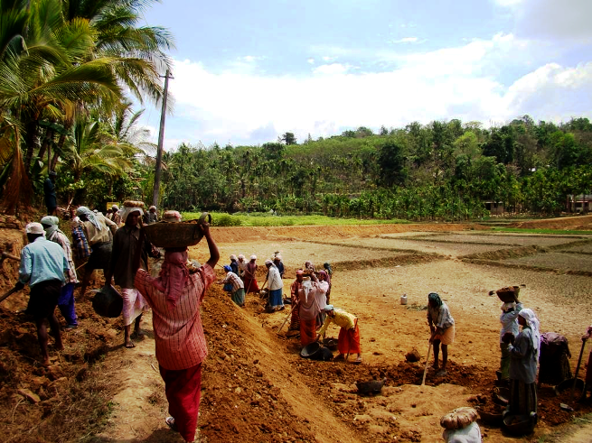

Conservation of ecosystems

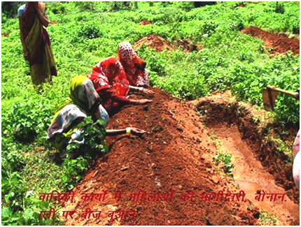

Women planting seeds

Wages are paid according to the rate decided by each state (notification made by Ministry of Rural Development in Gazette w.e.f. 1 January, 2011) subject to a minimum of INR 130 per day (~US$ 2.2 per day). Rates vary from state to state, based on Consumer Price Index. Haryana, a comparatively rich state, has stipulated INR 191 per day while the rate is INR 122 per day in the states of Bihar and Jharkhand, where several districts covered under NREGA are located. Wages, equal for men and women, are paid for a maximum of 100 days every year to each rural household.

Work is provided within a 5 km radius of the village. If not, extra wages of 10% are payable to meet transportation and living expenses. Facilities such as crèche, drinking water, shades, first-aid for injury, child minding are to be provided at the work site. Compensation of INR 25,000 is paid in the event of death or permanent disability at the work site. Free medical treatment is given in case of injury during the course of work.

State governments fix the amount of unemployment allowance, subject to the stipulation that it is not less than 1/4th the minimum wage for the first 30 days, and not less than 1/2 the minimum wage thereafter. Responsibility for payment of unemployment allowance is expected to incentivize State Governments to offer employment.

Institutional set-up and decentralisation:

State governments are responsible for implementing NREGA, while the Gram Panchayat (Village Assembly) executes the work at the village level. A Development Plan is presented by the Gram Panchayat to the Programme Officer at the Block level at the beginning of every year. The Plan includes assessment of labour demand, jobs to be done and relevant costs. The Programme Officer then decides whether a particular job should be sanctioned and a sanctioned job is started as soon as labour becomes available. (Please see Chart 1: Work flow under NREGA)

Most of the operational work of NREGA’s implementation takes place at the level of the Gram Panchayat, while data management for NREGA was mostly being done at the Block level. NREGASoft is an e-governance solution which attempts to take data management practices below the Block level and to the Gram Panchayat level. Gram Panchayats in many states use the software in online and offline modes. (Please see Chart 2: Screen-shot of the NREGASoft software)

Operations and processes to avail benefits:

The work application process is as follows:

Willing adult members of a rural household register under NREGA by writing or orally requesting the local Gram Panchayat.

Gram Panchayat checks eligibility and issues a free Job Card valid for 5 years (containing photographs of all willing adult members of the household) within 15 days of the application.

Job Card holder submits a written application for employment to the Gram Panchayat, stating start time and duration (minimum 14 days) for which he/she seeks work.

Gram Panchayat issues a receipt for the written application with a date.

Employment has to be given within 15 days of the date of application. (Please see Chart 1: Work flow under NREGA)

Wages are paid through cash, bank accounts or post offices and are to be given on a weekly basis, with a maximum delay of a further week.

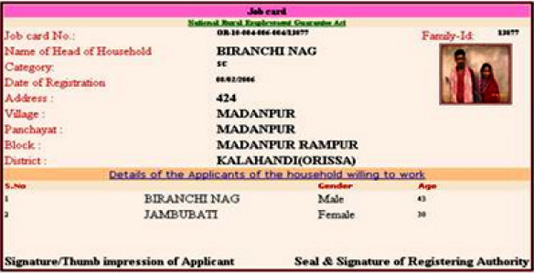

Job card

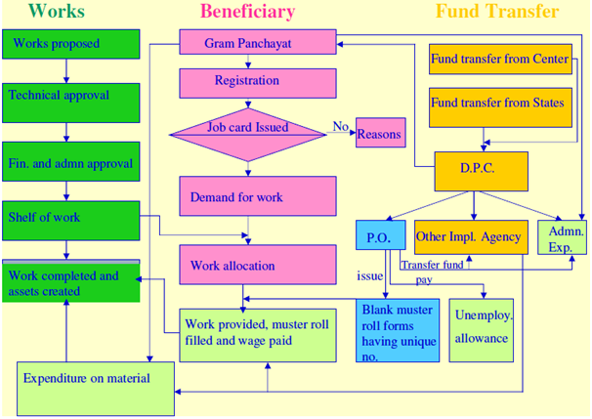

Chart 1: Work flow under NREGA

MIS and database:

All information is maintained and data is collected, disseminated and registered electronically. The systems are developed and operated by India’s largest IT services company, Tata Consultancy Services.

The National Informatics Centre, Ministry of Rural Development and other stakeholders together conceptualized a web-based management information system called NREGASoft, to address the planning, monitoring and workflow needs of the scheme. NREGASoft can be operated in the local language as well as in English and is available in offline and online modes to overcome problems of connectivity in rural areas. The software can capture all the activities under NREGA at the Centre, State, District, Block and Panchayat levels and is accessible by local government bodies and service providers, as well as by beneficiaries.

NREGASoft provides information to citizens in compliance with the Right to Information Act (RTI Act). Many documents including muster rolls, registers for registration applications, registers for job card are available. It facilitates faster exchange of information between stakeholders. The interface is customized according to the needs of the user. For instance, an illiterate worker is provided with a sound-based, icon-based, touch-screen model to access and enter information.

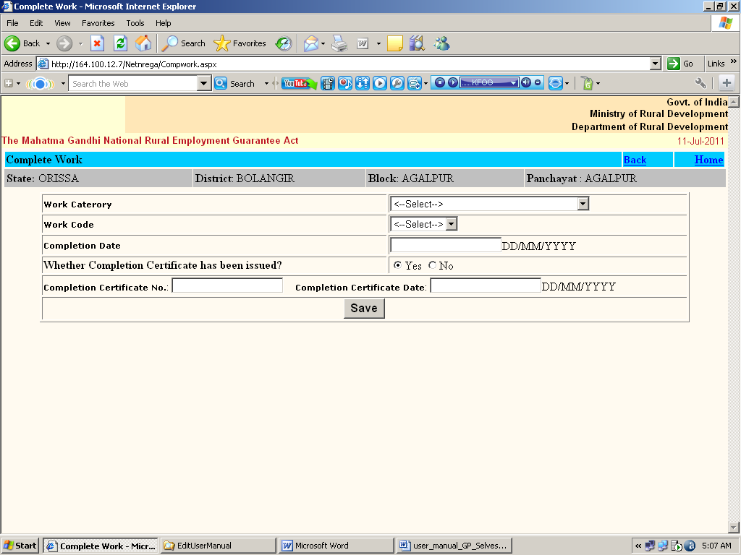

Chart 2: Screen-shot of the NREGASoft software

Some uses and features of the NREGASoft modules include:

Workers can track the registration process and issuance of job cards.

Beneficiaries can track the transfer of funds from the Ministry of Rural Development to them.

It captures information on the works undertaken.

A grievance redressing system allows people to lodge complaints and trace the response.

It allows and strengthens communication and co-ordination among stakeholders.

A detailed cost estimation of the works taken up can be done.

Details of the social audit are available.

Identity cards:

The Aadhaar card (developed by the Unique Identification Development Authority of India), launched on 1 January 2013, will be pilot-tested for NREGA and other schemes. The card allocates a unique identification number to all, and links it to a bank account number for direct disbursement of benefits.

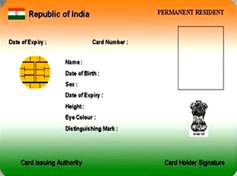

Monitoring and Evaluation:

Social Audit has to be done by the Gram Sabha (Village Committee). Social audit is an effective means of highlighting the real problems faced by people and bringing them to the notice of the government. In this process, villagers who are members of the Gram Sabha audit the workings of government bodies and perform checks on them. It is mandated that grievance redressing mechanisms for NREGA are put in place. All accounts and records should be available for public scrutiny and muster records have to be read out in public. A highly comprehensive MIS is carried out and monthly progress reports are brought out. The data is available on the website for public access.

An independent agency is being instituted as Ombudsman in every district for effective grievance redress. The functions of the Ombudsman are to receive complaints from beneficiaries and others and address such concerns according to the law. While the Ombudsman will be appointed by the State Government on the recommendation of a selection committee, it will act independently from the government.

Financial and legal sustainability:

NREGA is entirely financed from the government budget. It was enacted by legislation on 25 August 2005 by the UPA-led government supported by Left parties. Initially called the National Rural Employment Guarantee Act, it was renamed on 2 October 2009 in honour of Mahatma Gandhi. NREGA is institutionalised and sustainable.

The Central Government pays for:

Unskilled wages (which has to comprise at least 60% of total wages)

3/4th of skilled and semi-skilled wages and cost of materials (which cannot exceed 40% of total wages)

A percentage of administrative costs, including salaries at the Block level and work site facilities

The State Government pays for:

Unemployment allowance

1/4th of skilled and semi-skilled wages and cost of materials

A percentage of administrative costs

Communication and awareness generation:

Awareness generation and social mobilization is done through door-to-door campaigns, organising village conventions and personal contact programmes. Local communities are educated on the procedures to be followed to apply for NREGA entitlements. The programme also works with various NGOs to reach out to beneficiaries through awareness generation campaigns to educate them about NREGA. The NGOs also work with the residents to ensure that the workers are paid according to government regulations.

Financial and social inclusion of beneficiaries:

The NREGASoft modules allows for e-governance by the masses as people can track the status of their job applications and also monitor the flow of funds. People can lodge their concerns and complaints and get information on the NREGA works. This gives enforcement to the rights-based framework of the law.

In order to bring the rural poor under the organized banking sector and credit system, payment of wages into bank accounts is being implemented. Pilots are being conducted in the usage of smart cards and biometric signatures especially to encourage financial and social inclusion of people in remote villages. The Aadhaar card and Unique Identification Number for all people is presently being rolled out and once this is done, NREGA benefits will be disbursed directly into beneficiary bank accounts.

An emphasis on lessons learned from the programme (Chapter 3):

The Mahatma Gandhi National Rural Employment Guarantee Act, with its legal framework and rights-based approach, aims at enhancing livelihood security by providing up to 100 days of guaranteed wage employment to every rural household. NREGA enforces the right of the Indian citizen to work as given in the following articles of the Indian Constitution:

“Right to life… includes the right to live with human dignity; it would include all these aspects which would make life meaningful, complete and living.” (Supreme Court, Right to life covered in Article 21)

“The State shall… direct its policy towards securing that the citizen, men and women equally, have the right to an adequate means of livelihood…” (Article 39A)

“The State shall … make effective provision for securing the right to work…” (Article 41)

Children do not need to drop out of school or work to supplement the family income as adults can seek employment at any time. Migration to overcrowded urban and metropolitan cities in search of work is reduced. During lean periods of farming, people have an alternative source of income so that poor monsoons and droughts do not leave farmers penniless. It also eases the burden on farmers to pay their debts, who in the absence of income have to borrow money to increase the size of their farms or to cover costs during a bad agricultural season.

NREGA is an effort to preserve the ecological systems of rural India and increase agricultural productivity, which is important for food security. Latest information on workers, jobs, audit and documents such as muster rolls are available in public domain. It has led to an increase in average agricultural wages as employers have to match the NREGA rates to retain labourers.

Farm owners and construction companies have contended that the programme contributed to labour shortage as workers preferred to work for NREGA due to good sustainable wages and proximity of work sites to their homes. In July 2011, the government advised the states to suspend the programme during peak farming periods. In early 2012, the government proposed to widen the scope of the programme to allow farmers to employ labourers under NREGA.

Concerns have been raised about people not developing skills that can enable them to look for better jobs, due to the NREGA works using unskilled labour. However, NREGA was not designed to give permanent employment but as a safety net to provide temporary employment when rural people needed it the most. It has to be complemented by effective vocational training programmes. Pilot projects are being conducted in Rajasthan to provide training and skill development for workers, basic literacy, computer and financial literacy, facilitating wage payment through business correspondence mode.

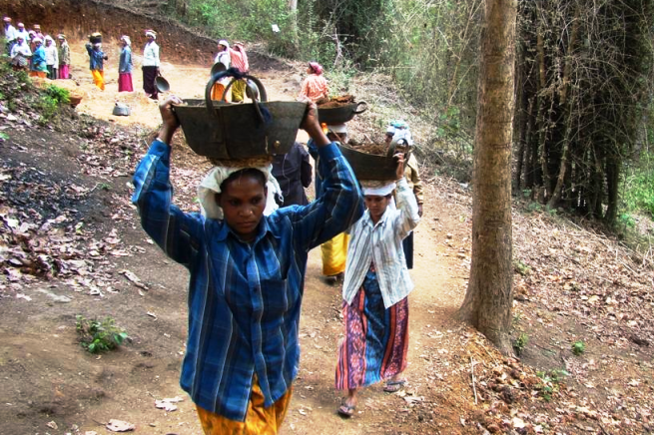
Forest upgrading and restoration

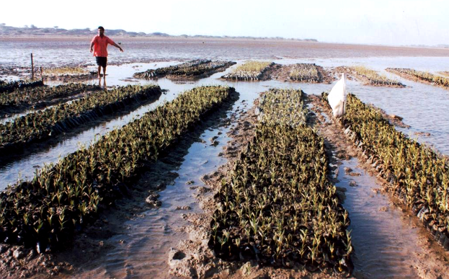
Restoration of mangroves

Statistics and data analysis:

The planned annual outlay under NREGA has increased considerably from its inception. Approximately 2/3rd of the total funds are used for paying wages. The central government has, in the recent past, reduced its budget allocation to the scheme as a sizeable portion of the funds have remained unutilised. The allotted funds in FY2012 formed 0.45% of the country’s GDP. The Central government had planned an expenditure of INR 330 billion (~USD 6 billion) in the scheme in FY2013, which accounts for 2.2% of its total expenditure.

Fund allocation to NREGA has increased from INR 121 billion in FY2007 to INR 416 billion in FY2012, while the annual expenditure increased from INR 88 billion in FY2007 to INR 375 billion in FY2012. The unused funds as a percentage of total expenditure declined from 27% in FY2007 to 10% in FY2012, which may indicate an improvement in efficiency and management of resources.

NREGA covers about 619 districts across the country. In FY2007, 37,850,390 households (24% of total households in the country) had job cards. This number has increased to 122,750,202 households with job cards (77% of total households in the country) in FY2012, indicating the relative popularity of the scheme. The number of people demanding employment under NREGA has been on a constant decline since its inception, falling from 56% of job card holders in FY2007 to 41% of job card holders in FY2012. Thus, people may be able to find work themselves in the village or nearby urban areas. The decline in people demanding employment could also be because of an expansion to bring all rural households under NREGA.

To the credit of the scheme, almost all (99%) who demanded work were given employment. Data has shown that almost 1/3rd of rural households (31%) in FY2012 worked under NREGA. Labourers often prefer to work here rather than with farm owners or private contractors, due to the promise of a basic minimum wage and proximity of work sites to their homes.

NREGA has achieved its objective of providing at least 33% of the total work to women, whose participation has averaged at 47% till date. It has been seen that women whose husbands go to cities to earn money often take up employment for a short duration to earn some extra money and to make fruitful use of their time. The programme has also covered the backward sections of Indian society, who are classified according to their economic and social situation as Scheduled Castes (aggregate share in NREGA employment of 28%), Scheduled Tribes (aggregate share in NREGA employment of 23%) and Other Backward Classes. The average daily income of workers was INR 118 in FY2012 against a gross national income of INR 545 per capita per day, adjusted to purchasing power parity.

From inception until March 2012, 14,706,788 works have been undertaken under NREGA. Of this number, 60% had been completed while 5,912,109 were ongoing. A majority of the works (over 80%) have been in infrastructure and land development, water conservation and irrigation, while the remaining works were in drought prevention, flood control and others.

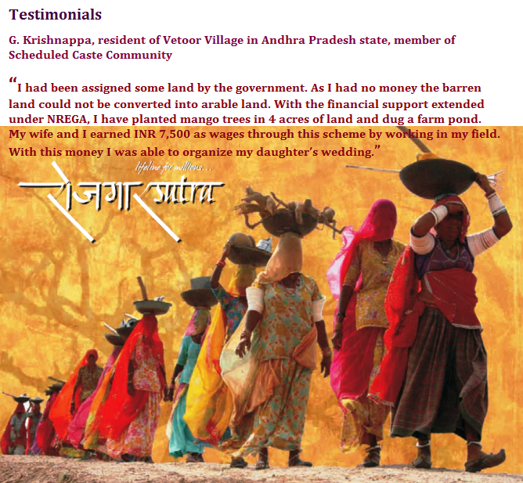

Linkages with the guiding principles of R202:

NREGA has been implemented across the country and any unemployed adult member with an NREGA card can ask for unskilled work under the scheme. If the person does not receive employment within 15 days, they can claim unemployment insurance. It specially targets the economically backward districts of the country which also have a major share of the country’s natural resources. Men and women, as well as economically and socially backward regions are treated equally while being given work, and paid equal wages. In this way, NREGA provides universality of protection, and is non-discriminatory and gender sensitive.

States stipulate their own wage rates depending on the economic and employment situation. This is subject to a minimum of INR 130 per day (~US$ 2.2 per day). As NREGA guarantees a minimum income for workers, it has had the positive effect of ensuring that farm owners and other employers have to pay as much to make sure that workers do not move away towards the decent wage rates paid by NREGA. The programme does not yet link with complementary skill development programmes, though this is being experimented.

At the same time, the Unique Identification Number and Aadhaar card for Indian citizens is being rolled out and NREGA benefits will be disbursed directly into beneficiary bank accounts using the card. This is expected to encourage participation of beneficiaries in the financial system as also promote social inclusion. Also the social audit conducted by members of the Gram Sabha (Village Committee) helps empower the villagers and bring transparency in the system.

Resources and bibliography:
- http://nrega.nic.in/netnrega/iceg.pdf
- http://www.slideshare.net/ginosmit/nrega-national-rural-employment-guarantee-act-guidelines-eng-presentation
- http://www.indg.in/social-sector/socialwelfare-faqs/1.nrega.pdf
- http://online.wsj.com/article/SB10001424052748704081604576143671902043578.html
- http://engdata.webdunia.com/dailynews/business/businessnews/0910/02/1091002049_1.htm
- http://www.odi.org.uk/publications/440-indian-national-rural-employment-guarantee-act-will-reduce-poverty-boost-economy
- http://www.livemint.com/Home-Page/r0MqnQwE2izn0XxdZAydbO/Jairam-Ramesh--We-are-now-looking-at-NREGA-20.html
- http://nrega.net.in/content/update-115-hunger-strike-sarguja-delays-wage-payments-more
- http://online.wsj.com/article/SB10001424052748704081604576143671902043578.html
- http://www.ft.com/cms/s/04473296-5865-11e1-9f28-00144feabdc0,Authorised=false.html?_i_location=http%3A%2F%2Fwww.ft.com%2Fcms%2Fs%2F0%2F04473296-5865-11e1-9f28-00144feabdc0.html&_i_referer=http%3A%2F%2Fen.wikipedia.org%2Fwiki%2FMahatma_Gandhi_National_Rural_Employment_Guarantee_Act#axzz1qAG58tUf
- http://www.hindustantimes.com/India-news/NewDelhi/NREGA-2-aimed-at-bolstering-UPA-2/Article1-815496.aspx
- http://articles.economictimes.indiatimes.com/2011-01-19/news/28430232_1_infrastructure-projects-infrastructure-space-core-sector
- http://online.wsj.com/article/SB10001424052970203986604577255370690983082.html
- Successful social protection schemes the world over, The Mahatma Gandhi National Rural Employment Guarantee Act, Amita Sharma

