ICROP ID card

Programme name: Integrated Community Registration Outreach Programme (ICROP)

Date of inception: 2001

Legal framework: ICROP is supported by legislations including the South African Social Security Agency Act, 2004; Social Assistance Act, 2004; Regulation No. 59 to the Social Assistance Act, 1992; Report of the Committee of Inquiry into a Comprehensive System of Social Security for South Africa; and others.

National social protection strategy or development plan: The National Development Plan 2030 is the blueprint for social programmes and policies, and was adopted in 2013.

Objectives:
- To provide an integrated one-stop set of social benefits and services to the hard-to-reach, homebound, sick and disabled population at their doorsteps
- To identify the socially excluded and isolated people and ensure accessibility, availability, adequacy, affordability and acceptance of social services
- To promote development, poverty reduction and social inclusion

Target population: socially excluded and isolated people in rural and semi-urban areas

Institutions involved: South African Social Security Agency

Status of programme: implementation phase

Services provided: ICROP is a mobile unit, equipped with modern technology, facilities and personnel to provide social benefits and services at the beneficiary’s doorstep

Lessons to be learned: Through a mobile service unit which visits hard-to-reach rural areas, ICROP provides a set of social services and transfers to the people who may be socially excluded, sick or disabled, and unable to visit hospitals and social service offices. In this way, the programme enables their inclusion in social security services

1. Background

Country context:
South Africa held its first democratic election in 1994 and adopted its Constitution in 1996, Act No.108 of 1996 conferring rights and responsibilities on its citizens for the first time. Section 279(1)(c ) of the Constitution states that everyone has the right to have access to social security, including, if they are unable to support themselves and their dependants, to appropriate social assistance. Subsection(2) of the Constitution states that the State must take reasonable legislative and other measures within its available resources, to achieve the progressive realisation of each of the rights embodied in the Bill of Rights in the Constitution. Eliminating poverty, social inequality, unemployment, mass deprivation and serious service delivery lags has been the priority of Government since 1996. In 2000 Cabinet appointed a Committee of Enquiry to investigate for the development of a comprehensive social security system for South Africa. In March 2002, the report of the Committee titled “Transforming the present, protecting the future” was adopted setting out the framework for social protection in South Africa. In February 2013, the National Development Plan 2030 was developed by the National Planning Commission and adopted.

Population:
South African has a population of 51.7 million people with 36% of its population under 19 years and 7.6% 60 years and older. It is a country with a relatively youthful population. The gender spread is 51.3% female and 48.7% male. The country has 11 official languages, 9 provinces and 4 race groups. Infant and child mortality is an issue of national priority, and the implementation of a comprehensive social protection programme for children is given importance.

Economic Indicators:
South Africa’s Gross Domestic Product was ZAR 3,209 billion in 2012 with economic growth of 2.5% in 2012 and 2.7% in 2013. The current account deficit is forecast to average 6.2% of GDP. Social policies and social protection programmes seek to address the twin issues of poverty and inequality. High unemployment is a serious challenge, with the unemployment rate reported at 25.2% in the first quarter of 2013 (Labour Force Survey, 2013). About 10.7% of the population is estimated to live below US$1.25 per day and 36.4% below US$2.50 per day (Statistics SA, 2012). The Gini coefficient is high, at around 0.69. The poverty maps below illustrate the areas of poverty and deprivation in 2001 and 2007. The maps show that despite the existence of social protection programmes in the country, there was no major improvement in deprivation from 2001 to 2007 in the areas of prevalence. The five areas of deprivation which were measured include income and material deprivation, employment deprivation, education deprivation, biological parent deprivation and service delivery deprivation. A revaluation of the existing social interventions was conducted, showing the need for expanding the existing service delivery framework. Thus, ICROP was conceptualised to take services and benefits to the excluded and isolated people.

Figure 1: 2001
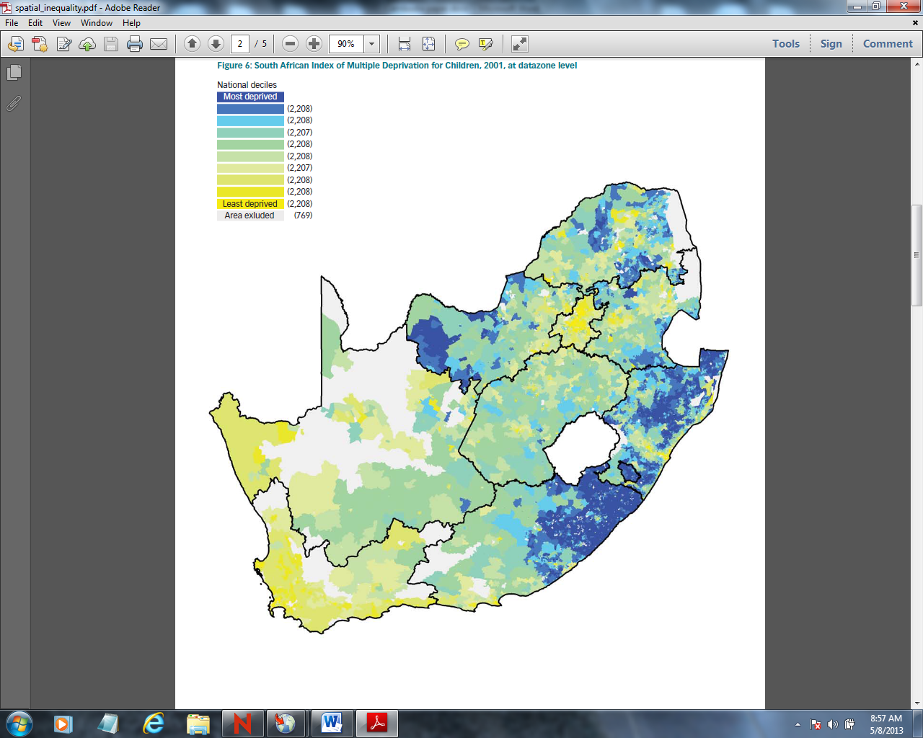

Figure 2:2007
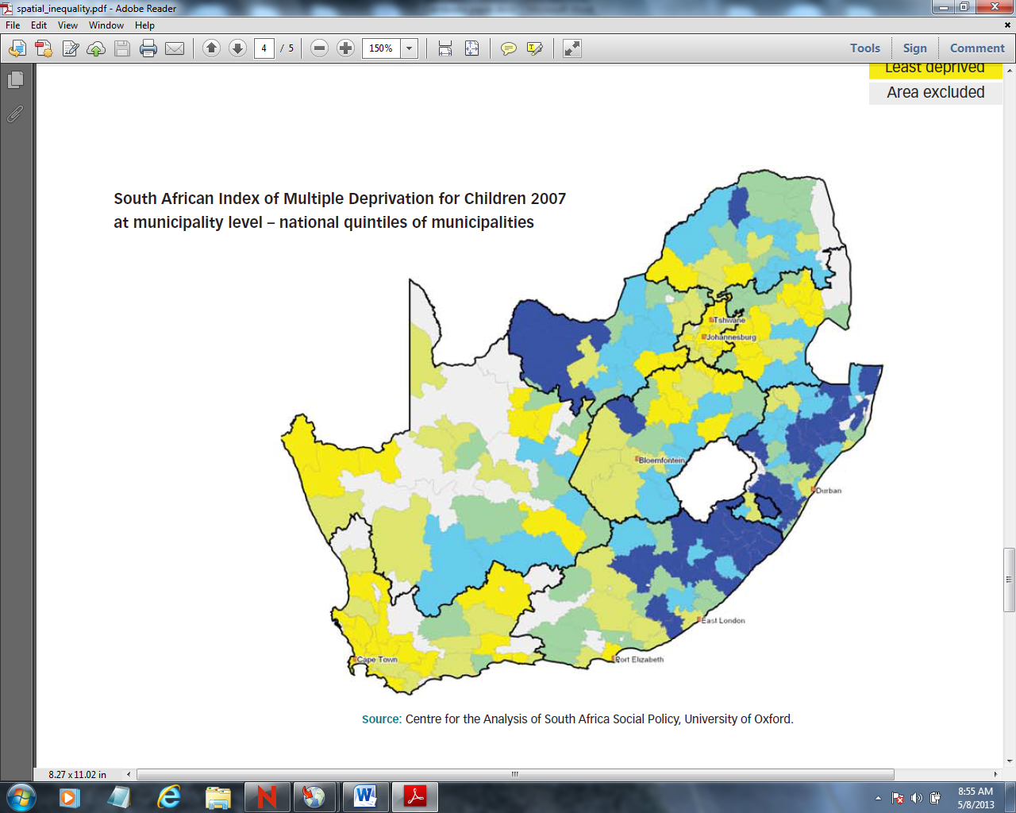

Social Protection Floor:
Prior to 1996, South Africa’s economy was skewed, with 90% of its wealth concentrated among 10% of the population. One response to this situation was to facilitate a redistribution of resources to stimulate broader participation in the economy and facilitate a reduction in income inequality. Existing social protection programmes were expanded to become fully inclusive. The social protection net included occupational pension funds, unemployment insurance, maternity leave, compensation for injuries, disability and death. Social security provisions for the economically inactive population existed in some measure, such as social grants for older people, people with disabilities and children. Social Relief of Distress is a short-term assistance provided to individuals who experience destitution or undue hardship. The social assistance cash transfer programme is South Africa’s largest and most extensive social intervention, which aims to provide a minimum quality of life to children, disabled people and the elderly. Social grants reach over 31% of the population in South Africa and its impact on reducing poverty ranges from 20% to 65% depending on the recipient group. South Africa also provides free primary health care for all citizens, school nutrition and fee waivers for poor students and a National Health Insurance Programme which is in the pilot stage.

Child Support Grant:
In 1998, the Child Support Grant (CSG) was implemented, to provide income support to all children. The income exclusion threshold for the CSG is 10 times the annual value of the grant. It enabled many caregivers who were employed but their earnings were on or below the means test threshold to access the Grant. The design of the CSG was informed by the high levels of child poverty, child mortality rates, stunted growth and malnutrition. In December 2012 there were 16,018,967 individuals being paid a social grant every month, with 10,718,337 adults collecting these grants either for themselves or behalf of 12 million children. The South African Social Security Agency (SASSA) maintains an active database of 21 million people including children, their caregivers, older persons, procurators, and persons with disabilities who either receive a grant for themselves or collect it on behalf of someone else.

Why ICROP was necessary?
Social assistance is a human right and accessibility is a constitutional mandate for its realization. Hence it is just not enough to ensure its availability, but access, affordability and acceptability are critical elements in service delivery to reduce social exclusion. Access entails the provision of information, location of the services, and facilities for people with disabilities. Availability includes the funds to provide the cash, and staff to provide a humane service. Affordability entail providing citizens their cash and services with minimal cost, waiting periods and inconvenience. Acceptance entails the provision of services which respond to citizen’s needs and maintain their dignity.

Systems are implemented to determine the citizen’s response to services, through call centres, suggestion boxes, public hearings, community meetings, surveys and media reports to facilitate broader acceptability of the service and inclusion in a participatory system. Despite the provision of basic social services and benefits for long periods, there continued to be a number of people who were excluded from accessing social grants, especially the Child Support Grant. This necessitated SASSA to consider a more intensive approach to reach the excluded, hence the implementation of the Integrated Community Registration Outreach Programme.

Process of development:
Since the inception of democracy in 1994, the Government was concerned about the high levels of poverty in South Africa. Redistribution of resources through cash transfers became the country’s main poverty reduction strategy. Plotting the poverty pockets and developing deprivation indices were tools for intervention. Three years after the implementation of the Child Support Grant, its coverage and impact were considerably low. The Department of Social Development (DSD), which was operating the CSG, decided to implement an integrated mobile outreach service into areas with low coverage. Thus, an outreach programme was started in 2001, which was the precursor to ICROP. DSD, together with the Department of Home Affairs, provincial and local offices, started implementing this outreach programme. Within a year of its implementation, the take-up rate of CSG increased ten-fold. In May 2007, SASSA decided to institutionalise the outreach programme and thus began ICROP which targeted more areas and communities. ICROP collaborated with more Government Departments including the Departments of Social Development, Home Affairs, Health, Education, Police Services, Agriculture, Provinces and local governments.

2. Description

The Integrated Community Registration Outreach Programme (ICROP) aims to reach out to the socially excluded and isolated people and communities. It attempts to provide them with access to social assistance benefits and social services, to reduce poverty, social exclusion and isolation. ICROP is a mobile service or a mobile unit, equipped with modern technology, facilities and personnel to provide direct services to individuals and communities.

Target Population:
ICROP targets mainly rural, deep rural and peri-urban areas which were the most socially excluded and isolated in terms of the 2007 deprivation index compiled from the census data, household surveys and longitudinal studies. The data on eligibility is matched with the take up rates from the administrative data like Socpen to identify the areas and individuals excluded from access. The primary targets are children and their caregivers who are eligible for child grants but are not accessing them. The excluded are also generally the most isolated and vulnerable because of the lack of infrastructure and communication networks. Since 2007 there has been a significant improvement in increasing the take up of child grants and reducing the isolation of rural communities. In 2011, about 45%, of the population was concentrated in rural areas, of which 20% were in deep rural areas (Census, 2011).

Objectives:
- To provide a one-stop shop of services and benefits for the hard-to-reach population at their doorsteps
- To visit the homebound, sick, frail and disabled in their homes, in order to enable their inclusion in the social protection net
- To identify the socially excluded and isolated to ensure accessibility, availability, adequacy, affordability and acceptance of services
- To promote development, poverty reduction and social inclusion
- To create awareness about the right to social protection
- To promote the visibility of a caring government

Services and Transfers:
ICROP was equipped to provide the full range of cash transfer and relief programmes. Other government departments supported the SASSA services to render more comprehensive and integrated social protection provisions. ICROP uses standardized processes, just like the fixed service points of SASSA. Application for cash transfers or social relief are completed in real time if there is network connectivity and an outcome is given instantly. If there is no network connectivity, an application is taken offline and an outcome is given in a time period of 7-21 working days. Since 2007, ICROP has served over 730 wards, completed more than 290,000 applications for social assistance and enabled thousands of children to access the Child Support Grant.

Inter-relationships between policies and departments:
The National Development Plan was recently adopted in 2013 and will be the blueprint for social programmes and policies, going forward. The lead agency for the implementation of social protection and social assistance programmes is the South African Social Security Agency, a public entity developed for this purpose. The Department of Social Development renders an oversight function with respect to SASSA and concentrates on the delivery of social services. Hence the efficiency of the South African Social Security Agency is dependent on the efficiency of other Government Departments that control access to social assistance and social protection programmes. An identity document for adults and birth certificates for children are required for accessing grants, thereby involving the Department of Home Affairs which administers the national population register and issues identity documents. The award of a disability grant is based on a recommendation by a doctor employed by the Department of Health. The award of a foster child grant is dependent on the Department of Social Development to determine children in need of care and the Department of Justice to issue foster care placement orders. SASSA is dependent on the availability of community halls in local authorities and the cooperation of the Department of Cooperative Governance and local municipalities are essential for service delivery. The Police Services are required for commissioning of affidavits, safety and security at paypoints. There is also close collaboration with the Department of Education to monitor and manage school enrolments and attendance to promote human capital development.

Horizontal and vertical integration of structures, processes and systems is necessary and has been done in several ways. Horizontal integration is done through an Inter-Ministerial Committee for different priorities, and clustering of Government Departments for sector planning. Vertical integration is done through Ministerial and Head of Department forums which evolve to lower levels of forums and committees to enable integrated implementation. Cooperative governance bodies at the local level have enabled the development of integrated services, which are usually biased towards urban areas. In urban areas, while services may be available, they are inadequate. In hard-to-reach areas, both availability and adequacy are issues.

Decentralisation of Services:
Some government departments have assigned powers and functions to provinces while others are centralized. At the same time, SASSA services are decentralised at the provincial, district and local levels. Social security and social assistance are considered as rights based services that must be implemented according to uniform standards. It is thus a national function with decentralised offices at district, area and ward levels. The centralized powers and functions with decentralised service units, as in the case of SASSA, proved to be a more cost-effective model with a standardized approach to service delivery across the country.

The decentralised SASSA model includes district and local offices, services, pay points and ICROP. Figures 3-5 show the structure of the decentralised services and service delivery points across the country. In addition, the cash payment system includes banks, ATM’s, merchants and departmental stores which are not included in the service delivery network.

Figure 3 Structure of Service Delivery in SASSA

Figure 4: Distribution of Local Offices and Service Points
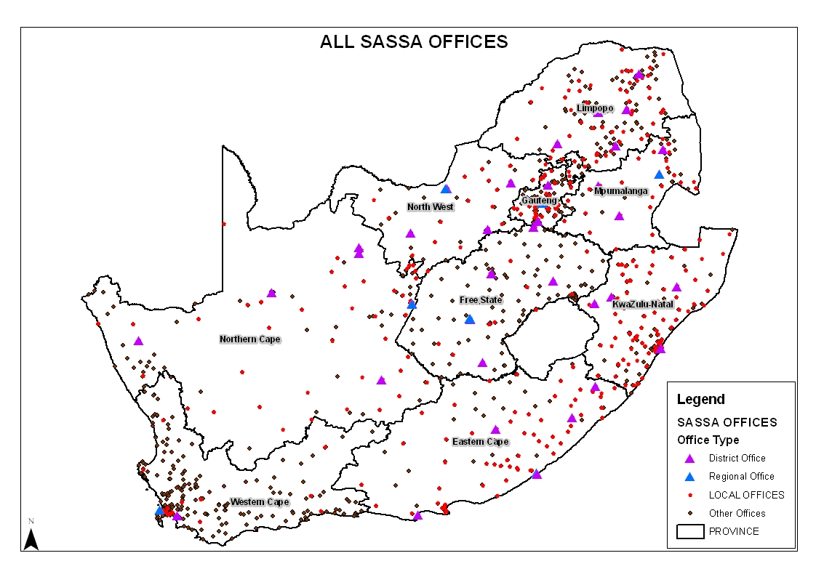
Figure 5: Distribution of cash pay-points
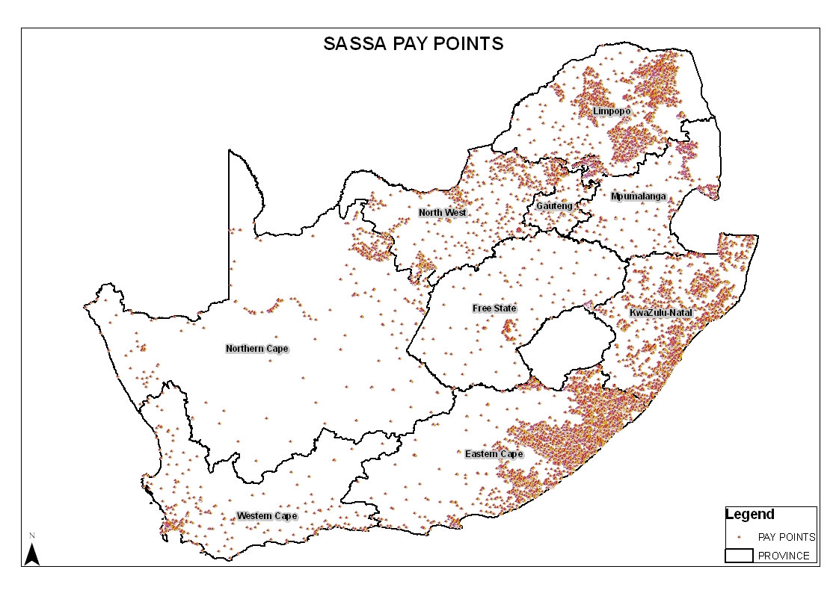

Evolution of the ICROP Programme:
- 2000 to 2006: The ICROP project was initiated in 2000 with the Department of Home Affairs and the Department of Social Development as the critical partners. The mobile units were sourced from the Department of Home Affairs, thereby compelling integration because of the joint financial commitment.

- 2007 to 2010: In May 2007, SASSA established the ICROP, which expanded the scope of the previous outreach programme from the implementation of the CSG to the delivery of social assistance in social excluded, poor and vulnerable regions. The scope of the project was larger and the integration among different government departments was broader. It included a range of services rendered by different government departments namely SASSA, the Departments of Social Development, Home Affairs, Heath, Agriculture and South Africa Police.

- 2008 to 2010: In August 2008, the Presidency launched the “war on poverty” project targeting 23 of the poorest wards in the country. ICROP was the programme used to take services to the people. ICROP has since evolved into a government-wide programme to take all services in an integrated manner to the most excluded and isolated people. The success of the ICROP is dependent upon its awareness in the communities.
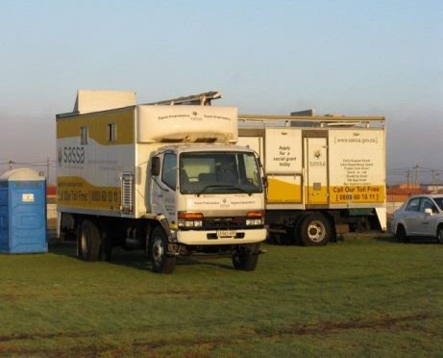

An ICROP Mobile Vehicle

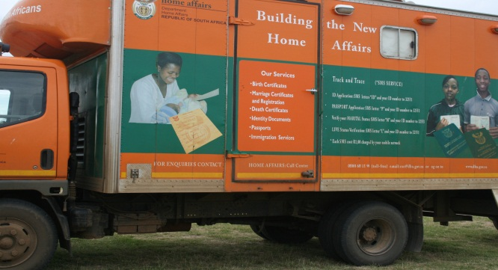
Department of Home Affairs Mobile Unit

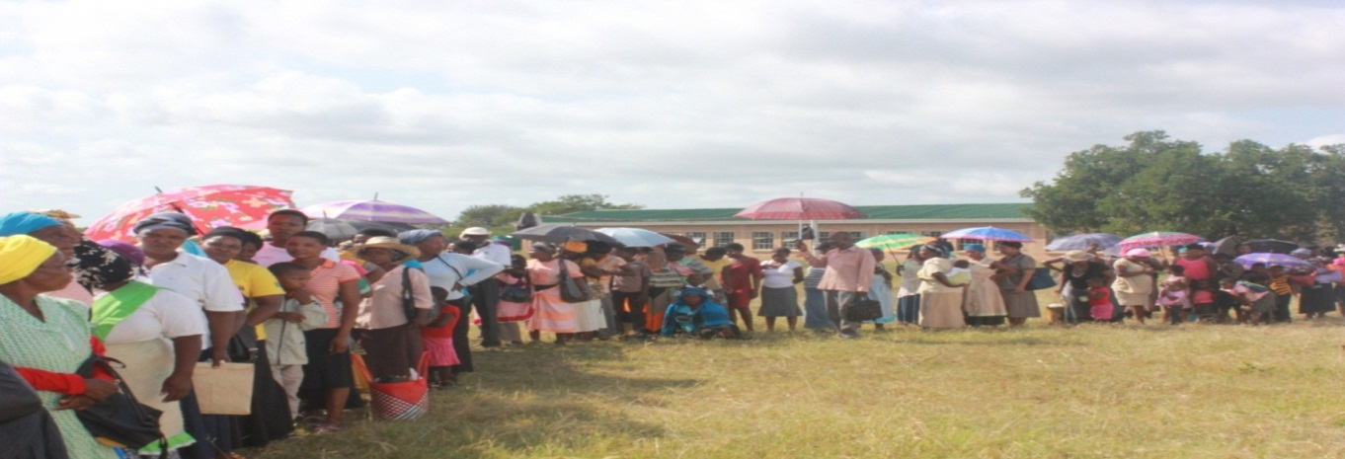
People queuing to receive a service

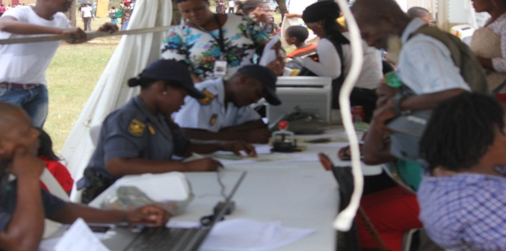
South African Police compiling affidavits

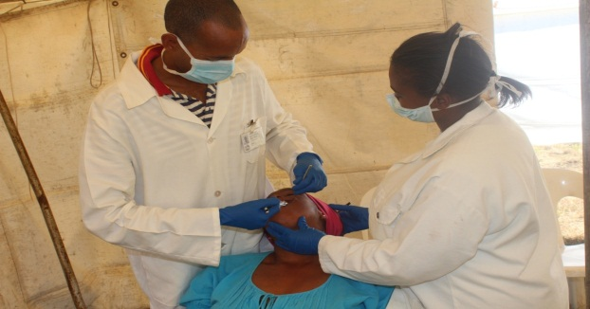
Doctor assisting a citizen

Operations and procedures:
The processes and procedures for the application of social assistance are the standard processes and procedures implemented at any service office of SASSA. The same norms and standards are also maintained. The standardized business processes are depicted in the flowchart below.

Flow Chart
Screening
Attesting/
Capturing
Quality
Control
Engagementagement ofoent of th
Verification
Approval/
Rejection

a

A

Internal Reconsideration applications
Help Desk

Payments
Appeal Applications
Registry for Files

- Engagement: all citizens are greeted by a customer care official and their need is determined
- Screening: applicants are screened to see that they have the right documents and that their request is correctly channelled.
- Attesting: capture of the application online
- Quality control: ensuring that the correct application is completed, documents are correct and there is a person completing the application
- Verification: approval or rejection of the application with the person being informed immediately

Management Information Systems:
Social assistance is managed by the following systems:
- Socpen: the main system for beneficiary information and payments
- File management system: capture, storage, retrieval and tracking of files
- Live link: storage, retrieval and tracking of letters in batches sent to beneficiaries
- Financial Management and Information System (Oracle): budget management, processing of financial transactions and maintenance of assets
- Grant Payment System: a smart card (debit card) which can be used at merchants, departmental stores, ATMs, banks and dedicated pay-points to access benefits.

Figure 6 shows the operations of the main system i.e. Socpen. Socpen interfaces with the national population register in real time in order to verify the identity, marital status and children. Batch offline interfaces with the government employees system (Persal and Persol). There are other periodic interfaces with SARS (Income Tax), UIF (employment benefits) and many other systems.

Figure 6: Overview of the beneficairy information system
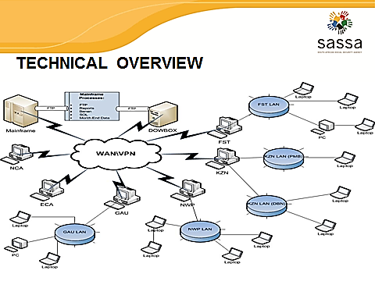
Social grant payment system:
ICROP does not pay grants, but it completes the enrolment for payments and provides information on payment inquiries. The payment of social grants is outsourced to a private company. In April 2012, the payment system was standardized into one national system with one service provider. Each beneficiary, upon completion of a successful application, is biometrically enrolled (fingerprints and voice recording). They are then issued with a smart card which contains the beneficiary details and biometrics. The funds are transferred monthly to the service provider who pays out the benefits into each beneficiary account. The benefit amount can be accessed by the beneficiary at accredited merchants, departmental stores, ATMs, banks or at dedicated pay-points. There are 9,937 pay-points which are serviced by mobile ATMs. If a beneficiary requires the funds to be transferred to their personal bank account, they call a toll-free number and through voice activation, the funds are transferred into their account. The voice activation serves as certification to confirm that payment is made to a live beneficiary.

Appeals and restorative justice:
SASSA has a three-tier appeal or restorative justice system for adverse decisions and the termination of benefits. If a right is to be withdrawn or an adverse decision taken, the Administrative Justice Act No.2 of 2000, requires that SASSA duly inform the beneficiary of the intended action or decision and afford them an opportunity to make representation as to why the decision should not be implemented. If the beneficiary fails to do so or the representation is unsuccessful, the beneficiary then has the recourse to apply for internal reconsideration of the decision which is the first leg of the appeal process. Applications must be adjudicated within 90 working days. If the outcome is still unfavourable, the beneficiary can then appeal to the Independent Tribunal appointed by the Minister. If the outcomes continue to be unfavourable, the beneficiary or applicant can then approach the courts. Pending the outcome of an appeal, the beneficiary or applicant can apply for social relief of distress which is awarded for six months but can be rewarded on re-application. Applications for representation, internal reconsideration and appeals can be completed at any SASSA office or by ICROP. Feedback can also be obtained from an ICROP service.

Monitoring and Evaluation:
SASSA has monitoring and evaluation units that monitor the coverage and quality of services. The monitoring system has three units namely:
- Institutional monitoring: to assess the effectiveness and efficiency of the agency’s performance quarterly;
- Service delivery monitoring: works in close collaboration with the monitoring and evaluation department in the Presidency. There is an initiative to develop a national citizen response monitoring system in line with the National Development Plan’s recommendation to complete service delivery audits and manage citizen’s responses;
- Evaluation: to assess required change, non- or under-performance, institutionalise citizen response systems, assess the value-add of the new payment card.

Financial and legal sustainability:
The budget for ICROP is appropriated by Parliament and managed according to the Public Finance Management Act, No.1 of 1999. The social assistance programme and the operations of SASSA are funded from tax revenues. For the financial year 2013-2014, the allocation for cash transfers was ZAR 113 billion and the operational budget for SASSA was ZAR 6.3 billion. The budget for ICROP was approximately ZAR 5.5. The cash transfer constitutes around 3.2% of GDP. The value of the cash transfers is adjusted annually to cater for inflation. The income threshold for exclusion is also increased annually to enable the continuity of income support to those in receipt and include those adversely affected by price increases. The cost of ICROP is largely maintenance and staff.

The operations of SASSA and ICROP are governed by the following core legislations:
- Constitution of the Republic of South Africa Act, 1996;
- South African Social Security Agency Act, 2004 (Act 9 of 2004);
- Social Assistance Act, 2004 (Act 13 of 2004);
- Regulations to the Social Assistance Act, 1992 ( Regulation No. 59 of 1992);
- Report of the Committee of Inquiry into a Comprehensive System of Social Security for South Africa;
- National Development Plan, 2030;
- Public Finance Management Act, 1999 (Act No. 1 of 1999).

Communication and awareness generation:
There are several publicity and awareness campaigns while starting a project, including television, radio, road shows, public hearings and newspapers. Traditional advertising is also done through pamphlets, brochures, internet, community radio, community newspapers, community meetings and billboards.

Financial and social inclusion of beneficiaries:
ICROP also aims to make beneficiaries financially independent by providing opportunities for skill development, employment and entrepreneurship, similar to the workfare programmes. This project faced difficulties in taking off, as more than 8 million young parents had to be assessed, screened and given financial opportunities. To integrate 8 million people into income generating projects or employment was a challenge. Recently, there has been a change in the approach, and financially sustainable projects are started on a small scale.

One example of such a small-scale project is to be implemented through SASSA’s relief programme that funds food and school uniforms for the destitute. The programme has an annual budget of ZAR 185 million (2013-14). According to the conception of the project, the food is to be sourced from small gardens and producers within communities to further benefit them. CSG beneficiaries will be trained and skilled to produce uniforms, based at schools where children are eligible to receive assistance.

Among other initiatives, SASSA intends to source its corporate clothing from cooperatives managed by its beneficiaries. SASSA is implementing a bursary and scholarship programme for continuing education and training, with preference given to CSG beneficiary children who have completed schooling. Internships within SASSA will also be given to these children to help prepare them for long-term employment. These initiatives are presently at the inception phase.

Lessons learned and improvements:
- The programme was designed without considering the physical impediments that may restrict optimisation of the programme. The vehicles were too big and could not reach communities with narrow roads or no physical infrastructure. Similarly it was too expensive to use bakkies because it could not transport service personnel, hence more than one vehicle had to be used, making the programme expensive. It is important to assess the terrain of the beneficiary area before procuring mobile units.
- A demand-driven service is more effective than a supply-driven service unless it is accompanied by extensive awareness. The size of the vehicle does not impact the number of applications or beneficiaries. The latter is dependent on the number of people demanding the service and the speed of the networks, if available.
- Integration alone is not sufficient to reduce social isolation. Having competent, well-trained and knowledgeable staff is critical for the success of the programme.

3. Impact of ICROP:
An evaluation was recently completed on the coverage of CSG and areas of exclusion. Evidence indicates that rural and traditional areas targeted by ICROP had high rates of inclusion. Hence ICROP was successful in reaching the socially excluded and isolated as identified by the deprivation index of 2007 but the patterns of exclusion have since changed. An analysis of the administration data in 2012 indicated that the most excluded from child grants were children 0-1 and those 12 -18 years. It was also determined that contrary to previous assessments the issue of social exclusion is now in the more affluent provinces and urban areas especially the big cities. These were the areas not targeted by ICROP and which now appear to experience higher levels of exclusion.

Figure 7: Areas of Exclusion and Interventions by ICROP
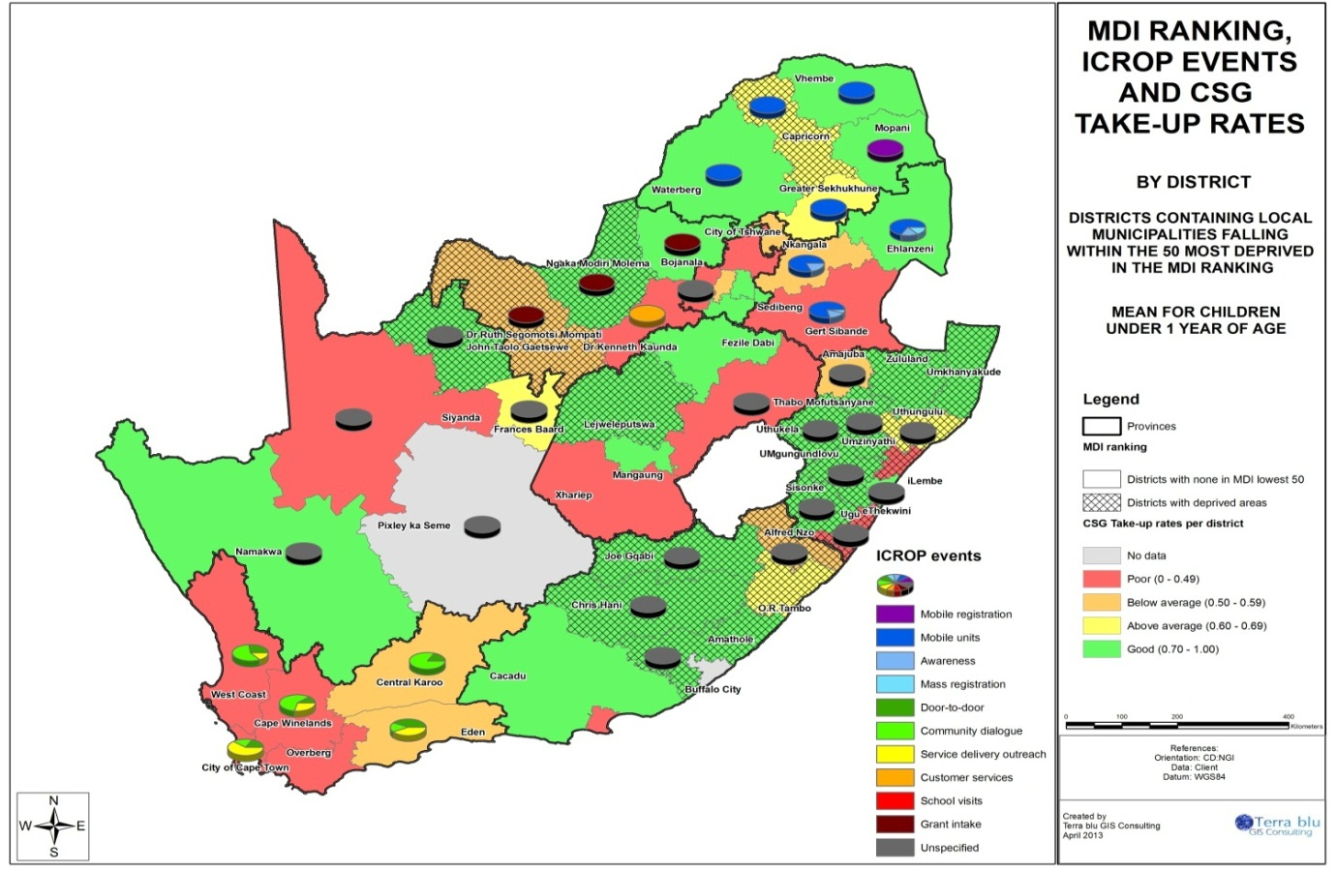

Transparency, accountability and traceability:
Social assistance and its accessibility are human rights, and therefore the criteria for eligibility, award and amounts are legislated. Information must be both accessible and available to people. The programmes that implement the rights must be fully transparent and accounted for. Reports are produced which must be tabled in Parliament and made available to the public on demand. To inform citizens, there are call centres, information desks, advertisements and campaigns to inform the citizens. People who feel aggrieved have recourses to appeals and to the courts. Litigation with respect to administrative injustice at one stage was rather profound but as the administration improved, it has diminished. Accountability for public spending and value for money is regulated by the Public Finance Management Act. For its implementation, strong governance is prescribed, through audit committees, performance audits, financial misconduct boards and periodic reports to Parliamentary committees such as the portfolio and public accounts committees.

Biometric authentication for both officials and beneficiaries are strongly advocated, to perform audit trails and traceability in cases of fraud, corruption and leakages. Between April 2012 and April 2013, biometric authentication of beneficiaries was completed. The results indicated that 5-10% of the beneficiaries who have not as yet completed the process may either not exist or have abandoned their rights. The next stage is the biometric authentication of all employees of SASSA.

Coherence of the Social Protection System:
Workers who are employed in the formal sector are covered through sickness and maternity leaves, pensions, unemployment insurance, compensation for injuries and disabilities, among other benefits. The economically non-active population is covered through social pensions, disability and child benefits. It is the economically inactive population, except for the child benefits, that do not have any social security. This gap in social security provision has been identified and is being addressed. A draft discussion document on social security reform is in the process of consultation. The following reforms are being initiated towards comprehensive social protection coverage namely:
- Implementation of National Health Insurance System
- Universalising the basic social pension to become the basic pension
- CSG has been extended to all children below the mean-test threshold
- Universalizing the early childhood development programme
- Expansion of the Expanded Public Works Programme
- Job Creation through the development and expansion of infrastructure

Representation in programme management:
For contributory social protection schemes, representation by workers or through their representatives is legislatively endorsed. For non-contributory schemes, representation is neither legally nor culturally enforced. Participation takes place through consultation, community meetings, public hearings and stakeholder forums. There is no institutionalised mechanism for public consultation and responses. However, the National Development Plan has assessed this to be a weakness in service delivery. It has advocated for service delivery audits and a citizen response system to be institutionalized, in order to determine citizens’ needs and responses to services.

4. Contribution to the principles of R202
The social assistance programme in South Africa seeks to address absolute poverty and hence, the value of the benefits provided are higher than the absolute poverty measures. This seeks to ensure the adequacy of the benefit amounts. ICROP takes non-discrimination and gender equality into account, as per the constitutional mandates in South Africa. It aims to reach out to sick, disabled and homebound people, through its mobile services.

At present, SASSA is conducting studies related to diversity of methods and approaches, financing mechanisms and delivery systems, according to the social and economic context in the country. It follows the National Development Plan 2030 which is the blueprint for social programmes and policies. Though ICROP has some coherence with social, economic and employment policies in the country, there are gaps which need to be addressed. The programme endeavours to have greater integration among institutions responsible for delivery of social protection. It has regular monitoring and evaluation procedures, transparency in procedures, and effective and accessible complaint and appeals mechanisms.

5. Resources and Bibliography

- Aguero, Carter and Woolard (2007) The Impact of Unconditional Cash Transfers on Nutrition: the South Africa Child Support Grant. International Working Paper no.39 Sept. 2007, United Nations Development Programme.
- Barnes, Wright, Noble and Dawes (2007) South African Index of Multiple Deprivation for Children, Census 2001.Human Sciences Research Council Press, Cape Town.
- Committee of Inquiry (2002) “Transforming the Present, Protecting the Future”, Department of Social Development. South Africa.
- Customer Care Department (2007) “ICROP Strategy”, SASSA. South Africa.
- Department of Social Development website www.dsd.gov.za
- Operations Department 2012 “Standardisation of Business Processes” SASSA, South Africa.
- National Planning Commission (2013): National Development Plan, 2030, Presidency, South Africa.
- National Treasury (2013) “Budget Speech” South Africa.
- Presidency (2008) “War on Poverty: Framework for Implementation”, South Africa.
- Samson et al (2004) “The Social and Economic Impact of South Africa’s Social Security System”. Commissioned by the Department of Social Development. Economic Research Policy Unit, Cape Town.
- SASSA website at www.sassa.gov.za
- Statistics South Africa (2012) “Labour Force Survey, South Africa.
- Statistics South Africa (2012) “Poverty Profile in South Africa”, South Africa.
- Statistics South Africa (2011) “Census in Brief”, South Africa.
- 15.Social Assistance Act ( 2004) “ South African Government”.
- UNICEF, DSD, SASSA (2010) “Child Support Grant Evaluation 2010”. South Africa.
- UNICEF,DSD, SASSA(2012) “The South African Child Support Grant. Impact Assessment”. South Africa.

SASSA Mobile Offices Services rendered in an open field
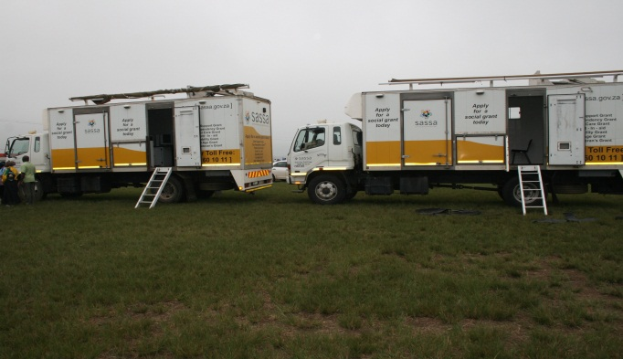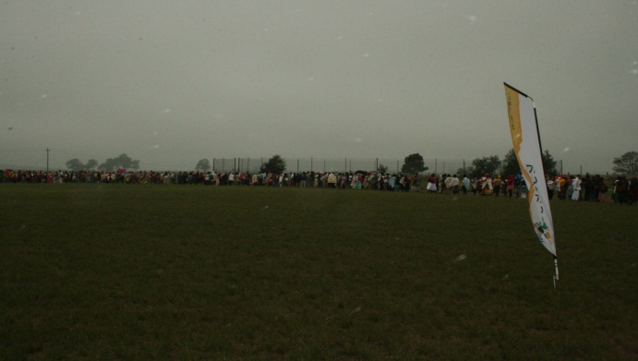

Preparation for a ICROP Service Biometric Enrolment of Beneficiaries
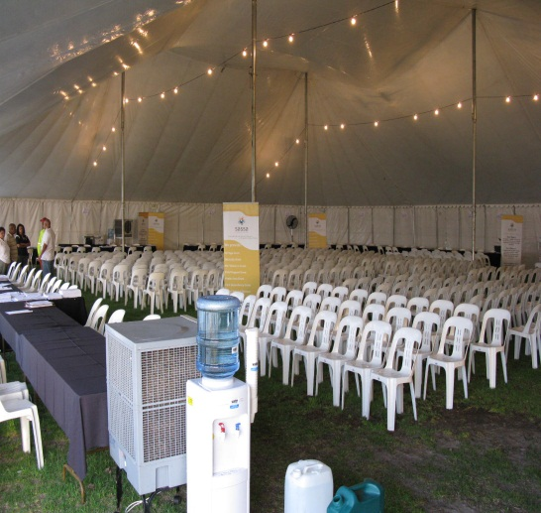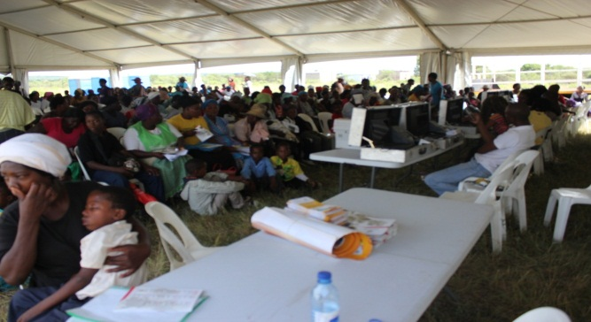

Staff completing Applications for Social Assistance Crowds Accessing the Service
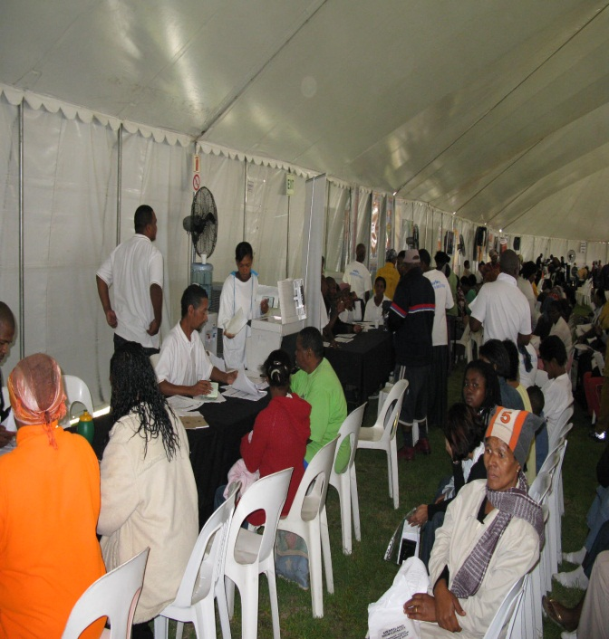
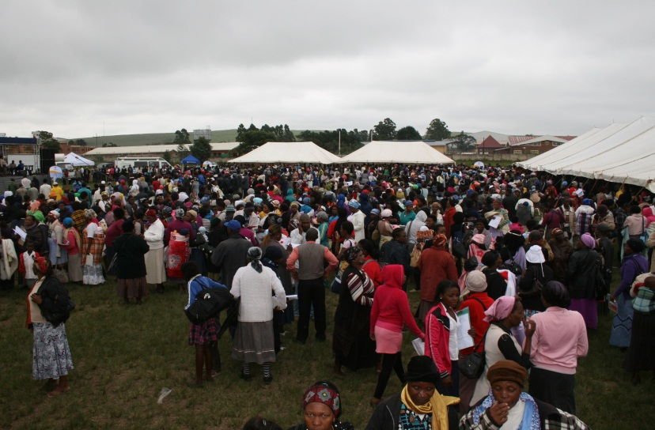
Health and Police completing medical assessments and affidavit respectively.
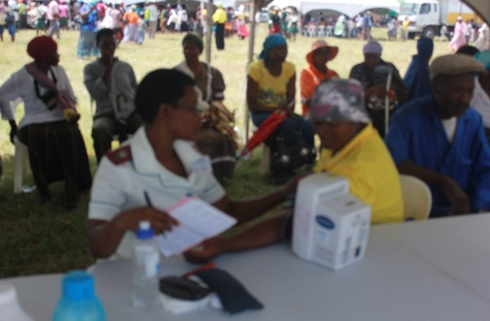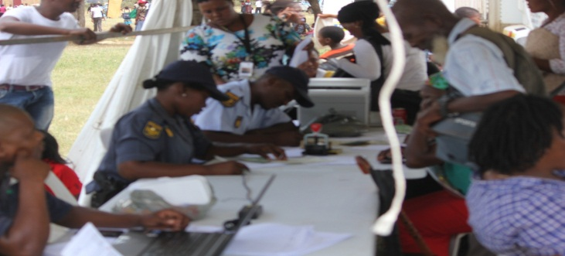

Department of Agriculture Providing the Food Parcels
