RSBY ID card

Programme name: Rashtriya Swasthya Bima Yojana (RSBY)
Date of inception: April 2008 in some States, other States joined at different times
Legal framework:
National social protection strategy or development plan:
Objectives: To improve access to health care, and to reduce out-of-pocket expenditure on health
Target population: Population below the poverty line and informal economy workers
Institutions involved: Ministry of Labour and Employment (national level), State Nodal Agencies set up for RSBY (state level)
Status of programme: Implementation phase
Services provided: Hospitalization and defined day-care surgeries are covered up to a limit of INR 30,000 (US$500) and transportation allowance of INR 1000 (US$17) for a family of five for one year, pre-existing diseases are also covered from the first day of the policy
Lessons to be learned: RSBY uses a smart card and biometric identification system to provide health insurance benefits to poor and vulnerable people. Its IT platform is being used to deliver other social benefits as well. This leads to cost savings, ease in access to benefits by people, effective and easier monitoring of beneficiaries.

- Background

Country context:

RSBY: CREATING AN INFORMATION TECHNOLOGY PLATFORM TO DELIVER SOCIAL SECURITY SCHEMES IN INDIA

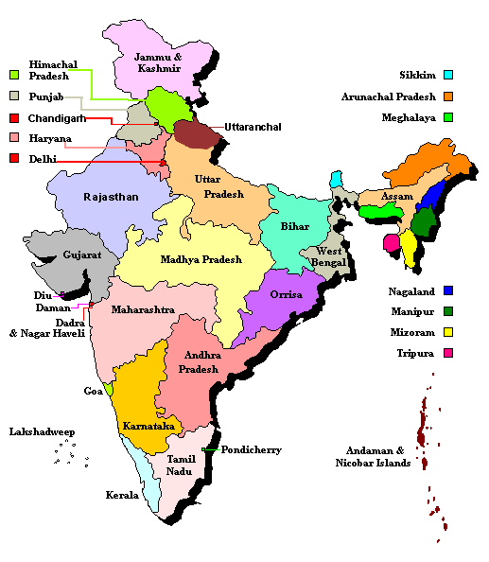
India: General characteristics
Population (in thousands) total | 1,173,108,018  (July 2010 est.)
Area | 3,287,263 sq km
Age Structure  0-14 years  15-64 years  65 years and over | 31.3%  61.3%  7.4%
Infant mortality rate (per 1 000 live births) both sexes | 53
Life expectancy at birth (years) female | 65
Life expectancy at birth (years) male | 62.1
Maternal mortality ratio (per 100 000 live births) | 450
Characteristics - Economic
Gross Domestic Product | Rs. 8,35,34,950 million  US$ 1,576,731 million
Labour Force | 467 million
Percentage of workforce in organised sector | 6%
Percentage of workforce in Unorganised sector | 94%
Unemployment Rate | 9.8%  (2011)
Per capita total expenditure on health (PPP int. US$) | 109
Private expenditure on health as percentage of total expenditure on health | 73.8%
HDI Rank | 134
HDI Health Indicators – Life expectancy at birth rank  HDI Poverty Indicator - Human Poverty Index Rank  HDI Education Indicator – Adult literacy and gross enrollment in education | 128  88  120

Sources: Government of India budget 2012, World Statistics, IMF Publications, WHO World Health Statistics 2010, UNDP

There has been a growing belief amongst decision makers in India that the absence of a meaningful social security arrangement was not merely a problem for individual workers, but had wider ramifications in the economy and society. Consequently, definite initiatives were taken towards inclusive growth, wherein marginalized sections of the society could participate as well as benefit from development. Providing social security to the entire workforce, especially the unorganized workers that constitute 94% of the labour force, emerged as one of the major concerns in the country.

The high growth rate (averaging around 8% per annum during the past couple of decades) provided an opportunity to undertake various social protection initiatives for its population. It also created the necessary fiscal space to take such steps. The Unorganized Workers’ Social Security Act, 2008 was legislated to provide a framework for social protection to this huge segment of workforce (430 million). The initiatives also included facilities like life and disability insurance, employment guarantee, pension and so on.

Health care in India is financed through various sources, including individual out-of-pocket payments, central and state government tax revenues, external aid and profits of private companies. National Health Accounts data of 2004-05 shows that central, state and local governments together account for only about 20% the total health expenditure in India. More than 78% of the health expenditure comprised un-pooled, out-of-pocket expenditures, which is also one of the highest in the world. External aid to the health sector accounted for a negligible 2% of the total health expenditure.

The Government of India recognized inequities in its health delivery and financing infrastructure and introduced various measures to overcome it. One measure was to increase the budgetary allocations for health care. The government is targeting to increase its spending on health care from the current 1.1 of GDP to 3% of GDP. However, just increasing the budget for health is not a solution in itself. There are limitations in the absorptive capacity of the public health care system, apart from the manner in which these funds are utilized.

Process of development:
Governments in India have introduced various demand-side financing mechanisms to provide financial security for vulnerable segments of the society in the last few years. Health insurance schemes like the Universal Health Insurance Scheme (UHIS) launched by the Ministry of Finance in 2003, State level health insurance schemes launched by the states of Punjab, Kerala, Assam etc. are some examples. However, most of these Central or State Government funded schemes have had problems due to poor policy design, lack of clear accountability at the state level, lack of sustained efforts in implementation, weak monitoring and evaluation, unclear roles and responsibilities of different stakeholders, and poor awareness among beneficiaries about the schemes. However, there are exceptions like the Arogyasri scheme in the state of Andhra Pradesh and other states like Karnataka and Tamil Nadu.

The federal Government felt that there was a need for a national level Health Insurance scheme in the country for providing financial security to the vulnerable sections of the society. Learning from the experiences of other major government and non-government health insurance schemes in India, it was decided to launch a health insurance scheme which later came to be known as Rashtriya Swasthya Bima Yojana (RSBY). Below Poverty Line population (BPL) were considered as the first target of this scheme. Subsequently, many more categories of unorganized workers are being added to the scheme. These categories include building and other construction workers, domestic workers, street vendors etc.

While evolving the conceptual framework it was imperative to comprehend the characteristics of the target group. At the outset, as the targeted beneficiaries were poor, they could not be expected to pay cash up-front and take reimbursement later. Therefore, the scheme had to be cashless. Secondly, the beneficiary group was largely illiterate. Hence, they were not in a position to undertake documentation. The scheme, therefore, needed to be a paperless. Thirdly, some of the target population was migratory in nature. So they required a scheme which was able to provide benefits anywhere in India. The scheme had, therefore, to be portable across India.

What is RSBY?
RSBY is a Health Insurance Scheme which was launched on April 1, 2008 by the Central Ministry of Labour and Employment (MoLE), Government of India. The objectives of RSBY are to provide financial security to certain identified categories of unorganised workers and their families from hospitalization-related expenses and to improve access to quality health care. Another objective is to empower the beneficiaries by giving them a choice to select any public and private health care provider for treatment.

RSBY provides hospitalization coverage up to INR 30,000 (approximately US$500) per annum for a family of five on a floater basis. Transportation charges are also covered up to a maximum of INR 1,000 (approximately US$17) per year with a limit of Rs. 100/- (approximately US$2) per hospitalization. In addition to these, beneficiaries are also entitled to pre-hospitalization up to 1 day before and post-hospitalization up to 5 days from the date of discharge from the hospital. Another special feature of the scheme is that unlike general health insurance scheme where pre-existing diseases are excluded, all pre-existing diseases are covered from by RSBY from the onset. Another important feature is that there is no discrimination against the elderly and there is no age limit.

RSBY uses Smart Card technology to enrol beneficiaries. A biometric smart card is given to each BPL family which enables them to avail the benefits all over the country.

A beneficiary enrolled under RSBY can visit any hospital which is part of the network of health care providers. This network is being created across India, through empanelment based on pre-defined criteria. As of March 2013, approximately 12,000 hospitals (more than 70% are private) comprised the RSBY delivery network. Providers are empanelled by the State-selected insurance company based on prescribed criteria. A health care provider empanelled by any of the insurers in RSBY gets automatically empanelled by all the other insurers. For empanelment, hospitals have to agree to install necessary hardware and software to be able to process beneficiaries’ Smart Card transactions. They have also set to up a dedicated RSBY desk with trained staff. Once a hospital is empanelled, a nationally-unique hospital ID number is generated so that transactions can be tracked at each hospital. Each empanelled hospital is connected with the district server of the insurance company. This facilitates transfer of data related to hospitalization on a daily basis.

- Description

Target population:
RSBY aims to cover all the Below Poverty Line (BPL) population, and defined categories of unorganized workers, estimated to be approximately 70 million families, comprising 350 million persons, by 2017. The BPL families are estimated through household surveys conducted by the respective States while respective Government departments prepare lists of unorganized workers.

Services and transfers:
Hospitalization and defined day-care surgeries are covered up to a limit of INR 30,000 (US$500) and transportation allowance of INR 1000 (US$17) for a family of five for one year, pre-existing diseases are also covered from the first day of the policy

Institutions involved and decentralization:
At the national level, the Ministry of Labour and Employment is the responsible agency. At the state level, State Nodal Agencies are set up for RSBY. RSBY is an example of how a scheme can evolve successfully through cooperation of different stakeholders. In the initial stages of the scheme there were organisations like the World Bank and GTZ (now GIZ) that supported in the development of design and processes. In addition to the beneficiaries who are focus of the scheme, there are six primary stakeholders in the scheme: The Central Government, State Governments, State Nodal Agencies, Insurance Companies, Hospitals and NGOs. The roles of each of these stakeholders are clearly defined in the scheme.

Operations and processes to avail benefits:
RSBY involves a set of complex but well-defined processes. The detailed process flow is depicted pictorially in Annexure 1. The broad process flow for RSBY is described below:
  - Once the decision to implement RSBY is taken by a state Government, an independent body or “State Nodal Agency” is set-up.
  - The State Nodal agency collects/ prepares beneficiary data in the specified RSBY format.
  - Once the beneficiary data is prepared, an insurance company is selected through an open bidding process.
  - Annually, an electronic list of eligible beneficiary families is provided to insurers by the State. An enrolment schedule for each village, along with dates, is prepared by the insurance company with the help of district officials. The insurance company is provided a maximum of four months to enrol beneficiary families in each district.
  - Insurance companies hire intermediaries to reach out to the beneficiaries before the enrolment. In addition, the beneficiary list is posted in each village at the enrolment station and prominent places prior to the enrolment camp. The date/location of the enrolment camp are also publicized in advance.
  - Mobile enrolment stations are established at local centres (e.g., public schools) at each village at least once a year. These stations are equipped by the insurer with the hardware to collect biometric information (fingerprints) and photographs of the members of the families covered and a printer to print smart cards with photo. The smart card, along with an information packet describing benefits, hospitals in network, etc. is provided to all enrolled persons once they have paid the Rs. 30/- (US$ 0.5) registration fees. The process normally takes less than 10 minutes.
  - A local Government official (field key officer—FKO) needs to be present at the camp and must insert their own government-issued smart card and provide their fingerprint to verify the legitimacy of the enrolment. This way each enrolled person can be tracked to a particular official. In addition to the FKO, an insurance company/smart card agency representative is present at the enrolment camp.
  - At the end of the enrolment camp, a list of enrolled households is sent to the state nodal agency by the insurer. The list of enrolled households is maintained centrally.
  - Before commencement of the enrolment process, the insurance company empanels both public and private hospitals. Each empanelled household is provided with a smart card which also contains a national unique ID.
  - A beneficiary, after receiving the smart card and after the commencement of the insurance policy, can visit any empanelled hospital across the country to get the cashless treatment.
  - Hospitals send online claims to the insurance company and after due diligence, the insurance company settles online claims of the hospitals.

Financial sustainability:
RSBY is a Government funded scheme where the premium is paid through a tax funded mechanism. The funding for the premiums is done jointly by central and state governments. 75% (90% in case of Jammu & Kashmir and North-eastern States) of the premium is contributed by the Central Government while 25% (10% in case of Jammu & Kashmir and North-Eastern States) of the premium is contributed by the State Government. The insurance premium is determined at the state-level based on an open tender process. Registered insurers compete in competitive bidding.

It was also decided by the Government that the beneficiaries will also pay a small amount of INR 30 (US$ 0.5) as registration fee. This was done so as to increase the sense of ownership of the scheme in the beneficiaries. This amount is aggregated at the State level and is used to take care of the administrative cost.

Statistical data:
In five years of operations RSBY has been able to move from 2 States to 28 States and Union Territories in the country. The highlights of the performance of the scheme by end of March 2013 are as follows:
RSBY Data
Number of Families Enrolled at present | Approx. 35 million
Persons enrolled at present | Approx. 125 million
% of people covered as of total target population | 58%
Number of States where RSBY is being implemented | 28
% of States which have started RSBY Implementation | 95%
Number of Hospitals empanelled | 12,000
Number of Hospitalisation cases till now | 5 million
Average Hospitalisation Rate | 3%
RSBY Economic Data
Total Expenditure on premium subsidy of RSBY in 2012-2013 | Rupees 15,000 million  US$ 250 million
Administrative Expenditure on RSBY by Government of India | Rupees 50 million  US$ 0.9 million

Source: Ministry of Labour, Government of India

Challenges Faced:
- Getting buy-in of the stakeholders – The first major challenge before implementing RSBY was to get the buy-in of officials within the Central and State Governments, insurance and smart card industries. Intensive meetings were organised with all the stakeholders to explain the scheme design and get them on board.
- Supply of necessary hardware and software – RSBY needed supply of smart card related equipment in large numbers. These machines were not available in the required numbers. The buy-in of the industry helped in their responding to the demand and import of the equipments to match the demand.
- Development of Key Management System (KMS) – One of the main features of RSBY design was to provide a foolproof secure system to prevent any fraud or misuse. Therefore, it was a huge challenge to develop a KMS that could provide necessary security at different levels.
- Improving enrolment and hospitalisation – Printing and issuance of smart cards in the village is one of the most challenging aspects of RSBY. The smart cards are to be issued on the spot and in difficult terrain. Once the smart cards are issued, another challenge is to improve the awareness of the beneficiaries about the usage of the smart card.
- Lack of capacities at different levels – Building the capacities at each level to implement a complex scheme like RSBY was another challenge. These capacities were to be built amongst all the stakeholders, including government officials, insurance companies, hospitals and NGOs.

Success Factors:
Factors which are responsible for the success of RSBY are as follows:
- Partnership approach – Right from the designing of the scheme, attempts were made to take the stakeholders into confidence. A partnership approach was adopted with all the stakeholders.
- Standardisation – A national scheme like RSBY required a high degree of standardisation, especially in the context of the technology that was being used so that it could work uniformly across India. In addition to all the key documents, all the software and hardware were standardized and guidelines were issued regarding their preparation, usage and certification.
- Flexible approach – RSBY has evolved continuously since inception. Different provisions and processes of the scheme have been revised in response to the ground realities.
- Attention to the details – Each process and step related to the implementation of the scheme has been elaborated and documented clearly. Similarly, roles of each stakeholder and their relationship with others have been clearly defined so as to avoid any ambiguity.
- Empowerment of the beneficiaries – The beneficiaries, in this context, the poorest of the poor, were empowered as they were now being given a choice of public and private hospitals, across the country.
- Business model – This was perhaps the first ever business model at this scale for a social sector scheme with insurance companies and hospitals finding “fortune at the bottom of the pyramid”.

- An emphasis on the lessons learned from the programme:

Use of technology:
The use of technology in RSBY is one of the highlights of the scheme. It is perhaps one of the few schemes in the developing world where technology has been leveraged at this scale for delivering social benefits.

RSBY has been successful in using smart card technology. A smart card is given to each beneficiary family at the time of enrolment in the scheme. The smart card is prepared and printed on-the-spot in the village by the insurer and handed over to the beneficiary. This card can be used by the beneficiary in any empanelled hospital across India to obtain treatment. In addition to the smart card, to provide more protection from fraud and to improve targeting, biometric technology is also used. Fingerprints of all beneficiaries are collected during enrolment at the village level. One thumb impression of each of the household beneficiaries is stored in the smart card. This fingerprint is used to verify the identity of the beneficiaries at the hospital.

In addition to biometric technology for providing security, another technology is used to provide a secure environment for the smart card issuance and usage in the form of a Key Management System. The key management system helps in reducing fraud and improves accountability. A government officer called a Field Key Officer (FKO) needs to be present at the enrolment station and the role is to verify each beneficiary family using their own smart card and fingerprints. This ensures that only the correct beneficiary is issued the card by the insurer. Similar key cards are used at each place where the smart card is used.

RSBY has been able to position itself as a paperless scheme with the help of technology. Claims are submitted online by the hospitals and similarly the insurer can make online payment to the hospitals. In addition to this, a robust backend data management system is being developed for RSBY which will ensure smooth flow of data from across India to both the state and central governments in real time.

The aim of the scheme is to use technology not only for controlling fraud and monitoring utilization, but also for finding innovative solutions. For example, the enrolment software has been designed to ensure that the male member of the household compulsorily insures his wife.

Use of RSBY’s technology platform to deliver other social security benefits:
RSBY has been able to demonstrate that a social security scheme can be delivered efficiently and effectively through appropriate use of IT systems. The scheme has already reached out to around 35 million families through smart cards.

Recognizing the potential of the RSBY smart card platform, other Ministries and Departments have shown interest in delivering their own social security schemes through the RSBY platform.
- The Department of Financial Services, Ministry of Finance implements a life and disability insurance scheme called Aam Aadmi Bima Yojana (AABY). It has taken a decision to use the RSBY smart card platform to deliver AABY benefits.
- The Ministry of Rural Development has taken a decision to deliver the National Social Assistance Programme (which also targets BPL) through the RSBY platform by harmonizing the data between these schemes.
- The state of Chhattisgarh has taken a decision to deliver benefits under the Public Distribution System (PDS) programme to deliver food grain and kerosene subsidy through the RSBY smart card platform.

The coordinated approach for providing benefits immensely benefits the target population as they can get enrolled under RSBY and other social security schemes at the same time. Beneficiaries can also avail the benefits through a single channel and will not need to approach different persons or institutions.

This approach results in cost savings because parallel costs of delivering different social security benefits to the same person are reduced. It is easy to track beneficiaries that are covered under these social security schemes. The biometric system ensures that entitlement reaches the targeted person or family only. In case of a programme like Public Distribution System, this approach not only saves cost through efficiency but also generates huge savings for the Government through reduced leakages and duplications.

RSBY is gradually demonstrating that it is not only able to deliver health insurance to poor and vulnerable sections of the society effectively, but is also creating an IT platform which can deliver other social security benefits effectively.

- Linkages with the guiding principles of R202

The RSBY has been in operation for just over two years but the impact is clearly visible. Data from RSBY and many external evaluations have revealed the following:

- Improvement in access to healthcare – Access to health care for the targeted segment of RSBY has improved considerably in the past five years. Data from the studies shows that hospitalisation rate in RSBY districts are increasing continuously. For the districts which finished only round 1, hospitalisation rate is 1.9% and it has increased to 5.04% for the districts which have completed round 3. If we compare these rates with National Sample Survey data of 60th round in India, then hospitalization rate for poorest 40% of the population was found to be only 1.75% there. This shows almost three times increase in the rate of hospitalization for RSBY beneficiaries.
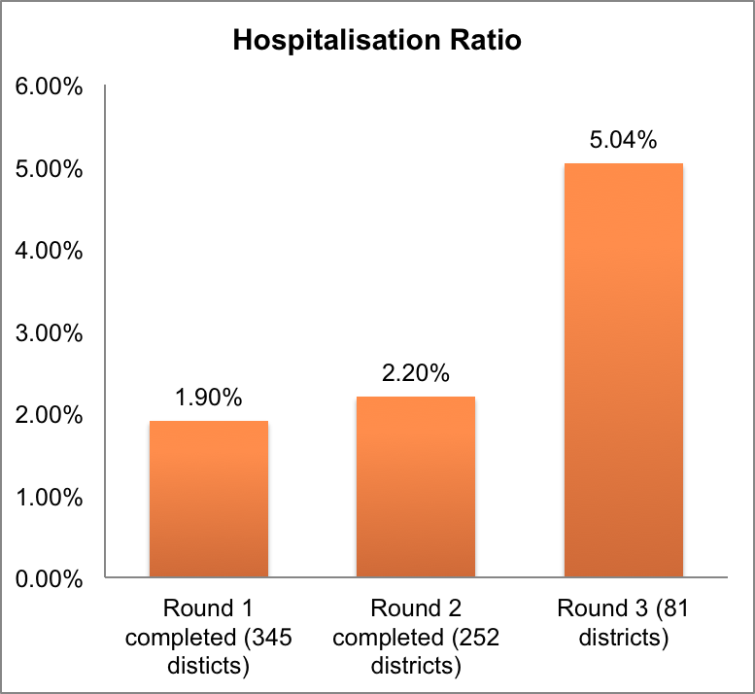

- Gender Equity – Data from past years have shown that gradually, more women are getting enrolled in the scheme and more women are using hospitalization services. Women now outnumber men nationally, wherein 54% of RSBY’s hospitalization cases have been for women.
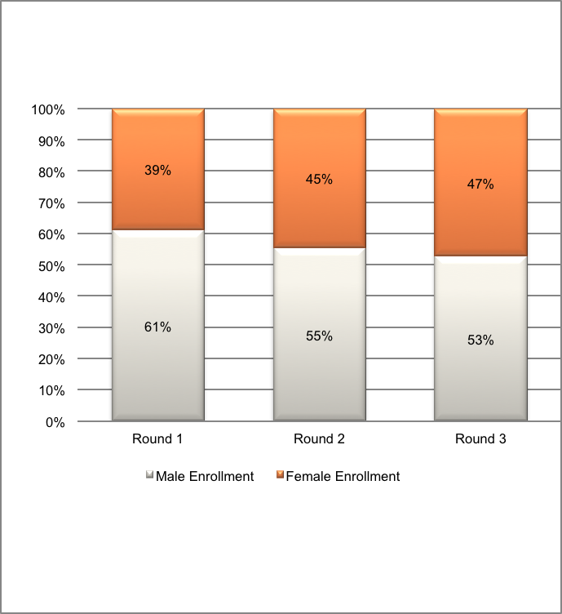
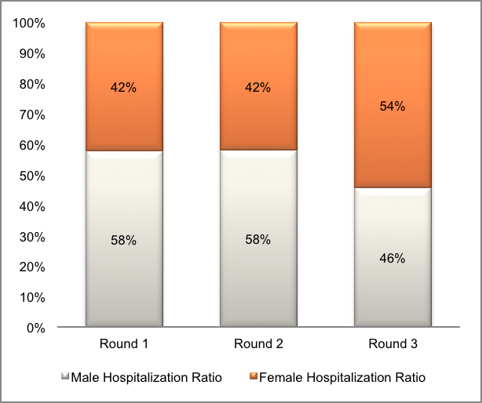

Gender Wise Enrolment Rate
Gender Wise Hospitalization Ratio

- Reduction in Out of Pocket Expenditure (OOPE) on Health – One of the objectives of introduction of RSBY was to reduce the OOPE on health by the poor population. The latest survey (carried out in 2012) in RSBY in three States of Uttarakhand, Karnataka and Bihar shows that while 90% of the RSBY enrolled patients did not spent any amount at the hospital for the treatment, poor patients who were eligible for RSBY but not enrolled in RSBY, on an average spent INR 17,000 (USD 280) per year on hospitalization expenses.

- Setting up of health infrastructure in rural areas – One big challenge being faced by RSBY was the lack of health infrastructure, especially in rural areas. Evidence is now available that the private sector is finding value in setting up health related infrastructure in regions which were hitherto not serviced. This is largely because RSBY is creating a demand for health services in the rural areas which has in turn created an incentive for the private players to set up hospitals.

- High level of satisfaction – Different surveys in the States of Kerala, Gujarat, Haryana, Bihar, Uttarakhand, UP and Karnataka have shown that more than 90% of the beneficiaries who have taken treatment under RSBY are satisfied with the treatment and the services provided by the hospitals.

- High Renewal Rate – One of the biggest challenges in voluntary health insurance schemes is low renewal rate. However, RSBY has demonstrated that beneficiaries are very happy to renew the scheme. The latest survey shows that even amongst the beneficiaries of RSBY that have not used RSBY services, 90% of them wants to enrol next year.

- Transparency and coherence - The smart card system brings in transparency and traceability, and helps prevent fraud, due to the use of biometric details. It also allows to track the usage of health care services in India. Due to gradual the take-up of RSBY’s smart card by other social security schemes in the country, beneficiaries can register and avail services and transfers in a more coherent manner.

Annexure 1: RSBY Process Flow

