“BISP” ID card

Programme name: Benazir Income Support Programme (BISP)

Date of inception: October, 2008

Legal framework: The programme was enacted through the Benazir Income Support Programme Act XVIII, 2010 (w.e.f. 30 April 2009). BISP was initiated as an independent authority and the BISP bill was passed unanimously by the National Assembly and the Senate.

National social protection strategy or development plan:

Objectives: Its long term objectives are to:

Establish a nationwide safety net programme, with effective and transparent targeting and delivery mechanisms (BISP is a targeted means to uplift underprivileged and vulnerable families out of poverty)

Meet the MDGs related to eradication of extreme and chronic poverty and empowerment of women

Target population: Poorest households comprising over 15% of the total population

Institutions involved: BISP operates through the separation of functions. Implementation is done along with partner organizations including Provincial Education Departments, National Database Registration Authority, commercial banks, survey organizations and development partners.

Status of program: Implementation phase

Services provided: Cash transfers are made to women in target households. Some transfers are based on the principle of co-responsibility, and beneficiaries have to enrol their children in primary school education. Complementary programmes and services including vocational training, small interest-free loans, health and life insurance are also provided.

Lessons to be learned: The selection of BISP beneficiaries was the domain of Parliamentarians until 2009 when the poverty scorecard methodology was introduced. The BISP database is one of the largest of its kind. The payment mechanism is automated, cash transfers are provided through technology-based options. An automated case management system is present, with interface at the sub-district level. There is complete separation of functions for transparent implementation and third party evaluation in order to improve efficiency and service quality.

Background

Country context and process of development:

While poverty and vulnerability have immense costs for individuals and households in terms of acute deprivation, poor health, undernourished children and shortened lives, they also have a greater bearing on society in terms of slowdown in economic and social development. Economic growth generates opportunities for poor and vulnerable households in the long run, but policy-based interventions are needed to make sure that the less fortunate segments of society can participate in the growth and development process, and partake in its fruits along with other sections of society. Such policy-based interventions are essential for further stimulating and sustaining the growth and development process in a developing country like Pakistan.

The global economic slowdown in 2008 and the sharp escalation of oil and food prices severely impacted Pakistan’s economy resulting in lower economic growth and double-digit inflation. This placed most families under severe financial stress. As a response to the macro-economic crisis in the country, social protection was made a priority in order to provide a ‘lifeline’ to the poor and vulnerable segments of society. Also, Pakistan ranked very low on the ADB social protection index (Baulch, Wood, and Weber 2008). The Benazir Income Support Programme (BISP) intended to compensate economically vulnerable families for the erosion of their purchasing power.

Recognizing the need to expand the existing social safety net, the Government of Pakistan launched the Benazir Income Support Programme in July 2008 with the immediate objective of cushioning the negative effects of the food crisis and inflation on the poor, particularly women. This was done through the provision of cash transfers of PKR 1,000 per month (approximately US$ 12) to eligible families. BISP is a means-tested program and the largest direct cash grant scheme in Pakistan’s history and the 3rd largest budgetary allocation. The field operations were started on 8 October 2012 and the programme was officially launched on 9 November 2012.

BISP was the flagship programme of the Government of Pakistan for women empowerment and poverty alleviation. It was initiated as an independent authority and the BISP bill was unanimously passed by the National Assembly and the Senate. Its long-term objectives are to establish a nationwide safety net programme, marked by effective and transparent targeting and delivery mechanisms; and to meet the Millennium Development Goals (MDGs) related to eradication of extreme and chronic poverty and empowerment of women.

BISP has evolved over the past few years into the country’s main social safety net programme. It is fully in line with Pakistan’s Medium Term Development Framework (MTDF). The MTDF aims to end discrimination against women and their social and financial exclusion which is multifaceted in nature. This is envisaged through the provision of an enabling environment for women to develop their full potential and share in the benefits of economic growth, prosperity and social development. The MTDF prioritizes economic growth to address concerns related to women’s rights, security, social protection and empowerment as active citizens.

Linkage with policies and national development plan:

Description of the programme or policy

Target population:
BISP targets poor households. It is being implemented all across Pakistan with special attention accorded to remote areas. Eligible households are identified through a targeting process, which consists of household surveys and the application of a Proxy Means Test Formula (PMT) that determines the welfare status of the household on a scale of 0-100. A Nationwide Poverty Scorecard Survey was undertaken in October 2010 to identify beneficiaries. Families are considered eligible for monthly cash transfers if they have a score of 16.17 or below and there is one female beneficiary per family. Computerized National Identity Card (CNIC) holders are eligible for the benefits.

Eligibility is verified through a proxy means test. To be eligible, a family must have/be:
- a female applicant who possesses an ID card;
- monthly family income below PKR 6,000 (USD 67);
- a widowed/divorced woman with no adult males in the family;
- a member who is physically or mentally retarded; and/or
- a member suffering from a chronic disease.

Families are not eligible to participate if they have/are:
- members employed by the government, government-affiliated authorities or departments, armed forces;
- a household member who draws a pension from the foregoing;
- a member receiving post-retirement benefits from the foregoing;
- a member who owns more than 3 acres (1.2 hectares) of agricultural land or more than 80 square yards (67 square meters) of residential land or home;
- a member receiving income support from any other sources;
- a member possessing a machine readable passport;
- a member who has a National Identity Card for Overseas Pakistanis; and/or
- a member who has a bank account (except at banks catering to the poor, including microfinance banks).

Services and transfers: A cash transfer of PKR 1,000/month (PKR 2,000 once every 2 months) is provided on a non-conditional basis. BISP also provides an integrated package of services to the target population. Recently, it has expanded to include several special initiatives.
- Waseela-e-Haq empowers women through the provision of small loans.
- Waseela-e-Rozgar is a vocational training programme that offers members of eligible families up to 1 year of professional training.
- Waseela-e-Sehat provides financial assistance for obtaining basic healthcare.
- Waseela-e-Taleem initiative provides conditional cash payments upon primary school enrolment for children in the 5-12 age group.
BISP also provides cash payments for emergency relief efforts to families affected by terrorism, war and natural disasters. The four initiatives are described in further detail below.

BISP has recently launched a co-responsibility cash transfer initiative called Waseela-e-Taleem. The initiative encourages families to enrol out-of-school children in the age group of 5-12 years, for primary education and to continue with their education. This is done in return for cash transfers of PKR 200 per month per child, paid quarterly (to maximum 3 children per family). In return, families must comply with the co-responsibilities of school admissions and a minimum of 70% quarterly attendance. The initiative aims to develop long-term prospects of human capital formation to graduate out of abject poverty.

BISP intends to implement the programme by using a phased approach which involves testing the programme in select districts first and then expanding it by incorporating the lessons from the test phase. The most significant part of this initiative is the compliance monitoring of the co-responsibilities. The benefits of non-compliant families and children would be suspended upon two consecutive non-compliances. The compliance monitoring process is being implemented by the district education departments in close coordination with BISP Tehsil offices. The process is described in a later section.

Waseela-e-Haq aims to break the vicious cycle of poverty by providing interest-free financial assistance to randomly selected beneficiaries. The selection of these families is done through a computerized and transparent balloting process. It is designed to promote self-employment among women or their nominees to help improve their livelihood standards. Up to PKR 300,000 of long-term interest-free financial assistance is provided. The financial assistance is based on social capital, rather than by keeping physical assets as collateral. Till date, 41 draws have been held and a total of 51,670 beneficiaries have pre-qualified. 16,446 have been trained. As of March 2013, PKR 1.828 billion had been disbursed to 10,910 beneficiaries while 8,501 beneficiaries had started their own businesses.

BISP aims to promote economic growth among beneficiaries through the provision of vocational training. Waseela-e-Rozgar provides free vocational training to every beneficiary woman or her nominee from her own family. This initiative envisages empowering the female beneficiary or her nominee to become economically independent by acquiring demand-driven vocational skills and technical education. Waseela-e-Rozgar leads to capacity building and professional development. Till 31 March 2013, around 11,644 persons had been trained while 39,374 persons are currently enrolled. It is expected that by 30 June 2013 approximately 70,000 persons would have been trained.

The fourth initiative called Waseela-e-Sehet aims to provide improved access to healthcare services and reduce the financial burdens of the marginalised groups due to health related expenditures. The life insurance was launched on 1 January 2011 to provide coverage of PKR 100,000 in case of death of the bread-earner of every beneficiary family. Over 3.78 million beneficiary families now have their bread-earners covered for three years under the life insurance scheme launched by BISP in collaboration with State Life Insurance Corporation of Pakistan (SLIC). Till date, about 8,075 deaths have been reported and 3,865 claims have been paid. A pilot health insurance scheme has been launched in one district, providing full hospitalization, pregnancy care, day-care treatment and diagnostic tests up to a maximum limit of PKR 25,000 per family per year. To facilitate the beneficiaries, Benazir Health Cards (biometric cards) are issued to enrolled families. This scheme will be gradually extended to other districts.

BISP is using innovative mechanisms for service delivery and grievance redress. In order to improve the efficiency and transparency of the payment system, BISP has introduced alternate payment mechanisms including the Benazir Debit Card, Smart Cards and Mobile Phone Banking. After completion of the pilot phase, BISP has begun rolling out payments through Debit Card. Around 75% of total beneficiaries are being paid through technology enabled mechanisms.

Institutional set-up and decentralisation:
BISP is an autonomous body with its headquarters in the federal capital of Islamabad and offices at the provincial, regional, district and Tehsil (sub-district) levels all across the country. BISP has around 540 Tehsil offices serving as hubs for delivering services to the beneficiaries at the lowest administrative level. To maintain transparency and credibility, BISP operates through separation of functions as shown in the chart below.

Figure 1: BISP Seperation of Function
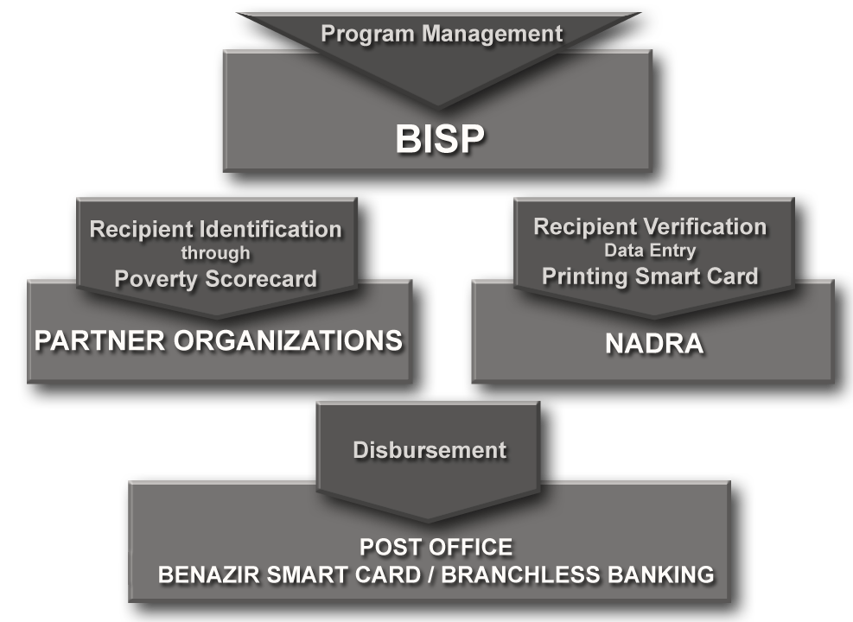

In administering the BISP, management, recipient selection, verification and disbursement processes are separated. The BISP Board comprises government officials and NGOs (with equal representation), technical experts working for the programme for a 3 year term. Its functions include taking financial and budgetary decisions, monitoring, policy-planning and approving eligibility criteria, among others.

There is a BISP Council comprising the President, the Prime Minister and other individuals appointed by the President on the advice of the Prime Minister. Its functions include mobilising financial resources, advising the Board on policy matters, monitoring the Board’s performance, and developing ideas for enhancement of the programme.

The National Database and Registration Authority (NADRA) was charged with establishing a registration system for the entire population. It transmits the final list of recipients electronically to Pakistan Post. The initiative of outsourcing essential functions including targeting and delivery of the cash to specialized institutions is expected to have reduced leakages and increased efficiency and effectiveness.

Operations and processes to avail benefits:
Programme managers and Parliamentarians have no control over or access to the funds, which are transferred electronically from the Treasury to Pakistan Post and then delivered to recipients. Recently, branchless banking, smart cards and mobile phone banking, in partnership with private commercial banks, have become the medium for disbursing benefits.

MIS and database:
BISP has evolved over the past few years into the country’s main social safety net programme. One of its major achievements is the implementation of a poverty census across Pakistan. It used a targeting process to identify eligible households through a Proxy Means Test (PMT) and poverty scorecard used to determine the welfare status of the household on a scale of 0-100.

Selection of BISP recipients was the domain of Parliamentarians until 2009 when the poverty score card methodology was introduced by World Bank. The Nationwide Poverty Scorecard Survey was started in October 2010 and has been completed across Pakistan except in two tribal agencies (districts) of the Federally Administered Tribal Areas. The scorecard survey has 13 multiple-choice questions revolving around assets and expenditure. Each answer carries a pre-determined score and all the answers are fed into a software to calculate the cumulative score. People are eligible for BISP if they score less than 16.17 points, while those scoring 1-11 are classified as extremely poor.

Some features of the scorecard survey are mentioned below.

7.2 million households living below the cut-off score of 16.17 were identified.

A national registry containing the socio-economic status of around 27 million households across Pakistan was created.

This is the first census of its kind conducted in South Asia.

GPS devices were used to map information, particularly to cope with natural disasters and other emergencies.

The targeting process was validated through a third party evaluation.

The data collected through the poverty scorecard survey is being made available to all interested organizations, including public sector, civil society organizations, academicians, donors and others. The “National Socio-economic Registry” which houses this database was made operational during 2011 and a Data Sharing Protocol was developed whereby a number of organizations are being provided data based on individual requirements. However some concerns have been raised about NADRA’s database linking with other social protection institutions. Many such institutions currently operate as silos and as a result the social protection system remains fragmented. The existence of some parallel and competing social protection programmes in the country reduce effectiveness.

BISP contracted third party organisations (Innovative Development Strategies and GHK) to conduct a validation through spot check and evaluation of the different procedures relating to the scorecard implementation. The specific objectives of these assignments were to test the completeness and quality of the survey conducted by the partner organizations. The spot check assignment found that the overall coverage of BISP’s targeting survey at national level is 93% and the magnitude of difference in the poverty score across the two surveys (i.e. national roll out of poverty survey and spot check representative survey) is small. Additionally, the process evaluation interim results show that almost 85% of the processes were followed for all the activities completed under the poverty scorecard survey.

Graph 1: Number of BISP Beneficiaries Receiving Cash Grants

Graph 2: Annual Payment of Cash Grants (in Billion Rs.)

Identity cards:

Computerized National Identity Card (CNIC) is the core product of NADRA issued to a valid and legitimate citizen of Pakistan. It uses modern technology to guarantee authenticity. Every citizen of Pakistan above the age of 18 is eligible for a CNIC.

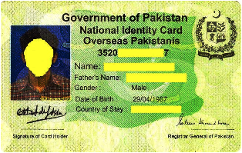

English ID card

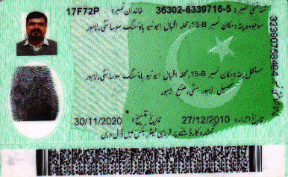
Urdu ID card

Monitoring and Evaluation:

BISP has a detailed M&E plan in place. Internal monitoring and progress reporting is done by the network of BISP offices across Pakistan. Third parties are involved to conduct evaluations. A grievance redressing mechanism is functional at the level of the 540 Tehsils. Most complaints, such as information updates, are resolved at this level. Daily complaint logs are generated, recorded and managed.

A proposal is under consideration to place the list of recipients on the website to enable instant, round-the-clock independent third party validation that the families receiving the payments fulfil the eligibility criteria.

The Waseela-e-Taleem initiative uses an ‘Optical Mark Recognition’ compliance monitoring process. The verified school admission forms are entered into Waseela-e-Taleem‘s MIS at the Tehsil offices and handed over to the concerned education department officer at the Tehsil level. The education supervisors from local education departments then hand over the quarterly attendance sheets to their respective schools for filling. The schools are given training on filling the attendance sheets. The schools then submit the filled attendance sheets by using the same channel of sheets communication.

Financial and legal sustainability:

The programme has been enacted by law and the BISP bill was passed unanimously by the National Assembly and the Senate. However, fiscal sustainability is a concern. The UN, World Bank, US government, British government through DFID and Asian Development Bank have provided financial and technical support to BISP.

Communication and awareness generation:

Financial and social inclusion of beneficiaries:
Beneficiaries are provided with the national ID card or the CNIC. Payments are collected through bank transfers and debit cards. Around 75% beneficiaries are paid electronically. Linking the poor with the financial sector through the BISP magnetic strip card offers promise in terms of escaping poverty. The beneficiaries from poor and marginalised families are given potential opportunities for productive and self-sustaining ventures.

An emphasis on the lessons learned from the programme (Chapter 3)

There is an increasing role of complementary interventions in determining sustainable impact of cash transfer interventions on uptake of education and health services, nutrition outcomes, and for improving livelihoods to increase the chances of graduation from poverty. Global experience suggests that where programmes are combined with complementary, well-sequenced interventions they have greater potential. BISP has also initiated complementary programmes including Waseela-e-Rozgar (technical and vocational training), Waseela-e-Haq (micro-finance), and Waseela-e-Sehat (life and health insurance).

The target households are very poor, with an average monthly consumption of PKR 1,601 per adult (US$ 16). This translates to individuals living on less than US$ 1 per day. Among other population groups, the BISP initiatives target children exhibiting higher rates of malnourishment than the national average. Many women in Pakistan are not able to participate in key decisions related to the household, particularly on those related to finances. The objective of BISP was to empower these households and improve their livelihood standards.

BISP has also contributed to the social and economic empowerment of women by making them the primary focus of the monthly cash transfers and other benefits such as life and health insurance, technical and vocational training, micro-finance. More than 15 million women have got their CNIC because of BISP, including around 0.5 million women in the economically backward regions of the Federally Administered Tribal Areas.

Best practices from around the world were tailored to the Pakistani environment to improve the social protection system in the country. The changes to BISP over the years have included:
- Switching from community based targeting to a scientific targeting
- Developing a comprehensive database of poor households
- Instituting an automated payment generation system
- Establishing an automated case management system with beneficiary interface at the Tehsil level
- Utilizing third-party evaluations to improve service quality

BISP is moving from unconditional cash transfers to co-responsibility cash transfers (CCT). At present, the provision of non-conditional grants without a clear linkage to co-responsibilities such as vocational training, skill development and entrepreneurship may be creating some dependency on aid while not contributing towards graduating upwards and out of poverty. In this regard, the implementation of co-responsibility cash transfers is expected to benefit poor and socially excluded households.

4. Linkages with the guiding principles of R202:

BISP is a targeted programme benefitting the poor households of Pakistan. It provides a cash transfer to supplement their monthly expenditure, which has been seen to be as low as US$ 16 on average. It specially focuses on remote and tribal regions to uplift livelihoods of the people there. In order to empower female members of the households, who often do not play a significant part in important financial and other decisions, the cash transfer is given to the female head of family or her nominee.

Beneficiaries have received the Computerised National Identity Cards due to enrolment in BISP. Transfer of benefits through bank accounts and withdrawal of money using debit cards provides some measure of social and financial inclusion for beneficiaries. Monitoring and evaluation is conducted by BISP offices as well as third parties to bring in a measure of transparency and accountability. The grievance redressing mechanism at the Tehsils level is used to resolve complaints and requests for information on a regular basis.

5. Resources and bibliography:
- http://www.bisp.gov.pk/
- http://tribune.com.pk/story/331740/benazir-income-support-programme-does-the-cash-flow-to-blue-eyed-voters/
- http://www.adb.org/sites/default/files/pub/2009/proceedings-social-assistance-cct.pdf
- Article by Faiza Effendi, UNDP
- http://www.pakistantoday.com.pk/2011/06/25/news/profit/bisp-a-commitment-falling-short/

Cut-off score of 16.7 does not represent poverty line. However, this cut-off was decided on the basis of the available fiscal space.

