Samajik Suvidha Sangam

Programme name: Samajik Suvidha Sangam (SSS)

Date of inception: 14 August 2008

Legal framework: SSS is registered under Societies Registration Act, 1860

National social protection strategy or development plan: (Is there a national social protection strategy or development plan in place? Is the programme part of the strategy or plan?)

Objectives:

Improve access to social services and efficient delivery system

Integrate existing social security schemes and rationalise schemes and services

Convergence of administration at district level

Target population: Identified Poor and vulnerable in urban areas

Institutions involved: Gender Resource Centres, District Resource Centres, Mother NGOs – field level functionaries – NGOs

Status of programme: Implementation phase

Services provided: Facilitate access to social protection programmes and schemes for beneficiaries; education, training and empowerment for women; help service providers identify, enrol and monitor beneficiaries

Lessons to be learned: Identification of potential vulnerable through a new definition of poverty. Creation of centralised database and integration for use by all partner departments & their schemes.

Background

Mission Statement: To provide social justice in the best coordinated way to ensure that the under-privileged and the poor regularly receive welfare services for both sustainable growth and eradication of poverty though convergence of organizing, joining forces, facilitating and making community voices heard effectively.

Country context: (Please mention relevant economic, social and employment-related statistical indicators for the country)

Justification and process of development:

Mission Convergence was conceived to aid the government realise its goals of poverty alleviation and inclusive growth. The initiative aims to integrate the existing social security schemes and deliver them through a unified structure in a decentralized manner with a parallel focus on empowering women through interventions in the areas of livelihood, health, non-formal education and legal literacy. The Delhi Human Development Report 2006 highlighted adverse development indicators. The under-privileged and marginalised people in Delhi did not have effective access to the Government’s social schemes due to lack of awareness, lack of documents and multiplicity at the administrative front.

The Government of Delhi in 2008 made policy and implementation level decisions to bring a major shift in the way the delivery of social services to the poor and vulnerable was organised. This was aimed to address the following gaps in the existing system:

There was no accurate estimate of beneficiaries or any mechanism to track and reach out to them. There was a need to identify and reach out to the deserving who were not accessing benefits.

Procedures to access benefits were complex.

A dedicated organization was needed so it could work on simplifying procedures, increasing inter-departmental coordination and information sharing, enhancing effectiveness of service delivery at the grass-root level, involving local communities in the delivery.

It was important to identify beneficiaries using measures of vulnerability and not just low income levels due to the following reasons:

It was difficult to determine the exact income levels and procure income proof.

This did not take into account the higher expenditure needs of vulnerable households, such as those having disabled or sick members.

An effective and dynamic database with unique biometric identification cards/IDs was needed, to be used by all line departments.

A strong IT backbone was required to check leakages, increase efficiency, transparency and accountability.

Linkage with policies and national development plan: (Please write about linkages of the programme or service with national social protection or employment strategies, national development plans, decentralisation policies, and so on)

Description of the programme or policy

Target population: Beneficiaries are urban poor identified with proxy means, through three types of parameters which are described below. The targeting mechanism with the income proxy indicators was influenced by the Kudumbashree model in Kerala.

Geography: people living in places of residence identified as vulnerable like notified and non-notified slums, resettlement colonies (F,G,H type), unauthorised colonies and the homeless.

Socially deprived groups: women or child headed households, households and families having old people, disabled persons and those suffering from debilitating illness

Occupationally vulnerable: people earning their livelihoods in vulnerable and odd jobs such as rag pickers, construction workers, street vendors, casual domestic workers and cycle rickshaw drivers

SSS conducted three rounds of surveys in September-October 2008, April-August 2009 and May, 2010-April 2011. These surveys were targeted at notified and non-notified slums, residents of settlement colonies, among others. Through these surveys SSS generated a database of about 12.64 lakh households covering about 60 lakh persons. Of these 5.74 lakh households are classified as “most vulnerable and vulnerable”.

Of these numbers, 139,478 households are classified as “most vulnerable”, i.e. households with elderly, disabled, diseased people, single women, female-headed and child-headed households. At the same time, 145,205 households and 629,639 persons were classified as “”, i.e. occupationally vulnerable households.

Services and transfers: There are 38 social sector schemes spread across 8 departments. It started with 40 centres and in the last 5 years has increased to 124 centres and 17 extension centres in Delhi.

Services to beneficiaries

Facilitate the access to social protection programs

The GRCs and DRCs provide help families access the social protection programs. These services include:

Information about government schemes implemented through SSS: scheme procedures, conditions, and formalities

Guidance and assistance on how to complete the common form required to register under all the programmes

Provision of the e-entitlement card that grants access to the services

In-house activities: women empowerment programmes

The GRCs are originally women empowerment centres. As such, they provide:

Non-formal education: vocational training and skill development

Health and nutrition programmes in health camps (organized once every month) and in clinics, awareness generation on ‘Water and Sanitation issues’

Formation and support of self-help groups: they support micro-enterprises created by women through marketing and communication assistance, partnership with financial institutions

Provision of job opportunities (see a real-life example in the box below)

Services to service providers

As the intermediary between beneficiaries and social protection providers, the GRCs and DRCs provide the following services to the welfare providers:

Developing outreach strategies to identify and access beneficiaries

Responsible for conducting and updating household surveys

Identification and enrolment of the beneficiaries, verification and authentication of the information

Forwarding of proposals to entities in charge, processing, follow up, feedback and reporting

Verification: ensure the authenticity of information given in forms, through cross-checking between the database of household survey

Home visits in case of discrepancies or lack of data

Management of the records of application received at SSS
An integrated mechanism: hiring vulnerable women in the Canteen of Delhi Secretariat

There was a need to administer the Canteen of Delhi Secretariat. SSS selected an NGO through a ‘Request for Proposal’ process. The NGOs prepared written proposals detailing their past experiences, plan for the Delhi Secretariat and plans for providing training and employment opportunities to vulnerable women. On this basis, SSS selected the NGO to operate the canteen.

40 vulnerable women organized into four groups to look after the four main functions of the canteen: cutting and preparation; cooking; cleaning; and serving at counters, meetings and conferences. In order to build the capacities of the vulnerable women, SSS provided training through the GRC vocational training programme and was supported by the NGO in this. Partnerships with other women groups were implemented, for example for procurement of masalas (spices) and paper bags for packing, headgear and aprons.

This experience provides an example of integration between social protection programmes and employment services.

Institutional set-up:
The State has instituted a hierarchical governing structure that plays the role of mentor and guide to SSS and brings accountability to the programme design at each stage. The Programme Management Unit (PMU) headed by the Mission Director and a secretariat of support staff, including technical experts and government staff on deputation, facilitates the entire process and act as the interface between SSS, its partners including the government and the 9 line departments. The overall policy guidance is given by the Governing Council of SSS headed by the Chief Secretary, Government of Delhi. At the Apex is a Policy Review committee headed by the Chief Minister. This is the highest governing body of the SSS responsible for taking all policy related decisions to facilitate effective implementation.

Gender Resource Centres (GRC) are the first entry point for the registration and enrolment of the Delhi citizens under all social protection programs. They were originally centres aiming to empower women and providing services such as trainings under the responsibility of the Department of Women and Child Development. Their responsibilities have been expanded and now include:

Registration of beneficiaries and processing on behalf of welfare schemes

Identification and enrolment of the beneficiaries, verification and authentication of the information

Forwarding of proposals to entity in charge, processing, follow up, feedback and reporting

Management of the records of application received at the GRC
- Making required data entry of the application forms related to the demographic details of households this further used for generating period MIS reports.

With the extension of the roles of the GRC, a substantial number of additional offices have been set up. There is one GRC per 100,000 households, located in vulnerable areas based on the poverty mapping exercise. The GRCs are managed by contracted NGOs, under certain criteria and with funds granted by Samajik Suvidha Sangam. An accreditation tool is being developed to strengthen the control on these NGOs. The GRCs are accountable to the PMU,SSS.

District Resource Centres (DRC) are located in the District Commissioner’s office. The DRCs are responsible for planning, project orientation and mentoring of GRCs on schemes, and coordination between actors (GRCs, DC, Departments, municipalities, NGOs). They are also an entry point for the beneficiaries to register. They are managed by contracted NGOs as well, and work under the supervision of the DC Office, to which they are accountable.

Mother NGOs (MNGOs) are NGOs that are responsible for monitoring and mentoring the NGOs that administer the GRCs. They supervise and monitor various activities related to women empowerment. They also provide training and mentor newly-established GRCs to understand concepts, establish activities, develop linkages and effectively implement their roles. There are 3 MNGOs and they are accountable to Programme Management Unit, SSS.

Every GRC has about 11 permanent staff in charge for registering people, counselling and other activities. The SSS also recruits volunteers for certain tasks from time to time:

Teaching: non-formal education for children, adult education for illiterate women, remedial education for children

Skill development for vocational training: cutting and tailoring, embroidery, IT workers

Health: Health Camps and Health Clinics, Water and Sanitation Issues

Administrative support: filling up the forms needed to avail the welfare schemes, verification

Analytical documentation: documenting the achievements made, hurdles overcome, case studies

Social audit: checklist to evaluate performance, look for gaps

The Centre for Advocacy and Research (CFAR) was charged to develop a module on Mission Convergence and train 50 master trainers (short term assignment). The training focused on building the capacities of monitoring officers of MNGOs on various issues (Self Help Groups, Health, Gender equality, Water and Sanitation, Computer training to use SSK application module etc). The MNGOs in turn can train the GRC teams and Community based groups. Apart from that, there are in-house training programmes in GRCs. These trainings aim to build the technical expertise of the GRC project staff.

Tasks and responsibilities of each actor are explained through the diagram below.

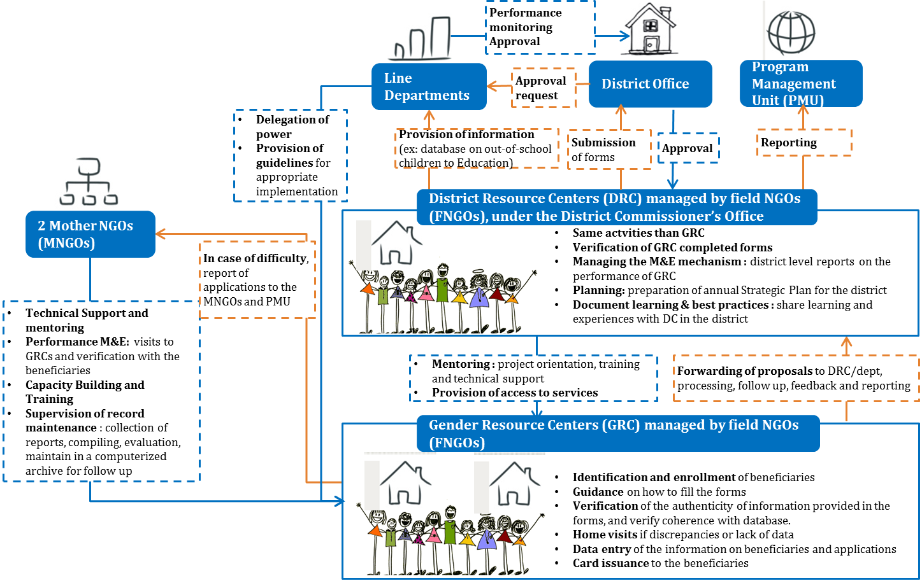

Decentralisation and harmonisation of service delivery: A District entitlement committee was formed to sanction the scheme to the applicant and local leaders – MLAs have also been nominated as the authority to recommend the entitlement benefits to the vulnerable person/households. Earlier this was limited to the state level office of department. (Please write about how decentralisation has aided in organising and delivering the services to the target group better, thereby improving efficiency and increasing outreach. Please explain how the programme, service or integrated policy has supported the decentralization process by giving responsibilities to the sub-national administration for the provision of services and transfers)

Operations and processes to avail benefits: Submission of the households/person details.

Assigning a unique family ID.

Mapping with UID/AADHAAR database for authentication.

Submission of entitlement application form.

Application process.

Delivery of the entitlement as services, Kind or Direct Cash. -(As bullet points, please list the steps for the beneficiaries to avail the services, from the beneficiary’s point of view. Also mention case management mechanisms or mobile teams, if any)

Management information systems:

Database of beneficiaries, services and programmes: SSS created a single database with two components:

A front-end interface (an online portal called System integration application) between service delivery partners (GRCs, DRCs, schools, hospitals and such) to be used by the 8 line departments for the 38 social welfare schemes

A dynamic database of all beneficiaries, with instant access to their socioeconomic data for appropriate targeting and avoiding fraud

GRCs are responsible for conducting and updating the information on beneficiaries through household surveys. At the office, GRCs ensure the authenticity of information given in forms, through verification and cross-checking with the household survey data. The GRC is responsible for conducting home visits in case of discrepancies or lack of data. The database is to be used and enriched by all departments.

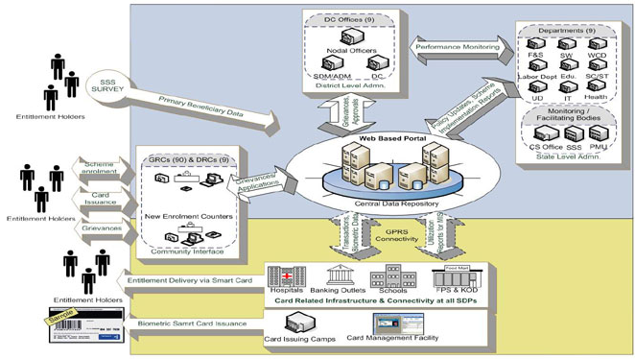

Identity cards: A unique 12-digit identity number, named Aadhaar is being issued by the Government of India (UID project) and the enrolment is facilitated by GRCs. SSS is one of the registrars under UIDAI

UID enrolment began in GRCSs in March 2011 with 2 centres, which later spread to all 124 centres across Delhi. The database correction exercise has been integrated with the UID enrolment process that also gave opportunity to capture EIDs that enhanced the possibility of AADHAAR seeding in the survey database. This will give SSS beneficiaries the opportunity to correct their information if they wish to, leading to a cleaner and more accurate database. First phase of AADHAAR enrolment was completed successfully and the second phase is underway currently.

Monitoring and Evaluation: The baseline of management is the Resource Manual, a comprehensive manual prepared by SSS detailing the administrative and financial guidelines to be adopted and followed. The Grievance Redressal System enables to gather feedbacks and grievances from the community. After receiving the feedback, action is undertaken to resolve the issue.

Internal monitoring of GRCs:

Day-to-day monitoring: three Mother NGOs are engaged for an ongoing monitoring and regular review.

Surprise Visits: at PMU level, “Nodal officers” pay visits to the GRCs and provide inputs for improvement, after the visits.

Financial monitoring: visits are conducted by the MNGOs and PMU Accounts Assistant. The Mission Director also conducts surprise visits.

Grievance Redressal Cell at the PMU: Beneficiaries or staff can report problems (underpayments made to the staff, non-issuance of appointment letters, authenticity of vouchers, not following the prescribed financial guidelines, etc.) to the Grievance Redressal Cell, located at the Program Management Unit. The information about this cell is displayed in the office of every GRC. The cell is convened every Wednesday between 2.00-4.00 pm. The Grievance Cell takes up complaints of the GRC staff.

Third Party Audit: Third party Chartered Accountant firms undertake financial and management audit every Financial Year. They also review work plans, progress reports, project resources, project budgets, project expenditures, project delivery, recruitment, operational and financial effectiveness (procedures, processes, management), authenticity and accuracy of annual financial statements. Following the third party audit, GRC projects can be terminated for financial irregularity or under performance.

Constitution of Management Committee of GRCs and DRCs: The Management Committee is in charge of determining required actions in cases of violations, irregularities, non-compliance and other issues related to governance, management, activity-planning and budgetary norms related to DRC and GRC-Suvidha Kendras.

Management of MNGOs: Each MNGO is monitored by Specialists placed at PMU, SSS. The baseline for the management of MNGOs is a guideline that describes the team composition of MNGOs, criteria for appointment, roles. The guidelines are issued by the PMU and SSS at the beginning of each financial year.

Reporting of MNGOs: MNGOs are in charge of mentoring and monitoring of the GRCs. The training plans are made in advance by the thematic specialistshave to be approved by a Specialist Research and Training placed at PMU, SSS. Apart from that, the MNGOs have to submit regular reports about their informed and surprise visits to GRCs on a monthly basis to the concerned Nodal Officer of all districts. The MNGOs prepare quantitative and qualitative reports of the GRCs.

Finally, there is a Quarterly and Annual analytical report, collected by MNGOs and analysed by Research Analyst. In case of low performance of any GRC, the MNGO is answerable about corrective measures. The Nodal Officer attached with each MNGO can also visit the MNGO office and the field with them, to support the improvement of the GRC. There are also regular meetings conducted with MNGOs at PMU, SSS.

Challenges include ensuring the management of NGOs and clarifying the responsibilities between all created institutions including MNGOs, PMU, DRCs.
SUCCESS STORY

Mrs Ragini Sharma, 30 years, is a single woman from a lower middle class family. She studied up to class XII and has a 5 year old daughter. She had no source of income and for a while, her parents supported her. Being energetic and hardworking, she wanted to do something. Her neighbours who had availed benefits from Gender Resource Centres informed her about them. One day she came to a GRC and enrolled in a livelihood programme in the Art & Craft trade according to her interests. After completing the programme successfully, she started her own business making dolls, bouquets, flower pots, gift items and toys from her house. She sells her products to the B. R. Tyagi Public School and other local schools, gift shops, at weekly markets and earns around INR 3,000-5,000 per month. She is happy with her work and enjoys living with her daughter.

Financial and legal sustainability: (source of funds?) SSS is registered under the Societies Registration Act, 1860.

Communication and awareness generation: The information about SSS is disseminated to the communities through regular meetings and IEC strategies with community mobilisers and Self-Help-Group outreach workers.

Financial and social inclusion of beneficiaries:

Microfinance Program support to reach out to the urban poor in Delhi: SSS is collaborating with Self Employed Women Association (SEWA) Delhi Trust on an innovate project to facilitate access of urban poor women to microfinance services through a cooperative, Mahila SEWA Urban Cooperative Thrift and Credit Society Limited. The project is expected to provide an institutional framework for financial inclusion of poor women. It has a target of providing financial literacy and inclusion of over 100,000 urban poor women in Delhi over five years.

This system includes ‘Bank Sathis’ (grass-root level agents of the cooperative working on a commission basis), use of guarantors, compulsory savings. These measures will help to maintain financial discipline. Each new member has to provide a share capital of INR 100 and a monthly deposit of a minimum of INR 50. Micro-finance services such as saving and credit services are provided at a reasonable cost. The interest charged for loans is 1.5% per month which is much lower than the market rate.

The SJSRY’s Skill Training for Employment Promotion amongst Urban Poor (STEP-UP) programme provides training in several service, business and manufacturing activities. Skill training is linked with accreditation and certification on Public Private Partnership mode with involvement of institutions.

Mega camps
SSS organizes fairs to provide information to communities on the existing schemes, help them to fill up the forms, submit the forms to the concerned departments. It is organized on a quarterly basis in each district in different locations during the year, preferably on a holiday or Sunday.

Objectives:
- Bring the service delivery even closer to the beneficiaries and increase awareness on the GRC
- Ensure that all line departments collaborate to remove bottlenecks; before the camp the GRC lists out issues, bottle-necks, grievances that they face with the concerned departments to DRCs so as to resolve them during the mega camp.

Organisation:
The mega camps are built on the basis of already existing health camps, but with additional involvement of other departments. It is organized under the leadership and supervision of Deputy Commissioners. A standard manual on Mega Camps is developed by the PMU, in order to outline the minimum interventions that are expected from different departments during the event. The budget is INR 7.2 million for holding 36 Mega Camps across 9 districts (4 in a year per district).

Communication strategy:
Pre-camp Information Education Communication (IEC) activities such as printing and distribution of posters, banners, leaflets, pamphlets, flex banner, street plays are conducted for awareness raising.

Impact of the programme, policy or service and linkages with the guiding principles of R202

Impact on final beneficiaries and their dignity, graduation out of poverty and social inclusion: (Please provide recent statistical data and evidence on impact of the programme, policy or service on beneficiaries in terms of expansion of social protection coverage, poverty reduction, access to decent jobs and markets, and so on, if such data is available)

Impact on the transparency, accountability and traceability of the implementation of the Social Protection Floor: (Please provide evidence on the impact of the programme, policy or service on the improvement of the database system of the social protection system as a whole, the capacity to keep track of financial flows, to monitor the extension of social security extension)

Impact on the efficiencies of the social protection system as a whole and its financial sustainability:

In July 2009, SSS was identified as the implementing agency for RSBY by the Government of India and assigned to enrol beneficiaries through GRCs. Enrolment in RSBY substantially increased post involvement of Mission Convergence and around 212,000 families were enrolled in 2009-10, representing 49% of target beneficiaries. 75.8% of enrolments were contributed by Mission Convergence. Out of 145,222 enrolments, 110,048 families were vulnerable families enrolled by the network of GRC-SKs.

The Swarn Jayanti Shahri Rojgar Yojna (SJSRY) is a poverty alleviation scheme launched by the Government of India in 1997. The scheme aims to provide gainful employment to the urban unemployed or underemployed urban youth by helping to set up self-employment ventures. A major component of SJSRY is Skill Training for Employment Promotion amongst Urban Poor (STEP-UP). The programme aims to provide training in several service, business and manufacturing activities. From April 2009 onwards, SJSRY is being implemented through SSS.

Impact on the coherence of the social protection system: (Please provide evidence on the improvement of coherence of the social protection system as a whole, across institutions as well as with employment, social and economic policies)

Impact on representation and democratic governance, empowerment of populations and local administration, communities: The SSS communication strategy consists of:

Identifying outreach points in communities

Involving communities in the strategy

Involving formal and informal Community Based Structures, Self Help Group federations, as part of all strategies

Involving local communities through formation of local management committee

The SSS has been setting up a separate mechanism and structure to address the issues of homeless since 2009. SSS selected 1 MNGO (Community Medicine Department of St. Stephen’s Hospital) and 7 NGOs to carry out a homeless Survey at night. Each surveyed person was given a provisional card. The SSS also set up Resource Centres for Homeless, responsible for collecting data on these persons and for providing services 4 NGOs have been selected to run the Homeless Resource Centres.

Lessons to be learned: (Kindly write about supporting families to graduate out of poverty through integrated packages of services and transfers)

Resources and bibliography:

http://www.missionconvergence.org/

Research on Single Window Services, Diane Taieb, Valerie Schmitt, 2012

Upgrading Social Protection Strategies in Delhi, World Bank, 2011

Qualities of Community Mobilisers for Conducting Data Correction and Validation Exercise, Mission Convergence

Data correction steps, Mission Convergence, 2010

Innovation support for Social Protection, Factsheet, UNDP India, 2011

Concept note GRC

Protocol for data correction and updation for phase 1 & 2, Mission Convergence, 2010

SSS, a status report, Mission Convergence, 2011

