PROPOSAL OUTLINE

This is the general structure for the research proposals; the resource person should put emphasis on point no. 4. The parts in red are to be retained in the format of the final proposal. Please maintain the font and ensure that it does not exceed ten pages.
Bolsa Verde

The Programme or policy ID card provides a snapshot of the programme, policy or service for quick reference.

Programme name: Bolsa Verde (Green Grant) or Environmental Conservation Support Programme

Date of inception: June 2011

Legal framework: Law nr. 12.512, approved on 14 October 2012.

National social protection strategy or development plan: Government public policy

Objectives:

Promotion of citizenship

Improvement of living conditions

Increase people’s in extreme poverty income

Provision of an incentive for the conservation of the ecosystems

Beneficiaries participation in environmental, social, technical and professional trainings

Target population: Social groups in situation of extreme poverty living in areas of environmental relevance

Institutions involved: The Administrative Committee is made up of the Ministry of the Environment (MMA), the Office of the Chief of Staff of the Presidency of the Republic (CC/PR), the Ministry of Social Development (MDS), the Ministry of Agrarian Development (MDA), the Ministry of Planning, Budget and Management (MPOG) and the Ministry of Finance (MF).

Status of program: The Green Grant was initially implemented in the Northern region of the country, where the greatest concentration of federal environmental areas was identified. As of 2012, the Bolsa Verde was expanded to the rest of Brazil.

Services provided: Environmental, social, educational, technical and professional training

Lessons to be learned: (In a few words, please write about how the programme serves to “Developing sectors of the economy through a combined set of social protection and employment measures”)
The Programme design generated interaction between the different governmental organizations responsible for other policies which were also focused on the regions covered by the Bolsa Verde. This interaction resulted in indirectly modifying governmental activities, allowing the development of alternative strategies, given the difficulties related to the geographical conditions of the region, which resulted again in increased access by these families to important government schemes. The Green Grant Programme has the potential to be an important remuneration programme for conservation services across the country at the federal level, aiming to include around 73,000 families by 2014, improving their social conditions while, at the same time, keeping the forests standing.

Background

Country context: (Please mention relevant economic, social and employment-related statistical indicators for the country)

The Brazilian economy has grown very fast over the last few decades and this has led to important advances in terms of social and economic development. Nevertheless, the country has been facing environmental challenges given the speed of its urbanization, its raising population and the exploitation of natural resources. This context has made it all the more necessary to guarantee government policies that are suitably adapted from the point of view of economic efficiency, environmental integrity and social equality.

Justification and process of development: (Please elaborate how the programme, policy or service came into being. What factors led to its design and implementation and what programmes existed before, if any?)

The Bolsa Verde Programme started as part of “Brasil sem Miséria” (Brazil Without Extreme Poverty Plan), meant by the Federal Government to raise the income and living conditions of the population. The idea and design of the Bolsa Verde Programme came about during the development of Brasil sem Miséria, from January to July 2011, when the Ministry of the Environment (MMA), the Ministry of Social Development and the Fight against Hunger (MDS), the Ministry of Agrarian Development (MDA), the Ministry of Planning, Budget and Management (MPOG) and the Office of the Chief of Staff of the Presidency of the Republic (CC/PR), met to prepare the project. While gathering data for a plan of action for the Brasil sem Miséria Program, it was noted that despite only 15.6% of the Brazilian population was residing in rural areas, these locations were home to around 7.5 million extremely poor people, i.e. almost half of those living in situations of extreme poverty (46.7%) lived in the countryside. Rural families living in situations of extreme poverty have a large part of their lands registered in the Federal community. According to the Brazilian law, the administration of public forests for sustainable development, with a view to the conservation and generation of income, should be conducted through the assignment of public forests to local communities.

Linkage with policies and national development plan: (Please write about linkages of the programme or service with national social protection or employment strategies, national development plans, decentralisation policies, and so on)

Description of the programme or policy

Target population: Social groups in situation of extreme poverty living in areas of environmental relevance:

Florestas Nacionais, Reservas Extrativistas federais e Reservas de Desenvolvimento Sustentável federais, administradas pelo ICMBIO;

Projetos de assentamento florestal, projetos de desenvolvimento sustentável ou projetos de assentamento agroextrativista instituídos pelo INCRA;

Territórios ocupados por Ribeirinhos, Extrativistas, Populações Indígenas, Quilombolas e outras Comunidades Tradicionais;

Outras áreas rurais definidas como prioritárias pelo Governo Federal

Services and transfers: (What social protection and employment services and transfers are provided to the target groups under the programme, including cash transfers, training, access to health care, public works and school feeding, among others? Please give one or more real examples, if available, of how the services and transfers are provided in an integrated way, and linked with one another)

The Green Grant is an income transfer programme for environmental conservation. It is a programme that approaches the usual concept of payment for environmental services while recognizing the economic value of the protection of ecosystems. Therefore, it offers an economic incentive to those communities providing environmental services, such as: control of erosion, carbon storage and climate regulation. In the Bolsa Verde Programme, the compensation will take the form of R$ 300 or $ 150, to be paid quarterly to each beneficiary family by the Caixa Economica Federal (CAIXA), which will be acting as the program’s financial agent. The payment will always take place during the last 10 days of each month. The cash can be withdrawn from Caixa branches and from ATMs upon presentation of the Bolsa Familia card. The payment is made in full, with partial withdrawals and purchases using the card not being allowed. The cash is made available for 150 days, after this period, if the family hasn’t withdrawn the money, it will be returned to the MMA.

Institutional set-up: (Kindly elaborate on the organisational structure by listing the different institutions and giving a short description of their roles and functions. Please mention whether an inter-ministerial coordination mechanism was established and how it functions. Please feel free to use flowcharts or diagrams for the illustration)

The Bolsa Verde includes an Administrative Committee made up of the Ministry of the Environment (MMA), the Office of the Chief of Staff of the Presidency of the Republic (CC/PR), the Ministry of Social Development (MDS), the Ministry of Agrarian Development (MDA), the Ministry of Planning, Budget and Management (MPOG) and the Ministry of Finance (MF). It is coordinated by the MMA while the Programme is executed by the Department of Extraction. The Aministrative Committee is responsible for approving and planning the Programme, suggesting priority areas for the implementation of the Green Grant, articulating the actions of the Federal Government organisations involved and suggesting criteria and procedures for:

The selection and inclusion of the beneficiaries, according to population and regional characteristics, and depending on the availability of the budget and finance;

Monitoring and evaluating the Program;

Renovation of the adhesion of the families;

As for local administrators of the Programme, they are responsible for collecting the signature on the terms of adhesion to the programme and for providing local support for the implementation of the Programme, such as, for instance, during environmental monitoring activities. In addition to this, they form part of the task force identifying families in conditions of extreme poverty and which are still not included in the CadUnico.

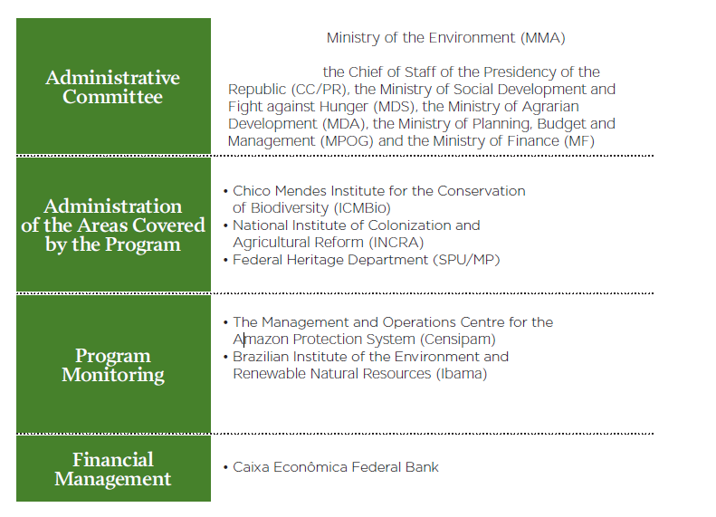
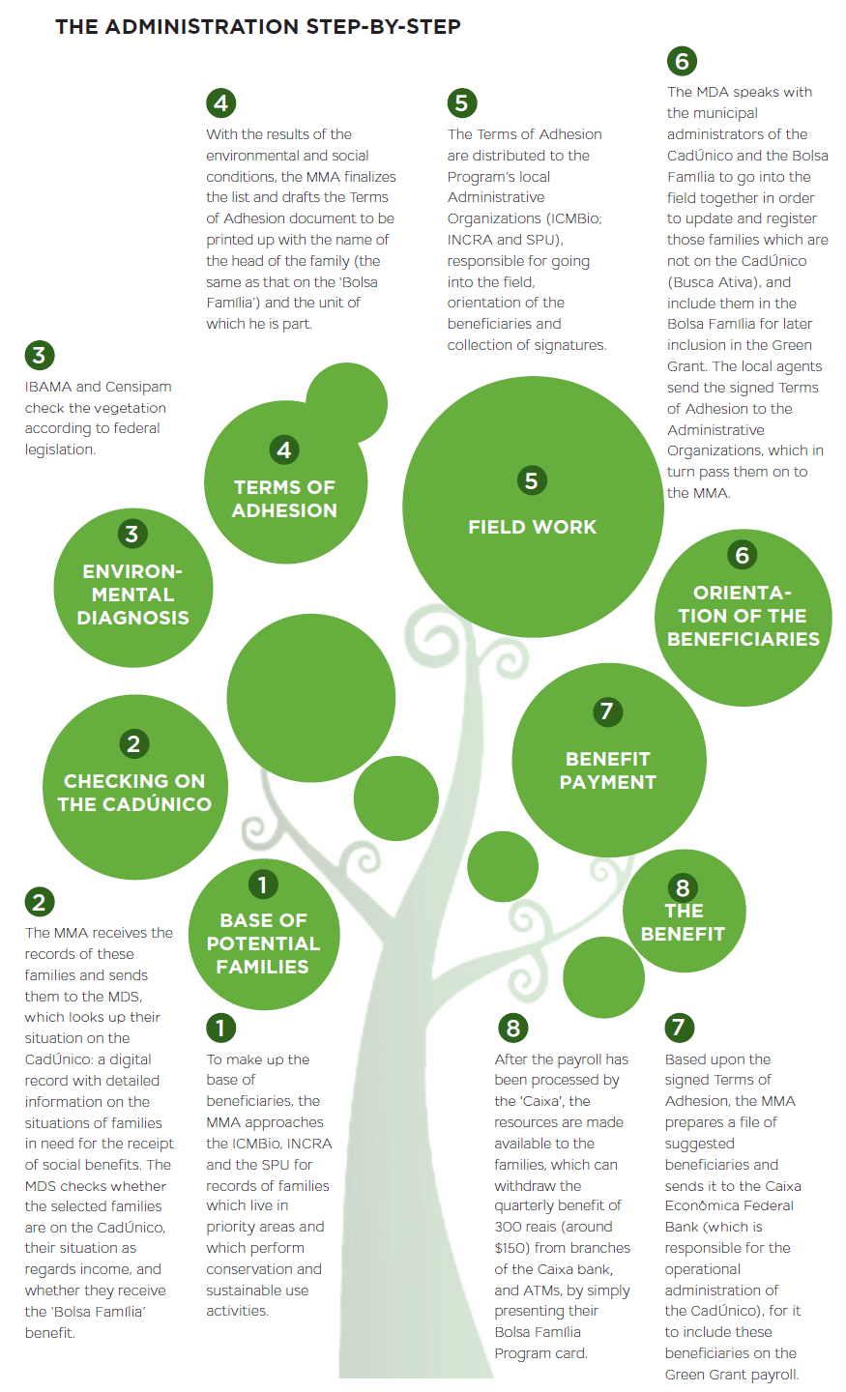

Decentralisation and harmonisation of service delivery: (Please write about how decentralisation has aided in organising and delivering the services to the target group better, thereby improving efficiency and increasing outreach. Please explain how the programme, service or integrated policy has supported the decentralization process by giving responsibilities to the sub-national administration for the provision of services and transfers)

As we can see from the diagram, the Bolsa Verde Programme is strongly decentralised. Even though the process starts from the MMA, which makes up the base of beneficiaries, the ICMBio, INCRA and the SPU are consulted on the first stance to facilitate records of families who live in priority areas and perform conservation activities. After receiving the records of these families, the MMA sends them to the MDS, which makes sure their names are on the CadUnico. On the other side, IBAMA and CENSIPAM conduct an environmental diagnosis. With the results of the environmental and social conditions of the families, the MMA finalises the Terms of Adhesion to be distributed among the beneficiary families in the field, through the Local Administrative Organisations (ICMBio, INCRA and SPU) and the MDS which, in turn, would register those families who are still not on the CadUnico, and include them in the Bolsa Familia for later inclusion in the Green Grant. Based upon the signed terms of adhesion, the MMA sends the names of the suggested beneficiaries to the Caixa Economica Federal. After the payroll has been processed by the Caixa, the families can withdraw the 300 reais (about $ 150) by simply presenting their Bolsa Familia card.

Operations and processes to avail benefits: (As bullet points, please list the steps and processes for the beneficiaries to avail the services. Also mention case management mechanisms or mobile teams, if any)
The requirements for a family to be granted a Bolsa Verde are:

Being in a situation of extreme poverty

Being registered with the CadUnico

Pursuing the environmental conservation activities outlined in the terms of adhesion
A sort of case management mechanism is the in loco sample monitoring, carried out by means of periodic visits to the beneficiary families, with the aim of not only evaluating the result of the programme but also to check cases in which deforestation is noted on the satellite images. In such cases, before the Bolsa Verde payments to the families living in the affected area are suspended, local agents will try to understand the reasons behind the deforestation. The methodology is still under preparation.

Management information systems:

Database of beneficiaries, services and programmes: (How is data collection done? Please mention about surveys, if any. What is the process for identifying and registering a user and determining eligibility? How is beneficiary verification done? How is the database updated?)

As requirement for being a beneficiary of the Green Grant Programme, a family should meet the following conditions:

Social Conditions: be in a situation of extreme poverty; be registered with the Federal Government’s Single Registry of Social Programmes (CadUnico)

Environmental Conditions: live in a priority rural area, as defined by the Programme, which both complies with environmental legislation and develops conservation and sustainable use activities.

The first survey of the families, along with the evaluation and registration of individuals as beneficiaries, was performed between July and September 2011. Initially, the Programme was structured with the country’s Northern region being prioritized. As of 2012, the Bolsa Verde Programme was expanded to the rest of Brazil. As part of this, around 20,400 families suitable to join the Programme were identified by May 2012; 6,400 of them living in Conservation Units, 10,000 in settlements and 4,000 in agro-extractive riverine areas. Of these, approximately 6 thousand families have already been included in the programme (total 23,355 families in May 2012).

At the second stage of the Programme, actions aimed to develop a database, environmental training for the beneficiaries, a sample monitoring system with local visits to the beneficiary communities to check they are complying with the commitments stated in the Programme. There has also been closer work conducted with “Busca Ativa” Programme, for inclusion and updating of families in the Government Single Registry of Social Programmes (CadUnico). Specific training has been provided for the local Programme administrators in order for them to be able to do their job at the highest standards in the field. Since the launch of Brasil Sem Miseria and the Bolsa Verde Programme, regular meetings have taken place involving all the Government organizations responsible for them in order to follow their implementation and monitor their results. CENSIPAM is responsible for developing, monitoring and maintaining the database for the families beneficiary of Bolsa Verde, in accordance with the policy of transparency. The so called SISVERDE, supposed to be concluded by 2012 would include:

Registration data: about people and areas

Monitoring data

Families’ payments

CENSIPAM would, therefore, validate and store the data (reports, maps, payment slips) before making them available on the website.

Identity cards: (Does the programme or service make use of identity numbers, smart cards, etc.? Please provide an image of the card, if available)

Bolsa Familia’s cards, with just a sticker bearing the Bolsa Verde logo. Those who might come to leave the Bolsa Familia Programme after having entered the Bolsa Verde Program will receive a specific Bolsa Verde card.

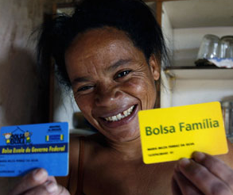

Monitoring and Evaluation: (Are there any mechanisms in place to track the impact of the programme, policy or service on beneficiaries and what are they? What are the grievance redressal mechanisms that are in place? Is an ombudsman in place?)
The Administrative Committee is responsible for approving and planning the Programme and for the selection and inclusion of the beneficiary families.
The monitoring of the vegetation of the units where the beneficiary families are located is carried out by the IBAMA (Brazilian Institute for the Environment and Renewable Natural Resources), together with the CENSIPAM (Management and Operations Centre for the Amazon Protection System).
The CENSIPAM is a Government body of the Ministry of Defence, created to manage the SIPAM (Amazon Protection System). The first phase of the Green Grant (2011) was conducted by the SIPAM only in the Legal Amazon (9 states in the North: Acre, Amapa, Amazonas, Mato Grosso, Para, Rondonia, Roraima and Tocantins), covering an area of around 61% of the entire national territory, and was validated by the IBAMA.
The second phase (2012) expanded the Green Grant to the rest of the country. The North accounts for 64% of the areas covered by the programme; the Northeast 26%; the Southeast 6% and the Central-West 4%.
The following strategies have been outlined with the aim of evaluating the Programme:

Quarterly and annual satellite tracking

Regular updates on deforestation via satellite and radar hotspots

On-site monitoring by means of periodic visits to families, with a view not only to evaluating the environmental effects, but also the performance of the public policy on the areas in question

Financial and legal sustainability: (Is the programme or service supported by law? How is it funded?)

The Bolsa Verde Programme has been created in June 2011, through the Provisional Measure of the Environmental Conservation Support Programme and regulated afterwards, by Decree in September 2011. Only in October 2012, Law n. 12.512 instituted the Environmental Conservation Support Programme, extending the areas benefitting from the Bolsa Verde Programme. The resources destined to the Green Grant Programme come from the Ministry of the Environment (MMA)’s annual budget.

Communication and awareness generation: (What efforts have been taken to increase awareness of the programme, policy or service among the target groups? What media are used for such awareness generation? Please also mention any specific efforts to reach out to vulnerable groups such as the homeless.)

Financial and social inclusion of beneficiaries: (Please write about any partnerships with employers and recruiters for vocational training, apprenticeships or permanent hiring. Are there any tie-ups with banks and micro-credit programmes for financial inclusion of beneficiaries?)

In line with the aim of the Green Grant to encourage the beneficiaries to participate in activities focused on environmental, social, educational, technical and professional training, a methodology aimed at the environmental qualifications of the beneficiaries has been developed. The International Education Institute of Brazil (IIEB), a non-profit civil organization, is responsible for the development of this methodology. The IIEB has extensive experience in working with traditional peoples and communities providing environmental training. The development of the methodology has been financed by the British Embassy.

Impact of the programme, policy or service and linkages with the guiding principles of R202

Impact on final beneficiaries and their dignity, graduation out of poverty and social inclusion: (Please provide recent statistical data and evidence on impact of the programme, policy or service on beneficiaries in terms of expansion of social protection coverage, poverty reduction, access to decent jobs and markets, and so on, if such data is available)

Around 17,000 families were brought into the Bolsa Verde Programme during its first stage (from June to December 2011), all of them located in the Amazon State, covering a total area of 11.3 million hectares. In 2012, the Programme reached the whole Brazil, reaching 25,000 families by the time of the Rio+20 event in June 2012.
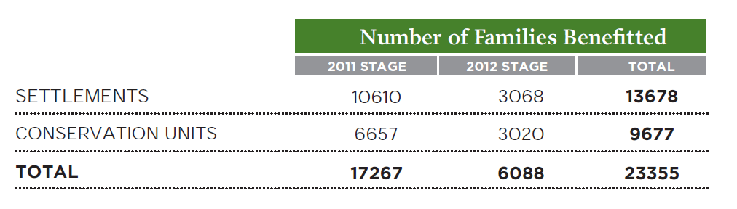
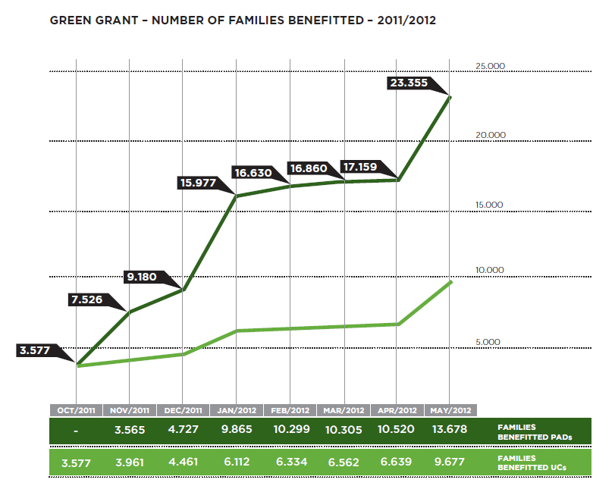

Impact on the transparency, accountability and traceability of the implementation of the Social Protection Floor: (Please provide evidence on the impact of the programme, policy or service on the improvement of the database system of the social protection system as a whole, the capacity to keep track of financial flows, to monitor the extension of social security extension)

Impact on the efficiencies of the social protection system as a whole and its financial sustainability: (Please provide evidence of economies of scale and reduction of costs e.g. through reducing overlaps and duplications, standardizing processes and tools, involving sub-national administration in the operations and funding, and so on)

Impact on the coherence of the social protection system: (Please provide evidence on the improvement of coherence of the social protection system as a whole, across institutions as well as with employment, social and economic policies)

Impact on representation and democratic governance, empowerment of populations and local administration, communities: (Please provide evidence on the improvement of awareness and representation of final beneficiaries through tripartite or bipartite arrangements, involvement of communities in programme design and implementation through the establishment of appeals mechanisms, and so on)

The Programme design generated interaction between the different governmental organizations responsible for other policies which were also focused on the regions covered by the Bolsa Verde. This interaction resulted in indirectly modifying governmental activities, allowing the development of alternative strategies, given the difficulties related to the geographical conditions of the region, which resulted again in increased access by these families to important government schemes. The Green Grant Programme has the potential to be an important remuneration programme for conservation services across the country at the federal level, aiming to include around 73,000 families by 2014, improving their social conditions while, at the same time, keeping the forests standing.

Lessons to be learned on Module title: (Kindly write about “Developing sectors of the economy through a combined set of social protection and employment measures”. Please also highlight the strengths of the programme, service or policy and also challenges faced in its design or implementation. Such aspects could be considered as learning experiences for other countries.)

The Programme design generated interaction between the different governmental organisations responsible for other policies which were also focused on the regions covered by the Bolsa Verde. This interaction resulted in indirectly modifying governmental activities, allowing the development of alternative strategies, given the difficulties related to the geographical conditions of the region, which resulted again in increased access by these families to important government schemes. The Green Grant Programme has the potential to be an important remuneration programme for conservation services across the country at the federal level, aiming to include around 73,000 families by 2014, improving their social conditions while, at the same time, keeping the forests standing.

Resources and bibliography: (Please provide a list of a maximum of 10 key resources on the programme, policy or service including articles, case studies, videos, websites, guides and manuals of procedures and other management tools)

Government of Brazil
http://www.brasil.gov.br/sobre/cidadania/brasil-sem-miseria/rural/bolsa-verde
http://www.brasilsemmiseria.gov.br/
Ministry of the Environment
http://www.mma.gov.br/desenvolvimento-rural/bolsa-verde/item/8928
Ministry of Social Development
http://www.mds.gov.br/falemds/perguntas-frequentes/bolsa-familia/bolsa-verde/beneficiarios/bolsa-verde
News article
http://www.ipsnews.net/2011/10/brazil-green-grant-may-do-little-to-protect-amazon/

