WFC ID card

Programme name: Worker Facilitation Centres (WFCs)
Date of inception: 2011
Legal framework: The Unorganised Workers Social Security Act, 2008 talks about the formation of WFCs for identifying informal economy workers and delivering social security benefits to them.
National social protection strategy or development plan: WFCs were set up in line with the Unorganised Workers’ Social Security Act, 2008. The Act provides for the formation of Social Security Boards at the national and state levels to design and implement social protection schemes. WFCs will exist at the local level, to deliver the benefits.
Objectives:
To build awareness among informal economy workers about their entitlements and provide information on social protection schemes
To identify and register prospective beneficiaries
To guide and assist them in accessing benefits
Target population: Informal economy workers in Karnataka
Institutions involved: Department of Labour (Government of Karnataka state), GIZ
Status of programme: Pilot phase, to be expanded to the entire state
Services provided: WFCs use a case-based approach through Community Facilitators, who collect information through household visits. WFCs identify eligible beneficiaries, provide information and assistance in obtaining documents and filling applications, and follow-up on their status.
Lessons to be learned: WFCs help improve access to social security through a “single window” and case-based approach targeting households. By doing so, they improve coordination among different schemes and their procedures and also reduce the disadvantages of a fragmented social protection delivery system.

Worker Facilitation Centres, Karnataka, India; Hans Christoph Ammon; Namerta Sharma; D Rajasekhar

Background

Country context:
The Directive Principles of the Constitution of India states that, “the State shall strive to promote ... a social order in which justice, social economic and political, shall inform all the institutions of the national life” and in particular, shall ensure that, “the citizens, men and women equally have the right to an adequate means of livelihood”. In India, about 93 per cent of the workforce is in the informal or unorganised sector and contributes around 60 per cent to the gross domestic product. However, a vast majority of the informal sector workers do not have a direct and formal relationship with the employer, and therefore no access to sufficient and reliable social protection. This is due to demand-side factors such as lack of awareness, illiteracy, lack of organisations as well as supply-side factors such as fragmented social protection policy, poor targeting, high transaction costs, lack of convergence. Because of limited or no access to formal social security, informal economy workers frequently faced crises due to social and economic risks. They would then depend on informal social protection mechanisms such as moneylenders, which increases poverty and makes them more susceptible to vulnerability.

Against this background, the Indian government has passed the Unorganised Workers’ Social Security Act (UWSSA), 2008. The Act provides for minimum social protection towards ill health, old age and death. Subsequently, the government formulated three schemes to deliver these benefits, namely National Health Insurance Scheme for the Poor, National Old Age Pension Scheme and Life and Accidental Insurance for the Poor. For other social protection benefits, the Act placed the responsibility in the hands of provincial governments to come up with relevant programmes by setting up Social Security Boards. The progress in complying with the Act has been uneven across states. Although the Act mentioned the formation of Worker Facilitation Centres (WFCs) for the identification of informal workers and delivery of social protection benefits, the functions and jurisdictional details were not specified.

Social protection in India comprises promotional and protective social assistance, social insurance and micro insurance. There are a large number of social protection schemes initiated by the Central and state governments for the welfare of informal workers. However, the delivery of these schemes face problems like wrong targeting, corruption, poor transparency, low level of awareness and high transaction costs and do not assume the character of legal entitlement. The social protection policy has not been coherent. As rightly described by the Prime Minister Dr. Manmohan Singh, “India has devised a system that fragments resources” - a situation that has to be overcome.

Justification and process of development:
It is in this context that the pilot project of “Social Security Benefits to Unorganised Workers” in Karnataka by the Department of Labour, Karnataka government and German International Cooperation / Deutsche Gesellschaft für Internationale Zusammenarbeit (GIZ) on behalf of German Ministry of Economic Cooperation and Development/Bundesministerium für wirtschaftliche Zusammenarbeit (BMZ) becomes important. This project, which started to effectively function from 2011, aimed to improve the access to social protection benefits among informal economy workers through WFCs. Designed as a single window to improve access to social protection benefits and embedded into the local government, it was expected that these WFCs would have information advantages. This was because they were set up at the lowest administrative level of village councils or urban wards and each WFC covered about 1,000 households.

WFCs are extremely relevant in the current context of accessing social protection among the poor and informal economy workers. They are linked to the national context and policies in the following manner.
- The informal labour market changes constantly with small farmers joining and leaving the informal labour market, rural workers commuting to work in the urban informal sector and a growing urban informal sector resulting from widespread unemployment and poverty in rural areas. As a result, there is information asymmetry which leads to targeting problems. WFCs have the potential to resolve this as they are closer to the people.
- A large number of schemes have been formulated to meet social protection needs such as housing, food and nutrition, education, illness, old age, disability and death. However, these schemes are not universal and are often delivered by different departments. For instance, over 50 social protection schemes have been implemented in Karnataka state by about 10 different government departments. This leads to the problem of fragmentation. WFCs have the potential to bring synergy and convergence at the delivery level, as they function as a single window and are embedded into the local government.
- Another problem with the delivery of social protection schemes in India is that each scheme is different in terms of objectives, key benefits, eligibility criteria, registration and application procedures. In the context of widespread poverty and illiteracy among informal economy workers, and problems of isolation and lack of organisation among them, they find it difficult to gain access to social protection benefits. Hence, it is important to provide awareness and build capacity among informal economy workers, and this function can be performed by WFCs.
- The social protection delivery system is complex in India. Often the provincial government designs and funds schemes, the district administration makes decisions, and the taluk level officials deliver the benefits. The average distance between a village and taluk headquarters is 15 kms, and opportunity costs to obtain benefits (time taken to fill applications, obtain documents and follow up) is high. This leads to dependence on middlemen and therefore, higher transaction costs. WFCs are located close to informal economy workers, and have the potential to address these problems.

Linkage with policies and national development plan:
In 2008, the Government of India enacted the Unorganised Workers’ Social Security Act, 2008. The Act provides for the constitution of a National Social Security Board at the Central level. A minimum level of social protection coverage including healthcare, disability, death and old age benefits is to be provided. The National Board will recommend formulation of social protection schemes providing healthcare, death, disability, maternity, old age and other benefits to unorganized workers as may be determined by the Government. Social Security Boards, constituted at the State Level, are entrusted with the responsibility of overseeing the implementation of schemes, and designing new schemes as and when required. The delivery of the benefits is envisaged through setting up of Worker Facilitation Centers at the local level (Gram Panchayat and Urban Ward).

As a follow up to the Act, the National Social Security Board was set up in 2009, and it has recommended extension of coverage of social protection schemes like Janshree Bima Yojana (Social Insurance for death and disability benefits), Rashtriya Swasthya Bima Yojana (National Health Insurance), Old Age Pension to certain categories of unorganized workers. The Indira Gandhi National Old Age Pension scheme is being expanded by revising the eligibility criteria. However, there is general dissatisfaction among the informal economy labourers for whom this act is enacted. The demand of the workers is entitlement and not charity. Their expectation is to have a comprehensive law covering aspects of their work and life at work, including regulation of their employment, wages, social protection, safety, conditions of work etc.

Hence, there is a need to coordinate further among policies and programmes on social protection. Coordination is important to minimize risks that arise from having a highly fragmented social protection delivery system. The pilot project of “Social Security Benefits to Unorganised Workers” in Karnataka is an attempt in that direction. In line with UWSSA, this project has formed WFCs as a single window by adopting a case-based approach at the household level, and coordination among policies and programmes at the macro level. The Karnataka government has agreed to upscale the project to the entire state of Karnataka.

Description

Target population:

WFCs target informal economy workers such as agricultural labourers, construction workers, domestic helpers, garment workers, home-based workers in Karnataka. These workers usually do not have a formal employer - employee relationship, fixed job contracts or entitlement to minimum wages. They are poor and vulnerable and lack sufficient access to social protection.

WFCs, Community Facilitators and services:
There are 250 WFCs in six agro-climatically different districts in Karnataka state. The districts were selected based on high growth rates in the recent past, presence of the IT industry and rapid growth of the informal sector. WFCs are housed in the office of the village council (municipal office in urban areas) and are equipped with a computer, printer, internet connectivity and furniture. The functions of WFC include:
- Act as common information centres to build awareness among informal economy workers on their entitlements and different social protection schemes;
- Identify households and workers eligible for social protection benefits, and manage and update the database on workers;
- Facilitate access to benefits by helping workers obtain relevant documents, submit application forms and follow-up; and
- Provide assistance in claiming benefits.

For the effective functioning of WFCs at the local level and for achieving inter-departmental coordination, there was a need for a formal announcement. The State Government has issued a Government Order specifying the need for, objectives and functions of WFCs.

An Executive Committee is formed, consisting of representatives of different categories of informal economy workers and villages within the jurisdiction of the WFC. The main function of the Committee is to bring the problems of the informal economy workers to the WFCs and provide information to the workers. The WFC is also accountable to the village council.

Community Facilitators (CFs) are appointed to run the WFCs. CFs are usually from the same locality, thus contributing to high acceptability within the community. CFs collect basic information through household visits, upload the data, identify eligible workers and households, provide information on the schemes, assist the informal economy workers in obtaining relevant documents and in filling application forms, undertake follow-up of the applications. Payment to CFs is based on their performance, information collected and assistance provided by them in a month.

Coordinators, at the district and taluk levels, supervise the work of CFs and help them follow-up their applications. The offices of district and taluk coordinators are an integral part of the administration, and these personnel are accountable to the district and taluk officials. The District Coordinator brings issues to the state and places them before higher-level bodies.

Institutional set-up:
- At the state level, there is a Steering Committee headed by the Chief Secretary of the government, and secretaries of relevant departments as members. This committee meets twice a year and provides guidance and support for inter-departmental coordination and cooperation.
- The Implementation Committee is headed by the Commissioner of Labour. In this committee, the implementing officers from the relevant departments are members. This committee meets once every quarter to discuss the problems related to implementation of the project, take corrective action, and facilitate inter-departmental coordination in the pilot districts.
- The District Coordination Committee is headed by the highest ranking official at the district level. It meets once in two months. Its function is to facilitate inter-departmental cooperation for convergence of different benefits and greater outreach towards beneficiaries.
- The Project Management Unit (PMU) consists of technical staff from GIZ and the State Coordinator placed at the Department of Labour. The PMU acts as a nucleus to receive data, carry out analysis, consolidate and share information with the steering structure, take necessary approvals and advice, coordinate quality checks and impact studies. The steering structure, as formalised by the government in an administrative order, is shown below.
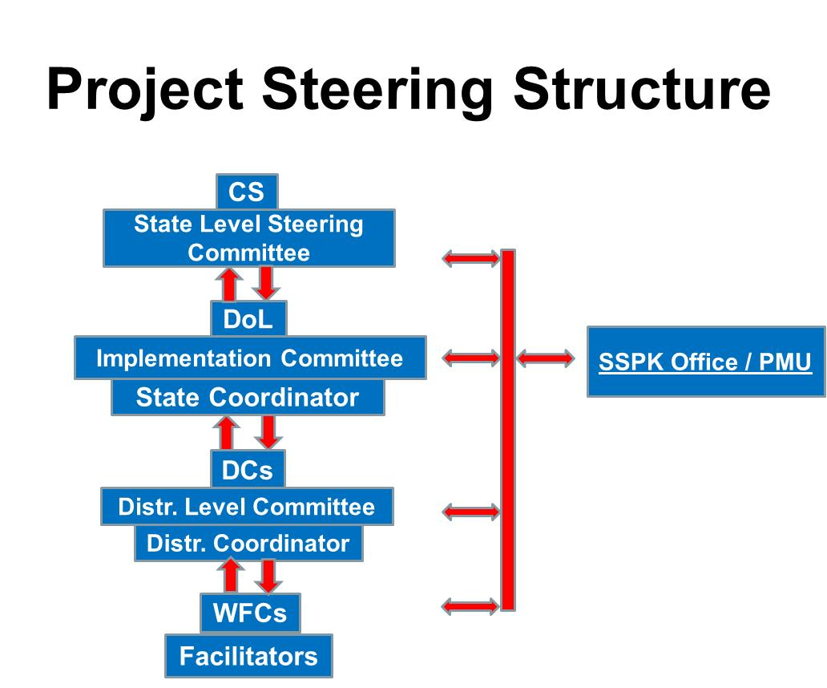

Facilitation and procedures followed to avail benefits:
WFCs act as a single application counter for the receipt of applications related to social protection schemes implemented by various government departments. The approach followed by WFCs is case-based. The community facilitators do not wait for the targeted beneficiaries to come to the WFC and apply for social benefits. Instead, they visit the households within the jurisdiction of that WFC. The purpose of the visit is to identify beneficiaries, create awareness, and enable households and workers to apply for social protection schemes. The process of facilitation can be divided into four stages, i.e. identifying, assisting, submitting and following-up.
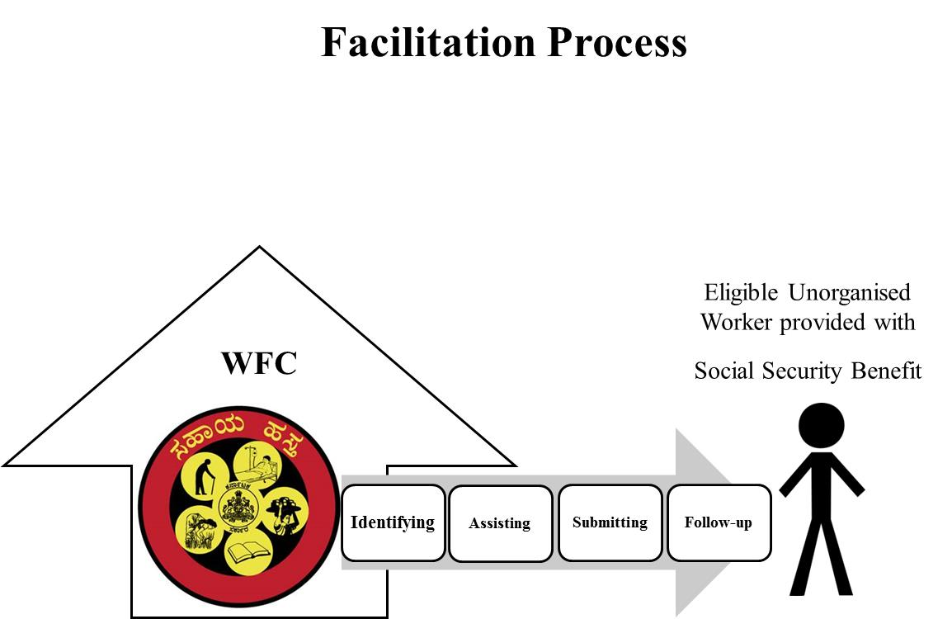

- Identification: The facilitator contacts self-help groups in a village to identify and find the informal economy households there and visits them. The main purpose of this visit is to explain about WFCs and collect basic information in a prescribed format. The format contains characteristics of the household and workers, current access to formal social security benefits, their interest in specific schemes, and eligibility status. The data is analysed to assess the existing access to social security benefits and compute the number of workers and households who are eligible to various social protection schemes.

The number of social protection schemes implemented by the Karnataka government is large. The project aims to find eligibility of prospective beneficiaries, and promote access to schemes that provide benefits in case of unemployment, illness, accidents, old age, and death. The project also promotes access to educational scholarships, admissions into residential schools and hostels. Access to contributory and non-contributory pensions for the elderly, widows and disabled is also promoted. The schemes formulated for specific informal economy worker groups, for instance, construction workers, are also covered by WFCs.

- Assistance: Once the informal economy workers or households have been identified and their eligibility ascertained, the community facilitator provides them with information. Such information includes objectives, benefits, eligibility criteria and application procedures for social protection schemes. If required, the CF helps the worker obtain the necessary documents including income certificate, caste certificate, and so on. The CF will also help the worker in filling up of application forms.

- Submission: Once the application has been completed, the CF will submit the required documents, application form, and applicable registration or membership fees to the concerned departments on behalf of the worker or eligible household member. The necessary approvals to submit the applications on behalf of workers and handle money have already been obtained from the concerned departments.

- Follow-up: The CF will check and determine the status of the application with the concerned department and report to the household. In performing this function, CFs are helped by coordinators at the district and taluk levels. If bottlenecks exist, they are reported to the PMU. Finally, the beneficiaries are informed about the status of the application, i.e. whether it has been sanctioned or rejected.

Management information systems:
WFCs aim to facilitate access to benefits under several social protection schemes and to a large number of workers. Thus, it is imperative to use a Management Information System (MIS) to have transparency and accountability. The design of the MIS for the project is given below. It can be used to generate reports, take routine and structured decisions. Specific functions of the MIS include uploading data, determining eligibility of prospective beneficiaries, targeting, registration, and interface with data from other departments.

Design

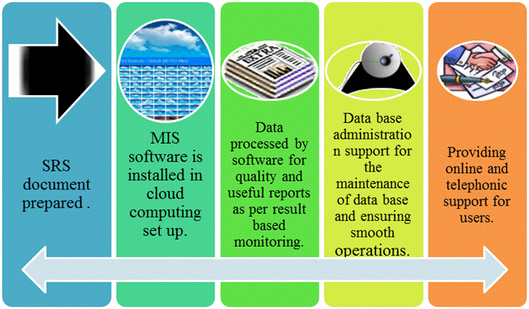

Integration of data sources of the various departments
Every government department running different schemes has its own MIS and data collection is done by scheme. It is expected that the streamlining of the databases will lead to wider coverage and better outreach. To strengthen the back-end of the single window concept, a process reengineering will be undertaken. Simplification and convergence of application formats and procedures without losing the data will also be undertaken.

Monitoring and Evaluation:
Periodic quality checks are undertaken by a third party in the field. The quality check consists of three components.

- In order to collect basic information from the informal economy households, the CFs will canvass questionnaires among informal economy households residing in the jurisdiction of WFC. In each round of the quality check, 5 to 8 per cent of the questionnaires canvassed during the reference period were physically checked. Feedback on mistakes in the questionnaires was provided to CFs in one-to-one meetings. The quality of work done by CFs in filling the questionnaires was rated on a five-point scale (very good, good, average, bad and very bad). The criteria adopted in arriving at the rating were explained to CFs in the one-to-one meeting. This method not only helped in assessing the quality of work but also improved the capacity of the CFs over time.

- Back-checks were undertaken in 1 per cent of questionnaires filled by each CF through household visits during the reference period. The main purpose was to verify whether or not the CF visited the household to provide information, and if there were any mistakes in the data collected. The information obtained during the back-check was rated on a three-point scale (no problems, problems and serious problems). The findings from the household visits along with the ratings were shared with the CFs in one-to-one meetings.

- The quality of facilitation was vital for the success of the project. Hence, an attempt was made to find out the number of visits made by CFs for facilitation, quality of work in providing information to households, help provided in filling questionnaires, whether or not the CF provided information on the status, whether money collected from the household was more than what was required, and other points. A rating on a four-point scale (very good, good, problems found and serious problems) was given and shared with the CFs in one-to-one meetings. If the quality of facilitation was good, the CF was appreciated for it. Otherwise, the factors for poor facilitation were shared with the CFs and they were sent for capacity strengthening.

Financial and legal sustainability:

The project on WFCs enjoys financial and legal sustainability. It follows the Unorganised Workers’ Social Security Act, 2008. The Act talks about setting up of Worker Facilitation Centres to identify and improve delivery of social protection benefits to the unorganised workforce in the state of Karnataka. In addition to the Karnataka government, the project is also supported by GIZ on behalf of the German Ministry of Economic Cooperation and Development.

Capacity building and awareness generation:
The project on WFCs has focussed extensively on facilitating communication and generating awareness among stakeholders. In this regard, capacity building becomes important. Capacity building is a process of strengthening the capabilities of the individuals and institutions involved at various levels in delivering social protection benefits. Following this perspective, focus has been put on department officers at various levels involved in implementation and CFs. Two types of training are provided, namely on conceptual understanding of social protection and informal economy workers, and building soft skills among CFs.

The methodology for the training involves learning from experience and is based on adult learning principles of engaging the head, heart and hand. Learning is based on action learning, high participation of the learners, field work, mobilisation of all mental resources through group exercises. The participants are given opportunities to practice their skills during the training and internalise concepts. The project has focussed on developing curriculum, material development, training of trainers, establishing a pool of certified training and preparing training manuals.

In all, five training programmes were provided:
- A 4-day induction covering introduction to the project, theory on social protection and informal economy workers, interaction with community and surveys, roles and responsibilities, government-run schemes;
- A 3-day programme on imparting facilitation skills including communication and active listening;
- A 4-day work effectiveness training covering self-assessment, conflict management and emotional intelligence
- Orientation to the informal economy by the Karnataka government; and
- Providing knowledge on key social protection schemes.

For creating awareness among informal economy workers and households, the following tools were developed and applied. Firstly, a 20-minute film on the social protection needs of informal economy workers has been made. This film was used by community facilitators for advocacy among trade unions and self-help groups, and to explain the services provided by WFCs. In addition, colourful visual information, education and communication material on social protection schemes and WFCs has been produced for CFs and government officers. The materials are easy to read and can be used as handbooks and posters.

An emphasis on the lessons learned:

The project on WFCs sought to bring coordination among the different social protection programmes and policies at the micro and macro levels, in order to help the final beneficiaries.

Single window approach
The major functions of WFCs are to:
- obtain the status of access to social protection by unorganized worker households;
- ascertain the number of eligible households and members;
- provide information and create awareness on schemes; and
- encourage the households to apply for and access social protection schemes.

WFCs seek to coordinate the social protection needs and entitlements of the households and its members at the household level. Further, the needs of the household in terms of accidental, health and life insurance, and pensions are matched with social protection schemes provided by different government departments. To do this effectively and dynamically, an MIS is used. Different measures undertaken include, for instance, tracking the age of elderly persons for old age pensions. Eligible households are then informed and encouraged to apply for the scheme.

Against the backdrop of asymmetric information available to prospective beneficiaries, complexity of the social protection delivery system, illiteracy and poverty among informal economy workers who are pre-occupied with livelihood issues, WFCs have helped to identify eligible households and facilitate access to social protection benefits. WFCs act as a single window service following an individual-based approach. The community facilitators do not simply sit in the WFC and wait for people to come there to seek information and submit filled applications. CFs play a pro-active role by undertaking household visits (on average, two visits per household) for providing information, helping the households obtain relevant documents, filling applications and finding the application status regularly. The Karnataka government has decided to adopt this model and upscale to every district in the state.

WFCs have significantly improved the coverage of schemes that are most relevant to informal economy workers. These schemes pertain to health insurance, accident and death benefits and pensions. They focus on important schemes, rather than all schemes which are promoted by the government. Performance-linked pay for facilitators and officials has played an important role in increasing outreach. At the same time, incentives can influence the behaviour of the CFs towards undertaking actions that are not in line with the objectives and values of the project. Hence, quality checks and regular monitoring help detect such behaviour so that corrective action can be taken. Convergence of social protection delivery and processes is improved through the single window service of WFCs. This is better done through cooperation between the implementing government departments and WFCs.

Inter-departmental task forces improve outreach and coordination
Stakeholders at the local implementation levels can play an important role in the delivery of social benefits. At the village council level, there are elected members and officials to village councils, health workers, and functionaries who are in charge of promoting the public works programme, Mahatma Gandhi National Rural Employment Guarantee Scheme. These officials, entrusted with increasing awareness and improving access to social protection schemes, have good rapport with informal economy households due to their proximity to the people. They have formal or informal coordination mechanisms at the micro level. This comparative advantage of the filed officers is used by WFCs, thereby improving coordination and targeting of social protection schemes.

In order to improve the coverage of informal economy households under formal social security schemes, the project constitutes task forces to conduct facilitation drives. An example of a task force which promoted registration of construction workers is described. A construction worker in Karnataka has to fulfil several requirements to register under the Construction Workers Welfare Board. These include obtaining a certificate from the employer that the person is a construction worker; an age certificate or a doctor’s certification that the person is between 18 and 60 years old; certain number of photographs, and so on. Construction workers found it difficult to fulfil these requirements and were reluctant to spend time in procuring the documents, as the opportunity costs of foregone income were high. As a result, the registration of workers was a slow and tortuous process.

The project then set up task forces at the local level of village councils and urban wards. The task forces constituted a government-certified doctor who could provide an age certificate to the applicant, an employer inspector who could provide a certificate of employment as a construction worker, and a labour inspector to obtain signatures and other official clearances. Before the date of the facilitation drive, the WFC database was used to identify eligible construction workers within the jurisdiction of the WFC, motivate them to fill applications, and mobilise them to the site of the facilitation drives. In order to reduce the opportunity costs to workers, the facilitation drives were organised on holidays, Sundays and wage days. At the facilitation drives, workers were also encouraged to join contributory schemes like National Pension Scheme. The idea and mechanism of the facilitation drives are shared with the government. Targets are to be fixed for the officials, who will be encouraged to organise worker registrations during such drives. The facilitation drives are also to be organized at construction sites. In the next phase of the project, it is planned to undertake regular facilitation drives for different schemes such as accident, disability and death insurance, national pension schemes, construction worker benefit packages, and so on.

The project has also set up inter-departmental committees at the district and state levels. At the state level, Steering Committee and Implementation Committee have been set up for policy discussion and making, and pave the way for coordination in the delivery of social protection schemes at the micro level. At the district level, a coordination committee was set up under the chair of the senior government official to achieve coordination in the delivery of social services. Each of these committees consists of officials from the departments that are entrusted with the delivery of key social protection schemes for health insurance, social assistance, accidental and death insurance, old age pensions. This coordination mechanism has played a key role in scaling up of the project to the entire state. In the extended phase, the Karnataka government will declare that village councils in rural areas and municipalities in urban parts will act as single windows to receive the applications for selected social benefits. The list of the households that have applied for, and received benefits will be displayed at the offices of the Gram Panchayat or Ward regularly to bring transparency.

Bottom-up feedback
The inter-departmental coordination committees have also been used for providing bottom-up feedback on loopholes in the application procedures, and bottlenecks in the delivery mechanisms. Two such examples are described.

During registration of construction workers, the process of obtaining an age proof not only caused difficulties to workers but also slowed the registration process. Many workers did not have a birth certificate or acceptable age proof, and were illiterate or semi-literate. Upon receiving this feedback, other government documents where the person’s age is mentioned were also accepted. This resulted in reducing the problems faced by eligible construction workers.

For the National Pension Scheme, the government has appointed official facilitators at the district level to conduct registrations. This resulted in lower registration numbers, as the few official facilitators could not visit the large number of villages in a district, which may also be far apart. Additionally, informal economy workers found it difficult to reach the district for registration as they would lose one or more days of work. Once this problem was identified, the identification and registration processes were decentralised, and monthly contributions were collection instead of annual contributions.

Linkages with the guiding principles of R202

Impact and Progress
According to the 2001 census, there were 361,525 informal economy households within the jurisdiction of 250 worker facilitation centres (see Table 1). Basic information was collected through a structured questionnaire from 77 per cent of the eligible households. Of 277,948 households for which the basic information was collected, data was uploaded into the MIS for 94 per cent of the households. There are variations in the coverage of informal economy workers for the different districts of Karnataka, due to difficulties in appointing community facilitators.

Table 1
July 2013 | Households to be surveyed | Surveys conducted | Data uploaded
District | Households to be surveyed | Surveys conducted | Data uploaded
Bellary | 67,715 | 51,415 | 50,930
Mysore | 88,696 | 70,420 | 65,586
Bangalore (urban and rural) | 81,548 | 53,342 | 41,732
Gulbarga | 59,989 | 56,115 | 55,726
Dakshina Kannada | 63,577 | 46,665 | 46,374
Total | 361,525 | 277,948 (77%) | 260,348 (94%)

Of 277,948 households for which basic information was collected, the project found that 260,479 persons were eligible for one social protection scheme or the other (see Table 2). On an average, one person from each household was found to be eligible. The low number of eligible individuals is due to several reasons. Firstly, several households have already been accessing social protection schemes. Secondly, all households are not eligible to the schemes promoted. Thirdly, some schemes like hostels and scholarships are not very attractive due to poor quality of government-run hostels, small scholarship amounts.

Applications for availing benefits were submitted for 47 per cent of the eligible beneficiaries. Also, 72 per cent of applications submitted were sanctioned. This is a creditable achievement. There is a considerable gap between the eligible beneficiaries and the number of applications submitted due to the following reasons:
- Complex and time-consuming procedures (filling application forms for each scheme, attaching documents, obtaining age proofs);
- Reluctance of informal economy households to register for contributory schemes, largely because of non-specification of the future benefit stream by the scheme; and
- Large number of documents required and difficulty in acquiring them.

Table 2
July 2013 | Total Eligible Beneficiaries | Applications Submitted | Applications Sanctioned
District | Total Eligible Beneficiaries | Applications Submitted | Applications Sanctioned
Bellary | 53,842 | 26,632 | 23,112
Mysore | 63,701 | 29,807 | 25,359
Bangalore (urban and rural) | 51,660 | 18,368 | 12,154
Gulbarga | 57,851 | 25,022 | 14,446
Dakshina Kannada | 33,425 | 22,236 | 13,209
Total | 260,479 | 122,065 (47%) | 88,280 (72%)

Impact study
An impact evaluation has been undertaken by researchers from the Institute for Social and Economic Change, Bangalore and University of Oxford by adopting Randomised Controlled Trial design. The main objective of the study was to find the extent to which WFCs improve access to social protection benefits among informal economy workers. Baseline data was collected from informal economy households located in 150 village councils. Of this number, 100 village councils were “treatment WFCs” and 50 village councils were “control villages” with no WFCs.

A survey was undertaken in a sub-sample of 30 treatment WFCs and 30 control villages in June 2012. The findings show that the popularity of WFCs was growing, and people appreciated the functioning of the Community Facilitator. Older centres performed better, thereby suggesting that the performance of WFCs improved over a period of time. Households of the treatment WFCs had better awareness and improved access to key social protection schemes. For instance, the coverage of the National Health Insurance Scheme (RSBY) was 75 per cent higher in households with WFC presence. However, with regard to all schemes, there was no significant difference, because many households were not eligible to all the schemes, and there were difficulties in accessing social assistance schemes.

Resources and bibliography:
- NCEUS (2006). Social Security for Unorganised Workers. Report. National Commission for Enterprises in the Unorganised Sector; New Delhi.
- NCEUS (2007). Report on Conditions of Work and Promotion of Livelihoods in the Unorganised Sector. New Delhi: Academic Foundation.
- Rajasekhar, D, Suchitra J Y, S Madheswaran and G K Karanth (2006). Design and Management of Social Security Benefits for Unorganised Workers in Karnataka, GTZ, New Delhi, 2006.
- Rajasekhar, D (2012) Social Security for Unorganised Workers in India, in N Jayaram and D Rajasekhar (eds). Vulnerability and Globalisation: Perspectives and Analyses, Rawat Publishers, Jaipur, 2012.
- Sen, Gita and D Rajasekhar (2012). Social Protection Policies, Experiences and Challenges. In R Nagaraj (ed.) Growth, Inequality and Social Development in India: Is Inclusive Growth Possible?, New York: Palgrave Macmillan.

The authors gratefully acknowledge the support of Project Management Unit, Bangalore, and field teams in the five locations.
Programme Director, Social Security Programme, Karnataka, (SSP (K), GIZ
Senior Technical Expert, Social Security Programme, Karnataka, GIZ
Professor, Institute for Social and Economic Change, Bangalore

