

International Labour Organisation

EIIP – Capacity Building for Contracting

Institutional Assessment and Contractor Tracing

Cambodia Contractor’s Tracing Study

by

by

Mukesh C.Gupta

Chief Technical Adviser
ILO/ADB/JFPR – CMB/05/06M/ADB

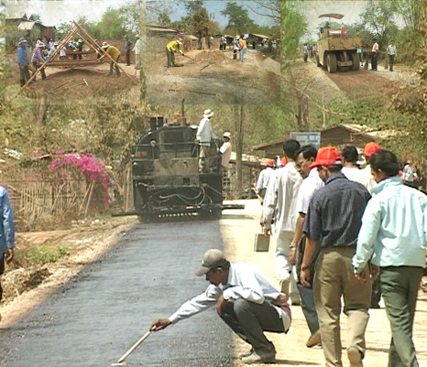

July 2008

Contents

P.No. Title Page No.

1.0 General Introduction 3-5

2.0 Overall Transport Sector Description 6

2.1 Transport Sector Policies and Strategies 6
2.2 Transport Sector in Cambodia 6
2.3 Labour-Based Appropriate Technology in Road Works 7
2.4 Involvement of Private Sector in Development 7
2.5 Road Infrastructure 7-9

3.0 Local Small Scale Road Contractors Development 10

3.1 General Features of Road Construction Industry 10
3.2 Implementation Capacity of Government Institutions 10-11
3.3 Training for Development of Local LBAT Contractors 12

4.0 Findings – Contractors Tracing Study 13

4.1 Implementing Agencies – Institutional Development 13
4.2 Progress Local Contractors 14
4.2.1 Contractor’s Capacity & Assets 14
4.2.2 Annual Turnover 15
4.2.3 Types of Works 15-16
4.2.4 Market Share 17
4.2.5 Current Work Methods 17
4.2.6 Profitability – Work Methods 17
4.2.7 Availability of Work 17

5.0 Constraints 18-19

6.0 Sustainability Assessment 20

7.0 Conclusions and Lessons Learned 21

Annexes

Map of Cambodia

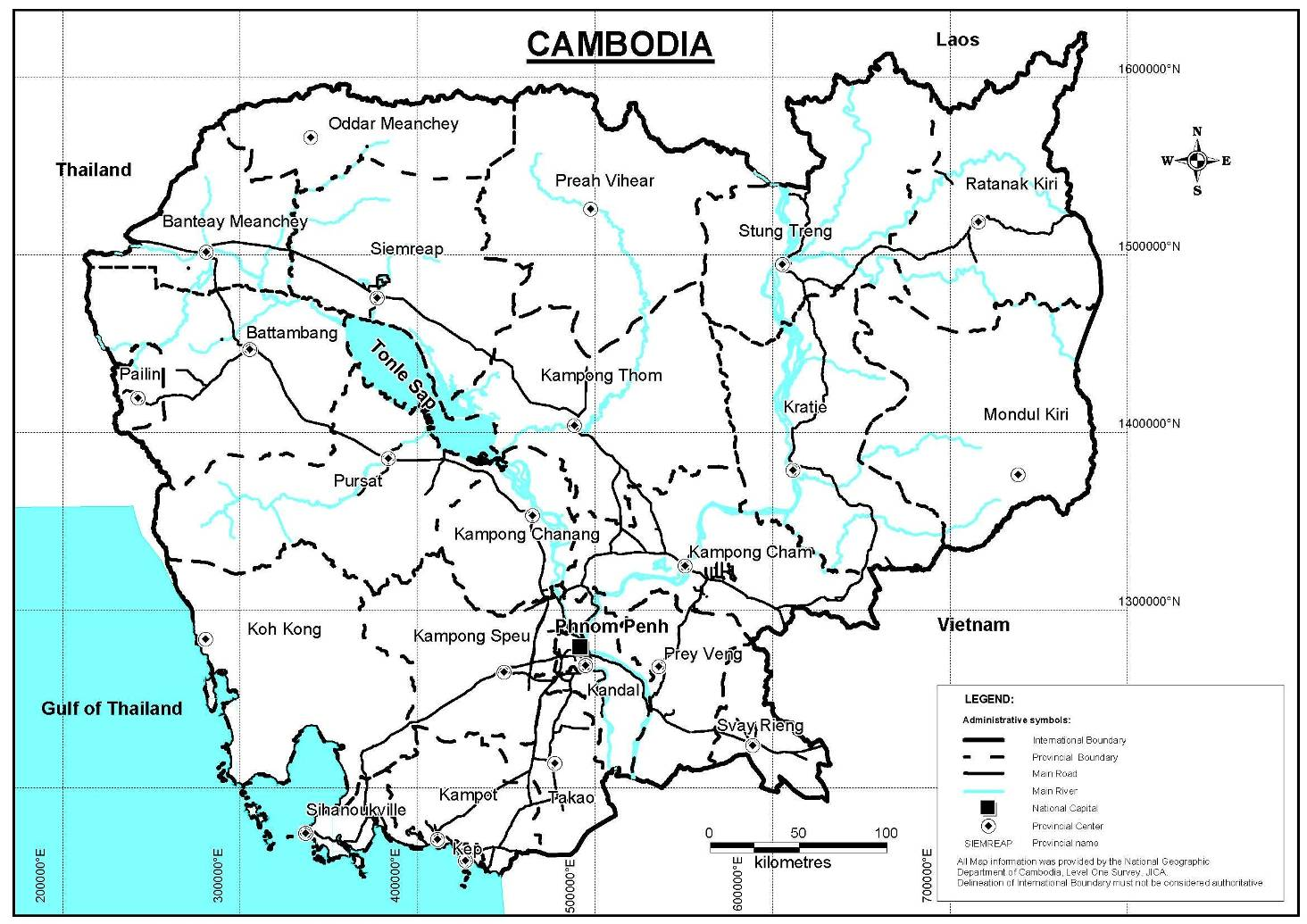Draft – Contractor’s Tracing Study Report
Cambodia

1. General - Introduction

Cambodia is one of the poorest countries in Asia. The country ranked 129th out of 177 nations on the Human Development Index in the 2006 Human Development Report. Life expectancy at birth is 56.5 years. 85% of the 13.091 million population lives in rural areas. Poverty reduction in the country will largely depend on the reduction of rural poverty and inequality. Lack of access is one of the root causes of poverty. There is overwhelming evidence that the provision of rural roads is a critical factor in reducing poverty. Access is an important factor in rural development. People need to have adequate access to water, land, energy, health services, education, transport services and markets. Lack of access limits the opportunities that people have to improve their social and economic well being. Therefore improving access and reducing poverty are linked.

The Cambodian economy is improving with an estimated economic growth of 9% for 2007. Overall poverty incidence is 36% and inequality has also been assessed as very high, particularly along urban-rural lines. Most economic growth of the past decade has been confined to urban enclaves, while rural growth, especially in staple food production, has barely kept pace with the increase in population. The daily wage for rural labourers does not cover a family’s basic nutritional requirements, leaving nothing for health, clothing and education. The informal economy (IE) plays a very important role in the Cambodian economy, accounting for an estimated 62 % of GDP, and providing employment to approximately 85% of the Cambodian workforce. Both men and women in the informal economy earn very low incomes.

To promote economic growth and create jobs in rural areas, the Government aims to restore road access throughout the country. The last decennium has seen substantial progress, with rehabilitation of the national highway network nearing completion and rehabilitation of provincial and rural roads progressing. The growing number of rehabilitated roads makes maintenance urgent, especially of rural secondary and tertiary roads, which are typically rehabilitated to gravel or laterite standard and deteriorate fast, within 3–5 years, if not maintained. Insufficient road maintenance may ultimately render unattainable the goal of providing countrywide access.

In Cambodia, labour-based local resource-based approaches for rehabilitation and maintenance of rural infrastructure have been successfully exercised through force account works followed by the involvement of private sector small scale contractors. In early 1990, the labour-based methods were introduced through various ILO managed projects. It was relatively easy to establish common standards, work methods and procedures through central government controlled projects. The socio-economic benefits of large scale employment generation were obvious and the financial comparison with equipment-based methods seemed to be favourable.

Subsequently, ILO shifted its strategy to improve service delivery through the development and involvement of private sector. The shift to more decentralised projects and private sector execution, however, has been a major challenge. There was no local capacity to manage infrastructure projects effectively. Local consultants and contractors who could take over from the force account units were not available. Adequate management, contracting and working procedures for locally managed projects and executed by small-scale and/or emerging consultants and contractors had to be developed and tested first. Over the past fifteen years, a number of ILO and other donor funded projects had been involved in the development of a cadre of labour-based small scale contractors and institutional strengthening of MRD /MPWT in effective planning designing, monitoring and execution of labour-based road works.

During 1992-2008, the ILO, together with a number of development partners, had been engaged in the development of appropriate approaches and systems as well as in the implementation of numerous contracting development projects. Most of these project assisted in the development of local capacities to manage decentralised projects through improved planning, design, contract documentation, supervision and management. They would generally facilitate an improvement to the enabling environment including market access for local industry, local governance and transparency, and hence ensure quality results and sustainable jobs. The other main activity in the above projects was to create a cadre of capable domestic contractors for effective service delivery and it is understood that in most projects the contractor development process was regarded as highly successful.

In this context, ILO has launched a “Contractor Tracing Study” in order to assess the appropriateness of its small scale contractor’s training approaches used in different countries. This Study would analyse the strategy about the capacity building projects for contracting in construction, looking at small-scale labour-based contractors with regard to their further development and success beyond the project frame and in the open market. Whether or not the enabling environment had been developed such that these contractor firms survived beyond the project frame and whether they were able to sustain themselves in the open market and whether they still apply a local resource-based work approach is still a question to be answered.

The Study would enable the development partners together with the ILO to assess the long-term sustainability of the approach with regards to local contracting capacity development. The Study focuses on the following aspects:

- Efficacy of the enabling environment that local institutions have developed to promote participation of private sector and the capacity of local institutions to effectively plan, design and monitor rural infrastructure works;

- Small-scale labour-based contractors and consultants with regard to their further development and success beyond the project frame and in the open market;

- Employability of trained staff.

The aim of the study is to highlight on the issues of the development of the individual enterprises and employability of trained staff and clarify what have been the main reasons for successes and failures. A further aim of the study is to provide inputs to the overall socio-economic impact of the approach, particularly with regards to poverty related issues.

2. Overall Transport Sector Description in Cambodia

2.1 Transport Sector Policies and Strategies
A recent draft national transport policy by the Ministry of Public Works and Transport (MPWT) contains a series of statements, and is a follow-up step to the 2002 transport sector strategy. The main emphases of the transport sector policy are to link transport sector investments with poverty alleviation, to make provision for adequate maintenance funds for sustainable sector development, and to encourage private sector involvement.

A draft rural road policy of the Ministry of Rural Development (MRD) updated in 2002 led to the formulation of “Strategic Plan for Rural Roads” in August 2007. This Plan elaborates how the policy directions will be implemented, and is fully aligned with the draft policy. The purpose of the rural roads strategic plan is to set out the long-term direction and framework for rural road development and management in Cambodia, so that there is a consistent and unified approach to the planning, improvement and maintenance of rural roads. The contents of this document are designed to provide a secure basis on which MRD can strengthen its capability to plan, design, maintain and manage rural roads in a sustainable way; and the RGC and donors can determine appropriate and complementary funding and other support for the sub-sector. The main targets in this strategic plan are to bring all the rural roads up to maintainable standards within 20 years in a phased manner. The Strategic Plan has identified four categories of issues as critical to the achievement of this objective: programming and planning issues; financing issues; sustainability issues and the institutional.

2.2 Transport Sector in Cambodia

The transport sector in Cambodia comprises roads, railways, inland water and air transport. The shares of passenger and cargo transported by road far outweigh the shares by other modes. Roads in Cambodia are divided into four broad categories: national, provincial, tertiary and sub-tertiary roads, and there are three categories of sub-tertiary roads. While the MPWT is responsible for the National and the Provincial roads, the MRD is responsible for the Tertiary and Sub-tertiary roads.

The inland waterway system plays an important role in the movement of freight and passengers in Cambodia. However, its importance can be considered second to road transport. The total navigable waterway length is 1,750 km. Only a third of this length (580 km) is navigable year round (World Bank, 2004). The system consists of the Mekong River and its tributaries, the Tonle Sap Lake and its tributaries, the Tonle Sap River, and the Bassac River. The Mekong River, Tonle Sap and Bassac rivers account for approximately a half of the navigable inland waterway length.

Railways play a minor role in the transport sector. Royal Railways of Cambodia (RRC) is a state owned enterprise under MPWT. Air transport in Cambodia caters mainly to passenger traffic and the cargo movement by air has increased considerably in the recent years. MPWT carries the overall responsibility for the management and development of rail, air and inland water transport in Cambodia.

2.3 Labour-Based Appropriate Technology in Road Works
In Cambodia, there is clear evidence of the advantages of the use of labour-based methods over equipment-based methods in road works. A Cambodian study commissioned by the ILO ASIST-AP in 2002 mentioned several advantages of the use of labour-based methods over equipment-based methods in rural road construction (Stiedl, 2002). The main advantage is the high employment generation potential of labour-based techniques: labour-based methods have the potential to generate 18 times more employment than equipment-based methods. The study quoted that the use of labour-based methods in upgrading, combined with maintenance, of the existing maintainable network, could generate between 3.6 to 6.5 million person days of work per year. Labour-based methods were also considered to be cost-effective. The estimated break-even wage rate to bring the cost of the labour-based approach into parity with its equipment-based counterpart was US$ 2.1 per day. The MRD Policy strongly advocates use of the labour-based appropriate technology (LBAT) in the construction and maintenance of rural roads. The positive factors on the side of LBAT are that Cambodia already has considerable experience in the use of LBAT.

2.4 Involvement of Private Sector in Development and Maintenance
The role of the private sector has been highlighted in the National Strategic Development Plan (NSDP) 2006-2010. The “Rectangular Strategy” of the government also highlights the need for the promotion of the private sector which is considered as the “engine of growth”. The private sector is responsible for the provision of an overwhelming majority of jobs in Cambodia. Small and Medium Enterprises (SMEs) make up 99% of the enterprises and half of the employment in the private sector. The private sector in the construction industry consists of individual entrepreneurs (often informal), SMEs, and international companies that are active in Cambodia. The draft policy for rural roads strongly encourages the use of local private sector contractors in construction, rehabilitation and maintenance of road works.

2.5 Road Infrastructure
Road transport plays a major role in the transportation of passengers and cargo in the country. The road network is approximately 38,500 kilometre (km), of which approximately 10,500 km are national roads and provincial roads under the responsibility of MPWT, and approximately 28,000 km are tertiary roads under the responsibility of MRD. Table below depicts the road classification and division of responsibilities. Since mid-1990 there has been a major effort to improve the network. However, the road network is still in poor shape. A road condition survey in 2002 shows that only a fourth of the national and provincial road network is in good to fair condition. The tertiary and sub-tertiary road network (24,000 km) has only 16 percent in fair condition. In order to overcome its road network problems, the Government established a Road Fund in 2000. Since January 2002 it has been financed from surcharges on fuel. However, other challenges remain:
- As per government reforms and Decentralisation & Deconcentration Policy (D& D Policy) infrastructure provision and funding is being devolved to the provinces, but most lack the management capabilities required to effectively monitor the road network and prepare and execute plans for road maintenance.
- Small-scale local road contractors that can effectively execute basic road maintenance are emerging slowly due to lack of demand. Thus, international contractors, the remaining force account units under Ministry of Public Works and Transport (MPWT) perform whatever road maintenance is taking place. All of these employ equipment-intensive techniques that are ill-suited for maintenance of local roads and generate few job opportunities.
- Although MPWT and MRD are the main actors in the management of roads in Cambodia, there is a lack of coordination between them in terms of operation and capacity building. Typically, most provinces have few maintainable roads, about 300 km, and moreover their prioritization and administration at provincial level is fragmented between the provincial offices of the two ministries . The small volume of roads and funding constraints hinders professionalism in road maintenance management.

Type | Definition | Responsibility
National Roads | - Roads that connect the capital to the main international border crossings and/or provincial capitals. | MPWT
Provincial Roads | Roads that connect:  - District centres to provincial centres or to primary roads  - A provincial centre to another adjacent provincial centre  - Industrial, commercial, tourist and other centres that have large transport needs | MPWT
Tertiary Roads (T roads) | - District to district roads | MRD
Sub-tertiary Roads:  Sub-tertiary Road Type 1 (ST1 Roads)  Sub-tertiary Road Type 2 (ST2 Roads)  Sub-tertiary Road Type 3 (ST3 Roads) | - District to commune  - Commune to commune  - Commune to village or village to village | MRD

National and Provincial Road Network

Type | Length  (km) | Good and fair  (km) | Poor  (km) | Bad  (km)
National Roads | 4,757 | 1,186 | 2,439 | 1,132
Provincial Roads | 5,700 | 1,291 | 2,426 | 1,983
Total | 10,457 | 2,477 | 4,865 | 3,115
Percentage |  | 24% | 47% | 30%
Source: World Bank (2004)

To promote economic growth and create sustainable jobs in rural areas, the Government launched various initiatives as listed below to restore road access using employment intensive technology throughout the country. The Government’s Rural Roads Strategic Plan has set out long-term directions and a framework for the development and management of rural roads so that there is consistent and unified approach to planning, rehabilitation and maintenance of rural roads. The strategic objective of this Plan is “ Improve social and economic conditions of rural Cambodia, with an emphasis on improving the livelihood of rural poor and creating livelihood opportunities for women in rural areas, through sustainable improvement and maintenance of rural roads” The Strategic Plan aims to bring the entire rural roads network to maintainable condition within 20 years in a phased manner.

3. Local Small Scale Road Contractors Development in Cambodia

Initiatives to involve the local construction industry commenced on a trial basis in the ILO rural road reconstruction programme in the mid 1990s, at which time the first capacity assessments of the industry were carried out. The capacity of the local construction industry in Cambodia has gradually developed over the past decade. In the past, there have been limited opportunities for local companies given the dominance of foreign contractors and consultants, and the use of force account methods for many road works. However, there is now a growing capability due to an increased volume of joint-venture and sub-contracted works under different donor-funded projects. Various training initiatives through donor-funded projects have resulted in the availability of an increasing number of LBAT contractors in the country.

The MRD and its Provincial Departments (PDRD) use the following three different models for the implementation of the tertiary road related road works:
- Implementation by private contractors through local competitive bidding;

- Implementation though the use of force account methods;

- A combination of force account and private sector: under this method while the private sector supplies (some or all) the equipment and materials, the actual work is carried out by the public sector using government equipment and force account labourers.

In 1998, with the launching of the ILO Upstream Project and ADB financed Rural Infrastructure Improvement Programme(RIIP), the private sector was given the lead role in both improvement works as well as road maintenance. Different categories of contractors were used for works with varying complexity and size. Local building contractors were utilised for the construction of culverts and small cross-drainage structures. Large construction companies were engaged for the supply of gravel and medium-sized contractors with some civil works experience were trained in labour-based road works and thereafter engaged in the construction and maintenance of rural roads. At the same time, petty contractors were mobilised in the communities along the roads to carry out routine road maintenance. The RIIP also carried out a substantial amount of building works for schools, government offices and markets, which was also carried out through the engagement of local contractors. Subsequently, the private sector development and training inputs were further carried on until 2008 by the ADB’s North Western Rural Development Project and ADB/JFPR project.

3.1 General Features of the Local Road Construction Industry
ILO has been the lead agency in the introduction of LBAT in the development and maintenance of rural infrastructure in Cambodia. During 1990’s, LBAT was introduced through force account methods in Siem Reap wherein thousands of unskilled workers were employed and engaged in various road works and Angkor Watt clearing activities. Thereafter, ILO shifted its implementation strategy through private sector local small scale contractors. The emphasis on small scale contractors development was based on the idea that they had limited amount of equipment and capital and would therefore adapt easily to the use of appropriate technology. Cost effectiveness, profitability and long term sustainability were the prime consideration for the local contractors to remain in the business.

Road Contractors in Cambodia could be classified under two categories. First category is the unregistered petty contractors who had no past experience of labour-based road maintenance and basically act as supervisor to organise and manage labour for routine road maintenance contracts. They could also be termed as Community Contractors chosen in consultation with the Commune Chiefs and are responsible for 10-15 km of routine road maintenance activities.

Second category is the small/medium scale contractors who were formerly registered as tradesman or building contractors, possessed some basic equipment and entrepreneurial skills. Although their past experience has been building works, they were established business entity with administrative and technical staff that could be further trained for effective execution of labour-based road works.

3.2 Implementation Capacity of Government Institutions

Initially, the institutional capacity of MRD and its provincial departments was weak. The implementation capacity of the MRD and its provincial institutions gradually improved over the last decade through various training programmes in labour-based contracts management. Developing local contractors requires an efficient contracts management organisation which can effectively supervise and take care of all financial and administrative responsibilities in a transparent manner. During 1998-2008 various training programmes were organised by ILO, RIIP, NRDP, ADB/JFPR projects to strengthen the capacity of MRD local staff to efficiently manage and implement labour-based rural infrastructure works carried out by the private sector. This training also installed systems and procedures for contracts management, financial management, procurement of goods and services in a transparent manner. However, the MPWT lagged behind in acquiring LBAT contract management skills as its areas of operations were mainly confined to heavy equipment based technology by foreign contractors. In 2006, the ADB/JFPR Mainstreaming Project took lead in reducing this LBAT gap between the MRD and MPWT with the establishment of Joint Road Maintenance Unit in Battambang comprising of staff from the two Ministries.

3.3 Training for the Development of Local LBAT Contractors & Supervisory Staff

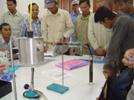
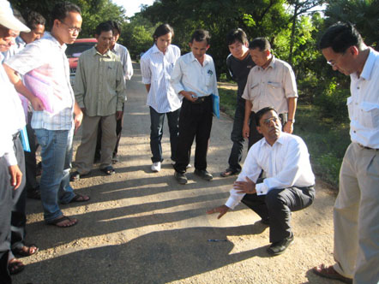
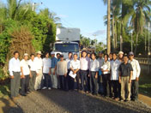

Since 1998, the following ILO supported and ADB funded projects took a lead in the development and training of small scale LBAT contractors and capacity building of the MRD/MPWT staff:

- ILO Upstream Project 1998-2001
- ADB - Rural Infrastructure Improvement Project (RIIP) 1996-2001
- ADB – North Western Rural Development Project (NRDP) 2002-2008
- ADB/JFPR – Mainstreaming Labour Based Road Maintenance (ILO TA) 2006-08

The key features of various training programmes for the development of small scale contractors in Cambodia were:

- the need for training and development was not only limited to contractors but equally important for Client’s supervisory staff;
- training focused on LBAT, contracts management, routine and periodic maintenance, resource planning and business management;
- training comprised of theoretical class room training followed by the In-Situ practical training at actual road construction and maintenance sites;
- training providers provided full technical backstopping to the contractors during their trial contracts in resource planning and all other aspects of project implementation;
- Client staff (MRD & PDRD staff) also learnt new guidelines and procedures regarding daily, weekly reporting, preparation and certification of payment certificates and monitoring of quality control as per contract conditions and the specifications;

Typical Profile of Small Scale Contractors Training Course for the rehabilitation of paved and unpaved roads by the ILO/ADB/JFPR Project is shown in Annex- .

4. Findings - Contractors Tracing Study

The Study findings presented below have been grouped under three categories:

- Implementing Agencies – Institutional Developments

- Progress – Local Contractors

- Constraints

4.1 Implementing Agencies – Institutional Developments

Over the past 10 years, there has been considerable institutional capacity building in MRD, MPWT and their provincial departments. The Ministry of Economy & Finance(MEF) in collaboration with the ADB and the World Bank have introduced Standard Operating Procedures (SOP) for administrative, financial and procurement in respect of all externally funded projects in Cambodia. The SOPs have been officially endorsed by the Government in 2006 by issuing Gazette Notification for their adoption by all the official agencies. The MEF has also organized various training courses for clear understanding of all the staff of the implementing agencies. A large number of MRD staff has been trained through their deployment in Project Implementation Units (PIUs) of various projects where they had complete exposure and on the job training not only in the technical issues but also procurement of goods and services, engineering designs, preparation of bid documents, pre-qualification of contractors, invitation of bids, evaluation of bids, supervision and monitoring of works executed by the contractors, preparation and scrutiny of payment certificates, financial management in accordance with the SOPs and guidelines of the ADB and the World Bank. All the donor funded projects are subjected to external and internal audit as per the established guidelines in the SOPs. Some teething problems in clear understanding of Procurement Manual, Financial Management Manual of the SOP faced by the implementing agencies are being noted and resolved through period reviews and workshops organized by the MEF. Both MRD and MPWT feel that the procurement of goods and services including bidding of contracts has improved considerably due to standardized procedures (SOPs).

With the launching of Rural Roads Policy (2002) and Rural Road Strategy Plan in 2007, the MRD has set out clear objectives and the road map for the development and maintenance of rural roads. The Rural Roads Standards, Specifications for Road Works and the Bidding Documents for Local Competitive Bidding have been standardized and officially endorsed by the MRD for adoption by all the nation wide projects. Most of these Bid Documents, Design Standards and norms for execution are the by-product of RIIP project (1996-2001).

The MPWT and its provincial departments have developed their capacity to a lesser extent for the application of LBAT in their operational activities.

4.2 Progress Local Contractors

About 78 small scale contractors were trained during the last decade through various donor funded projects ( List Attached Annex- ). For the purpose of this Study 18 Contractors were chosen ( List Attached Annex - ) through random sampling and interviewed to find out about their capacity, annual turnover, types of work and their experience with the labour-based technology. For the purpose of analysis of data obtained and in order to keep the identity of contractors as confidential, they have been allocated Code Number A-1 to A-18. A detailed Questionnaire (Annex- ) was developed to record the above details during the interview.

4.2.1 Contrctors - Capacity & Assets

Table below indicate the starting asset value and June 2008 asset value of the 18 contractors. It would be seen that their assets tripled over the past 7-8 years at an annual average increase of 29.83%. Percentage growth varies from 50% to 500%.

4.2.2 Annual Turnover

The average annual turnover for the 18 contractors is tabulated below. The average starting annual turnover was US$ 86,778 and it increased by 593% in 2006 and 861% in 2007. This clearly reflects that on an average all the companies were gainfully engaged during the past 6-7 years. A similar growth trend has been observed in the assets of these contractors.

4.2.3 Types of Work

The findings of the types of work and market share are summarized below

No. | Road | 2001 | 2006 | 2007 | June-2008 | Remarks
1 | Road Works | 21% | 44% | 31% | 26%
2 | Road Structures | 8% | 8% | 13% | 4%
3 | Buildings | 49% | 35% | 39% | 42%
4 | Irrigation | 8% | 3% | 5% | 19%
5 | Markets | 6% | 0% | 0% | 0%
6 | Equipment Rental | 7% | 0% | 0% | 0%
7 | Materials Supply | 0% | 5% | 6% | 6%
8 | Earth Works Rasing for building | 0% | 5% | 0% | 2%
9 | Water Supply | 0% | 1% | 6% | 2%

It would be seen from above Table that most contractors were doing a mix of road and building works. Roads and structure works increased from 29% in 2001 to 52% in 2006 and 44% in 2007.

With increase in economic activities, market share for civil works in private sector increased from 5% in 2001 to 50% in 2006. Donor funded projects by ADB/World Bank etc were the main provider of works in the road sector.

Types of Work | Road Construction | Road Maintenance | Building | Irrigation | Water Works | Drainage Works | Sanitation
No. of Contractors | 18 | 13 | 13 | 14 | 4 | 15 | 6

Types of Work – 2001
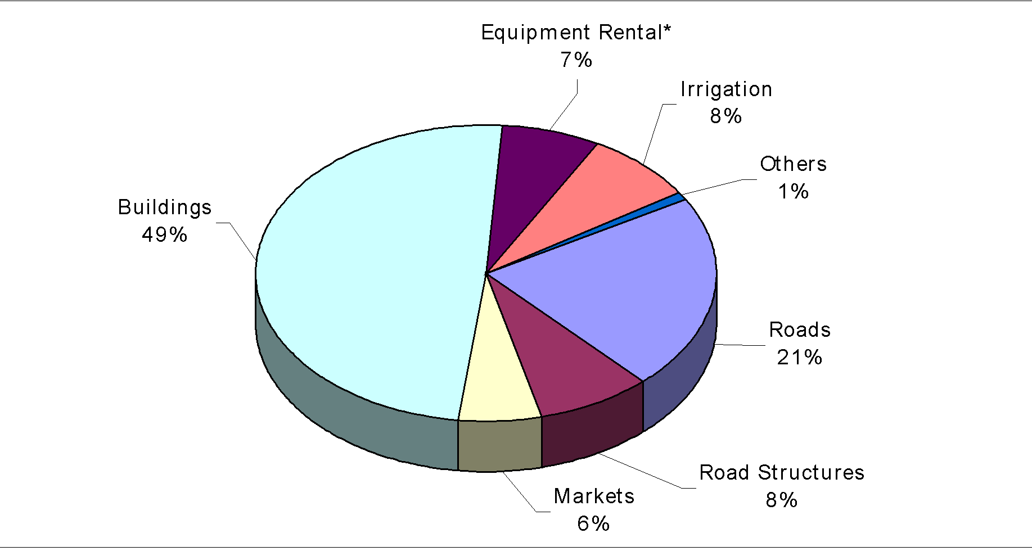

4.2.4 Market Share

Market Share - 2001

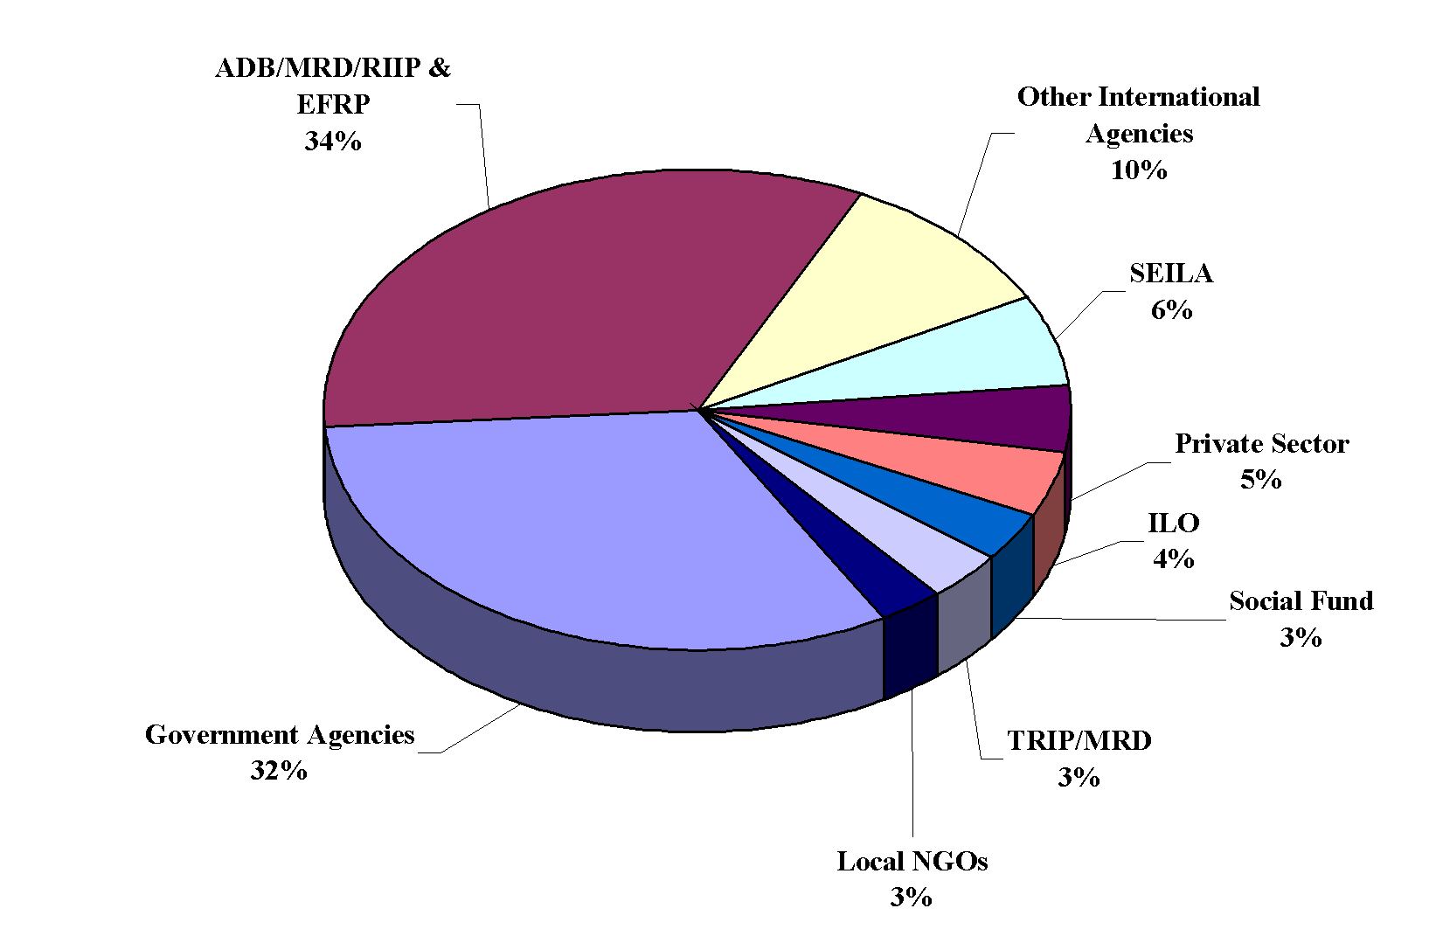

4.2.5 Current Work Methods

Although all the contractors interviewed participated in labour-based road rehabilitation and maintenance training, they were asked about their views on the sustainability of labour-based methods. Out of total 18 contractors only 2 replied that they do not use labour-based methods and use heavy equipment for road works . The remaining 16 use labour-based and equipment supported methods.

4.2.6 Profitability – Work Methods

16 out of 18 contractor found labour-based and equipment supported methods as most profitable. 2 contractors responded that the equipment based methods were most profitable.

4.2.7 Availability of Work

All the 18 contractors confirmed that they had enough work available after finishing of the ADB’s RIIP and NRDP projects. Work from private sector in the buildings sector almost accounted for 50 percent of the available work. Road Construction accounted for maximum availability of work during the past 5 years.

Types of Work Availability | Road Works | Building | Earth Works | Irrigation
No. of Contractors | 11 | 8 | 4 | 6

5. Constraints

The following constraints were informed by the contractors and the implementing agencies in the development of local road construction industry:

Delayed Payments

Most contractors complained about the late settlement of their payment certificates by the clients. In some cases, the reported delays were as long as 6 months which led to acute cash-flow problems and resulted in cost increase and delays in the completion of works. The Client Ministries MRD/MPWT acknowledged delays in payments to the contractors and informed that this was mainly because of delays in the replenishment of funds by the MEF.

Price Increase

Many contractors bitterly complained about the absence of “Price Escalation Clause” in the standard bid documents for local contractors. They stated that during 2007-2008, there had been sharp global increase (50-70%) in the cost of construction materials such as cement, steel, bitumen, stone chippings and diesel etc. In the absence of any price increase compensation clause in the signed contract agreements, the clients refused to pay any compensation to the contractors. As a result, many of the contractors were forced to abandon their contracts unfinished resulting in heavy losses. The contractors suggested that the government and donor agencies should consider such genuine price increase which was unforeseen and unprecedented and try to encourage the contractors to finish the works in hand by paying some reasonable compensation.

The Client Ministries MRD/MPWT acknowledged the sharp increase in the prices of construction materials and stated that since most contracts were of short term duration (6 months), the increase in prices was not foreseen and hence the price escalation clause was not included in the bid documents in consultation with the ADB. Although MRD/MPWT were in favour of payment of some reasonable compensation to the contractors but MEF turned down such requests due to procurement regulations.

Labour Shortage

Most contractors complained about availability of unskilled labour for deployment on LBAT works. This problem has become more pronounced during the past 2-3 years. They informed that in the recent past, there has been a shift in preference of unskilled labour as they prefer to work in building or agriculture sector where there is more continuous demand and the wages are also 20-30% higher than the road sector. This problem is more acute in provinces which are bordering Thailand where local labour prefer to work across the border at US$ 3.5 to 4.0 per day. With these labour shortages, the contractors were obliged to reduce the labour inputs by increasing the use of heavy road construction equipment. The labour shortages and higher wages also adversely affects the economic viability of labour-based road works.

Training

Most contractors acknowledged that the training provided by the ILO and other ADB funded projects has been very useful in their development of their companies and staff. Some contractors were of the view that attending client sponsored training was a “Entry Ticket” for becoming eligible to bid for the road works. But they felt more than satisfied with the newly acquired skills about the contracts management, analysis of rates, clear understanding of the bidding procedures and bidding documents helped them to use these skills while submitting their bids and the execution of works.

Many contractors highly appreciated the latest training programs organized by the ILO TA Team under ADB/JFPR project wherein training apart from labour-based road rehabilitation was also imparted on the construction of bituminous surfacings such as Single/Double Coat Surface Dressing, Otta Seal, Sand Seals etc. They felt that with increased funding levels in the road sector and higher traffic levels on the provincial roads, many roads would now qualify for upgrading to bitumen standards. Thus, there is going to be huge demand for such type of road construction.

Some contractors felt that LBAT option may not be appropriate for future works in Cambodia because of higher wage costs and labour shortages. They were of the opinion that the future training inputs for local contractors should focus on Labor-Based and Equipment Supported technology with special emphasis on the use of bituminous roads or other innovative surfacing materials. The future training programmes should provide extra focus on financial management, asset management, cost-benefit analysis and resource planning for the contractors.

High Interest Rates & Difficulties in Obtaining Bank Guarantees for Performance Bond

Some contractors indicated that they were required to pay interest rates as high as 20-25% in getting bank loans. Also, the banks in Cambodia asked them to deposit equivalent amount before issuing any Performance Bond / Guarantees to the Clients. This resulted in blocking 10% of the bid amount with the bank during the project implementation period and further increased their cash flow problems.

Corruption & Poor Quality of Site Supervision

6 contractors expressed their serious concern about the prevailing level of corruption which reflected either poor quality of works or high unit rates to accommodate for the costs. 5 Contractors also mentioned about the lack of adequate supervision by the client’s supervisory staff.

6. Sustainability Assessment

The government policy clearly promotes increased participation of the private sector to improve the rural infrastructure service delivery. The MRD Strategic Plan for Rural Roads also favours use of LBAT and small scale contractors for the rehabilitation and maintenance of rural roads network. Over the last decade, there has been considerable increase in the capacity of MRD and its provincial departments in effective planning, designing and monitoring of labour-based road works through small scale contractors. There has been a gradual phasing out of the Force Account Works and the execution of most of the public works is being shifted to private contractors.

In the recent past, Cambodia has witnessed about 9 percent GDP growth and increase in nation wide economic activities including growth in agriculture. This has resulted in changed trends and opportunities in the labour market. Agriculture is the mainstay of Cambodia’s economy. With improvised agriculture extension services and better irrigation facilities the farmers in many provinces go for 2-3 rice crops in a year. This has resulted in sharp increase in the demand for agriculture labour through out the year.

Unlike a decade ago when unskilled labour supply at US$1/day was available in abundance, nowadays it is difficult to recruit unskilled labour at US$2/day. The labour supply situation is more acute in provinces neighbouring Thailand such as Pailin, Banteay Meanchey, Oddar Meanchey where most of the unskilled labour prefer to work across the border in Thailand at a daily wage rate of Thai Baht 100-120 (US$ 3-4) per day.

During the last five years there has been a big boom in construction activities in the tourism sector, garment industry, housing sector and other economic areas through out the country. As the topography in the Mekong Delta is flat and flood prone, the construction activities entirely require huge amounts of earthworks in embankments for raising the plinth level of housing, factories and other business premises. Thus it is a pre-requisite for any economic activity in the country and has led to a creation of a huge private sector earthwork construction industry in Cambodia. These contractors mainly use heavy earthmoving equipment such as bulldozers, motor graders, loaders, tippers and vibrating and sheep foot rollers etc. The respective earthwork contractors also actively participate in the construction and maintenance of roads producing no shortage of heavy equipment within the private sector in the country.

These activities have promoted and created large scale employment opportunities for the skilled and unskilled labour force in the building construction sector. People in rural areas prefer to work in the construction and agriculture sector due to receiving higher wages, light work and more opportunities for longer duration employment. It is becoming increasingly difficult to employ labour for the labour-based road rehabilitation and maintenance activities.

In view of above mentioned labour shortages, the local contractors are finding it increasingly difficult to practice LBAT and are resorting to judicious mix of heavy equipment and labour in executing the road works. With increased allocation of funds, the road sector too is growing at a faster pace and generating more opportunities for contractors in the road rehabilitation and routine maintenance activities. This labour-based and equipment supported trend is likely to continue in future. However, the labour-based routine maintenance activities through community contractors will continue unhampered.

7. Conclusions and Lessons Learned

Several ILO and other donor funded projects have proved the appropriateness of the labour-based methods for road rehabilitation and routine maintenance activities.

Efficiency of rural infrastructure service delivery can be considerably improved through participation of private sector small scale contractors.

Cambodia has gradually transited through an early period since the 1990s when the country faced the challenge of mass scale employment generation for the rural unskilled masses to a current scenario when labour shortages are being felt in the road sector due to increased labour demand in other sectors. This would mean reduced participation of labour and increased deployment of equipment for road sector activities.

Development of private sector small scale contractors has witnessed continuous growth in terms of their assets and annual turnover. On account of increase in the wage rates and labour shortages, the contractors have improvised their work methods through use of labour-based and equipment supported methods for road rehabilitation. For routine maintenance works, labour-based methods through Community Contractors remains the preferred approach by the client Ministries.

Future training inputs for local contractors should focus on Labor-Based and Equipment Supported technology with special emphasis on the use of bituminous roads or other innovative surfacing materials. The training programmes should provide special focus on financial management, asset management, cost-benefit analysis and resource planning for the contractors.

The supervisory staff in the Client Ministries would also require continuous training to enhance their capacity and understanding about the upgrading of existing gravel roads to bituminous standards in a phased manner. So far, MRD only dealt with the rehabilitation and maintenance of gravel roads.

The standard bid documents should include “Price Escalation Clause” in order to compensate the contractors for any price increase in the cost of construction materials during the contract period.

Delays in payments to the contractors are very critical for effective and timely execution of the contracts. It is high time that the MEF and the donor agencies must streamline their funds replenishment procedures on a priority basis.

Annex -

List of Contacts

1. H.E. Try Meng Under Secretary of State, MRD
2. H.E Chhin Kong Hean Director General, Public Works, MPWT
3. Mr.Chuop Setha Director, PDRD, Battambang
4. Mr.Sang Savat Director, DPWT, Banteay Meanchey
5. Mr.Din Kim Director, DPWT, Pailin
6 Mr.Khan Manner Director, DPWT, Battambang
7 Ms. Sor Monirath Director, PDRD, Pailin
8. Mr.Mao So Director, PDRD, Banteay Meanchey
9. Mr.Nida Ouk Senior Project Implementation Officer, CARM, ADB
10. Mr.Ky Vyrin Head, JRMU, ADB/JFPR TA 9048
11 Mr.San Bunthen Senior Engineer, JRMU, ADB/JFPR
12 Mr.Van Samsan Training Engineer, JRMU, ADB/JFPR
13 Mr.Lean Phirun Senior Engineer, JRMU, ADB/JFPR
14. Ms.Ham Syna Senior Technician, JRMU, ADB/JFPR

List of Contractors Interviewed is attached separately.
Bibliography

- Ministry of Rural Development – Policy for Rural Roads 2002.
- Ministry of Rural Development – Rural Road Strategic Plan -2007
- Ministry of Rural Development – 5 Year Plan
- ILO/MRD Results of Survey on Contractors Trained in Labour-Based Road Construction and Maintenance by Chhieu Veyara and Dara Johnston Aug. 2001

List of Contractors Study

No. | Name of the Company | Address and Contact Number | Remarks
1 | Hong Chhay  Construction CO., Ltd | #621, Group 14, Rumchek 4 Village, Rattanak Commune, Battambang District, Battambang Province  Tel: (855) 012 950 421, Fax: (855) 053 952 316 | 1998
2 | Hong Huot Ly CO., Ltd | # 422, group 20, group 20, Angchak village, Ochar Commune,  Battambang District, Battambang Province  Tel: 012 927 020, 053 952 139 | 1998
3 | Heng Chhat  Construction Company | #155,Group 16, Svay Chrum Village, Thmorkol District, Battambang Province  Tel: 012 881 696 | 1999
4 | Lok Sour Company | O’takam 3 Village, Tourl Ta Eak Commune, Battambang District,  Battambang Province  Tel: 012 389 184, 092 601 741 | 2004
5 | Loung Chor | # 38, group 3, Thma Koul Village, Tapoung Commune, Thma Koul District, Battambang Province | 2003
6 | Bin Boniboth | # 140, group 6, Krous Village, Svay Dangkum Commune, Siem Reap District, Siem Reap Province  Tel: 012 882 313 | 1999
7 | Teav Navuth | Mondul I Village, Svay Dangkum Commune, Siem Reap District,  Siem Reap Province  Tel: 012 788 032 | 1999
8 | Minh Savath | Mondul III Village, Slarkram Commune, Siem Reap District,  Siem Reap Province  Tel: 092 823 278 | 1999
9 | Chea Bun Thoan (CBT) | Mondul I Village, Svay Dangkum Commune, Siem Reap District,  Siem Reap Province  Tel: 092 546 561 | 1999
10 | Taing Thai Khieng Construction Co., Ltd | Sophy Village, Kampong Svay Commune, Serey Sophon District,  Banteay Meanchey Province  Tel: 012 833 251, 012 833 241 | 1998
11 | Prak Sarak Company | Koll Rothan Village, Ou Ambil Commune, Serey Sophon District,  Banteay Meanchey Province  Tel: 012 712 571 | 2000
12 | Phao Nguon  Construction Co., LTD | Chamkatadok Village,Russeykrok, Commune, Mongkolborey District,  Banteay Meanchey Province  Tel: 012 912 457, 011 912 678 , 012 448 424 | 2003
13 | Chea Sang  Construction Co., Ltd | # 31, group 35, Phnom Toch Village, Phnom Toch Commune,  Mongkolborey District, Banteay Meanchey Province  Tel: 012 833 251, 012 838 429 | 1993
No. | Name of the Company | Address and Contact Number | Remarks
14 | Royal Mekong  Construction & Development Pte.Ltd. | # 81, Street 315, Sangkat Boeungkak II, Khan Tourlkork , Phnom Penh  Tel: 012 818 733 | 1998
15 | Sophorn Ratanak  Construction Co., Ltd | # 111, Street 360, Sangkat Tourl Svay Prey I, Khan Chamkar Morn , Phnom Penh  Tel: 012 818 733 | 1998
16 | Tep Kosal Civil Co., Ltd | # 132, Street 134, , Sangkat Veal Vong Khan 7 Makara , Phnom Penh  Tel: 012 930 096 | 1998
17 | Khmer Heritage  Construction Co., Ltd | # 677, Street 128, , Sangkat Tuek Laak I, Khan Tourl Kork , Phnom Penh  Tel: 012 777 747 | 1998
18 | D.C.C Co., Ltd | # 93, Street 105, Sangkat Boeung Keng Kang III, Khan Chamkar Morn ,  Phnom Penh  Tel: 012 777 765 | 1998

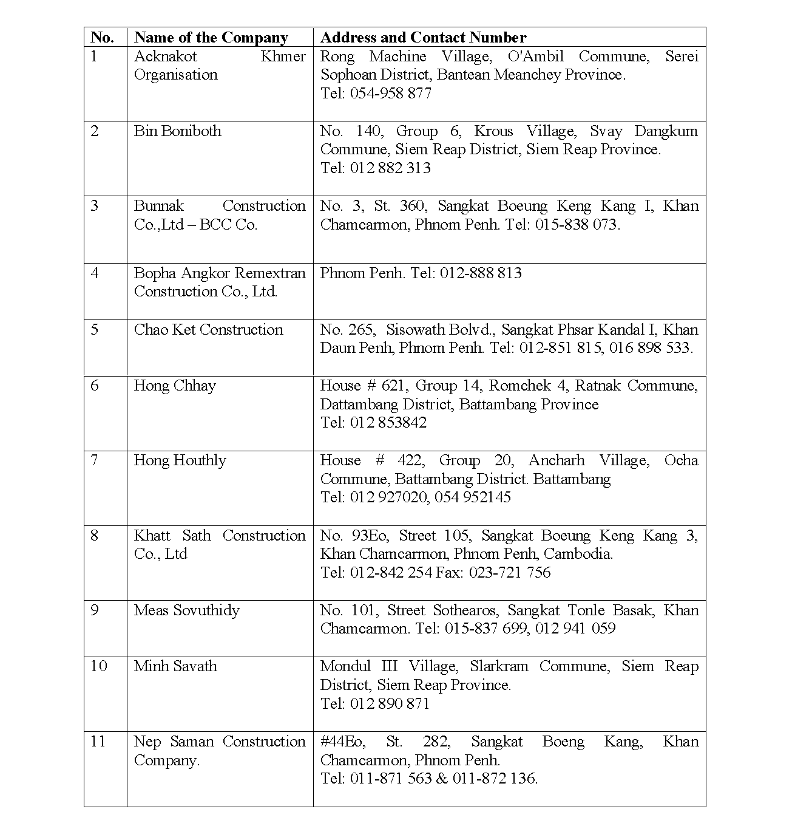
List of Contractors Trained Under ILO Upstream Project

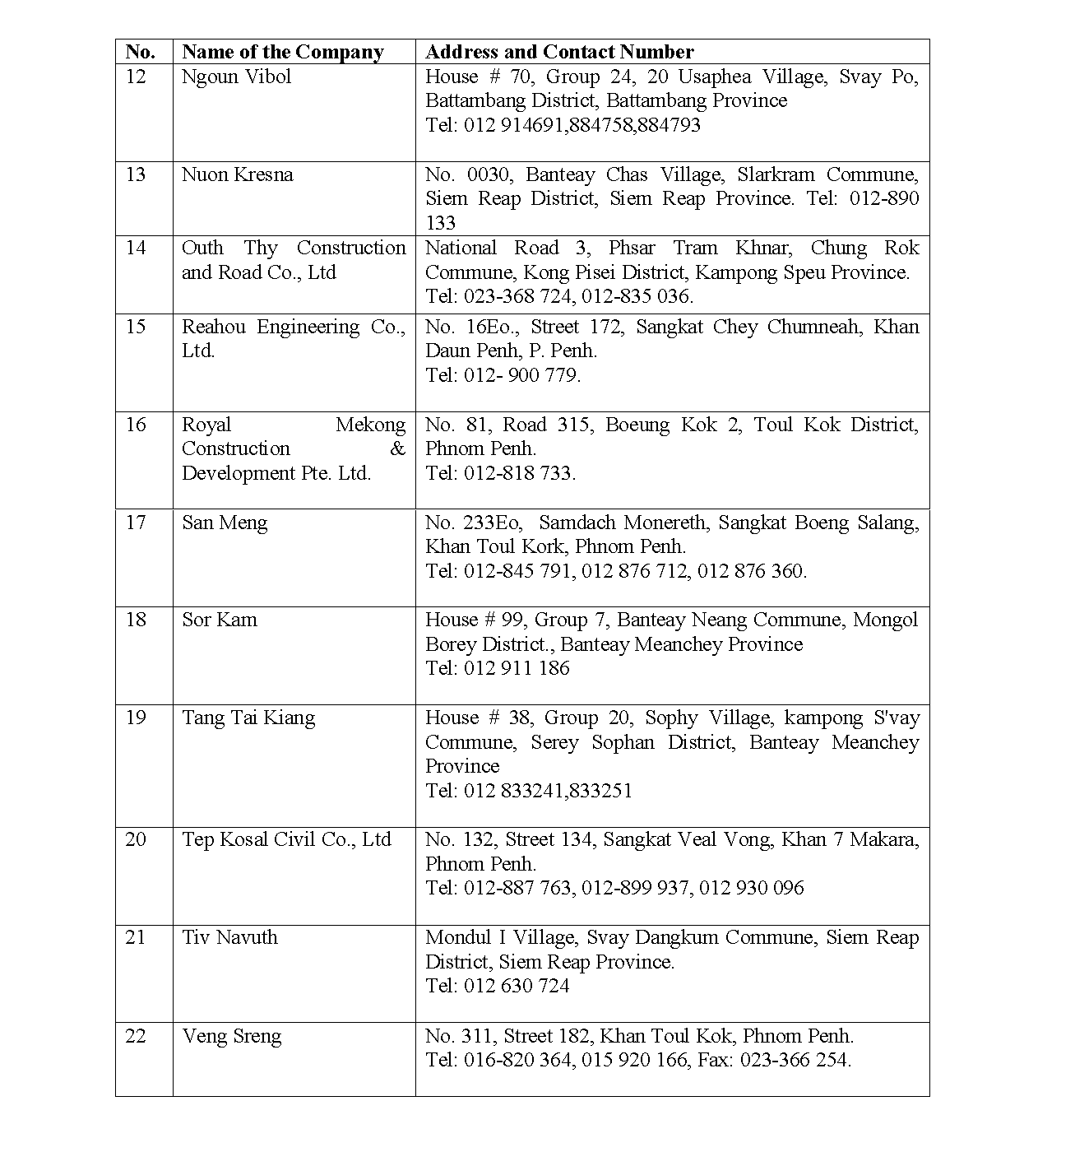
Annex-

Typical Profile of Contractor Training Course – ILO/ADB/JFPR Project – TA 9048

The training of contractors focused on theoretical class room training on various topics for labour-based road construction and maintenance for paved and unpaved roads. The training also comprised of in-field practical training regarding setting out, choice of good materials, materials testing, contracts management and clear understanding of the technical specifications for the road works.

For the participating Contractors, the training course took special care of the needs of the Director of the Construction Companies and their technical supervisory staff. The training course covered topics such as resource planning, financial planning, materials planning, equipment and human resource planning, cash flow requirements, analysis of rates for various items for road works, exposure to the bidding procedures, understanding of standard bidding documents, quality control guidelines and technical specifications and road works. For the Contractor’s Road Supervisors, training focused on field construction aspects of the road rehabilitation and maintenance

The Contents of the Training Course are described as under:

Planning & Feasibility of Labour-Based Road Projects

Surveying & Setting Out Using Profile Board

- Profile Board Method
- Centre Line Method
- Setting of ditches, side slope, camber formation and side drain

Surveying & Setting Out Using Leveling Equipment

- Definitions
- The Leveling Equipment / Instrument
- Basic Operating Procedures
- Practical Training
- Leveling Equipment practice on determining the differences in elevation
- Recording of levels
- Rise and Fall Method
- Height of Collimation Method

- Applications of Leveling
- Longitudinal Sections
- Cross-Sections
- Contouring

Labour-Based Road Construction Procedures

  - Clearing
  - Earth works
  - Embankment Construction
  - Drainage
  - Gravelling, Compaction

Soil, Materials Testing, Bitumen and Dynamic Cone Penetrometer

- Sieve Analysis of Fine and Coarse Aggregates
- Determination of Moisture-Density Relationship of Soils
- Determination of California Bearing Ratio (CBR)
- Density of In-Situ soil by the Sand Replacement Cone method
- Method of sampling of aggregate.
- Bitumen Types and specifications;

Bituminous Road Construction

- General, volume of traffic,
- Embankment
- Sub base
- Base Course
- Shoulder
- Wearing Course
- Aggregate
- Bitumen binders
- Determining the average least dimension of chippings
- Determining the basic bitumen spray rate
- Types of Bituminous Surface Treatment including Surface Dressing;

- Site Administration , Planning, Reporting & Work Organisation

Contract Management

- Bid Document
- Instructions to Bidders
- Preparation of Bid
- Submission of bids
- Bid opening and elevation
- Post qualification and award of contract
- Guarantees
- Bid evaluation process

- Contract Agreement.
- Bid Data sheet and Contract data sheet
- Bills of Quantities
- Specifications of Road Works
- Payment
- Work plans
- Filling of unit rate in the Bills of Quantities in the Bid Document

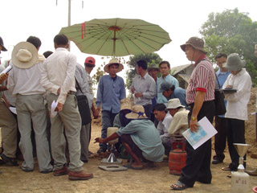
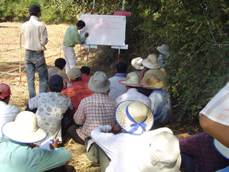

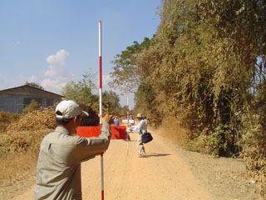
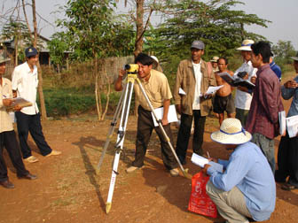

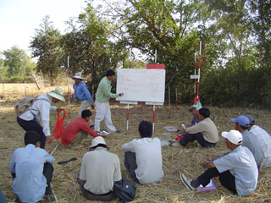
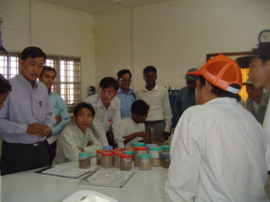

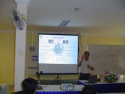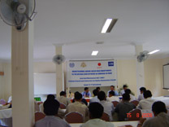

Photograph – Different Training Courses ADB/JFPR TA-9048 Project

Financial and Accounting

Financial Management Procedure
- Accounting System
- Operational Bank Account
- Bank Reconciliation
- Establishment Petty Cash Account
- Replenishment petty Cash Account
- Payment to Contractors
- Withdrawal application
- Financial Statement

Payment Certificate
- Certificate of Practical Completion of the Works
- Interim & Final Certificate of Completion of the Works
- Retention Money
- Cash flow

Bills of Quantities, Analyses of Rates and Cost Estimates
- The Bills of Quantities
- Calculation of the Quantities
- Tendering
- Planning & Resource Mobilisation
- Financing
- Execution
- Typical Examples of Unit Price Calculation for road works;
- Pricing the Quantities for Bidding / Tendering)
- Direct Project Cost
- Indirect Project Cost
- Risk allowance
- Company’s administrative cost
- Profit

Routine Maintenance

- Labour-based routine maintenance through Community Contractors;
- Simplified Contract for routine maintenance based on monthly work-plans;
- Monitoring and supervision of community contractors through Commune Chiefs;

Periodic Maintenance;

Emergency Maintenance;

Type and causes of pavement defects in bituminous roads;

Methodology for repair of bituminous roads i.e Pot hole repairs, cracks repair, edge breaks and depressions repairs;

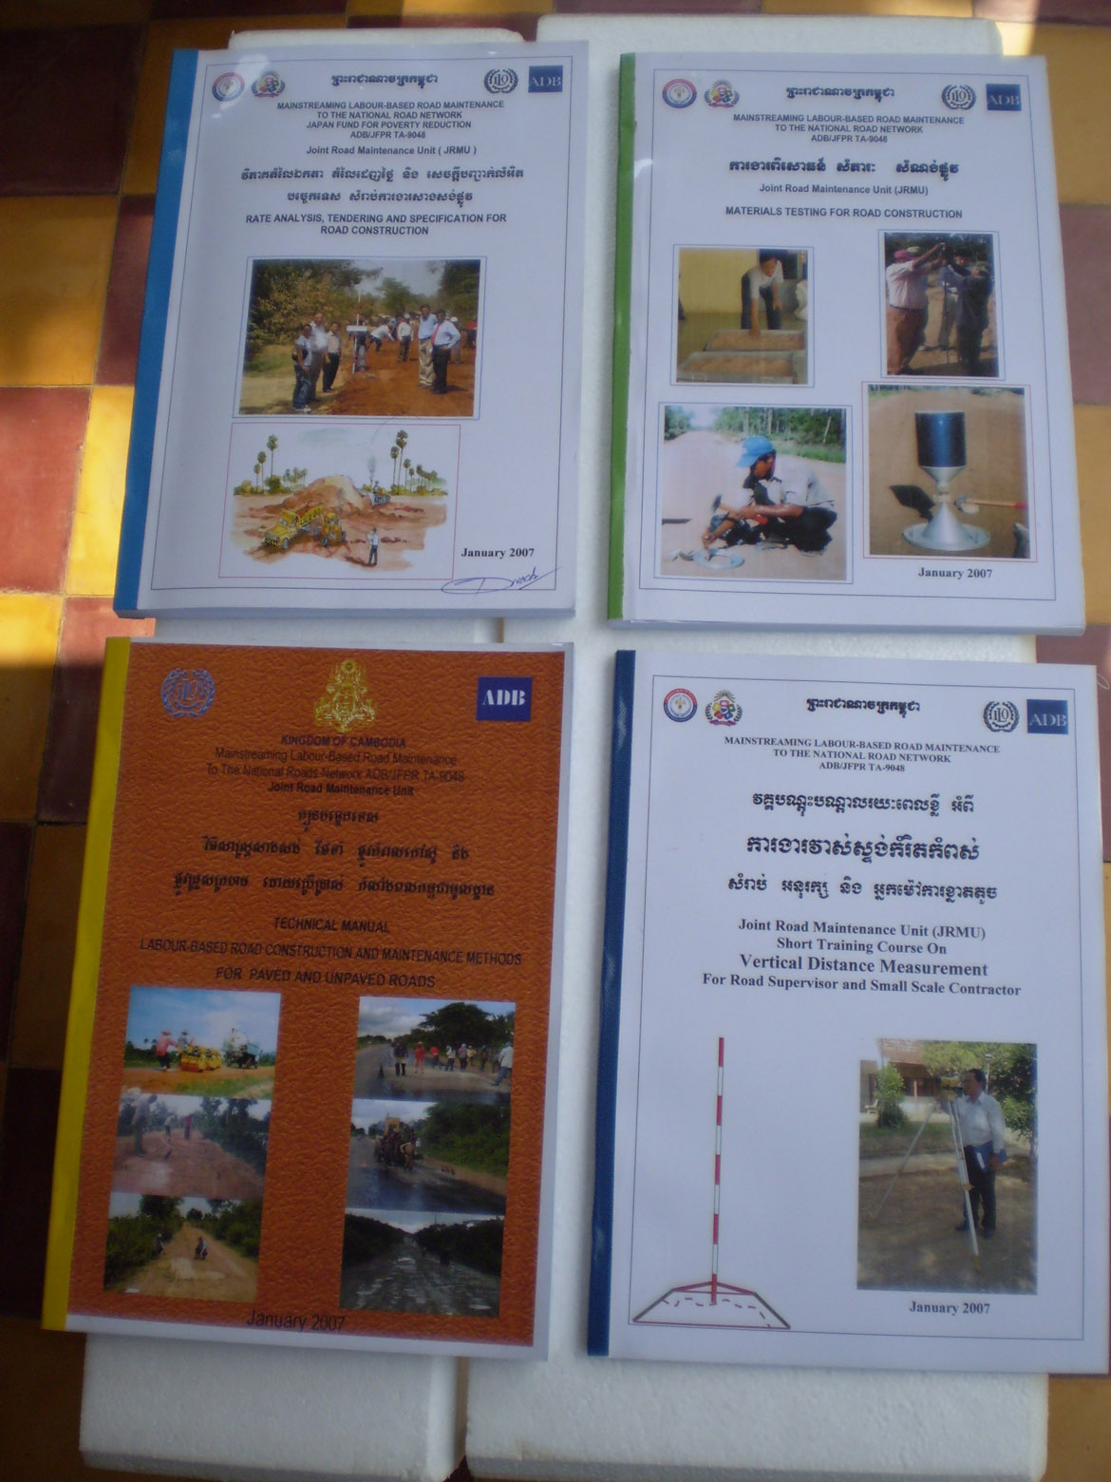
The following Training Manuals in English with Khmer translation were produced by the ADB/JFPR project and distributed to the trainees during the Training Course.

- Technical Manual on Labour-Based Road Construction and Maintenance For Paved and Unpaved Roads

- Technical Manual on Vertical Distance Measurements

- Technical Manual on Materials Testing for Road Construction.

- Technical Manual on Rate Analysis, Tendering and Specifications for Road Works.

- Technical Manual – Materials ad Equipment for Bituminous Road Construction, November 2007

- Gravel Road Routine Maintenance Manual, November 2007

Construction of Trial Sections – ADB/JFPR Project TA-9048

International Labour Organisation
EIIP – Capacity Building for Contracting
Institutional Assessment and Contractor Tracing

Questionnaire for Contractors
Country: | Project Title(s):
Development Support Agency:

Implementation Agency:

Contractor’s Name, Address and Contacts:

Note for the Contractor:
Use of data: This questionnaire is used to collect important data to find out the development progress of labour-based contracting in your country and the impact that it might have had to the sector. The collected data will be analysed and summarised in a general evaluation country report.

Confidentiality: Your information will not be used for any other purpose than for this study. Your company’s name as well as your own name will not be revealed in with this interview.

Part 1; Company’s Establishment and Capacity

1.1 Is your company registered with any Association? yes no

if yes, with which Association?
…………………………………………………………………………………………………………………………………

1.2 When did you establish your company?
Date first registration: ……………………………………………

1.3 What type of work does your company carry out?
road construction road maintenance building works irrigation works
water works drainage works sanitation works

1.4 What work method(s) do you apply?
labour-based only machine-based only mixed, depending on the nature of works

1.5 If you are working using different methods, which method gives you the highest profit?
…………………………………………………………………………………………………………………………………………………

1.6 Specify the number of staff and labour force:
That you had employed when you started your business |  |  |  |  | That you have employed currently
Engineers / Technicians | Site Supervisor | Operators + Drivers | Skilled Labourers | Unskilled Labourers | Engineers / Technicians | Site Supervisor | Equipment Operators | Skilled Labourers | Unskilled Labourers

1.7 Specify the types and numbers of your equipment:
That you were owning when you started your business: | That you are owning now:
- …………………………………………………………...  - …………………………………………………………...  - …………………………………………………………...  - …………………………………………………………...  - …………………………………………………………...  - …………………………………………………………...  - …………………………………………………………...  - …………………………………………………………...  - …………………………………………………………...  - …………………………………………………………... | - …………………………………………………………...  - …………………………………………………………...  - …………………………………………………………...  - …………………………………………………………...  - …………………………………………………………...  - …………………………………………………………...  - …………………………………………………………...  - …………………………………………………………...  - …………………………………………………………...  - …………………………………………………………...
1.8 In case you (also) hire equipment, please specify the typical equipment sets that you hire for road works:
- ………………………………………………………….............................................................................................
- ………………………………………………………….............................................................................................
- ………………………………………………………….............................................................................................
- ………………………………………………………….............................................................................................
- ………………………………………………………….............................................................................................
- ………………………………………………………….............................................................................................

  - Do you have your own company infrastructure, e.g. workshop, office, stores, etc.?
yes no
If yes, please specify:
Infrastructure when you started your business: | Infrastructure you are using now:
- …………………………………………………………...  - …………………………………………………………...  - …………………………………………………………...  - …………………………………………………………...  - …………………………………………………………...  - …………………………………………………………...  - …………………………………………………………...  - …………………………………………………………... | - …………………………………………………………...  - …………………………………………………………...  - …………………………………………………………...  - …………………………………………………………...  - …………………………………………………………...  - …………………………………………………………...  - …………………………………………………………..  - …………………………………………………………...
Note: behind each item indicate in brackets (o) for owning and (h) for hiring

  - Please specify a breakdown of the most important handtools you own (type and number):
Handtools you owned when you started your business: | Handtools you are owning now:
- …………………………………………………………...  - …………………………………………………………...  - …………………………………………………………...  - …………………………………………………………...  - …………………………………………………………...  - …………………………………………………………...  - …………………………………………………………...  - …………………………………………………………...  - …………………………………………………………...  - …………………………………………………………...  - …………………………………………………………...  - …………………………………………………………...  - …………………………………………………………...  - …………………………………………………………...  - …………………………………………………………... | - …………………………………………………………...  - …………………………………………………………...  - …………………………………………………………...  - …………………………………………………………...  - …………………………………………………………...  - …………………………………………………………...  - …………………………………………………………..  - …………………………………………………………...  - …………………………………………………………...  - …………………………………………………………...  - …………………………………………………………...  - …………………………………………………………...  - …………………………………………………………...  - …………………………………………………………...  - …………………………………………………………..
  - How did you get your initial capital for investments, registration, hiring of staff, etc. when you started your business:
had my own money (personal savings, from family or friends)
got a loan from a local bank
got a loan through a support project from a donor
got a grant through a support project from a donor
any other source, please specify …………………………………………………………………………………..

………………………………………………………………………………………………………………………………………………….
If you got a loan, have you been able to pay it back until today?
yes no

if no, please specify why not:
………………………………………………………………………………………………………………………………………………….

  - What is your financial situation today:
my company is financially independent and has no depths
my company makes regular profits and I can make new investments when required
my company still has a loan(s) → specify what kind ……………………………………………………
my company currently does not make any profit → specify reason(s) ………………………
…………………………………………………………………………………………………………………………………………

Any other comments to your financial situation:
………………………………………………………………………………………………………………………………………………….
………………………………………………………………………………………………………………………………………………….
………………………………………………………………………………………………………………………………………………….
………………………………………………………………………………………………………………………………………………….

Part 2; Company’s Performance

  - Specify the type of work that you typically carry out i) when your started your business, ii) today (e.g. road rehabilitation, periodic maintenance, routine maintenance, building, etc.:
Type of works carried out at start of business: | Type of works being carried out these days:
- …………………………………………………………...  - …………………………………………………………...  - …………………………………………………………...  - …………………………………………………………...  - …………………………………………………………...  - …………………………………………………………...  - …………………………………………………………...  - …………………………………………………………... | - …………………………………………………………...  - …………………………………………………………...  - …………………………………………………………...  - …………………………………………………………...  - …………………………………………………………...  - ……………………………………………………………  - …………………………………………………………...  - ……………………………………………………………

  - What is your company’s annual turnover:
a.) when your started your business: …………………………………………………………………………….
b.) today: ………………………………………………………………………………………………………………………….

  - List the major contracts your company has carried out in the last three years.

Contract Type (e.g. road rehabilitation, periodic maintenance etc.) | Client | Approximate Contract Sum  $
1.
2.
3.
4.
5.
6.
7.
8.
9.
10.
11.
12.

  - What do you consider are the biggest achievements your company has made since it started operations?
………………………………………………………………………………………………………………………………………………….
………………………………………………………………………………………………………………………………………….
………………………………………………………………………………………………………………………………………………….

Part 3; Company’s Development

  - Were you given any form of out-side assistance to develop your company?
yes, → please specify under 3.2
no, I developed the company with my own resources and through my own achievements

  - Specify the type of assistance that you were given:
Type of Assistance | Details: kind, amount, conditions, by whom?
Financial Loan
Equipment (Loan or Grant?)
Handtools (Loan or Grant?)
Training for you and your staff | → move to Part 4 of this questionnaire for details
trial contracts with fixed rates
any other; specify:
…………………………………………………………….
…………………………………………………………….
…………………………………………………………….
…………………………………………………………….
…………………………………………………………….
…………………………………………………………….

  - What measures have you taken / are you taking to further develop the capacity of your company?
………………………………………………………………………………………………………………………………………………….
………………………………………………………………………………………………………………………………………………….
………………………………………………………………………………………………………………………………………………….
………………………………………………………………………………………………………………………………………………….

  - If you are a member of a contractor association, do you get any development support in terms of training, information and advisory services, arbitration support, etc.?
yes no

if yes, please specify:
………………………………………………………………………………………………………………………………………………….
………………………………………………………………………………………………………………………………………………….
………………………………………………………………………………………………………………………………………………….
………………………………………………………………………………………………………………………………………………….

Part 4; Training

  - Did you and/or your company staff receive any form of training since the company exists?
yes no
if yes, continue with the following questions. If no, move to Part 5 of this questionnaire.

  - Specify the training you and your company’s staff received (tick as appropriate):

Who of your company? | Type of training | Who trained?  (Name of Institution / Consultant)
Company Director  Managing Director | theory basic technical subject  theory contract management  theory business management  practical training on site  trial contract,  on-the-job training  mentorship after trial contract  any other …………………………………….  ………………………………………………………  ………………………………………………………
Site Agent | theory basic technical subject  theory contract management  theory business management  practical training on site  trial contract,  on-the-job training  mentorship after trial contract  any other …………………………………….  ………………………………………………………  ………………………………………………………
Site Supervisor | theory basic technical subject  theory contract management  theory business management  practical training on site  trial contract,  on-the-job training  mentorship after trial contract  any other …………………………………….  ………………………………………………………  ………………………………………………………
any other staff? ………………………………  ………………………………  ……………………………… | ………………………………………………………  ……………………………………………………… ………………………………………………………  ……………………………………………………… ………………………………………………………

  - How was the training paid for?
it was all paid for by donor/government
→ Specify who? ……………………………………………………………………………………………………………………
it was paid for by donor/government with my contribution
→ Specify who and also percentage/amount of your own contribution?
……………………………………………………………………………………………………………………………………………….
……………………………………………………………………………………………………………………………………………….
all paid by myself/own company
→ Specify for who (your and your staff?) and approximate amount? ……………………………………………………………………………………………………………………………………………….
……………………………………………………………………………………………………………………………………………….

  - How would you rate the quality and usefulness of the training received to carry out your job today?
very useful, can apply in our daily work most of what I and my staff learned
mostly useful, can apply in our daily work some of what I and my staff learned
not really useful, can apply only little in our daily work of what I and my staff learned
not at all useful, cannot apply anything in our daily work of what I and my staff learned

If you rated “not really useful” or “not at all useful”, can you please specify the reasons:
……………………………………………………………………………………………………………………………………………………….
……………………………………………………………………………………………………………………………………………………….
……………………………………………………………………………………………………………………………………………………….
……………………………………………………………………………………………………………………………………………………….

  - How many of your supervisors, who were originally trained together with you, are still working in your company today?
……………………………………………………………………………………………………………………………………………………….
……………………………………………………………………………………………………………………………………………………….
what are the reasons that they no longer work for your company?
……………………………………………………………………………………………………………………………………………………….
……………………………………………………………………………………………………………………………………………………….

  - Do you and your staff require any further training at this point in time?
yes no
if yes, please specify who requires training and what kind of training:
…………………………………………………………………………………………………………………………………………………….
……………………………………………………………………………………………………………………………………………………….

Part 5; Barriers for Better Performance and Growth

  - What do you consider were the main barriers (obstacles) for your company to perform and grow since you started business?
(tick as appropriate)
bank finance too difficult to obtain  bank interest rates too high  difficulty in obtaining performance bonds / guarantees and their costs  long delays in receiving payments  no provision for price fluctuations  lack of equipment for hire  tender procedures and contract award too cumbersome and biased  corruption, fraud | contract conditions and specifications over complex and difficult to implement  contract documents are biased against the contractor  contracts are awarded to companies who bid too low (lowest tender)  site supervision and quality control by client’s representative is insufficient/poor  communication between the client’s representative and the contractor is poor  no work continuity  delays and shortage of supply - materials

  - Which of the obstacles that you have mentioned in the above list do you consider as the three major problems, starting with number 1 as the most prominent?
1. …………………………………………………………………………………………………………………………………………………
2. …………………………………………………………………………………………………………………………………………………
3. …………………………………………………………………………………………………………………………………………………

  - Have you ever been involved in an arbitration/court case with your company?
yes no

if yes, please specify:
………………………………………………………………………………………………………………………………………………….
………………………………………………………………………………………………………………………………………………….
………………………………………………………………………………………………………………………………………………….

Part 6; Prospects for the Future and Expected Challenges

  - How do you rate the future prospects for your company to acquire civil engineering or building contracts:
very positive, as lots of good contract works can be expected
positive, since there is much contract work on the way with realistic chances to get it
fair, there seems to be some contract work but on a limited scale with some realistic chance to get it
poor, there seems to be little work ahead and only remote chances to get it
very poor, there is nearly no contract work opportunity and it is likely that the company will have to close down

  - If you have chosen either “very positive, positive or fair” from the list under 5.1, what do you rate is the percentage of work that your company may be awarded under the following sub-sectors:

Labour-based road construction / improvement works ……………………%
Labour-based road maintenance works ……………………%
Equipment based road works ……………………%
Any other civil engineering works ……………………%
Building works ……………………%

  - Do you think that you will be getting work not only in the rural but also urban areas in future:
yes no

if yes, please specify:

  - Do you think that further support to develop your company would be useful?
yes no

if yes, please specify what kind of support would be the most useful:
………………………………………………………………………………………………………………………………………………….
………………………………………………………………………………………………………………………………………………….
………………………………………………………………………………………………………………………………………………….

  - What will be the three biggest challenges that your company will face in future?
1. ………………………………………………………………………………………………………………………………………………
2. ………………………………………………………………………………………………………………………………………………
3. ………………………………………………………………………………………………………………………………………………

Part 7; Lessons Learnt

  - Describe briefly the most important lesson that you have learnt since you started your company:
………………………………………………………………………………………………………………………………………………….
………………………………………………………………………………………………………………………………………………….
………………………………………………………………………………………………………………………………………………….
………………………………………………………………………………………………………………………………………………….
………………………………………………………………………………………………………………………………………………….
………………………………………………………………………………………………………………………………………………….

  - What would you do different if you could start again your company:
………………………………………………………………………………………………………………………………………………….
………………………………………………………………………………………………………………………………………………….
………………………………………………………………………………………………………………………………………………….
………………………………………………………………………………………………………………………………………………….
………………………………………………………………………………………………………………………………………………….
………………………………………………………………………………………………………………………………………………….

We thank you very much for your cooperation!!

EIIP – Capacity Building for Contracting

Institutional Assessment and Contractor Tracing

Who they were – What they are – What has been achieved
A study to assess the results of capacity development for contracting using emerging contractors applying labour-based approaches.

Terms of Reference for Country Survey in Cambodia

1. Background and Rationale
1.1 General
Most developing countries have gone through an economic, social and political reform process over the last two decades. One of the effects has been the move away from central government controlled and executed infrastructure development to more decentralised project control with local community and private sector involvement.
Local resource-based approaches, commonly expressed as ‘labour-based’, have in the past been successfully exercised through force account works in a number of countries. It was relatively easy to establish common standards, work methods and procedures through central government controlled projects. The socio-economic benefits were obvious and the financial comparison with equipment-based methods seemed to be favourable. The shift to more decentralised projects and private sector execution, however, has been a major challenge. In most cases there was no local capacity in place to manage infrastructure projects effectively. Local consultants and contractors who could take over from the force account units were not available. Adequate management, contracting and working procedures for locally managed projects and executed by small-scale and/or emerging consultants and contractors had to be developed and tested first.
Numerous governments together with development partners took up these challenges and introduced projects to develop a) local capacities with central and decentralised governments or project/contract management agencies, b) appropriate management approaches and procedures, and c) local small-scale contractors and to some degree consultants.
The ILO, together with a number of development partners, has been in the forefront in the development of appropriate approaches and systems as well as in the implementation of numerous contracting development projects. The first of its kind was the “Ghana Project” that started in 1986, where the ILO had the TA mandate and where over the years over 200 emerging small-scale contractors were trained and given a chance to enter the construction market. This pilot project was followed by many similar projects in Africa, Asia and Latin America.
Most of these projects would assist in the development of local capacities to manage decentralised projects through improved planning, design, contract documentation, supervision and management. They would generally facilitate an improvement to the enabling environment including market access for local industry, local governance and transparency, and hence ensure quality results and sustainable jobs. The other main activity in the projects was to create a cadre of capable domestic contractors and it is commonly understood that in most projects the contractor development process was regarded as successful. However, it was also clear that most of them operated under “greenhouse conditions” as they were protected and nurtured by the projects. Whether or not the enabling environment had been developed such that these contractor firms survived beyond the project frame and whether they were able to sustain themselves in the open market and whether they still apply a local resource-based work approach is still a question to be answered.
Consequently, development partners together with the ILO should now be in a position to answer this question to assess the long-term sustainability of the approach with regards to local contracting capacity development.
Whether or not local contracting capacities have been achieved, as a measure of effective decentralisation, is not only a result of having developed capable local contractors. As described above, this depends mainly on other factors including the enabling environment. However, whether the originally trained contractors are still in operation and whether they were able to develop further is a) an important indicator for the private construction sector, b) an important indicator for the decentralisation and privatisation reform process, and c) important to know whether the private sector development investments are sustained.
The aim of the study is to provide representative figures on the issues of the development of the individual enterprises and employability of trained staff and clarify what have been the main reasons for successes and failures.
A further aim of the study is to provide inputs to the overall socio-economic impact of the approach, particularly with regards to poverty related issues.

1.2 Contracting Development in Cambodia
Initiatives to involve the local construction industry commenced on a trial basis in the ILO rural road reconstruction programme in the mid 1990s, at which time the first capacity assessments of the industry were carried out. With the start of the ADB financed Rural Infrastructure Improvement Programme, the private sector was given the lead role in both improvement works as well as road maintenance. Different categories of contractors were used for works with varying complexity and size. Local builders were utilised for the construction of culverts; local building firms were trained and used for bridge construction works; larger contractors were engaged for the supply of gravel; medium-sized contractors with some civil works experience were trained in labour-based road works technology and thereafter engaged in rural road construction. At the same time, petty contractors were mobilised in the communities along the roads to carry out routine road maintenance. The RIIP also carried out a substantial amount of building works for schools, government offices and markets, which was also carried out through the engagement of local contractors.
Training of the road works contractors was provided jointly by the RIIP and the ILO, consisting of initial classroom training combined with on-the-job training. After completing initial training the contractors were first awarded a trial contract before allowed to bid for larger contracts. Eventually these firms were awarded contracts consisting of all the types of works required for improving rural roads, including gravel supply and bridge and culvert works. Smaller firms engaged only for culvert works and maintenance were also provided development assistance mainly through on-the-job training and extensive technical support during their initial works contracts.
Extensive capacity development was at the same time provided to the government agency in charge of the rural infrastructure programme. The Ministry of Rural Development and its provincial units had very limited contracts management experience, so a complete contracts management system was developed and established within the Ministry. As part of these development efforts, procurement and tender regulations, cash-flow arrangements and payment procedures were agreed with the Ministry of Finance. Technical, administrative and finance staff at headquarters and in the provinces were trained in the effective use of the newly developed systems and procedures, thereby establishing an effective contracts management capacity in MRD.
The systems and procedures were eventually adopted by other projects and rural development programmes. With some modifications, this contracts management is still in use today.

2. Study Objective
The objective of the study is to assess the approaches used in the capacity building projects for contracting in construction looking at small-scale labour-based contractors with regard to their further development and success beyond the project frame and in the open market.
Within this context, the objective of the study is to assess the approaches used in capacity building projects for contracting in construction looking at:
- the enabling environment in the sense that local institutions have developed adequate capacity to manage infrastructure development;
- small-scale labour-based contractors and consultants with regard to their further development and success beyond the project frame and in the open market;
- employability of trained staff.
Investigations should be made about the reasons for success or failure and what lessons could be learned for the future.

2. Study Organisation
The study is initiated and controlled by the EIIP branch of the ILO, Geneva. The EIIP has engaged an international expert for the overall study coordination and preparation of the final summary report. Consultants will carry out the survey in the particular countries under the guidance of the study coordinator. The roles of the study implementers are as follows:
The Country Study Coordinator is responsible for:
    - Finalising the detailed work plan and methods for the country survey,
    - Implementing the survey and supervise all activities at country level,
    - Liasing with the ILO Regional Office on facilitating and overseeing the study works,
    - Facilitating, coordinating and supervising the work of the country survey consultants,
    - Providing guidance to the survey consultants in mobilising and carrying out the data collection and interviews,
    - Facilitating access to government departments and agencies and their information,
    - Carrying out all coordination activities that might be required between the various parties (ILO Geneva, ASIST-AP and other agencies),
    - Monitoring the data collection process,
    - Reviewing and collating all reports and information,
    - Analysing the data and writing the final country report.
The Country Survey Consultant(s) is responsible for:
    - Collecting the base-data through the defined survey methods,
    - Carrying out interviews
    - Collating the country data and preparing the country survey report.
(→ For detailed tasks, refer to Section 3 below)

3. Tasks of the Country Survey Consultant
The country survey consultant will carry out the following tasks:
(i) Carry out the survey of local contractors mainly involved in rural road, bridge and culvert works and other rural infrastructure works where relevant. Tentative list of programmes include:
  - ILO Upstream Project
  - Rural Infrastructure Improvement Project
  - Northwest Rural Development Project
  - Mainstreaming labour-based road maintenance Project
(ii) Trace and review project documents to collate relevant data that are essential for the country survey,
(iii) Carry out interviews with: (specify below according to your country and agencies/persons involved)
  - Project management staff (current and/or former; as appropriate),
  - Government and or agency staff (current and/or former; as appropriate),
  - Support agencies (current and/or former; as appropriate),
  - Contractors (who are or were involved in the project),
  - Contractors’ association and/or national private construction sector development agency/authority (who are or were involved in the project),
  - Any other as applicable
(iv) Summarise data from questionnaires and draw conclusions
(v) Assist in preparing the Draft Country Survey Report
Note: The attached Country Study Guide specifies the above tasks in detail and provides guidance on the study methodology to be applied.

4. Output of the Consultancy
The Country Survey Coordinator will prepare a Country Survey Report, Volume I, Main Report; including the following sections:
- Table of Contents and Abbreviations
- Executive Summary
- Overall Sector Description
- General Features of the Construction Industry
- Government Contracts Management Capacity
- Survey Results
- Sustainability Assessment
- Conclusions and Lessons Learned;
→ For more details about the content to be covered by the report, refer to the attached Guideline for Country Survey
The consultant shall also compile all filled questionnaires as per categories and submit them in a separate report volume; Country Survey Report, Volume II, Annexes.
Additional information to be contained in Volume II may include:
  - List of interviewees and people met,
  - Tools used to collect data/information (e.g. sample questionnaires),
  - Any important support documents as may be required to clarify data/results,
  - Data, e.g. in tabular format (if not already presented in the main report),
  - Table listing the documents developed under the project, e.g. for contract management, designing and planning projects, training materials, etc.,
  - List of reference material for carrying out the study,
  - Any other important background information.
The report has to be submitted as computer readable file (Microsoft Word).

7. Qualification of the Survey Consultant
The Programme Country Survey Consultant needs the following qualifications:
- Degree in Civil Engineering with at least ten years practical work experience in rural infrastructure development programmes in developing countries.
- Extensive experience in contracting capacity development, with particular reference to local resource-based contract works for rural and/or urban infrastructure.
- Excellent skills in spoken and written English, with a proven record of project document and report preparation.

Related Documents:

- Guideline for Country Survey
- Checklist General Project Information
- Checklist for interviews with development support agency
- Questionnaire for interviews with implementing agency/client staff
- Checklist for Interview with Implementing Agency
- Checklist for Interview with Contractors’ and/or Consultants’ Association of Constructing Development Agency
- Questionnaire for interviews with contractors

