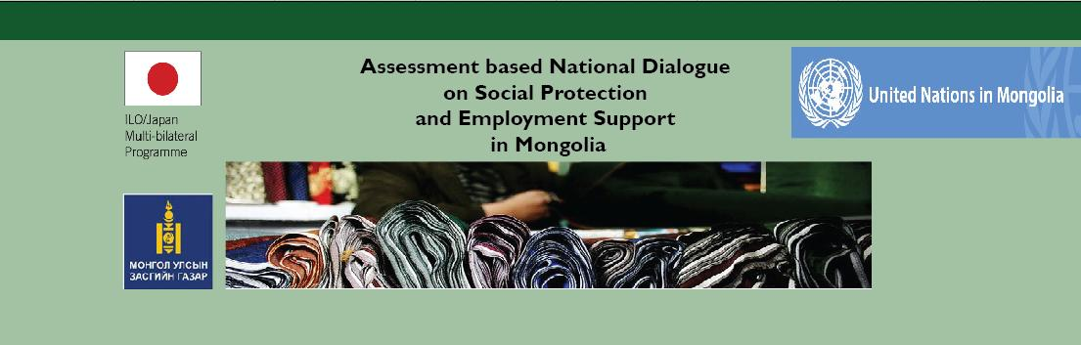
Assessing the cost of a social protection floor in Mongolia:
Methodology and preliminary results
Friday 2 May 2014
Temuujin Hall, 5th floor, Chinggis Khaan Hotel, Ulaanbaatar
AGENDA
 | Moderator: Ms. B.Otgonjargal, State Secretary, MPDSP
11:00 – 12:00 | Taking forward the recommendations of the assessment on social protection and employment support: assessing the cost of a social protection floor in Mongolia  - Ms.Celine Peyron Bista, Chief Technical Advisor, MAPS Project, ILO Regional Office for Asia and the Pacific  - Ms. S.Baigalmaa, National Project Manager, ILO MAPS Project
12:00 – 13:15 | Lunch break
13:15 – 14:45 | Group discussions: Discussion on the main scenarios and proposed parameters  Groups are divided per SPF guarantee on a rotating basis (Group-1 discusses recommendations for Guarantee-1 for 15 minutes, then move to Guarantee-2, and etc…), as below:  Group 1 - Health  Facilitators: Ms. Ts.Tsolmongerel, MOH and Ms. B.Tsogtzolmaa, WHO  Group 2 - Children  Facilitators: Ms. G.Oinbayar, NAC and Ms. S.Baigalmaa, ILO  Group 3 - Working Age  Facilitators: Ms.Ch.Erdenechimeg, MOL and Mr. Yo.Nyamdavaa, ILO  Group 4 - Elderly  Facilitators: Ms.L.Munkhzul, MPDSP and Mr. T.Batsukh, ILO Consultant
14:45 – 15:45  15:45 – 16:00 | The Rapid Assessment Protocol (RAP), a tool to estimate the costs of social protection floors: Preliminary results of the RAP for Mongolia  - Ms. Celine Peyron Bista, Chief Technical Advisor, MAPS Project, ILO Regional Office for Asia and the Pacific  Questions and answers session
16:00 – 16:15 | Coffee break
16:15 – 16:45 | Social protection fiscal space in Mongolia: current situation and medium term assumption  - Ms. V.Rentsenkhand, Specialist in charge of Social Security Budget, State Budget Expenditure Division, MoF  Questions and answers
16:45 – 17:00 | Closing remarks  - Ms. B.Otgonjargal, State Secretary, MPDSP  - Mr. Akira Isawa, Assistant Minister, Ministry of Health, Labour and Welfare of Japan

