REPORT OF THE

of the forth

ASSESSMENT BASED NATIONAL DIALOGUE ON SOCIAL PROTECTION AND EMPLOYMENT SUPPORT:

ASSESSING THE COST OF A SOCIAL PROTECTION FLOOR IN MONGOLIA: VALIDATION OF THE COSTING RESULTS

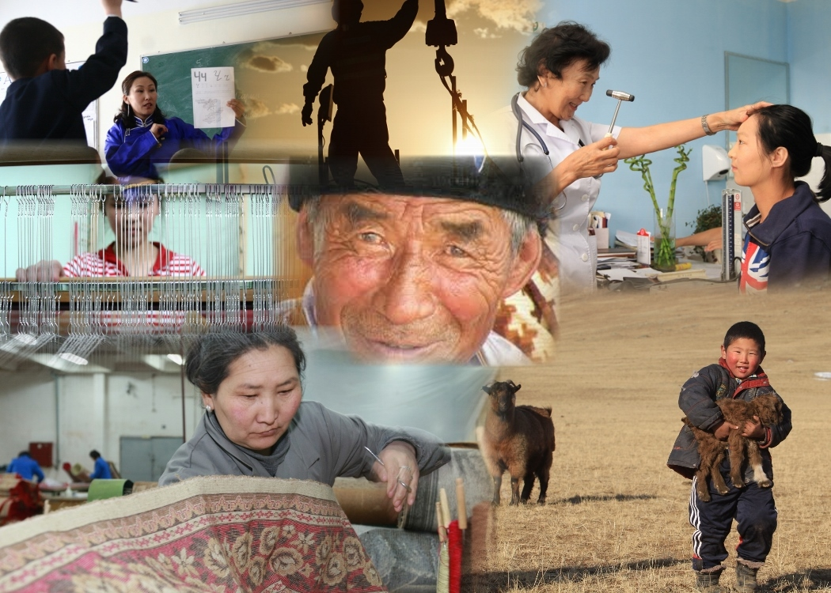

Ulaanbaatar, 12 September 2014
Puma Imperial Hotel

Contents:

  - Background
  - Opening remarks by Ms. Otgonjargal, State Secretary of MPDSP and Ms. Celine P. Bista.
  - Assessment based national dialogue on social protection and employment support in Mongolia: methodology, recommendations and agreed policy options Ms.Celine Peyron Bista, Chief Technical Advisor, MAPS Project, ILO Regional Office for Asia and the Pacific and Dr. S.Baigalmaa, National Project Manager, ILO MAPS Project
  - ABND in Mongolia: Rapid assessment protocol (RAP), results of the costing and preliminary considerations on the fiscal space, Ms.Celine Peyron Bista, Chief Technical Advisor, MAPS Project, ILO Regional Office for Asia and the Pacific and Dr. G. Enkhbayar, Professor of Public Management Academy
  - Working Group discussions on the next steps: Recommendations for improving coordination (policy and delivery)
- Group 1 – How to finance the SPF: Fiscal space analysis, taxes policies and budget allocations, Facilitator: G. Enkhbayar, Dr. Prof. Public Management Academy
- Group 2 – How to hand over the report to the government: Institutionalization of the ABND process, strategies for obtaining endorsement and launch by the Prime Minister and How to coordinate policies and implementation:
  - Results of the group discussions
  - Closing remarks of the Fourth ABND

- Background

In September 2013, the Government, notably the Ministry of Population Development and Social Protection (MPDSP) and the UN Country Team for Mongolia have launched the Assessment Based National Dialogue (ABND) on Social Protection and Employment support services (SP-ES).
During the first step of the ABND exercise, the development of the assessment matrix consists in (i) mapping for each of the four guarantees of the SPF an inventory of existing social security, social protection and poverty alleviation programmes, (ii) identifying policy gaps and implementation issues, and (iii) preparing a number of recommendations for the design and implementation of further social protection provisions with the aim of guaranteeing at a minimum the SPF to all the population.
Between September (launch of the ABND or Dialogue #1) and end of November 2013, the assessment matrix has been developed with all stakeholders involved in social protection in Mongolia, ministries and government agencies, social partners, civil society, academia and development partners, through national and local consultations.
The validation of the assessment matrix and key recommendation workshop (Dialogue#2) was held on 05 December 2013 in Ulaanbaatar. The workshop was attended by the Vice Minister of Population Development and Social Protection Mr E.Tamir, the Programme analyst of the ILO Country office for China and Mongolia Mrs. Samina Hasan and over 60 participants from ministries, agencies, local government institutions, academia, NGOs and UN agencies.
During December 2013 and May 2014, the key recommendations were selected, the scenarios are developed and costing of scenarios was estimated. On 13 March, a technical working group composed of experts and practitioners from MPDSP and Ministry of Labour, and the UN Working Group on Social Protection have converted the key recommendations into scenarios that can be further “costed”. These scenarios are specific social protection provisions that need to be introduced or further expanded to fill the gaps and guarantee at least a comprehensive social protection floor for all the population in Mongolia. The costs of these provisions is being calculated and projected over the 2014-2020 period using the ILO-UNICEF costing tool called the Rapid Assessment Protocol (RAP).
The third ABND exercise took place on the 2nd of May 2014 with the aim to share with all stakeholders the methodology of the RAP and preliminary results of the costing. In the morning session the official launching of the ILO MAPS project took place. Around one hundred technical staff and directors from relevant government institutions, workers and employers’ organizations, UN agencies, civil society representatives and other development partners that are dealing with social protection and employment support policies and programmes have attended the event. Also present were Mr. A.Isawa, Assistant Minister for International Affairs for the Ministry of Health, Labour and Welfare of Japan and Mr. Ya. Ariga, Deputy Director for Technical cooperation on labour international affairs division Ministry of Health, Labour and Welfare.
The high ranking officials of Mongolian counterparts have made welcome remarks in the occasion of the Launch of the Project, namely Mr. J. Bathuag, Vice Minister of Labour, Ms. B. Otgonjargal, State Secretary of MPDSP, Mr Adya, Secretary General CMTU and Mr. Erdenebaatar, Vice CEO, MONEF and Mr. Tim de Meyer, Director of the ILO office for China and Mongolia as well as Mr. Togtokhsuren, Governor of Uvurkhangai aimag, and Mr. D.Jargalsaikhan, Governor of Bayanhongor aimag.
From May to September 2014, the finalization of costing, observation of fiscal space and writing ABND draft report was implemented.

The fourth national dialogue “Assessing the cost of a social protection floor in Mongolia: validation of costing results and introduction of final report” was held on 12 September 2014 and had a goal to share with all stakeholders the final results of the costing of establishing a social protection floor and a draft of Report. Around 30 participants representatives of relevant government institutions, workers and employers’ organizations, UN agencies, civil society other development partners that are dealing with social protection and employment support policies and programmes took place in the discussion. Ms. Otgonjargal, the State Secretary of MPDSP, fully attended the morning session.

- The opening remarks

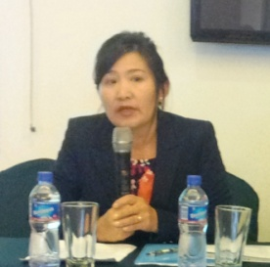 | In her opening remarks, Ms. B.Otgonjargal, State secretary of the Ministry of Population Development and Social Protection informed that the government is currently developing a new “Government policy guidelines on the pension reform” (2015-2030). The ABND will feed the drafting of this policy document. She also reminded the government’s commitment to explore the possible ratification of ILO’s Convention No.102.
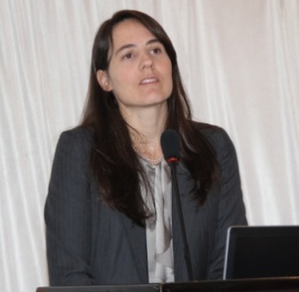 | Ms. Celine P. Bista, the CTA of ILO MAPS project, has thanked the MPDSP, in particular Ms. Otgonjargal, State Secretary, for the leadership in conducting the ABND and guiding the UN Working Group on Social Protection to achieve the results we have today. She also thanked Japan Government for a financial support due to which ABND is successfully implemented in Mongolia. Also she recalled that exactly one year ago, when the ABND just started she was approached with someone who asked whether Mongolia has a social protection floor in Mongolia. She re-stated again that Social protection is a human right not a luxury product and everyone without exception is entitled to basic social guarantees. Social protection is also a economic necessity.  She has emphasized that the results of the ABND show that achieving a social protection floor in Mongolia is recommendable and affordable. The country has made tremendous progress in extending social health insurance and education to all boys and girls; however effective and quality access still calls for policy actions. With only 8% of the herders contributing now for their old-age or being protected in case of maternity, sickness and accidents in an occupation that is prone to injuries, the situation calls for urgent responses. The results also urge for better linking social security with opportunities for decent, productive and sustainable employment for all women and men, including youth and people with disabilities. Achieving a social protection floor in Mongolia will not cost more than an additional 2% on budget that the government is already allocating to social protection, and it will guarantee a universal coverage and higher level of protection. This will represent a maximum cost of 26 USD per person per month to invest on social protection by 2020, less than a dollar per day.

3. Presentation: “Assessment based national dialogue on social protection and employment support in Mongolia: methodology, recommendations and agreed policy options”

Ms Celine Peyron Bista, Chief technical advisor of ILO MAPS project, recalled the SPF framework Concept and ABND Process. She highlighted that the Social Protection Floor is the first level of social protection in a national social protection system that enables and empowers all members of a society to access a minimum of goods and services at all times. It promotes income security through a basic set of guarantees including: (i) all residents have access to a nationally/provincially defined set of affordable essential health care services; (ii) all children enjoy income security through transfers in kind or in cash ensuring access to nutrition, education and care; (iii) all those in active age groups who cannot (or should not, in case of pregnancy) earn a sufficient income enjoy a minimum income security through social transfers in cash or in kind or employment guaranteed schemes ; and (iv) all residents in old age and with disabilities have income security at least at the level of the nationally defined poverty line through pensions for old age and disability or transfers in kind.

In her presentation, Ms. Bista also described the difference between proxy means/targeted and universal coverage of social protection as an answer to on-going debate in Mongolia. She has stated that the Social protection has 2 functions: one is a protective function by protecting people from financial risks caused by life and market’s changing circumstances; and a transformative function, especially in developing world promoting people’s opportunities (human development capital, employment promotion).

She brought forward the following 5 arguments that support universal coverage of social protection:
- Social protection is a universal human right;
- All faces individual and labour market related risks (Indonesia, UNRISD);
- Means tested targeting social assistance is counterproductive (van Oostrocht, 2002);
- Means tested targeting social assistance weakly links to redistribution and reduction of poverty (Gugushvili and Hirshi, 2014);
- Universal coverage is affordable (ILO, 2006, and RAP Thailand, Indonesia, Mongolia)
1. Social protection is a human right. The Article 22 of Universal Declaration of Human Rights has stated that every human has a right of social protection. Universal SP: providing at least access to a minimum guarantee of social services and income security (Social Protection Floor)
2. All faces individual and labour market related risks, universal social protection gives an opportunity for better risk management. Below is a Growth Incidence Curve of Indonesia developed by United Nations Research Institute for Social Development. 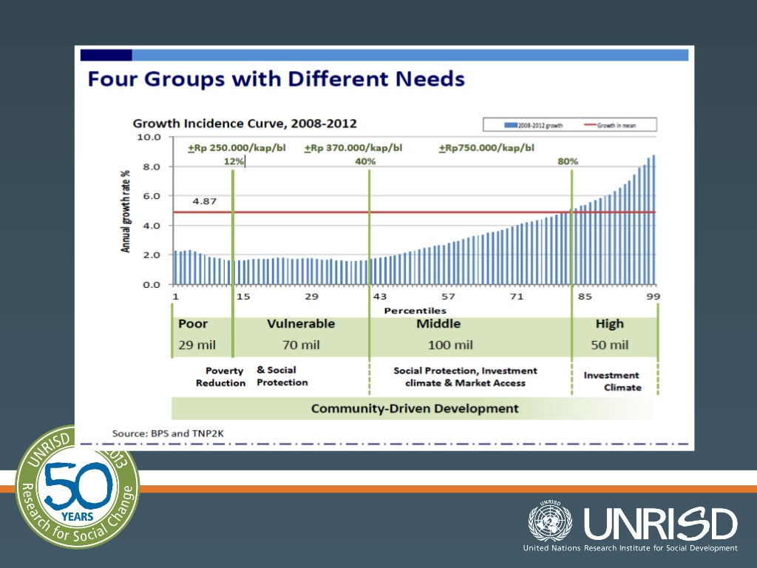
The target of proxy means scheme of social protection is poor; however 70 million people of vulnerable groups and one third of middle class have the similar level of income. It is proven that identifying the target group is the most challenging work and there is a danger of subjective selection on the grass root.
3. The universal coverage helps to organise more efficient use of resources. Means tested targeting social assistance has higher administrative costs, as the selection criteria require well developed identification and monitoring systems, whereas universal benefits allow for less complex eligibility procedures. Also, there is a dependency traps, where benefit recipients have little incentive to take up work or increase working hours because this would entail loss of benefits.
4. The universal social protection is more redistributive and inclusive.
- Exclusion/inclusions errors, none of the means tested is perfect, some ‘truly needy’ are bound to be excluded from the schemes, while part of the benefits will definitely leak out to those not in need.
- Selection process often rely on local authority and community, with risks of influenced judgments.
- If the income or number of livestock serves as eligibility criteria, households may split their income and/or livestocks among different family members.
- Lower take-up rates, partly because of stigmatization issues.
- Targeted approaches do not provide comprehensive social protection responses, that will link with productive and sustainable employment.
- Universal programmes lead to formalization of informal economy (registration)
5. The universal social protection is normally affordable. The universal social protection costed in the range between 3.7% and 10.6% of GDP for a number of low-income countries in 2010 (ILO). The universal coverage includes:
- Universal basic old-age and disability pensions,
- Basic child benefits,
- Universal access to essential care and
- Social assistance/100 days employment scheme
The table below describes the results of RAP calculation for universal child allowances. None of the countries except Mongolia has a universal child allowance at the moment, therefore Thailand, Indonesia and Vietnam are discussing through ABND a provision of introducing universal child allowance.
Country | Programme | % GDP
Thailand | THB 400/ month (US$ 15.6) (indexed)  0-12 years old | 0.34% (2020)
Indonesia | 33,333 RPs/ year (US$ 2.8) (indexed); 0-15 years old | 0.18% (2020)
Viet Nam | VND 255,500 (US$ 12.1) / month (indexed); 0-15 years old | 3.43% (2020)
Mongolia | 20,000 MNT / month (US$ 10.9) (indexed); 0-18 years old | 2.07% (2012)  1.00% (2020)

According to RAP calculations, the introduction of universal child allowance of 15.6 USD in Thailand would cost only 0.34 percent of GDP, in Indonesia 0.18 percent of GDP (2.8 USD per child) and in Vietnam 3.43 percent of GDP by 2020.

Also, Ms. Bista has shared with participants some thoughts about economic gains of universal social protection:
- Healthier and more productive work force (less absenteeism)
- Factor and stabilizer of consumption (less savings, during economic crisis)
- Risks management: costs for health, working injury, maternity, unemployment are shared among employers/employees, among SME and large companies,
- Alleviate burden of coping with high expenses

Dr. Baigalmaa Sanjjav has presented the process of ABND in Mongolia and the main recommendations drawn from the previous dialogues.

The Assessment based national dialogue currently being conducted in Mongolia had responded to the following 4 questions: i) What is the situation of Social protection in Mongolia?, ii) How far are we from the social protection floor? iii) What should we do in order to achieve the social protection floor? and iv) How much would it cost to close these gaps? The answers to above questions were summarized in the matrix:

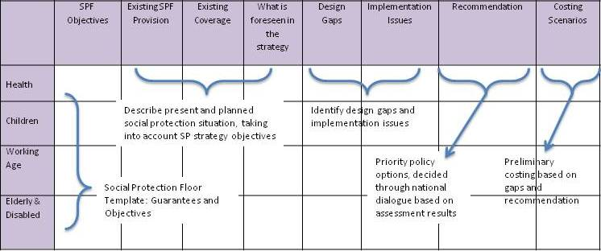

After finalizing the answers to above 4 questions there is still a need for further steps, which is beyond ABND and requires more active participation from the Government: v) How to finance the new social protection floor provisions? vi) What would be the return on investment? and vii) How to coordinate policies and implementation?
The ABND is now at the stage of validating the final results of RAP costing of a nationally defined Social Protection Floor in Mongolia and discussing whether there is a fiscal space to implement the additional provisions.

1.2 Discussion on Recommendations
STEP 1 – From situation analysis to recommendations
JUN
JUL
AUG
SEP
OCT
NOV
DEC
JAN
FEB
MAR
STEP 2 - Costing
2.1 Translation of recommendations into “costable” scenarios
2.2 Data collection (I) on POP, ECO, EAP, parameters for each scenario and projection of the costs using the RAP protocol
2.3 Preliminary results of the costing
1.1 Inventory of schemes, gaps, issues
2 May 14
2.4 Data collection (II) on GGO, ECO and finalization of the costing
3.1 Writing final assessment report
9 Sept. 14
STEP 3 – Finalization
3.2 Presentation to the Government
X?
2.5 Validation workshop
APR
MAY
SEP
OCT
NOV
JAN
5 Sept. 13
10 Au
5 Dec. 13

The results: recommendations and definition of the social protection floor in Mongolia
The proposed recommendations and the definition of the social protection floor in Mongolia are summarized in table below.

Guarantee | Proposed scenarios
Health  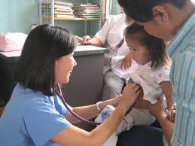 | - Increase the contribution rate of Category II (herders, unemployed, vocational students) for social health insurance (SHI)  - Include drugs in high demand in the list of essential medicine (for reimbursement at 100%)  - Reinforce monitoring and inspection role of the SHI offices to ensure quality at aimag- and soum-levels  - Ensure equality of treatment between Nationals and Non-nationals (higher contribution)  - Gradually decrease the out-of-pocket payment expenses  - Introduce a smart card registration system
Children   | - Keep the Child Money programme as it is  - Improve social inclusion of children with disability, e.g. by providing disability-friendly facilities  - Increase the meal allowance in pre-schools.  - Introduce supervisory mechanisms for higher safety and quality of meals in kindergartens and pre-schools  - Increase the number of kindergartens to improve its access for the excluded 25%
Working age  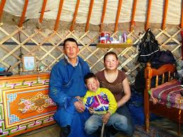 | - Increase replacement rate of maternity benefits under the voluntary social insurance (SI) scheme to the level under the mandatory SI scheme  - Increase flexibility in qualifying conditions and level of unemployment benefits  - Subsidize contribution of voluntary SI to improve coverage  - Introduce SI registration as a condition to EPP and subsidize SI contribution for EPP beneficiaries  - Entrepreneurship and vocational training for young herders (linked to SI)  - Training for unemployment benefit recipients  - Reinforce employment promotion services, e.g. counselling  - Training for disability pension beneficiaries to re-enter labour market  - Awareness and information campaign on EPP in rural areas
Elderly  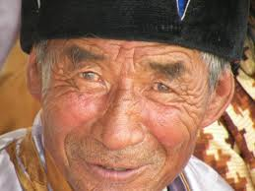 | - Equal retirement age between female and male  - Introduce a three pillars pension system: Pillar 0: universal minimum pension; Pillar 1: Contributory SI pension (voluntary and mandatory); Pillar 2: Complementary individual saving accounts.  - Develop long-term care and support system for elderly  - Improve integration of the benefits package for vulnerable elderly poor

For each guarantee the following conclusions were made:

Guarantee 1. Access to Health - Universal social health insurance coverage is achieved in the country, but the issue of effective access to quality health services still missing.


Level of Protection
Poor
Informal sector
Formal sector
SHI (mandatory & subsidized from the State)
Limited SHI coverage gap (8%, Cat. III)

Guarantee 2. Income security for all children is achieved - Income security, health and education for all children is achieved, but quality of nutrition and education is an issue.
Poor
Informal sector
Formal sector
Social Protection
Level
Social Health Insurance
Social welfare
programmes
Child Money Programme

Guarantee 3. Income security for working age - there is still a GAP.

Poor
Rest of Informal sector
Formal Sector
Level of Protection
SW targeted programmes
Social Insurance programmes
Coverage gap

Recommendation: Subsidy on social insurance, return to work and youth support programmes

Poor
Herders and self-employed
Formal sector
Level of protection
Subsidized SI
Better targeted EPP, increased outreach
SI + EPP= Reduce vulnerabilities and gradually increase formal economy

Guarantee 4. Income security for elderly - there is still a GAP
Poor
Herders and self-employed
Formal sector
Protection level
Voluntary insured
Social pension =115 000 MNT
Coverage gap

Recommendation: Subsidizing the contribution
Pillar 1
Poor
Herder and self-employed
Formal sector
Subsidized contributions
Pillar 1 Universal Basic pension
Protection level
Pillar 1
Pillar 2
Pillar 3
Pillar 2
Pillar 3

The results: cost of SPFs in Mongolia.

Ms. Celine P. Bista has continued the presentation with the brief description of the RAP costing tool, which is developed by ILO and UNICEF jointly.

For RAP calculations the following scenarios were used:
Guarantee | Low scenario for a SPF in Mongolia | High scenario for a SPF in Mongolia
Health | Increase the SHI contribution of herders, self-employed and vocational students to 1% of minimum wage | Fully subsidize the SHI contribution of herders, self-employed and vocational students
Children | Index the child allowance on inflation
Children | Index the pre-school meal allowance on inflation | Increase and index the pre-school meal allowance
Working Age | Increase the replacement rate during maternity leave to 100% for herders, self-employed and informal workers
Working Age | Subsidize the voluntary contribution to the maternity, sickness, injury insurance fund by 50% | Subsidize the voluntary contribution to the maternity, sickness, injury insurance fund by 70%
Working Age | Subsidize the voluntary social insurance contribution for beneficiaries of Employment Promotion Programmes by 50% or 100% (depending on the programme) | Fully subsidize the voluntary social insurance contribution for beneficiaries of Employment Promotion Programmes
Working Age | Implement new entrepreneuship and vocational training programmes for young herders, with social insurance contribution fully subsidized
Working Age | Implement a new EPP for persons under the pension disability pension and UI benefits
Elderly | Subsidize the voluntary old-age pension contribution by 50% and index the social welfare pension | Subsidize the voluntary old-age pension contribution by 70% and index the social welfare pension

The results of the RAP calculation exercises show that achieving a social protection floor in Mongolia is recommendable and affordable.

The RAP estimates that achieving a social protection floor in Mongolia will cost an additional 1.98% of GDP for a high scenario and 1.05% for a low scenario on the top of the already committed government’s social protection expenditures.

Dr. G. Enkhbayar, Professor of Public Management Academy, has presented the situation of a fiscal space of social protection in Mongolia.
The Government budget expenditure follows the revenue. During 2010-2011, the time of high price on commodities on the world market, Mongolia had a booming economy with GPD growth of 17-14 percent per annum. At this time Mongolia has increased its budget expenditure sharply without building enough funds for future.

The government expenditure for social protection, with a projection until 2020 based on Mid-Term Fiscal Framework 2015-2017 and prognosis of MED from 2018-2020 shows that by 2020, Mongolia will spend about MNT 1,110.0 billion for social protection, which equals to 2.5 % of GDP. In 2012 and 2011 Mongolian social protection expenditure reached its highest pick, occupying 9.5 and 8.6 percent of GDP. Since that time, share of social protection expenditure to GDP is steadily decreasing.

The share of social protection budget without any interventions to introduce Social protection floor, and the share of SP budget to GDP if Mongolia implements a low scenario and high scenario of social protection floor.

According to the World Social Protection Report 2014-2015 produced by ILO recently, Mongolian social protection expenditure is well below the World average.

Table: Social protection expenditures (% to GDP)
 | Countries | 2011 | 2012 | 2013
1 | Nepal | 2.31 |  | 2.19
2 | Cambodia | 1.79 |  | 2.23
3 | Kenya | 2.61 |  | 3.26
4 | Haiti | - |  | 3.27
5 | Tajikistan | 5.31 | 6.75
6 | Armenia | 8.46 |  | 8.61
7 | Mongolia | - | 8.87
8 | South Korea | 9.14 | 9.30
9 | Kirgizstan | 8.30 | 9.58
10 | Chili | 10.18 | 10.43 | -
11 | Russia | 15.97 |  | -
12 | Poland | 20.51 |  | 20.94
13 | USA | 19.56 |  | 20.03
14 | Hungary | 21.92 |  | 21.56
15 | Germany | 25.89 |  | 26.18
16 | Finland | 29.22 |  | 30.53
17 | France | 32.02 |  | 33.02
18 | Asia Pacific average |  | 5.3 | 5.3
19 | World average |  | 8.8 | 8.6

The expenditures of social protection will not cause big risks for Mongolian Government budget; it is affordable for budget.

The major risks of Government budget is associated with the following 3 situations:
1. Inflation - until today Mongolia had a goal to keep inflation below two digits, but according to latest statistics the inflation is already 14.9 percent yoy.

2. Payment of external debts:
According to latest statistics, the years between 2013-2035 are the years when Mongolia has to pay substantial amount of external debts, which could lead to destruction of government expenditures.

3. The revenue of Mongolian Government Budget from commodity prices is likely not to increase:

Dr. Enkhbayar has also emphasized that in addition to the above mentioned risks there is another big risk, which is the Parliamentary election of 2016 and Presidential election of 2017.

Working group discussion –

Next steps: Recommendations for improving coordination of policy and delivery

The participants were divided into 2 groups as follows:

    - Group 1 was to discuss how to finance the SPF: Fiscal space analysis, taxes policies and budget allocations, Facilitator: G. Enkhbayar, Dr. Prof. Public Management Academy
    - Group 2 was to discuss how to hand over the report to the government: Institutionalization of the ABND process, strategies for obtaining endorsement and launch by the Prime Minister and how to coordinate policies and implementation. Facilitator: Celine P. Bista; Baigalmaa S.
Presentation of groups:

Group 1. How to finance the SPF: Fiscal space analysis, taxes policies and budget allocations.

The group has discussed the different scenarios of how to increase the Government budget revenue and how to reduce the budget expenditures:
How to increase the revenue of the Government:
- The income tax of individuals should have two levels: 10% tax for the persons that earn less than 10 times of minimum wage and different (higher tax) for ones that earn more than 10 times of minimum wage.
- Introduce two level of taxes for VAT: 10% for consumers goods and 40% for luxury goods
- Introduce higher level of social insurance contributions for wealthier segment of population
- Introduce property taxes - improve privatization of land
Another way of creating a fiscal space is reducing the budget expenditures through:
- Reduce the number of government institutions, too much overlapping
- Reduce the number of government officials; Only in one year from 2013 to 2014 the number of public officials has increased by 30.0 thousand (from 150.0 thousand to 180.0 thousand).
- Increase efficiency of public services;

Group 2. How to hand over the ABND report to Government and how to coordinate policies and implementation:

The participants of Group 2 has agreed on the following work plan for preparing the launch of the ABND report:
- ILO to finalize the draft 1 of the report and the RAP, by 30 September 2015,
- Rapport translated into Mongolian and circulated by 31 October,
- Clearance obtained from UN agencies/UN Resident Coordinator and the following partners: MPDSP, MOL, MOH, MOE, MOF, including the foreword, by 15 December 2015,
- Final report ready for printing by 31 January 2015,
- In the meantime, preparation of a PSA “Why social protection is important to me?” and some pamphlets and fact sheets,
- Possible launch by the Prime Minister on the day prior to the National Day on Social Protection (not possible to be done on the same day), 22 April 2015.

The group also discussed some initiatives to pursue the coordination on social protection initiated with the ABND. The UN agencies working on social protection should identify one or two recommendation that they will translate into concrete technical assistance, with sufficient resources, and include this intervention in the UNDAF. This will be discussed during the next UN Working Group on Social Protection. The Government-UN social protection working group will also work on developing a monitoring framework with indicators to measure the effective implementation of the ABND recommendations. This monitoring framework will be based on the SPF indicators developed by ILO and the work now being undertaken by the MAPS project in ASEAN, and should be presented during the launch of the ABND report too.

