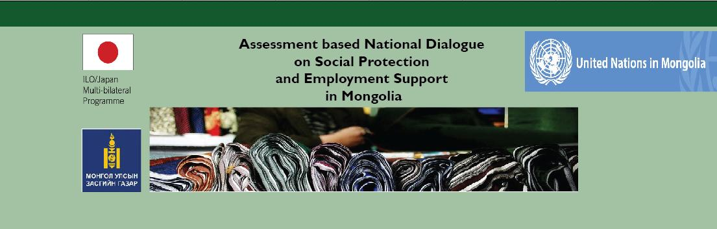
Fourth Dialogue: Validation of the costing results and draft report

Friday - 12 September 2014, Puma Imperial hotel, Ulaanbaatar
Time |  | Session
09:00-09:30 | Opening remarks  - Ms Otgonjargal, Ministry of Population Development and Social Protection, Director of the SP Policy Implementation Department  - Ms.Celine Peyron Bista, Chief Technical Advisor, MAPS Project, ILO Regional Office for Asia and the Pacific
09:30- 10: 45 | Assessment based national dialogue on social protection and employment support in Mongolia: methodology, recommendations and agreed policy options  - Ms. Celine Peyron Bista, Chief Technical Advisor, MAPS Project, ILO Regional Office for Asia and the Pacific  - Dr. S.Baigalmaa, National Project Manager, ILO MAPS Project  Questions and answers
10:45-11:00 | Coffee Break
11-00-11.45 | ABND in Mongolia: Rapid assessment protocol (RAP), results of the costing and preliminary considerations on the fiscal space  - Ms. Celine Peyron Bista, Chief Technical Advisor, MAPS Project, ILO Regional Office for Asia and the Pacific  - Dr. G.Enkhbayar, Professor of National Academy of Management  Questions and answers
12:00-13:30 | Lunch
13:30-15:00 | Group discussions on the next steps: Recommendations for improving coordination (policy and delivery)  Groups are divided into three groups on a rotating basis (Group-1 discusses the first topic for 30 minutes, then move to Group 2, and then to Group 3), as below:  Group 1 – How to finance the SPF: Fiscal space analysis, taxes policies and budget allocations  Facilitators: Dr. G.Enkhbayar, Professor of National Academy of Management  Mr. George Langis, International actuary expert  Group 2 – How to coordinate policies and implementation: Existing coordination mechanisms and recommendations for improving integrated design and delivery of the SPF guarantees and social services, how to hand over to the government: Institutionalization of the ABND process, strategies for obtaining endorsement and launch by the Prime Minister  Facilitators: Ms. Celine Peyron Bista, Chief Technical Advisor, MAPS Project, ILO  Regional Office for Asia and the Pacific  Dr. S.Baigalmaa, National Project Manager, ILO MAPS Project
15:00-15:30 | Results of the group discussions
15:30-15:45 | Coffee break
15:45-16:15 | Steps forward and calendar:  - Ms. B.Otgonjargal, Ministry of Population Development and Social Protection, Director of the SP Policy Implementation Department

