For presentation at the ILO International Workshop

Linking Work and Welfare for Vulnerable People

Hur, Jai-Joon and Kyu Sik Cho

May 30, 2013

Economic and Social Development Commission,
Republic of Korea

* Director-General of Employment Policy Research Division, Korea Labor Institute
** Policy Analyst, Economic and Social Development Commission, Republic of Korea

Program ID card

Program name and its characteristics: Successful Employment Package, an activation program to link work and welfare for vulnerable people.

Date of inception: 2009

Legal framework: Government initiatives in the context of ALMP to link work and welfare for vulnerable people and the self-support component of ‘National Basic Livelihood Security Act’

National social protection strategy or development plan: Linking work and welfare for vulnerable people had not received the spotlight in the context of a national social protection strategy until 2010, while its importance had been emphasized by the academia and policy researchers since mid-2000s. The present Park Geunhye administration, which started February 2013, has put it on the national policy agenda.

Objectives: i) minimizing the risk of falling into poverty in the case of unemployment or joblessness, and ii) maximizing poor people's capability for self-support;

Target population: Workable poor and working poor (those below 150% or less of minimum living costs)

Institutions involved: The program was designed by the Ministry of Employment and Labor, Korea Labor Institute, and other experts in the academia; Employment Centers, local government, private self-support centers, private employment service companies, and private training companies participate in implementing the program.

Status of program: It has been implemented since 2009, going through modifications.

Services provided: Setting a plan to self-support via diagnosis and intensive counselling; capacity building via group counselling, vocational training workplace experience, entrepreneurial school, etc; intensive job placement service; allowances during participation period and success bonus.

Lessons to be learned: It is crucial to provide individualized comprehensive employment services which link employment services and social services, combined with relevant allowance during the participation period for the government to support self-sufficiency of low-income people.

Contents

I. Background

II. Labor market context and stylized facts
1. Increase in poverty
2. Stylized facts about vulnerable groups

III. Policy initiatives to protect vulnerable groups
1. Two activation programs in competition: Successful Employment Package and Hope Ribbon Project
2. Subsidy for social insurance premiums

IV. Evaluation and Identified Challenges
1. Evaluation of the programs
2. Challenges for workfare delivery system
1) Current status of delivery system
2) Persistence of duality of the delivery system
3) Limited inter-ministerial collaboration depending on cases
3. Lessons to be learned

Acronyms

NBLS: National Basic Living Security
SEP: Successful Employment Package

- Background

These days, many countries have directed more of their social policy efforts and resources towards 'vulnerable groups' due to the growing trends of global competition, increased flexibility in the employment relationship, prevalent uncertainties in the economy and a greater frequency of economic crises.
Up until the foreign exchange crisis in 1997, Korea could minimize welfare needs by achieving high economic growth, which was recorded as an annual rate of 8.3% on average. Therefore, the share of social expenditure in the total government expenditure was moderate compared to other OECD countries. Since the two economic crises (the foreign exchange crisis in 1997 and the global financial crisis in 2008), however, income distribution has aggravated considerably and 'vulnerable groups' have emerged as the key target of the government's policies on employment and welfare.
As a consequence, the welfare policy to protect vulnerable groups and support their self-sufficiency has received the spotlight and become an issue of hot debate. Two policy measures, called ‘Successful Employment Package Program’ and ‘Hope Ribbon Project’, were launched by the Ministry of Employment and Labor and the Ministry of Health and Welfare, respectively. However, these policy measures leave much room for improvement: they fail to identify their target groups, the programs for integrating the vulnerable to the labor market and welfare programs are not well coordinated, and employment and welfare services are not reaching the appropriate target groups due to a lack of investment in the delivery system and an uncoordinated delivery structure.
As it becomes more and more crucial to map out policy initiatives to help vulnerable groups climb their way out of poverty, the government needs to increase links among the institutions, programs and services to promote work and welfare by: i) minimizing the risk of falling into poverty in the case of unemployment or joblessness; ii) maximizing poor people's capability for self-support; iii) making effective investments in vocational training and human resources development; and iv) creating a dynamic labor market which enables a smooth transition to stable work with higher incomes.
The purpose of this paper is to review the existing institutions, programs and services in the area of welfare-to-work in Korea and to share its experiences, focusing on the policy objectives proposed above. For this purpose, this paper first explains the labor market context of such policy initiatives and stylized facts found about vulnerable groups. Secondly, this paper reviews existing policy measures aimed at protecting vulnerable groups. Thirdly, the authors present elements of program evaluation and identified challenges to Korea’s workfare policy so that it protects vulnerable groups effectively, which is the background for launching a committee in the Economic and Social Development Commission. The "Tripartite Agreement on Reinforcing the Social Safety Net for Enhancing the Capacity of Welfare-to-Work", which was concluded at the Economic and Social Development Commission, is briefly explained in the appendix.

- Labor market context and stylized facts

- Increase in poverty

After being hit by adverse shocks in 1998, the Korean labor market fell into an unprecedented turmoil. Unemployment soared while non-regular workers and low-educated workers suffered disproportionately. Jobs were made increasingly precarious and core disadvantaged groups in the Korean labor market experienced recurrent unemployment, even if they did not fall into the long-term unemployment trap. Wage differentials between low-end workers and others widened and the gap in income distribution increased significantly.
The Gini coefficient drastically increased from 0.264 in 1997 to 0.293 in 1998 and further to 0.320 in 2009, which shows that income distribution was strikingly aggravated following the two financial crises (Figure 1). The aggravation of income distribution resulted from the reduction of low-income earners’ wages rather than from a fall in medium-income earners’ wages.

Figure 1. Poverty ratio and Gini coefficient

Note: Calculation based on market income of urban households with two or more family members
Source: Statistics Korea, KOSIS.

Figure 2. In-work poverty rate

Note: Calculation based on disposable income of urban households with two or more family members
Source: Statistics Korea, Household Survey and Hwang and Lee (2011)

The share of middle-income earners decreased from 75.4% in 1990 to 71.7% in 2000 and 67.5% in 2010, respectively. The share of poor people increased from 7.1% in 1990 to 9.2% in 2000 and 12.5% in 2010, respectively. The in-work poverty rate (the share of working poor among the employed) has also been on a steady rise from 4.7% in 1990 to 5.2% in 2000 and 7.5% in 2010, respectively (Hwang and Lee, 2011; Figure 2).

- Stylized facts about vulnerable groups

Several characteristics have been found about people in poverty. These can be summarized with four facts(Hur et al 2007, Hwang and Lee 2011):
- Risk of prolonged poverty due to unemployment: low-income families have a high risk of prolonged poverty in the case of unemployment. The evidence shows that a third of the low-income families with an unemployed family head stayed in poverty even after three quarters of a year from the date of the family head's job loss.
- Employment insecurity : precarious work, including temporary or daily jobs, self-employed people and unpaid family workers, accounted for 83.6% of the working poor. About 10% of those in precarious work are in poverty.
- Low-pay employment: the main reasons, which are attributable to the labor market, for people's poverty despite their paid work lie in low wage rates and a discontinuance of employment.
- Persistence and recurrence of poverty: those with precarious and low-wage jobs have a high rate of poverty experience. This population has a high frequency of exiting poverty, but as they remain just above the poverty line even after they get out of poverty, they also have a high risk of returning to poverty.

- Policy initiatives to protect vulnerable groups

- Two activation programs in competition: Successful Employment Package and Hope Ribbon Project

- Successful Employment Package

The Successful Employment Package (SEP in the following) is one of the key employment service programs for vulnerable groups which are implemented by the Ministry of Employment and Labor since 2009. In line with the call for the effort to institute a package program of employment support for low-income and vulnerable people specified in the “quadripartite (the government, employers, workers and civic groups) agreement" of February 23, 2009, the government integrated and expanded the existent self-support programs targeting the recipients of the National Basic Living Security(NBLS in the following) benefits into the SEP program for low-income people and began to run the program in 2009. The Youth New Start Program, the Elders New Start Program and the Stepping Stone Jobs Program, three major employment support programs for vulnerable groups under the Ministry of Employment and Labor, were integrated into the SEP program in June 2010. The implementation process is described in Figure 3.
For the implementation of SEP program, the Ministry of Employment and Labor has built a network of cooperation with local governments and selected about 5,300 participants from among the 20,000 low-income people listed by the local governments. The number of participant quota increased because of the aggravated labor market condition resulted from the global financial crisis. The SEP program was cited as a good example of closer interactions between the welfare and employment service delivery systems. In 2010, the first year when the program was in full operation, 29,110 persons participated in the program, and 9,800 out of the 14,591 graduates succeeded in getting employment, recording a success rate of as high as 67.2%. In 2011, the government provided SEP service to a larger number of vulnerable people (Table 1).

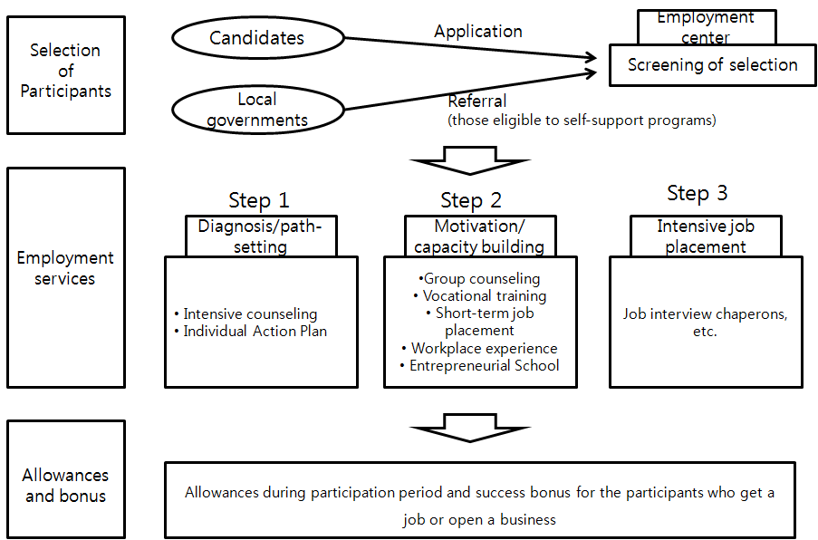
Figure 3. Implementation process of the Successful Employment Package program

- Hope Ribbon Project

This program, run by the Ministry of Health and Welfare, is designed to provide individualized case management and job placement services for vulnerable groups. Based on the individualized case management of recipients of the NBLS benefits (those below poverty line) and the group immediately above the poverty line (those below 120% or less of minimum living costs), customized employment and welfare services are offered to those target groups. The implementation process of the Hope Ribbon Project is described in Figure 4: The local government concludes a performance contract with the service provider → The local government receives applications and selects participants → The service provider provides welfare services for the participants → Job placement services are offered → Follow-up services are offered.
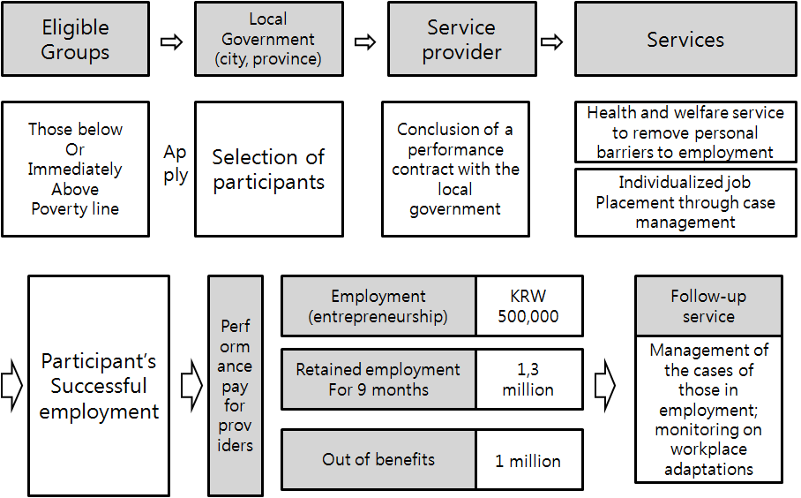
Figure 4. The Hope Ribbon Project

The service providers (provincial Self-Support Centers and the private employment service provider such as ‘Ingeus’) were chosen in an open competition system and the performance-based pay was adopted in order to increase the providers' self-support performance. In order to facilitate the employment and entrepreneurship of low-income people individualized one-to-one services are provided. In addition, the service providers may receive budgetary aid, the amount of which depends on their performance. The pilot project started in 2009 and, as of 2012, the program participants numbered approximately 4,000 in seven metropolitan cities and provinces.
‘Conditional recipients’ (those who receive NBLS benefits on the condition that they participate in self-support program) whose self-support capacity score is 70 points or higher are referred to the SEP program. A case manager, who covers about 40 participants, searches for community-based jobs and matches them with suitable participants. Welfare services (for housework, caring, nursing, etc.) are also offered to boost the participants’ motivation to work and remove practical ‘barriers to employment’.

- Subsidy for social insurance premiums

It has been widely agreed that, given the reality where small self-employed businesses and non-regular or informal employment take up a considerable share in the labor market, the traditional efforts for increasing the social insurance coverage are not sufficient in addressing the problem of unprotected workers.
In regard to Employment Insurance, only 25.7% of the employees in businesses with fewer than 5 employees were covered by insurance. Similarly, the EI coverage rate for temporary and daily workers in small businesses, who were regarded as 'vulnerable workers', was merely 29.8% and 7.4%, respectively. In the sectors which are highly represented by part-time or contract-based jobs, the employers and employees often collude with each other to avoid joining and contributing to the insurance. In the case of the National Pension, the share of those who filed a suspension of paying contributions has not decreased for the past 10 years, just hovering around 50% for small self-employed businesses.
As of 2010, among the wage workers who were to be covered by the Employment Insurance (13,915,000 persons), 67.0% (9,330,000 persons) were contributing to the three social insurances and 4,585,000 (33.0%) had at least one social insurance to which they were not contributing. Furthermore, it turned out that 83% of the latter group (3,821,000 persons) was covered by none of the three insurances.
Hence the share of the unemployed temporary and daily workers eligible for unemployment benefits was particularly low compared to permanent workers, the foremost reason for non-eligibility being no contribution to EI (Table 1).
With a wide coverage concentrated on regular workers and a narrow coverage on non-regular workers, the social insurances in Korea result in degrading the vulnerable people beyond the reach of the social insurances, who frequently fall into absolute poverty upon their job loss or retirement.
As there are a large number of people who fail to join the social insurances or avoid paying contributions, the social insurance system undermines the effective implementation and delivery of employment policies and services. The lack of protection by the social insurances increase the burden on the public assistance programs (e.g. the NBLS program) and will ultimately keep working against the efforts of economic growth and income distribution which are geared towards social integration.

Table 1. Reasons of ineligibility for unemployment benefits
(Unit: %)
 | Non-recipients by reasons |  |  |  |  | Recipients
 | No contribution to EI | Minimum period for eligibility not fulfilled | Reason of separation not justifiable | Benefits exhausted | Others | Recipients
Regular workers | 9.0 | 5.7 | 34.2 | 6.6 | 7.6 | 37.0
Temporary workers | 46.9 | 11.6 | 25.1 | 2.7 | 6.5 | 7.2
Daily workers | 61.6 | 13.5 | 14.9 | 1.1 | 6.6 | 2.3
Source: Statistics Korea, Supplementary survey on unemployed people not eligible to unemployment benefits of the Economically Active Population Survey, April 2009

In this sense, it is vital to reduce the loopholes in the social insurance coverage and guarantee more protection for low-income and vulnerable people by relieving the costs of social insurance compliance for low-income workers and their employers. If the vulnerable and low-income workers continue to remain beyond the reach of social insurances, it is highly likely that they, especially those in informal sectors, will be stranded in a cycle of unemployment and poverty during their working lives and end up in poverty after retirement as they have no guarantee for the right to pension benefits.
As the social insurances have a uniform rate of insurance premiums for all workers, regardless of their income level, low-wage workers experience higher marginal tax rates. This lowers the demand for and restricts the compliance rate of low-wage workers.
Recognizing that, the Employment Insurance System is still riddled with holes despite all the efforts made since 1998 on the legislative level (Table 2), thus a considerable part of vulnerable groups remain unprotected and, therefore, the social insurance system is limited in its roles and functions as a social safety net, the government introduced subsidies for social insurance premiums as an incentive for a larger coverage of low-income workers. The subsidies for social insurance premiums are offered for the Employment Insurance and the National Pension. Eligible recipients of this subsidy are low-wage employees and their employers in businesses with fewer than 10 employees who contribute to the Employment Insurance and the National Pension. The subsidy level is from 1/3 to 1/2 of the premiums paid by the employer and the employee (Table 3).

Table 2. Coverage Extension of EIS

Date | Unemployment  Insurance Component | Employment Maintenance/Promotion Subsidies & Job Training Component
July 1, 1995 | ≥ 30 employees | ≥ 70 employees
January 1, 1998 | ≥ 10 employees | ≥ 50 employees
March 1, 1998 | ≥ 5 employees | ≥ 50 employees
July 1, 1998 | ≥ 5 employees | ≥ 5 employees
October 1, 1998 | ≥ 1 employee | ≥ 1 employee

Table 3. Eligible wage range and subsidy level
Eligible wage range  (monthly average in KRW million) | Subsidy level
1.05 or more but less than 1.25 | 1/3 of the premiums paid by the employer and the employee
0.35 or more but less than 1.05 | 1/2 of the premiums paid by the employer and the employee

- Evaluation and Identified Challenges

- Evaluation of the programs

Many of the previous employment support programs of the Ministry of Employment and Labor were criticized for their drawbacks, such as low success rates, deadweight loss and substitution effect; on the other hand, the SEP program has been praised for helping vulnerable people work themselves out of poverty due to the high rates of employment and retained employment among the participants. The employment success rate amounted to 54.1% in 2009, 67.2% in 2010, and 65.2% in 2011, respectively (Table 4). The rate of employment retained for six months or longer was recorded at 58.7%.

Table 4. The number of participants and employment success rate the SEP program
(Unit: persons, %)
 | 2009 | 2010 | 2011
Number of participants | 9,831 | 29,110 | 63,728
Job finding rate | 54.1 | 67.2 | 65.2
Note: Job finding rate is defined as a rate of success within twelve months which is the maximum duration of ‘Package’ program per participant.
Source: Ministry of Employment and Labor.

Despite that the SEP program is an expensive program compared to simple placement service which public employment service agencies have delivered traditionally, the participation allowance is not large enough to work as an effective incentive for urgent low-income earners to participate in the program. Also, it is not easy for Employment Centers to access local residents, and they don’t serve the function of case management properly due to the lack of professional counselors. Even if the demand for professional counseling service has increased, the strict regulation of small government prevents Employment Centers from increasing the number of staffs. As a natural consequence, a disproportionately large part of the program has been contracted out to private providers.
As the individualized case management service is an essential part of the SEP program, it is necessary to restructure the existing employment service system in a direction towards a paradigm of case management services and build the required infrastructure with a view to ensuring greater efficiency and continuous development of the program. Yet, the organization and structure of employment services remain unchanged in most Employment Centers, leaving the transition to a new working structure as a future task for the government.
The SEP program and the Hope Ribbon Project have many things in common. However, the Ministry of Health and Welfare and the Ministry of Employment and Labor is competing rather than cooperating. It is crucial to work out ways to coordinate or integrate the two programs.

Table 5. Successful Employment Package vs. Hope Ribbon Project
Successful Employment Package  (Ministry of Employment and Labor) | Hope Ribbon Project  (Ministry of Health and Welfare)
- Conditional benefit recipients and two groups of low-income people just above poverty line (150% or less of minimum living costs)  - 76,000 participants in 2012 → (planned) 100,000 in 2013  - Individualized comprehensive employment services consisting of three stages (stage 1: diagnosis and career path setting, stage 2: motivation and capacity building and stage 3: intensive job placement)  - KRW1.5~1.9 million per participant is paid to private contractors; and KRW200,000~400,000 per month is offered to the participants in each stage. | - Those who want to participate, among the conditional benefit recipients, ordinary recipients and those immediately above poverty line  - About 4,000 participants in 2012 → (planned) 10,000 in 2013  - Job placement effort, through initial counseling, one-to-one individualized case management and links with welfare services  - Differentiated performance pay for service providers (KRW1.2~3.8 million per person) and reimbursement of actual costs per participant (KRW1 million)

As for the subsidy for social insurance premiums, although it is premature to evaluate its effect, it seems evident that, without effective enforcement initiatives, the coverage enhancing effect of the subsidy for low wage employees will not be dramatic. Therefore, it is necessary to complement the subsidy program by introducing a whistle-blowing or filing-up center against incorrect reporting of social insurance. Or reforms seem necessary, such as changing the contribution agency from the National Health Insurance to the National Tax Office, to enhance the compliance rate substantially, utilizing the subsidy as auxiliary measures (Hur 2013).

- Challenges for workfare delivery system

- Current status of delivery system

There are eighty-one centers across the nation (forty-seven General Centers; twenty-four Ordinary Centers; and ten Branch Centers). The expenditure on PES takes up 0.02% of the GDP, which is only an eighth of the OECD average. Due to the heavy workload, the staffs in the centers are forced to focus more on the work of unemployment benefit paying operations than on customer services.
A growing portion of PES has been contracted out to private employment service providers. The contracting-out to private providers has been promoted as a means of sharing the PES burden rather than developing differentiated services and ensuring high-quality employment services through the public-private partnership. The effectiveness and service quality of the contracted-out operations continue to be challenged. This partly explains the competition between SEP program run by the Ministry of Employment and Labor and Hope Ribbon Project run by the Ministry of Health and Welfare.
Local governments play a central role in the delivery of welfare services, but the self-support component of the NBLS program is implemented by local Self-Support Center. Meanwhile, local employment services started with the Ministry of Employment and Labor’s commissioned programs, such as Youth New Deal Program. By the year 2010, all local governments had set up their own 'task force for job creation' or 'employment support centers'.
Welfare services are provided through the public and private sector providers. Special administrative agencies of local governments serve as a channel of welfare service delivery. Welfare services are available in the offices of mid-level cities(shi), counties(gun) and districts(gu), offices of end-level eup, myeon and dong (3,464), and health centers (230). Local education offices (178) deliver schooling subsidies for low-income families, and employment support centers (81) provide unemployment benefits and vocational training.
Also, welfare services are provided by a variety of private organizations and social welfare facilities (as of 2009, 15,989 organizations of 101 different types). As for the training services, under the training voucher program ("Tomorrow Learning Card"), a participant may choose a training course among the government-accredited courses of private training providers.
The Social Welfare Integrated Management Network was set up (in January 2010) to improve service delivery. With the Network in place, 119 kinds of services offered by the Ministry of Health and Welfare have been integrated into the individual- and household-specific categories, and service omissions have been identified and other improvements have been made to build a foundation for customer-tailored services. Efforts are being made to create a "welfare information sharing system" involving all relevant government ministries and departments for the purpose of the integrated management of the information on eligibility and personal histories of welfare benefits and services.

- Persistence of duality of the delivery system

The responsibility of delivering various welfare services is divided among administrative agencies at the central government level: Social welfare services (Ministry of Health and Welfare); housing welfare services (Ministry of Land, Infrastructure and Transport); welfare services for women (Ministry of Gender Equality and Family); education welfare services (Ministry of Education, Science and Technology); and employment services (Ministry of Employment and Labor). These welfare services are provided through public and private sector service providers.
As the delivery of employment services and other welfare services are not coordinated with each other, it is not easy to work towards the policy goal of "Employment is the best welfare" based on the interconnections between employment and welfare services. It is required that the welfare services for vulnerable groups, which have been provided exclusively by the Ministry of Health and Welfare, should cease to be simply dispensational and should be closely coordinated with employment services.

- Limited inter-ministerial collaboration depending on cases

Recently, interrelatedness has been growing in the policy targets and initiatives of the Ministry of Health and Welfare and the Ministry of Employment and Labor, but the Ministries still fail to cooperate closely with each other due to the long-held practice of 'partitioned administration', calling into question the effectiveness of their policy actions.
Furthermore, overlapped targeting exists between the NBLS program by the Ministry of Health and Welfare and the employment service programs by the Ministry of Employment and Labor, which implies a high risk of the waste of administrative resources.

- Lessons to be learned

Supporting income for poor people to guarantee them a minimum living is one of the essential roles of the government. This essential role is embodied in the NBLS program in Korea. Welfare states, with a goal of guaranteeing social and civil rights, have been aimed at creating a society where everybody can enjoy adequate standards of living. Meanwhile, the advanced welfare states faced the need to adapt the previous function of income security in step with population aging, the changing function of families, and growing insecurity in the labor market. As a result, they have remodeled themselves into "active welfare states".
Active welfare states, on the one hand, stress the importance of addressing social risks in advance and, on the other hand, give a policy emphasis on the premise that the state's income assistance should be combined with 'activation' measures. In active welfare states, the problem of poverty is addressed with welfare solutions while activation measures are combined to help the recipients get back on track to economic self-support. Employment service and welfare services are coordinated closely for the proper functioning of the social security net.
In Korea, with activation programs such as SEP program and Hope Ribbon Project having been introduced, a consensus was growing that a further development of this programs to a refined institution was necessary. This is a backdrop to the Tripartite Agreement on Reinforcing the Social Safety Net for Enhancing the Capacity of Welfare-to-Work. Social partners and expert groups participated in a year-long discussion in 2012. The guiding principles were as follows.
Firstly, loopholes which are beyond the reach of employment and welfare services should be minimized. The broad area which is neither within the reach of unemployment benefits under the Employment Insurance nor within that of the NBLS program should be addressed. For this purpose, every job should comply to the system of social insurances to ensure a universal safety net. The NBLS program should be upgraded further by offering benefits separately depending on needs.
Secondly, low-income people with the ability to work should be given an opportunity to work themselves out of poverty. While activation measures need to be pursued, long-term policy perspectives should also be incorporated to reinforce human capital. When policy priority is given to employment, full consideration should be made about the strengths and weaknesses of the workfare system (the one encourages benefit recipients to get employment, even for low-paid work, while the other simply makes benefits conditional on work), and a balanced combination of the two is required.
Thirdly, effective governance and delivery systems should be designed and implemented to ensure that workfare policies fully achieve their goals, which closely link employment and welfare services. All required services should be adequately delivered to target groups in an integrated manner. To this end, it is crucial that the central and local governments, ministries and departments and the public and private sector should take up proper roles and increase cooperation among themselves.
The lessons and challenges identified from Korea’s activation program experience is that to implement activation program effectively, it is crucial to provide individualized comprehensive employment services which link employment services and social services, combined with relevant allowance during the participation period for the government to support self-sufficiency of low-income people and investment on capacity building of counseling staffs as well as hardware facilities.
More specifically, it is critical to adopt an activation policy which is geared to attract the recipients of the NBLS benefits with the ability to work into employment by taking the approach of 'employment service first'. To this end, more cooperation is required between the Ministry of Health and Welfare, the competent authority for the NBLS benefits, and the Ministry of Employment and Labor, the competent authority for employment and training services.

References

Economic and Social Development Commission. 2013. Report on Committee for Reinforcing the Safety Net for Enhancing the Capacity of Welfare-to-Work. March.
Hur, Jai-Joon, Byunghee Lee, Hyewon Kim et al. 2007. How to Support the Workable Poor. Ministry of Labor.
Hur, Jai-Joon. 2012. “Keys for Enhancing Social Insurance Compliance”. Paper presented at Committee for Reinforcing the Safety Net for Enhancing the Capacity of Welfare-to-Work, Economic and Social Development Commission. July 12.
Hwang, Deoksoon and Byunghee Lee. 2011. “Supporting Working Poor Through Activation.” Paper presented at Korean Social Security Association, Autumn, 2011

Appendix: The summary of "Tripartite Agreement on Reinforcing the Safety Net for Enhancing the Capacity of Welfare-to-Work" - Economic and Social Development Commission, on Feb. 19, 2013 -

1. To reduce loopholes in the social insurance system

To reinforce the social safety net, the generosity of premium subsidies for social insurance should be increased and the eligible firms and workers should be expanded. Employers and workers need to give accurate reports regarding their social insurances and exert efforts to prevent abuse as well as loopholes. The government should try to increase information sharing and other cooperative actions among different ministries and departments, while working out a way to increase the generosity of premium subsidies and to expand the eligible firms and workers.
To upgrade eligibility management, information on social insurances and taxes should be appropriately linked with a more effective system to manage the information on the workers who should be insured.

2. To upgrade workfare and to ensure closer links between employment and welfare services

To upgrade the workfare system, support programs for poor people should be redesigned by grouping this population into those with or without the ability to work. As for the poor people who are not able to work, the family supporter requirements should be eased on a gradual basis. Meanwhile, as for the poor who are able to work, the existing programs, such as self-support programs and the Successful Employment Package program, should be expanded and upgraded to ensure that these individuals work themselves out of benefits and poverty.

3. To upgrade the Employment Insurance System

Re-employment assistance and employment services for job seekers should be reinforced. The existing system of unemployment recognition should be reformed with a focus on practical vocational counseling in order to prevent benefit frauds and enhance the prospect of re-employment. Employment services should be expanded to the OECD level, the job capacity of the PES workers needs to be raised to the extent that more can be placed for the duties of facilitating re-employment of vulnerable groups, and objective criteria for performance evaluation should be created to enhance the professionalism of private employment service providers and promote their participation.

