Chapter 6 – Article 5: Linking NHSO in Thailand with the Ministry of Interior’s database
Programme/policy ID card

Programme name:
Application of the national citizen ID number for the management of the Universal Coverage Scheme (UCS) in Thailand

Date of inception:
2000, the UCS was launched in six provinces in April 2001, in an additional 15 provinces by June 2001, and nationwide by April 2002.

Legal framework:
The National Health Security Act was enacted on 18 November 2002, by the House of Representative and finally endorsed by the Senates.

National social protection strategy or development plan:
The right of every Thai citizen to access health care and the right of the poor to free health care are addressed in the 1997 and 2007 constitutions, and access to health services for all is part of the 8th National Social and Economic Development Plan (1997-2001)

Objectives:
The strategic objectives of the UCS are:
    - to focus on health promotion and prevention as well as curative care;
    - to emphasize the role of primary health care and the rational use of effective and efficient integrated services;
    - to foster proper referrals to hospitals;
    - to ensure that subsidies on public health spending are pro-poor, at the same time ensuring that all citizens are protected against the financial risks of obtaining health care.
The objectives of the use of the ID number are:
    - to ensure a universal coverage of Thai resident by providing the precise and extensive identification of beneficiaries;
    - to ease identification at service providers side using a unique ID number for all schemes;
    - to improve the service delivered to beneficiaries of health care system in Thailand by sharing data across services providers and social protection schemes;
    - to develop citizen health profiles for beneficiaries, using the unique ID as a primary key to link electronic medical records from various databases.
Programme/policy ID card

Target population:
All Thai people, notably those not covered by the two previously existing schemes (Social Security Scheme – SSS – and Civil Servant Medical Benefit Scheme – CSMBS);
Following the Ministry of Public Health policy in 2013, the health insurance system will be extended to the migrants who are not covered by the Social Security Scheme.

Institutions involved:
By the National Health Security Act, the National Health Security Office (NHSO) was established in 2002 as a public organization to administer and manage the UCS. It is mandated to develop access to service, effective information system for communications, evidence-based system for health care delivery, and enable the public freedom by selecting a personal Health care unit in accordance with their convenience and necessity. Its governing body namely the National Health Security Board (NHSB) is chaired by the Minister of Public Health (MOPH).
The Ministry of Interior (MOI) is responsible for the national civil registration (National Civil Registration Office).

Status of programme:
Implementation phase - ongoing

Services provided:
The system provides not only the current health insurance right status for all Thais but also the historical transactions among other insurance schemes. All administrative databases for individual outpatient and inpatients, medical and service transactions in hospitals are referred to this national unique ID number. Discharges summary and claims under Diagnosis Related Groups (DRG) and global budget for UC scheme and DRG systems for CSMBS also refer to the unique ID number of population.

Lessons to be learned:
In moving toward universal health coverage, the Thai story tells us that it is impossible or very clumsy if there is no national citizen ID number, especially when a country cannot reform toward a single fund scheme, such as the case in Thailand. This unique ID number serves as a personal reference of membership, for membership registration (check in and checkout from the scheme) and moving cross schemes, for reference in medical and financial transaction.
In a single fund system, the unique ID number would also be needed for the medical and financial transactions including disbursement of payment.
The registration of members and transfer across the three public health insurance schemes relies on the success and extensive coverage of the national civil registration systems, maintained by the Ministry of Interior

Background

Country context:
Despite the gradual extension of health coverage in Thailand since the 1970s and a strong tradition of health and social policies in favour of the poor (the ﬁrst government pro-poor scheme, namely the social welfare for the poor -Low Income Scheme- was launched in 1975), at the turn of the millennium it was clear that more needed to be done to achieve universal coverage (and improve access to health care – see figure 1 below). In 2001, approximately 30% of the Thai population (18 million people) -mostly informal sector workers in lower socioeconomic groups- had no health insurance and no automatic access to free medical care, although exemptions from fees were granted by hospitals on a case-by-case basis.
The right of every Thai citizen to access health care and the right of the poor to free health care are addressed in the 1997 and 2007 constitutions, and access to health services for all is part of the 8th National Social and Economic Development Plan (1997-2001). The 2007 Thai Constitution 9 describes the rights of citizens to public health services and welfare as follows:
A person shall enjoy an equal right to receive standard public health services, and the indigent shall have the right to receive free medical treatment from State infirmaries. The public health service by the State shall be provided thoroughly and efficiently. The State shall promptly prevent and eradicate harmful contagious diseases for the public without charge.
With almost three decades of application of targeting approaches for expanding financial risk protection schemes: the poor and vulnerable population, the formal sector public and private employees and the informal sector; Thailand had achieved universal coverage for the whole population by April 2002 through the installation of the Universal Coverage Scheme (UCS).
Figure 1: Coverage of Health Insurance 1991-2003
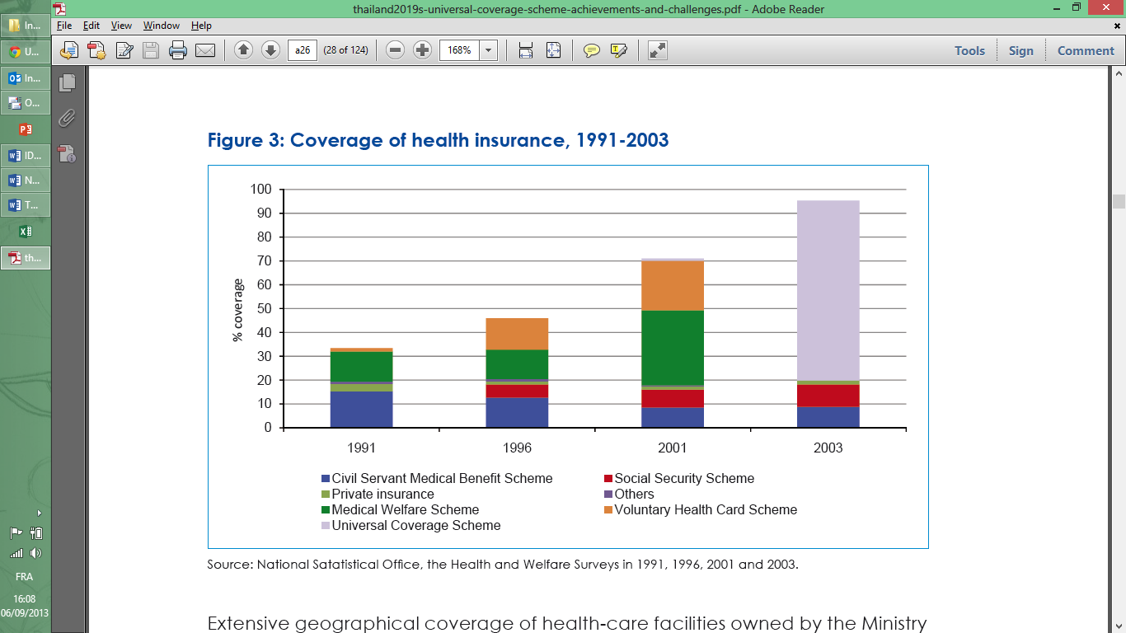
Source: National Statistical Office, the Health and Welfare Surveys in 1991, 1996, 2001 and 2003.

The Universal Coverage Scheme (UCS) covers the 76% of the population not covered by (a) the civil servant medical benefit scheme (CSMBS) for the government employees, spouses, and dependants under 20 years old, their parents and the government retirees; or (b) the Social Security Scheme (SSS) for the private sector employees excluding their spouses and dependants (see figure 2).
Figure 2: Dynamic of health insurance in Thailand
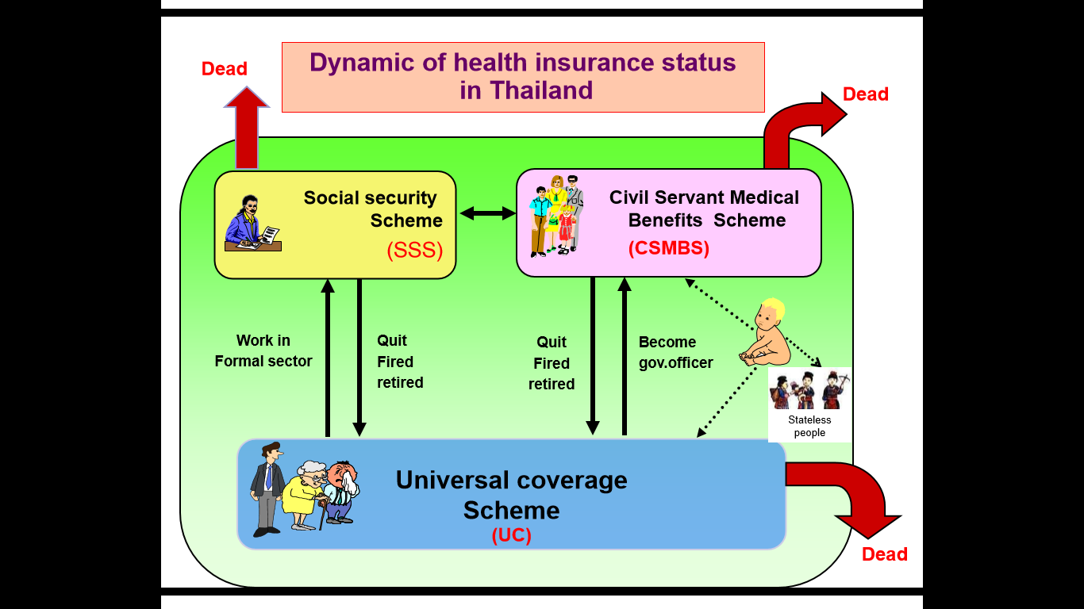
Main features of the UCS:
- Benefit package
      - Comprehensive program.
      - Prevention: annual physical examination, immunization, family planning, ANC, Antiretroviral drug for pregnancy women and dental preventive services.
      - Medical service include ambulatory and inpatient service.
      - Basic dental services.
      - Antiretroviral drug for HIV/AIDS patient has been included since 2006.
      - Peritoneal dialysis first policy has been included since 2008
    - Registration with preferred public or private CUP (Contract Unit of Primary Care)
      - The requirement of contract model is registration with a provider. In the UC scheme, the typical CUP is a District Health Systems in rural areas.
      - Generally, the beneficiary has to co-pay 30 baht per visit at the registered CUP, except for children under 15 years, the elderly, the poor and the disabled.
      - Beneficiary can receive health service at the primary care unit within the relevant network of health care units, or other health care unit, to which he is referred by his personal health care unit or network of health care units.
      - Care for accident and emergency illnesses: any accident or emergency case can go for medical care at any health facility (participating in the scheme) located nearest to the scene
      - CUP ensures proper referral to upper level of care if needed, then the CUP serves as a fund holding for OP services, the CUP pays for referral OP services.
- Provider payment
      - Capitation for outpatient services
      - Prevention and health promotion (P&P) services is paid based on a capitation
      - Inpatient services are paid by global budget with Diagnosis-related group (DRG) at regional level.
      - High cost and emergency care are paid by central pooling fund at the national level.
      - For the high cost medicines and medical devices in the special access items are central procured and reimbursed through vendor managed inventory (VMI) managed by government pharmaceutical organization at the national level.
- Healthcare providers
      - Accredited public and private healthcare providers
      - Advocates of primary care: beneficiaries are required to register with primary care providers which will function as gatekeeper. Private clinic can be a main contractor especially in the urban area.

Justification and process of development:
The UCS implementation stands on the ability to collect information of its beneficiaries. At the beginning of the UCS implementation the proportion of beneficiaries who were eligible to more than one scheme was high (around 10%). The need of identifying UCS beneficiaries among Thai residents (identification of people not entitles to SSS or CSMBS) had led to the establishment of a national health insurance beneficiary registries by the three health insurance schemes. National Health Security Office has been designated to be the focal point of the collaborative work. To have the update beneficiary’s information, NHSO had worked with the National Civil Registration Office, Ministry of Interior (MOI) to get all Thai citizen registries.
The National Civil Registration Office had established and maintains a national civil registration database. All births, deaths, marriage, divorced and migrations are by law required to register with the local registration office throughout the country, 24 hours for deaths, 15 days for births. The systems cover 98.5% of total births and 98.4% of total mortalities. The registration process provides a 13 digit unique identification number for every of 64 million Thai populations. (see figure 3) This ID number was used for registration to schools, legal documents, driving licenses.
Figure 3: National ID characteristics
The National Civil Registration Office and NHSO have applied the “Enterprise application integration” for daily exchanging the incremental data between the two databases. To date, Thai citizen demographical data have been effectively exchanged between the NHSO’s beneficiary registration system and Ministry of Interior (MOI)’s civil registration system. The NHSO is the focal point of all insurance registries. CSBMS, SSS send their beneficiaries update to NHSO at least twice a month. The NHSO central registration office processes and updates the country health insurance registries every two weeks using the information from MOI, CSMBS, SSS and NHSO’s provincial and hospital beneficiary registration centres.
Citizen who were not entitle in CSMBS or enrolled in SSS will be available for registration in UCS. That mechanism had forced the country to clean up the health insurance registry system – in particular the CSMBS registry database. (see figure 4)
Figure 4: Beneficiaries enrolment system
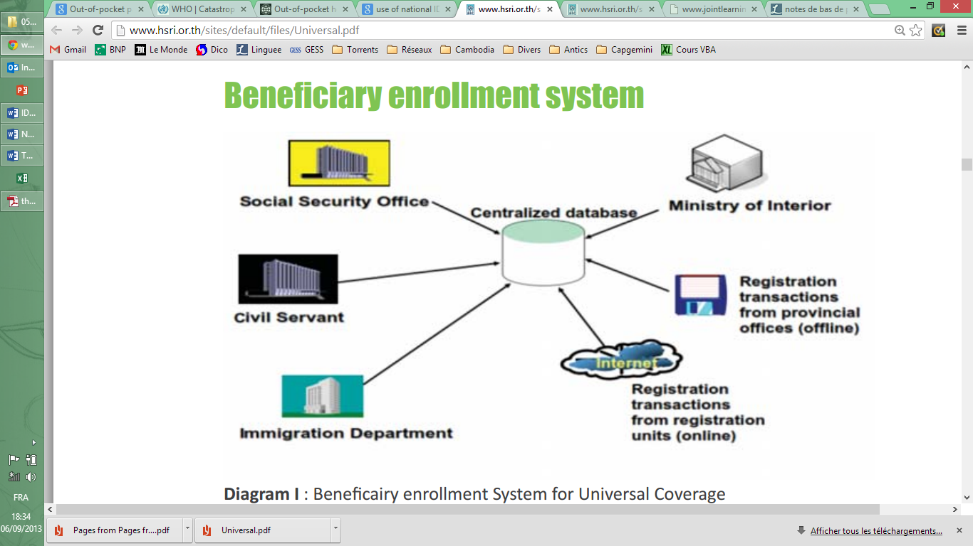
For registration of the migrants insured under MOPH health insurance scheme, the NHSO has developed an enrolment system with the health security ID card. (see figure 5)
Figure 5: Health Card for Foreigner
Healthcare providers can access the health insurance benefit registries both online and offline. The system help improving significantly providers’ point of service workflow.
The close collaboration between NHSO and MOI has leads to other health information system works that help country improve vital registration system. The project (initiated in 2011) between NHSO, MOI, MOPH and UNICEF to directly and electronically send every birth information from hospital’s delivery room to MOI’s database is the example of the improvement. That linkage reduces the previous birth registration process whereby the parents are required to register at the District Office within 15 days after delivery. The on-line birth registration system has been implemented in 44 pilot hospitals in 2011 before going nationwide in every public hospitals in 2013. However, it has not yet been extended to the hospitals/clinics outside NHSO network.

Description of the programme or policy

Target population:
The unique national citizen ID is applied to register the whole population into one of the three public health insurance schemes: the civil servant medical benefit scheme (CSMBS), the Social Security Scheme (SSS) and the Universal Coverage Scheme (UCS).
The National Civil Registration Office and the managers of the three insurance schemes update the population dynamic on a daily basis in order to register births (800,000 annually) and deaths (400,000 annually), as well as shifts in membership across the three insurance schemes (see Figure 2 above). Births are registered only with the CSMBS and UC schemes, as SSS does not cover dependents.
When the entitlement from previous insurance scheme expires (SSS members become unemployed and a 180 day grace period passes; CSMBS members reach the age of 60 or CSMBS members’ dependents reach the age of 20) the system automatically places them into the centralized database further processing for enrolment into UCS. That simple mechanism allows a seamless transition from one national health insurance scheme to another and decreases redundant registration among insurance schemes. (see Figure 6)
Figure 6: Decrease in beneficiaries enrolment errors from 2002 to 2005
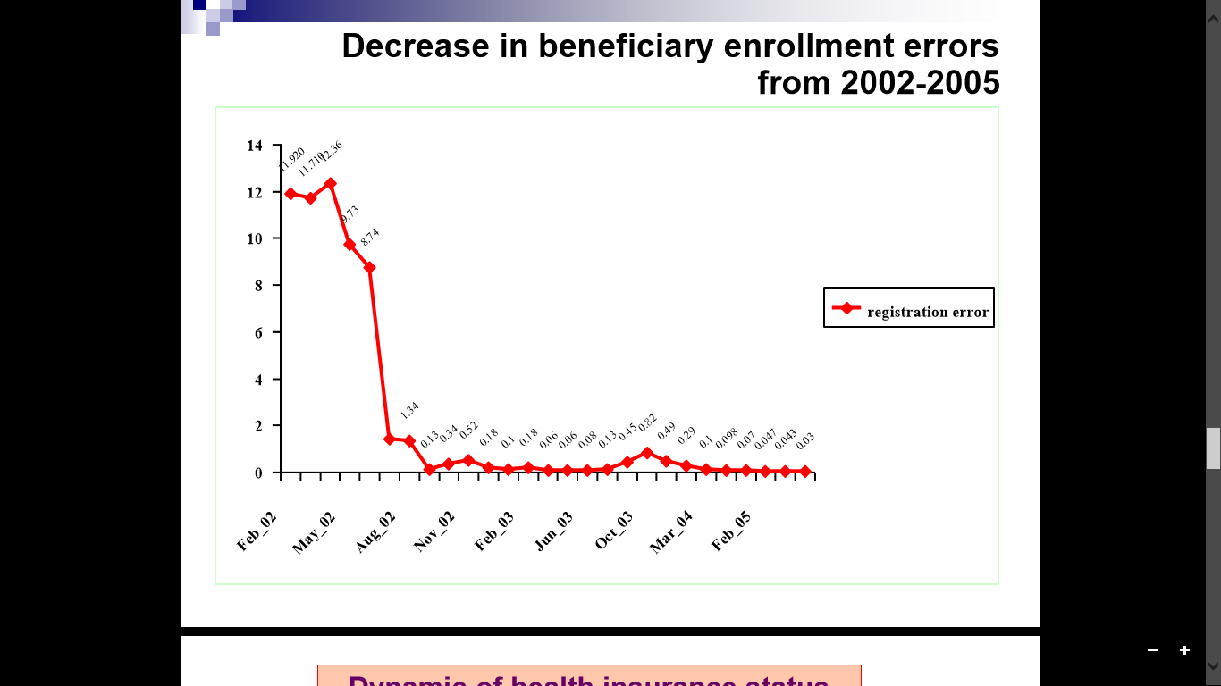
Source: NHSO

Services and transfers:
The national ID cards are issued to each citizen as they reach 7 years of age. As the government is in the process of rolling out second-phase state of the art biometric ID cards, the system is currently a mix of “smart” and non-“smart” cards. The biometric ID cards store the individual’s fingerprint information and include holograms to protect against fraud. For children under 7 years of age who do not have ID cards, the unique ID number which is documented in the respective household registration booklet will be used instead.
All civil registration data from provincial and district offices are then linked by the Ministry of Interior and synchronized every night with the National Health Security Office (NHSO) in a centralized database which itself liaises with the Social Security Office, department of state enterprises and local administrations, civil servants, etc.
The ID card allows a citizen’s use of services to be tracked throughout the health care system. At the point of service, individuals present the ID card. The service providers can validate the individual’s ID numbers and insurance status through web service technology which provides not only the most current status but also historical transactions among other insurance schemes. For children under 7 years of age who do not have ID cards, the unique ID numbers issued by the MOI when the birth registration undertaken and are documented in the respective household registration booklet. The birth certificate issued by the MOI is used until the person reaches the eligible age to have the ID card (i.e. 7 years old). (see figure 7)
An administrative database stores information tied to national ID numbers for all outpatients and inpatients, medical and service transactions. Discharge summaries, claims under diagnosis-related groups (DRGs), and the global budget (capitation) for the UCS also refer to ID numbers. Thus, the system can provide not only the current right status for all Thais but also the historical transactions among other insurance schemes. Health care professionals can authenticate themselves by using Smart ID card and access the patient proﬁle including his personal medical records in order to provide appropriate services for their patients.
Figure 7: benefit from using smart card
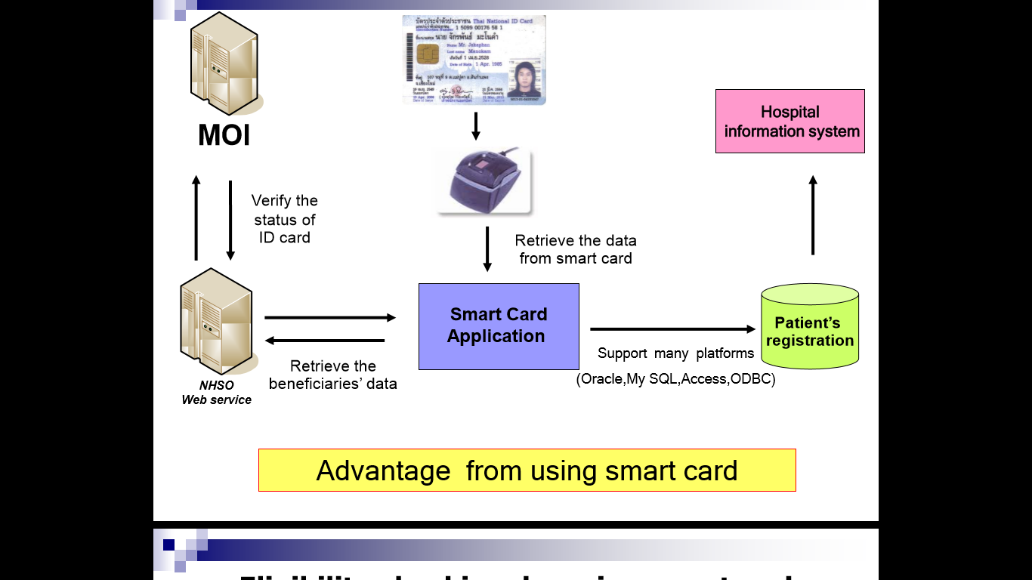
In conclusion, the three public health insurance schemes rely on the extensive development of the national civil registration systems.
    - Specificities for non-Thai residents
In accordance with ILO recommendation 202, the UCS is designed not only for Thai people but for all residents of Thailand, although the deliverance of Smart card by the MOI is restricted to the Thai nationality but MOI still issues the national ID for Non-Thai residents called “stateless people”.
In order to ensure the entitlement for all of non-Thai residents to social protection, the MOPH and NHSO identify this rest of non-Thai people according to the same process as MOI (including biometrics data recording such as fingerprints). That identification leads to the generation of a 13 digit code for that population using a specific codification that allows to preserve the unicity of those code.

Institutional set-up:
The National Health Security Office is set up according to the 2002 National Health Security Act, with two governing national Boards, namely the National Health Security Board and the Health Service Standard and Quality Control Board.
The National Health Security Board is responsible for setting policy, making decisions on the benefits package, deciding on appropriate provider payment methods, and setting rules and. The NHSB is chaired by the Minister of Public Health and NHSO secretary-general is designated as the board secretary. The NHSB’s 29 other members include representatives from various stakeholder groups: government officials (8 - namely Ministry of Defence, Ministry of Finance, Ministry of Commerce, Ministry of Interior, Ministry of Labour, Ministry of Public Health and Ministry of Education as well as the director of the Bureau of the Budget), local governments (4), NGOs (5), health professionals (4), private hospitals (1), and experts in insurance, medical and public health, traditional medicines, alternative medicines, financing, law, and social science (7).
The Health Service Standard and Quality Control Board is responsible for controlling, monitoring and supporting standard and quality of health care providers. The Board also provides comments on standard fees for treatments, regulate no-fault liability payment, support public access to UC information and give response to consumer complaints. The Board members include the heads of many health care institutes, representatives from professional bodies, private hospitals, health care professionals, Royal Colleges as well as municipalities and local administration organizations. Representatives from non-profit organizations working on children, youth, women, elderly and other vulnerable groups are elected as members. Six qualified experts in tropical family medicine, mental health and Thai traditional medicine are appointed as committee members by the Minister of Public Health. NHSO secretary-general is also designated as the Board secretary.
With regard to good governance, an audit sub-committee appointed by National Health Security Board will function as internal auditors. The audit sub-committee is to closely inspect into the system whether internal operation, especially financial management, complies with the laws and regulations. Regular reports are submitted to the National Health Security Board on a quarterly and annual basis.
The internal operation in NHSO is divided into two main sections, the head quarter and regional offices. The head quarter office consists of 15 bureaus responsible for policy and planning, system support as well as monitoring and evaluation. 13 regional NHS Offices take responsibility for administering and monitoring the fund management at the regional level. The regional offices will ensure that health security implementation is responding to the local health needs. In order to accomplish this goal, co-operation and participation of stakeholders in decision-making process and health-related activities are required. In each regional catchment's area, there is the number of population of 2.3 to 5 million. (see figure 8)
Figure 8: Organisation structure of NHSO
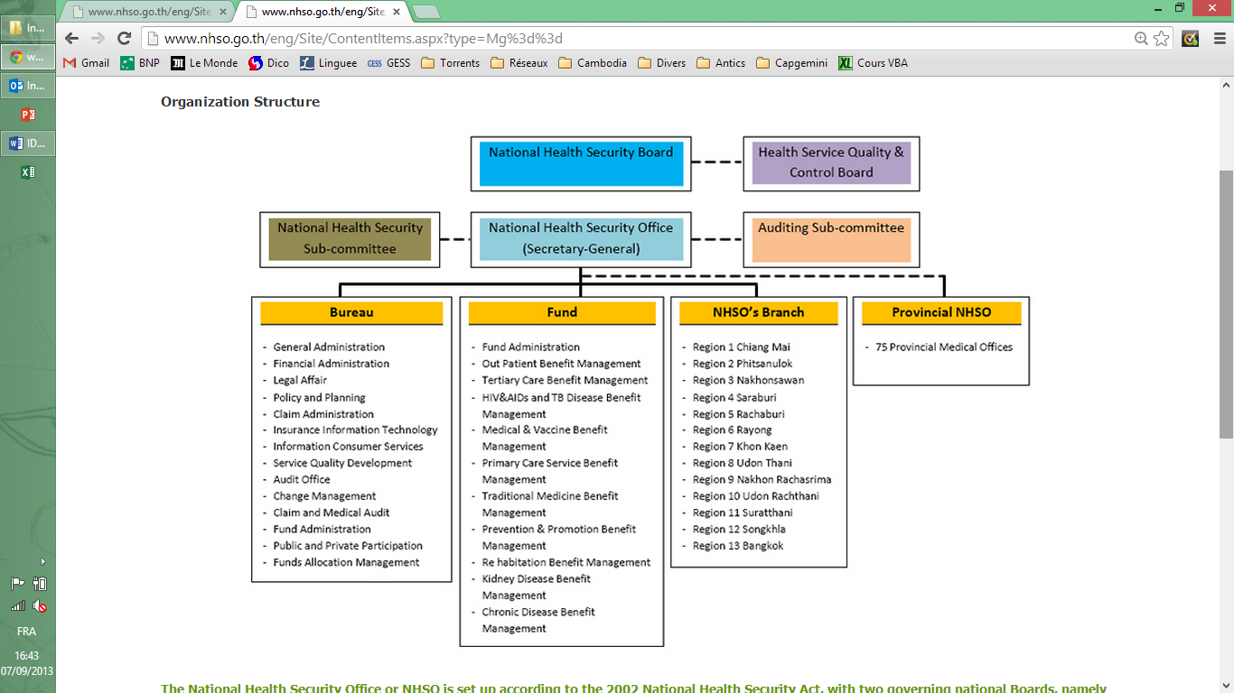
Source: NHSO website - http://www.nhso.go.th/

Monitoring and Evaluation:
The call center of health care insurance schemes was set up as part of a comprehensive approach to coverage. The center helps to ensure that clients will receive proper services, which are responsive to their speciﬁc health conditions. Also it is a convenient channel for clients to share any complaints or comments about the services. This feedback will be followed up in order to improve future services. The hotline numbers 1506 and 1330 operated by SSS and NHSO respectively are available on a twenty four hour basis
The Standard and Quality Control Board (SQCB) is another important body responsible for setting standards and guidelines on service quality and standards of health facilities.

An emphasis on the lessons learned of the programme:
The success of Thailand’s three schemes in achieving universal coverage relies on the extensive development of the national civil registration systems, and the national ID cards that allow for easy identification within the system. The national ID cards have led to great improvements in efficiency and transparency, as well as the prevention of fraud in membership registration and claims by healthcare providers. This unique ID number serves as a personal reference for membership registration (in, out, and across schemes), as well as for reference in medical and financial transactions, including disbursement of payment.
Though the ID cards have faced fraud, this issue is being addressed. The national ID card system is a large improvement on the previous system, and a system based entirely on smart cards will be a further improvement.
From the Thai experience, there are 5 essential components for the use of ID number to run Social Health Protection: Population database, ID Cards, Card readers, Beneficiary verification and finally IT infrastructure. (see figure 9)
Figure 9: the key components for implementing smart ID cards
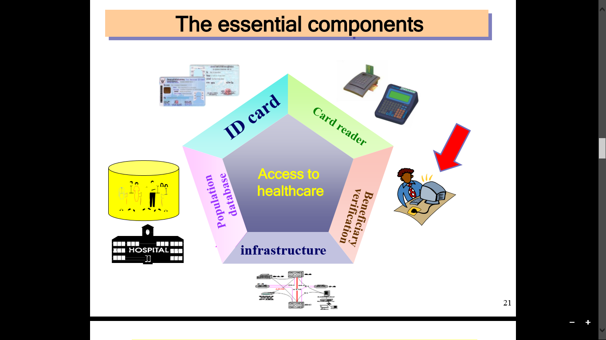
Thailand plans to increase the efficiency of the national ID card program by decreasing fraud, human error, and overhead costs. The government aims to complete the roll-out of smart ID cards by 2012. The smart cards make fraud virtually impossible, and will save the scheme money in the long-run despite sizeable up-front investments in the cards and card readers. There is also a movement to streamline the registry update process by ensuring that the National Registration Office and managers of three insurance schemes work together, using the National Health Security Office as a clearing house.

Linkages with the guiding principles of R202

Impact on final beneficiaries and their dignity, graduation out of poverty and social inclusion:
The unique ID number and identification card has allow to achieve universal coverage in Thailand (see Figure 1 above on the coverage of Social Health Insurance in Thailand).
      - Increased utilization (number of outpatient visits per member per year rose from 2.45 in 2003 to 3.22 in 2010, and the number of hospital admissions per member per year rose from 0.094 in 2003 to 0.116 in 2010 – NHSO annual reports 2009 and 2010) and low levels of unmet need due to unaffordable cost (1.3% for outpatient and 16.7% for inpatient services) demonstrate improved access to health care services
      - Decreasing catastrophic expenditures - out-of-pocket payments for health care exceeding 10% of total household consumption expenditure - and household impoverishment: the incidence dropped from 6.8% in 1996 to 2.8% in 2008 among UCS members in the poorest quintile; among members in the richest quintile the incidence dropped from 6.1 to 3.7% in the same period

Impact on the transparency, accountability and traceability of the implementation of the Social Protection Floor:
The national ID cards have led to great improvements in efficiency and transparency, as well as the prevention of fraud in membership registration and claims by healthcare providers. This unique ID number serves as a personal reference for membership registration (in, out, and across schemes), as well as for reference in medical and financial transactions, including disbursement of payment.
The use of a single ID number across the health care system in Thailand ease the tracking of the use of health protection.

Impact on the efficiencies of the social protection system as a whole and its financial sustainability:
There is also a movement to streamline the registry update process by ensuring that the National Registration Office and managers of three insurance schemes work together, using the National Health Security Office as a clearing house.

Impact on the coherence of the social protection system:
The three health care schemes are working on the same database for registration of beneficiaries ensuring the coherence of the whole system.

Impact on representation and democratic governance, empowerment of populations and local administration, communities:
The beneficiaries can easily access their insurance rights through the well designed of national registry database and also link to consumers protections management as needed.
The local administration can design the prevention and promotions plan suitable for their areas using the beneficiaries’ data defined by area.

Resources and bibliography:
      - NHSO website:
      - Thailand’s Universal Coverage Scheme: Achievements and Challenges, Health Insurance System Research Office (2012)

Source: NSO Health and Welfare Survey
The national ID card with 13 digits has been implemented since 1 January 1984. Prior to this date the ID cards with the individual’s photo but without the identical numbers were issued to the Thai citizens at the age of 15 years old. Following the National ID Act 2011, the ID cards are issued to the Thai citizens aged 7 years old to enable their easy access to and validate their rights and welfare.

