

Kingdom of Cambodia
Nation Religion King


Council for Agricultural and Rural Development
Social Protection Coordination Unit

Challenges ahead:
Moving toward expanded social security system for Cambodia as the social protection agenda

Phnom Penh
April, 2014

By Social Protection Coordination Unit
of Council for Agricultural and Rural Development

This paper, “Challenges ahead: Moving toward expanded social security system for Cambodia as the social protection agenda”, is solely an internal document to be circulated within the Technical Working Group on Social Protection and Food Security and Nutrition (TWG-SP&FSN). Section 9 and 10 of this document is cited from the in-progress study on “The Analysis of Fiscal Space for Social Protection for Cambodia Vision 2030”, which is not to be quoted until the final version of the mentioned document is released.

For further information, please contact:
H.E Dr. Sann Vathana
Deputy Secretary General of Council for Agricultural and Rural Development
Tel : +855(0)12 950410
Email : vathana20@yahoo.com
Summary

The paradigm for economic and social development must be shifted to new higher gear for high productivity, efficiency and with equity, and one of which is the moving toward the expanded social security for all as an agenda of social protection.

A typical social security system provides income during periods of unemployment, ill-health or disability, and financial support, in the form of pensions, to the retired. The issues that are raised with pensions are the potential transfers of resources between generations and the effect on savings behavior in the economy. The pensions systems in many developed economics are going under pressure in a process that has become known as the “pensions crisis”. The roots of this crisis can be found in the design of the systems and the process of change in population structure. The potential extent of this crisis provides strong ground for holding the view that reform of the pension system is currently one of the most pressing economic policy challenges. Given the steady expansion of formal types of employment, there is a window of opportunity for the extension of social security through employment-based social insurance provisions. Nevertheless, since employment formalization is a slow and gradual process, informal types of employment will persist and there is also a need to extend social protection provisions for informal workers through targeted or universal benefits.

Moreover, in the poorest 33 percentage, 38.6 percentage of the persons are in the age group 5-17 years. On the other hand, despite impressive nutritional improvement in the ‘90s and early 2000’s, child malnutrition is one of the biggest health problems that Cambodia is currently facing. Malnutrition is implicated in more than 6,400 deaths under five deaths every year. Cambodia is now off-track for Millennium Development Goal and National Strategic Development Plan targets for child nutrition. Addressing these issues through child-sensitive social protection intervention is the most appropriate consideration within the paradigm of economic growth.

The vast majority of Cambodians remain without coverage under any social health protection scheme and therefore face the risk of catastrophic health expenditures, in particular the near-poor, who still remain largely unprotected. Cambodia still does not have an effective and affordable social safety net system in place. Many of the interventions have been patchy and ad hoc, and are highly dependent on specific donor funding sources. Coverage for the poor and vulnerable is still very limited: programmes do not necessarily focus on the poorest areas and efforts have been largely fragmented, with weak coordination between the many ministries and institutions involved.

Meeting the NSDP and NSPS goals and objectives requires resources-institutional, human and financial. These resources can be potentially raised by the extent to which RGC can reallocate expenditures within the budget, by securing more grant donor support or increasing efficiency within the sector/ministry budgets. This note makes a case for the enhanced efficiency, an agenda that is line with the Public Financial Management Reform Programme (PFMPR) and which perhaps can be more easily and sustainably attained.

Successful implementation of revenue mobilization strategy is based on a three-pronged approach: 1; improving revenue administration and forecasting 2; implementing fair and efficient tax policies and 3; strengthening governance ensuring accountability and transparency. Furthermore, one of means to increase fiscal space is to shift budget between priorities sectors given fixed budget envelope. With full commitment from the government, budget expenditure has been shifted from security sector to priorities sector, health, education, and agriculture.

Content of the paper

Summary
1. Introduction : Why Social Protection is still needed?
2. Demographic pattern as a consideration
2.1 A snapshot on Cambodian demography
2.2 Demographical implication on the design of social security system
2.3. Children as the center of social protection design
3. The existing social protection programmes and gaps
3.1 Social protection floor as foundation of social protection policy
3.2. Coordination platform on social protection
3.3. Achievement in the social protection policy implementation
3.4. The role of Sub-National Administration
3.5. Challenges in social protection
4. NSPS costing exercise (2012-2020)
5. Economic growth: ensuring equity and inclusiveness?
5.1 The growth during 2008-2013
5.2 Projection of Economic Growth
6. Financial challenge: understanding social protection financing from fiscal space analysis
6.1 Mobilization of Domestic Revenues
6.2 Reallocation Between Sectors
7. The analysis of social protection investment
8. The policy priority for social protection in moving to social security
9. Conclusion
Reference documents

1. Introduction : Why Social Protection is still needed?

The rationale for elaborating an integrated and coordinated National Social Protection Strategy for the Poor and Vulnerable (NSPS) was dictated by the need to help accelerate the achievement of the CMDG and to move forward on major reforms agenda. It is imperative to support the poor and vulnerable while at the same time promoting their human capital. Broadening the scope of social protection will contribute to the reduction of chronic poverty, help the poor to cope with shocks, promote human capital, improve productivity and promote sustainable economic growth. At least three major reasons why Cambodia is needed for an effective and affordable social protection system.

First, Cambodia is moving rapidly through different stages of development (from the emergency to rehabilitation and to development) and has emerged from three decades of instability with an impressive record on sustained economic development and poverty reduction. In 2020 Cambodia will grow to another level and it may be double the GDP by then and poverty will greatly reduce as social and economic development will enhance the livelihoods of many Cambodian people. Cambodia will move forward to a developed and could become a middle-income country. Therefore, the paradigm for development must be shifted to new higher gear for high productivity, efficiency and with equity.

Second, households in Cambodia may face serious vulnerabilities and are prone to individual-specific and macroeconomic shocks and climate change. With the majority of the population engaged in rice subsistence farming depending on weather conditions, crop failures and resulting food insecurity are major concerns. Illness and related high health expenditures are further key factors driving households into chronic poverty - taking children out of school, selling productive assets or engaging in other detrimental coping strategies. The poverty and vulnerability situation of many people has been recently exacerbated by soaring food prices and the global financial and economic crisis, which caused deterioration in employment, incomes, and access to essential services for the entire population and might have contributed to further exacerbating inequality and disparities.

Third, by 2015, the ASEAN Community will be established based on three pillars, namely: the ASEAN Political-Security Community, the ASEAN Economic Community and the ASEAN Socio-Cultural Community. Despite considerable economic progress have been made in the last two decades and has lifted millions out of poverty, not all have benefitted from these gains. Many people are still poor, deprived of basic amenities, and vulnerable to increased risks due to global economic crises and climate change. Economic growth alone will not able to achieve sustainable development with equity. While economic integration has a number of benefits for regional competitiveness and trade, the potential social costs of integration must also be assessed. With the opening of a regional job market, labor mobility will most likely rise across the Community and broaden opportunities for overall employment. However, workers from countries like Cambodia, Laos and Myanmar, who generally have lower skill levels, might be pushed out of their current jobs by increased competition from in-migrating counterparts from within the region. In the region, 60% of the workforce is engaged in the informal sector, with little or no social protection against ill health, family emergency and financial uncertainty. With increased threats of unemployment, resulting these workers taking even more insecure and low-paying jobs, there might be a negative impact on regional peace, security, and prosperity.

2. Demographic pattern as a consideration
2.1 A snapshot on Cambodian demography
The age-structure transition in the country has been remarkable in the last ten years. In 1998, the country had an age-structure comparable to any other developing economy in the world. However, with rapid decline in fertility, the percentage of children population (0-14 years) that was 43 percent in 1998 has declined to 34 percent in 2008 resulting in increase in the working age- population (15-64 years) from 54 percent to 62 percent in the corresponding period. In case of elderly population (65+ years), there has been a marginal increase and this increase is likely to gain momentum from 2018 onwards because the life expectancy of the population has started increasing.

Cambodia’s population is estimated at 13.4 million according to the last population survey undertaken in 2008. With a median age of only 21.0 in 2008, the population of Cambodia is young on average. Children aged under 15 represent about 34 per cent of the total population, whereas the elderly aged 65 or above make up for only about 4 per cent. The total fertility rate is still high at 3.1, although it shows a decreasing trend; the population growth rate is estimated at 1.5 per cent per annum. At 62.5 years on average, life expectancy at birth is relatively low, mainly due to high child and infant mortality rates. The majority (80 per cent) of Cambodia’s population still live in rural areas, while only 20 per cent are urban dwellers.

With a high labour market participation rate of about 78 per cent among the population aged 15 and above, Cambodia’s economically active population in 2008 was estimated at approximately seven million persons. Total employment that year was estimated at 6.8 million persons, including about 2.9 million unpaid family workers. Among the 3.9 million paid workers in 2008, about 1.2 million were paid employees, whereas the remaining 2.7 million were self-employed or own-account workers. Despite an increasing trend in formal- sector employment, a high share of employment remains informal, with workers uncovered by social protection provisions. The share of employees in the formal economy is estimated at 17 per cent of total employment including public administration and defence. Given the steady expansion of formal types of employment, there is a window of opportunity for the extension of social security through employment-based social insurance provisions. Nevertheless, since employment formalization is a slow and gradual process, informal types of employment will persist and there is also a need to extend social protection provisions for informal workers through targeted or universal benefits.

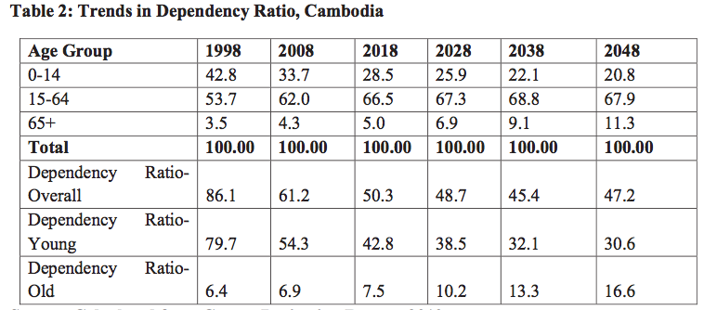

The overall and young dependency is expected to come down from the present levels while the old age dependency is likely to increase and the increase will be more pronounced from 2018 onwards and the momentum will accelerate thereafter. The country therefore in the near future would have to overcome a paradoxical situation where they would have to cater to the youth and start planning for the elderly from a development perspective.

Are we ready to accommodate those more than 50% of working-age population in 2020 to be productive labour forces and taxpayers? Currently, 82.5% of employed people are working in the vulnerable jobs where 58% of working-age population were below primary-school education and 15% are out-of school youth

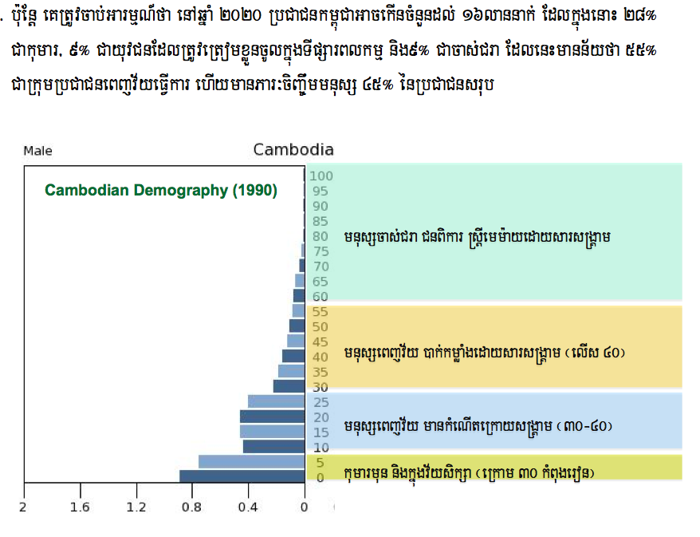

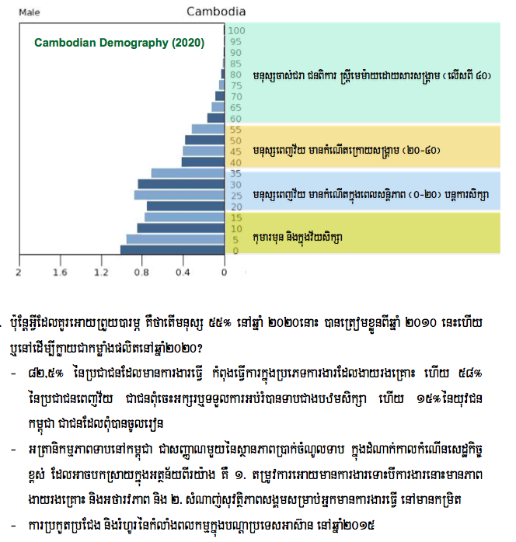

2.2 Demographical implication on the design of social security system
A typical social security system provides income during periods of unemployment, ill-health or disability, and financial support, in the form of pensions, to the retired. Although the generosity of systems varies among countries, these elements are present in all developed economies. In economic terms, the analysis of the social security system that provides assistance during unemployment or ill-health is concerned with issues of uncertainty and insurance. Specifically, unemployment and ill-health can be viewed as events that are fundamentally uncertain, and the provision of social security is insurance cover against bad outcomes. In contrast, retirement is an inevitable outcome, or at least an option, once the retirement age has been reached. Insurance is therefore not the main issue (except for the problem of living for longer than accumulated wealth can finance). Instead, the issues that are raised with pensions are the potential transfers of resources between generations and the effect on savings behavior in the economy. Both of these issues require a treatment that is set within an explicitly inter-temporal framework.

The pensions systems in many developed economics are going under pressure in a process that has become known as the “pensions crisis”. The roots of this crisis can be found in the design of the systems and the process of change in population structure. The potential extent of this crisis provides strong ground for holding the view that reform of the pension system is currently one of the most pressing economic policy challenges.

Social security in the form of pensions is important both in policy relevance and for its effect on the economy. The generosity of a pension scheme has implications for individual’s savings behavior and, in the aggregate, for capital accumulation. Since an economy may reach an inefficient steady state, the designs of pension schemes have an impact on economic efficiency.

Demographic changes and changes in employment behavior are currently putting existing state pension schemes under pressure because of their fundamentally pay-as-you-go nature. Reform proposals have focused on a move to a fully funded system, but such a reform can be detrimental to the welfare level of consumers living during the transition period.

2.3. Children as the center of social protection design
CSES 2010 suggests that in the poorest 33 percentage, 38.6 percentage of the persons are in the age group 5-17 years, in the middle 33 percentage they are 30.4 percentage, and in the richest 33 percentage they are only 23.7 percentage. Put alternatively, the total number of persons in the age group 5-17 years, if distributed by these three income (expenditure) groups, will yield a proportion of some 51.5% children below the poorest 33% of the income bracket!

Child Poverty/CSES 2010: Children are disproportionately poor

Malnutrition among children under 5, which prevents them from acquiring full cognitive capacity and increases their likelihood of being sick, remains a particular and critical issue to be addressed. These human development constraints, particularly among the poor, can hinder the potential for future equity, life cycle development from early childhood development to elderly, economic growth and prosperity in Cambodia.

Table 1: Summary 10 Nutrition Indicators: Cases and Risk Groups Derived from DHS 2010
Risk Group | Nutrition Indicator | Prevalence | Cases or At Risk | Risk or Deficit
388 thousand  Pregnant Women | Low BMI | 19% | 73.9 | Infant and Maternal Mortality
388 thousand  Pregnant Women | Low Height | 6% | 24.5 | Infant and Maternal Mortality
388 thousand  Pregnant Women | Anemia: Pregnancy | 53% | 204.9 | Infant and Maternal Mortality
388 thousand  Pregnant Women | Folic Acid Deficiency | 50% | 194.4 | Infant and Maternal Mortality
1.6 Million Children  < 5 Years of Age | Suboptimal Breastfeeding | 26% | 202.2 | Mortality & Morbidity
1.6 Million Children  < 5 Years of Age | Wasting | 44% | 628.3 | Mortality
1.6 Million Children  < 5 Years of Age | Underweight | 60% | 856.7 | Mortality
1.6 Million Children  < 5 Years of Age | Stunting | 65% | 928.1 | Growth, Development & Productivity
1.6 Million Children  < 5 Years of Age | Vitamin A Deficiency | 22% | 318.4 | Mortality
1.6 Million Children  < 5 Years of Age | Zinc Deficiency | 52% | 742.5 | Mortality & Morbidity
1.6 Million Children  < 5 Years of Age | Anemia: Childhood | 34% | 482.7 | Growth, Development & Productivity
3.3 million  Adults | Anemia: Women | 44% | 2,445 | Strength, Endurance and Productivity
3.3 million  Adults | Anemia: Men | 17% | 850.5 | Strength, Endurance and Productivity

The primary level completion rate, on the other hand, is slack and will require some extra effort to reach 100 percentage by the end of the plan. Next, enrolment and completion rates at the secondary level are disappointingly low compared to those at the primary level. Meeting the ESP targets mandates additional, renewed efforts.

Awareness of the Early Childhood Education (ECE) policy is limited; primary and lower secondary completion rates of especially the disadvantaged children, are low. Enrolment of children aged 12-14 years in lower secondary education is below the target owing to factors like lack of classrooms, and shortage of secondary teachers in newly-established institutions, especially in remote areas as well as poverty as children are required by their families to do work (contributing to high opportunity cost of sending children to schools). This is supported by 2010 CSES data.

Despite impressive nutritional improvement in the ‘90s and early 2000’s, and increases in both the rates of early and exclusive breastfeeding and the coverage of maternal and child micronutrient supplementation, child malnutrition is one of the biggest health problems that Cambodia is currently facing. Malnutrition is implicated in more than 6,400 deaths under five deaths every year. Cambodia is now off-track for Millennium Development Goal and National Strategic Development Plan targets for child nutrition. The 2010 Demographic and Health Survey shows that 28% of children are underweight and that from 2005 to 2010 the percentage of children too thin (wasted) has crossed the International Phase Classification Emergency Threshold, increasing from 8.4% to 10.9% (statistically significant change). There are now an estimated 80,000 cases of severely wasted children annually. Anaemia is prevalent both among children and women.

3. The existing social protection programmes and gaps
3.1 Social protection floor as foundation of social protection policy
The starting point must be the development of basic, affordable security benefit packages as a platform for reaching out to whole populations and forming the foundation on which to build progressively higher levels of protection.
After two years of intensive consultative and participatory process, the National Social Protection Strategy (NSPS) had been approved by the Royal Government of Cambodia on 18 March 2011. This NSPS is being promoted within the context of the Cambodia Millennium Development Goals (C-MDGs), achieved through the National Strategic Development Plan (NSDP-Update 2009-2013). The NSPS sets the framework for a sustainable and comprehensive social protection system for all citizens over the long term, comprising social security mechanisms for the formal sector together with the provision of improved social safety nets for the informal sector. For the near and medium future the Strategy gives priority to the development of effective and affordable social safety nets targeted to the poor and vulnerable with complementary social welfare services for special vulnerable groups.

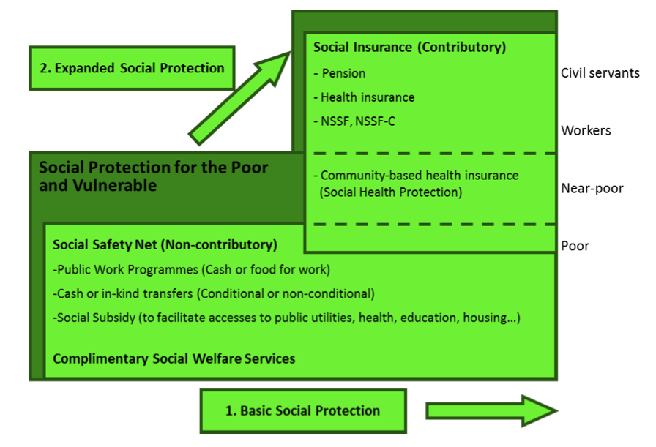
Adopted in 2011, the National Social Protection Strategy for the Poor and Vulnerable in Cambodia sets the framework for sustainable and comprehensive social protection for all Cambodians over the long term. This includes both contributory and non- contributory schemes.

The development of comprehensive social protection implies ensuring that the relevant components (non-contributory and contributory) are developed in parallel towards a sustainable system, whereby those who can afford social protection will access it based on their formal contributions and those who cannot will rely on the state for support until they develop such capacity over time. There are linkages and complementarities between the two major components of a comprehensive system of social protection.

3.2. Coordination platform on social protection

The 2011-2015 SPCU Workplan, developed by the end of 2011, served as the basic of activities of SPCU. Within the framework of this work plan, the coordination on NSPS is defined into two milestones: Milestone 1: the enabling environment for the coordination on strategy development, and Milestone 2: the enabling environment for the coordination on strategy implementation. Coordination on the development of strategy comprise of: Policy support and oversight, Partnership and capacity development, Information management, and Monitoring and evaluation.

In order to have an effective coordination at inter-agencies level on social protection agenda, CARD had organized several platforms of coordination after 2008 where the first mapping and scoping exercise on existing social safety net had been carried out. These coordination mechanism including:
- Interim-Working Group on Social Safety Net (IWG-SSN/SP), established in 2009, as a continued subset of Technical Working Group on Food Security and Nutrition, as an open platform for all agencies involved in social protection agenda,
- Social Protection Core Group (SPCG), established in 2010, as part of IWG-SP, included major DPs involved in social protection
- Social Protection Coordination Unit (SPCU), established in 2011 as the recommendation of Cambodia Development Cooperation Forum,
- Social Protection Taskforce (SPTF), established in 2012, as the recommendation of Samdach Techo Prime Minister, with CARD, NCDD, SNEC, and MoP as the lead coordinators

However, even though the well-established mechanism for coordination at inter-agencies level had been functioned since 2008, the evolution of emerging issues on social protection is to be captured through the groups. The coordination on technical consultation, flow of information and hence monitoring framework, and policy oversight required the participation of all agencies involved and remained a complicated task.

3.3. Achievement in the social protection policy implementation
The main social protection provisions and programmes as currently existing in Cambodia have been reviewed based on scope and relevance in relation to the NSPS; they include the following:
1. Four major assessments at policy level had been carried out including 1.) Social protection expenditure review (the assessment on financial capacity and fiscal space to finance social protection programs), 2.) The National Social Protection Strategy costing exercise (considering targeted and universal scenarios), 3.) The study on rates of return to social protection investment (support decision-making at policy level on selecting social protection interventions), and 4.) The Monitoring Framework for the National Social Protection Strategy (developed based on the existing data sources gathered through nationally administered surveys and pooled into 33 monitoring indicators);
2. Council for Agricultural and Rural Development had examined and developed the modality of empowering the Sub-National Administration to coordinate the implementation of social protection interventions at sub-national level. Two approaches had been elaborated including 1.) The Social Service Delivery Mechanism (to replicate the modality of One-Window Service Office for social service delivery in rural areas), and 2.) The Integrated Social Protection Approach (to harmonize and integrate the different social protection interventions according to the Guiding Principle on the Implementation of Social Protection Programs);
3. Social assistance or welfare services as provided by the Government of Cambodia through different line ministries, mainly the Ministry of Social Welfare, Veterans, and Youth Rehabilitation (MOSVY), which provides support to orphans, the disabled, the elderly and the poor. The Ministry of Education, Youth, and Sport (MOEYS) runs a scholarship programme to support poor students. Other benefits provided include emergency food assistance as coordinated through the National Committee for Disaster Management (NCDM), and vocational training through the Ministry of Labour and Vocational Training (MOLVT).
4. Social protection benefits, as also provided under donor-funded programmes, including the WFP-supported school feeding programme, under which school meals are served and take-home rations are provided to school children. Other interventions comprise public works programmes implemented under the Rural Investment and Local Governance Project (RILGP), and the ADB-funded Emergency Food Assistance Project (EFAP). Total social expenditure under all ODA- and NGO-funded programmes in the year 2010 is estimated at US$68 million. Total social expenditure in the year 2010, including ODA-funded programmes and subsidies for the health sector, is estimated at about US$634 million, an amount equivalent to 5.5 per cent of GDP. Social spending on health accounted for about 60 per cent of total social expenditure.
5. A model cash transfer program using government structures has been designed to provide benefits to pregnant women and young children taking into account early childhood development approach. Pilot programs are being implemented by development partners and the successful modality will be subject to review by CARD for national scale up;
6. In 2012-2013, 450,000 students in primary schools had received School Feeding Programs and nearly 100,000 students in 4,725 schools in 15-targeted provinces had received Cash and Food Scholarship. Royal Government of Cambodia had contributed 2,000 tons of rice to this intervention.
7. The Public Work Programs in the form of Cash for Work and Food for Work from various interventions had created more than 500,000 working-days for poor households. A new implementation modality of a cash for work program has been tested, the Productive Assets and Livelihood Support Program, which has increased national ownership and developed sub-national capacities to manage labour-intensive programs.
8. Social health expenditure, comprising supply-side subsidies to hospitals as funded from the national budget and through ODA grants, and demand-side social health protection schemes including the fee-waiver scheme for the poor, the voucher scheme for maternal health, the health equity funds for the poor, and the community-based social health insurance schemes. Total social health expenditure for the year 2010, including administration costs, is estimated at about US$385 million, including about $4.6 million spent by health equity funds and $1.2 million by community-based health insurance (CBHI) schemes. A numbers of pro-poor health financing schemes had been implemented including user-fee exemption (Health Equity Funds, Voucher for Reproductive Health Services, and Community-based Health Insurance). The Health Equity Fund has been expanded to 370 Health Centres and 64 Hospitals. About 167,000 people had been enrolled into the Community-based Health Insurance, which are implemented in 179 Health Centres and 13 Referral Hospitals including Phnom Penh.
9. Statutory provisions, adopted in accordance with the fundamental rights to social protection enshrined by the Constitution of Cambodia, and stipulated in the following laws: the Labour Law, the Law on the Common Statute of Civil Servants, the Law on War Veterans, the Law on Pensions for Members of the Armed Forces, the Law on Suppression of Trafficking, and the National Disability Law.
10. The National Social Security Fund for Civil Servants (NSSFC), providing social security benefits to around 175,000 civil servants and to their family dependants. Benefits provided include maternity and sickness cash benefits, funeral grant, employment injury benefits, and pensions. In the year 2009, a total of 67,500 pension benefits were disbursed including 28,000 retirement pensions. Total benefit expenditure in 2009 amounted to US$22.7 million.
11. The National Fund for Veterans (NFV), established in 2010 and providing social security benefits to members of the armed forces and the national police. The scheme also provides pensions to persons qualifying as war veterans. Total benefit expenditure in the year 2010 is estimated at about US$19.5 million.
12. The National Social Security Fund (NSSF), established in 2008 to administer social security benefits for private-sector workers as stipulated by the social security law, 2002. So far only the employment injury branch has been implemented, covering about 600,000 workers mainly in the garment and footwear industries. Total benefit expenditure in 2010 amounted to about US$0.6 million. Other statutory social protection provisions for private-sector workers are stipulated by the Labour Law (1997), including paid sick- and maternity leave, and severance pay for employees dismissed by their employer.

3.4. The role of Sub-National Administration
In governance, the ongoing reform process of decentralization and deconcentration (D&D), which aims at strengthening local governance and public service delivery, is creating new perspectives for the delivery of social protection benefits at the community level. The strengthened administrations at subnational level could be instrumental in the future for the delivery of a comprehensive package of social protection benefits. However, any novel approaches will need to be carefully designed and piloted first before they can be mainstreamed on a national scale. Overall, an efficient and effective public administration system is a key requirement for the functioning of a comprehensive social protection system. Further efforts aimed at developing administrative capacities and strengthening national social protection agencies will be required in the future.

3.5. Challenges in social protection
The vast majority of Cambodians remain without coverage under any social health protection scheme and therefore face the risk of catastrophic health expenditures, in particular the near-poor, who still remain largely unprotected. There is a need to move ahead with the implementation of social health insurance for formal-sector workers, both for public and private employees. This could be a critical step forward, resulting in additional demand-side financing for the public health system and improved quality standards through the use of performance-based contracting arrangements between the new purchasers and public health-care providers.

In order to achieve a lasting impact on poverty alleviation and the extension of social protection for the poor, the vulnerable and the non-poor, a strong commitment is required from both government and donors to ensure the allocation of the resources required. Since ODA funding cannot be relied on forever, the allocation of fiscal resources will be indispensable for the extension of social protection coverage in the future. In light of the limited resources available, a gradual and step-wise approach is the only viable option towards the development of a more coherent, institutionalized, and financially sustainable system under the full ownership of the Government. Further efforts to upgrade administrative capacities and to strengthen national social protection agencies will no doubt be crucial; they are a precondition for lasting progress on the path towards universal coverage.
- Cambodia is moving rapidly through different stages of development (from the emergency to rehabilitation and to development) and has emerged from three decades of instability with an impressive record on sustained economic development and poverty reduction. However, Global financial and economic uncertainty continues to threaten sustainability of Cambodia’s economic growth since its economy depends on external markets while its economic diversification remains limited. Poverty incidence in rural areas remains high and the achievement in narrowing the gap between the rich and the poor and between urban and rural people remains fragile. Therefore, the paradigm for development must be shifted to new higher gear for high productivity, efficiency and with equity.

- Public and legal services have not garnered the full confidence of the public. Legal framework remains not comprehensive while the dissemination of knowledge of laws and enforcement capacity is below the level desired by the Royal Government. Furthermore, the organization, structures and functions of the sub-national institutions have not fully responded to the needs of sub-national democratic development.

- Development of high quality and capable human resources to meet the immediate and long-term needs of economic growth and improving competitiveness during Cambodia’s socio-economic development remains a challenge for the Royal Government. It is required to particularly focus on strengthening the quality and responsiveness to labor market demand and the development of technical skills for youth and to expand the coverage, and strengthen quality and affordability of healthcare services.

- Households in Cambodia may face serious vulnerabilities and are prone to individual-specific and macroeconomic shocks and climate change. With the majority of the population engaged in rice subsistence farming depending on weather conditions, crop failures and resulting food insecurity are major concerns. Illness and related high health expenditures are further key factors driving households into chronic poverty - taking children out of school, selling productive assets or engaging in other detrimental coping strategies.

- With the planned opening of a regional job market through ASEAN Community Integration in 2015, labour mobility (of skilled workers) is likely to rise across the community and broaden opportunities for overall employment. However, workers from countries like Cambodia, who generally have lower skill levels, might be pushed out of their current jobs by increased competition from in-migrating counterparts from the region. 60% of the workforce is engaged in the informal sector, with little or no social protection in case of ill health, family emergencies or income uncertainty. With increased threats of unemployment, resulting in these workers taking even more insecure and low-paying jobs.

4. NSPS costing exercise (2012-2020)
A financial assessment of key interventions is listed as part of the NSPS action plan, aiming to determine resource requirements and to develop, together with development partners, a financing plan that will include pooling arrangements and a programme-based approach. A list of 12 policy options was selected based on relevance to the NSPS and on consultations with stakeholders in Cambodia. For some of the policy options proposed, the costing presented in this report includes a separate scenario that assumes the introduction of the respective benefits on a universal basis. This should be understood as a preliminary financial assessment of the building blocks that would constitute a social protection floor for Cambodia. The introduction of universal benefits is suggested in the NSPS as among the policy options to be considered towards the achievement of the main objective pursued, namely, the extension of social protection in Cambodia.

Policy options proposed
Policy option | NSPS objective | Programme description | Target population
1 | 1 | Cash transfers for the poor | ID-Poor 1
2 | 1 | Cash transfers for the poor | ID-Poor 1 & 2
3/3u | 2 | Cash transfers for pregnant mothers | ID-Poor 1 & 2 / universal
4/4u | 2 | Cash transfers for children aged 0–2 | ID-Poor 1 & 2 / universal
5/5u | 2 | Cash transfers for primary school children | ID-Poor 1 & 2 / universal
6 | 3 | National public works programme | ID-Poor 1
7 | 3 | National public works programme | ID-Poor 1 & 2
8 | 4 | Extension of health equity funds | ID-Poor 1 &2
9/9u | 5 | Social pensions for the elderly aged 70+ | ID-Poor 1/ universal
10/10u | 5 | Social pensions for the elderly aged 65+ | ID-Poor 1 & 2 / universal
11/11u | 5 | Social pensions for the elderly aged 60+ | ID-Poor 1 & 2 / universal
12/12u | 5 | Social pensions for the disabled | ID-Poor 1 & 2 / universal

The financial projections show that new perspectives are emerging in the near to medium-term future for the extension of social protection in Cambodia. In light of the declining trend in poverty prevalence rates and increasing national income, the projections show that realistic possibilities are opening up for the implementation of social protection programmes, particularly those targeting the poor and vulnerable.

Summary of proposed policy options and projection results
Policy option | Benefit amount | Type of programme |  | Beneficiaries  year 2012 | Expenditure year 2012¹ | Projected cost in % of GDP
Policy option | Benefit amount | Targeted | Universal | (millions) | (US$ millions) | 2012 | 2016 | 2020
1 | 60% of RFPL | X |  | 1.94 | 342.8 | 2.50 | 1.43 | 0.68
2 | 40/80% of RFPL | X |  | 3.45 | 638.2 | 4.66 | 2.82 | 1.53
3 | 80% of RFPL | X |  | 0.08 | 10.0 | 0.07 | 0.04 | 0.02
3u | 80% of RFPL |  | X | 0.33 | 39.1 | 0.29 | 0.22 | 0.16
4 | 60% of RFPL | X |  | 0.27 | 47.1 | 0.34 | 0.20 | 0.10
4u | 60% of RFPL |  | X | 1.00 | 176.4 | 1.29 | 0.97 | 0.73
5 | 60% of RFPL | X |  | 0.42 | 73.9 | 0.54 | 0.32 | 0.19
5u | 60% of RFPL |  | X | 1.70 | 300.1 | 2.19 | 1.70 | 1.44
6 | KHR 10,000/day  (year 2012) | X |  | 0.04 | 16.1 | 0.12 | 0.07 | 0.04
7 | KHR 10,000/day  (year 2012) | X |  | 0.08 | 28.7 | 0.21 | 0.14 | 0.09
8 | Medical care (in-kind) and cash allowances | X |  | 3.45 | 13.7 | 0.10 | 0.09 | 0.06
9 | 60% of RFPL | X |  | 0.06 | 19.2 | 0.14 | 0.08 | 0.04
9u | 100% of RFPL |  | X | 0.40 | 118.6 | 0.87 | 0.72 | 0.65
10 | 100% of RFPL | X |  | 0.16 | 46.6 | 0.34 | 0.23 | 0.14
10u | 100% of RFPL |  | X | 0.64 | 190.8 | 1.39 | 1.22 | 1.10
11 | 100% of RFPL | X |  | 0.23 | 68.1 | 0.50 | 0.33 | 0.21
11u | 100% of RFPL |  | X | 1.00 | 296.3 | 2.16 | 1.90 | 1.73
12 | 100% of RFPL | X |  | 0.04 | 13.3 | 0.10 | 0.06 | 0.03
12u | 100% of RFPL |  | X | 0.19 | 57.1 | 0.42 | 0.32 | 0.25

Tight fiscal means have been so far the main constraint, limiting the scope of social protection interventions to the most basic, this alongside the different interventions supported by development partners. With the on-going expansion of national income and improving revenue generation by the Government, new fiscal space is emerging and providing means for new government projects and the expansion of existing ones. The NSPS provides a strategic framework that should guide the choice and design of new social protection programmes as more resources become available. Since funding will remain constrained in the near future, it is recommended to adopt a step-by-step approach where selected programmes are given priority. In order to ensure their financial sustainability, a careful design of priority programmes and the appropriate sequencing for their implementation will be required.

5. Economic growth: ensuring equity and inclusiveness?
5.1 The growth during 2008-2013
Cambodia’s economic growth in the past decade was on average around 8% during 2002-2012 periods. Though the economy experienced a dip during the recent global crisis, it rebounded quickly to a medium-term growth trend of 7-8%. The share of agriculture to GDP decreased from 44.5% in 1998 to 33.5% in 2012, while the share of industry rose from 16.7% in 1998 to 23% and share of services increased from 34.8% in 1998 to 37.8% in 2012; and the share of construction to GDP rose from 3.4% to 6.6 while the share of garment increased from 5% to 10%. The nominal exchange rate has remained very stable for about a decade, and is traded at 3,995 riel per US dollar at the end of 2012. International reserves increased by more than 60%, from USD 2.16 billion in 2008 to USD 3.5 billion in 2012, equivalent to 4.5 months of imports.

At the same state, state capacity has been significantly strengthened. The Royal Government of Cambodia has been able to significantly increase the collection of domestic revenue from around 7.8% of GDP in 1998 to 15.3% of GDP in 2012. Public expenditure has also risen, mostly on social sectors and infrastructure. In 2012, public expenditure is around 20% of GDP with capital expenditure being around 8% and current expenditure was around 12.0%.

In general, Cambodia has turned current budget balance from deficit in the 1990s to surplus at the present, around 2.5% of GDP in 2012. The overall budget balance has remained deficit around 5% of GDP in 2012. The overall budget deficit has been financed by grants and loans (TOEF).

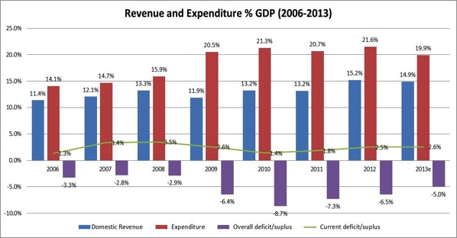

5.2 Projection of Economic Growth
In the past decades, Cambodia’s economy recorded high robust growth, except 2009 when it was hit hard by impact of global financial crisis when growth attained at 0.1%, followed by strong rebound in 2010. The growth has been underpinned by 4 pillar sectors, garment, agriculture, construction and tourism. With key institutional and structural reforms combined with strong endeavours to diversify economy and continued investment in hard and soft infrastructure, it is expected over the medium-term Cambodian economy will grow robustly at 7% per annum. Manufacturing sector, industrial sub-sector, will play more significant role in the economy.

High and sustained economic growth will be critical foundation for fiscal expansion. With annual 7% growth of GDP, domestic revenue collection could increase robustly, which could build up some fiscal space for required financing for development. But that increase alone might not be sufficient for overall development need of the country. Cambodia faces the challenge of financing its development programs in the context of its narrow fiscal space, such as investment in infrastructure, increased spending in social sectors.

 | 2000 | 2005 | 2012e | 2013p | 2014p | 2015p | 2016p | 2017p | 2018p
GDP at current price (Billion Riels) | 14,083 | 25,754 | 58,192 | 64,082 | 70,677 | 77,479 | 84,786 | 92,751 | 101,457
Real GDP (% increase) | 8.8% | 13.3% | 7.0% | 7.0% | 7.0% | 7.0% | 7.0% | 7.0% | 7.0%
GDP deflator in Riel (% increase) | -3.2% | 6.1% | 4.4% | 2.9% | 3.0% | 2.4% | 2.3% | 2.2% | 2.2%
Source: MEF Projection.

6. Financial challenge: understanding social protection financing from fiscal space analysis
Meeting the NSDP and NSPS goals and objectives requires resources-institutional, human and financial. These resources can be potentially raised by the extent to which RGC can reallocate expenditures within the budget, by securing more grant donor support or increasing efficiency within the sector/ministry budgets. This note makes a case for the enhanced efficiency, an agenda that is line with the Public Financial Management Reform Programme (PFMPR) and which perhaps can be more easily and sustainably attained.

Below is the framework of fiscal space analysis for financing social protection, listing the indicators that will be considered in the analysis:

﻿Mechanism/measure | Indicators
Mobilization of domestic revenues through:  - Increased economic activity real growth in gross domestic product (GDP) in a given tax system and structure and  - Increases in the average tax yield as a proportion of GDP | - GDP and real GDP growth (% p.a.) ·  - Tax Yields
Reallocation between sectors (cut lower priority expenditures to make room for more desirable ones) | - General government expenditure (% of GDP) ·  - Public education expenditure (% of GDP) ·  - Public health expenditure (% of GDP) ·  - Military expenditure (% of GDP) ·  - Agriculture expenditure (% of GDP) ·  - Social protection expenditure (% of GDP) ·  - Civil servant schemes (% of GDP)
Increase discretionary expenditure through debt cancellation and/or increased borrowing | - Total public sector debt (% GDP),  - Domestic and external·  - Debt service-to-revenue-ratio (as %)
Increase aid | - Total net ODA ·  - Total ODA, excluding debt relief
Debt | - IMF paper
Improve financial management of expenditure | - PFM and governance analysis/assessments
Political commitment to support an expansion in social protection provision | - Political economy analysis of government support to social protection
Source: Adapted from Handley (2009).

6.1 Mobilization of Domestic Revenues
Cambodia’s domestic revenue collection has recovered strongly after the crisis in 2009. During the 2010-2012 period, annual average growth is about 20% or equivalent to 0.55% of GDP per year. In 2012, the revenue was about 15.3% of GDP which is 26% higher than in 2011, with expenditure around 20% on average. Though Government’s revenue collection has increased significantly but fell short of the need to finance infrastructure development and other key social sectors (health and education), implying need to create fiscal space. Cambodia’s fiscal space is restricted by no domestic borrowing, no-concessional borrowing, and no monetary financing of fiscal deficit. In addition, generous tax exemption on investment has resulted in significant loss of revenue every year.

Also current revenue remains low by regional standards and has been unable to sufficiently finance Cambodia’s development expenditure. The regional average of domestic revenue collection is 17% of GDP. Studies on Cambodia’s tax system show that there is still significant gap to be improved in order to increase current revenue collection.

Below is the projection of domestic revenue over the next five year. Current revenue remains key source of national income, where non-tax revenue remains almost the same over projection period up to 2018. There is a very lively? debate on the proceedings of oil and gas? sectors in 2010, but recent argument suggest that revenue from the sector will not be as large as expected, even though oil and gas will be refined in Cambodia. Under baseline scenario, revenue will rise to 16%of GDP in 2017.

 | 2011 | 2012e | 2013p | 2014p | 2015p | 2016p | 2017p | 2018p
% of GDP
Domestic Revenue | 13.2% | 13.7% | 14.0% | 14.5% | 15.0% | 15.5% | 16.0% | 16.5%
Capital revenue | 0.1% | 0.2% | 0.1% | 0.1% | 0.1% | 0.1% | 0.1% | 0.1%
Current revenue | 13.0% | 13.5% | 13.9% | 14.4% | 14.9% | 15.4% | 15.9% | 16.4%
Tax revenue | 10.9% | 11.4% | 12.1% | 12.5% | 12.9% | 13.4% | 13.8% | 14.2%
Tax revenue (Central Gov.) | 10.2% | 10.9% | 11.4% | 11.8% | 12.2% | 12.7% | 13.1% | 13.5%
Direct taxes | 1.8% | 2.0% | 2.1% | 2.1% | 2.2% | 2.3% | 2.4% | 2.4%
Indirect taxes | 6.0% | 6.5% | 6.8% | 6.7% | 7.0% | 7.3% | 7.6% | 7.8%
Tax | 2.8% | 3.0% | 3.1% | 3.1% | 3.2% | 3.4% | 3.5% | 3.6%
Customs | 3.2% | 3.5% | 3.6% | 3.6% | 3.7% | 3.9% | 4.1% | 4.2%
Int'l trade taxes | 2.3% | 2.5% | 2.6% | 2.7% | 2.8% | 2.9% | 3.0% | 3.1%
Non tax revenue | 2.1% | 2.0% | 1.8% | 1.9% | 2.0% | 2.0% | 2.1% | 2.2%
Source: MEF, Projection.

ASEAN integration will impact on Cambodia’s international trade tax, thus domestic taxation will play a more important role in generation national revenue. The Royal Government of Cambodia aims to increase its domestic revenue by 0.5% of GDP annually. The Revenue Mobilization Strategy 2014-2018 of the Royal Government of Cambodia, which will be launched some time in 2014, is likely to further enhance revenue collection. The Strategy is aimed to improve three dimensions of the collection: oversight, policy and governance in order to achieve of increasing current revenue by at least 0.5% of GDP per annum and achieve the share of current revenue to GDP target of 16.5% by 2018 (RMS Draft 2013).

Successful implementation of revenue mobilization strategy is based on a three-pronged approach: 1; improving revenue administration and forecasting 2; implementing fair and efficient tax policies and 3; strengthening governance ensuring accountability and transparency, particularly in-depth reforms at the two key revenue collection agencies, General Department of Customs and Excise and General Department of Taxation. The positive economic performance and improved revenue collection should ensure room of fiscal space to be expanded.

The Revenue Mobilization Strategy will address the following issues:
- Non-compliance and tax arrears under the “real regime”
- Discretionary tax assessments under the estimated regime.
- Amendment of the investment law: likely increase substantial amount of revenue collection as the revenue forgone due to this law is around 5 to 6 % of GDP (IMF Study)
- Non-tax revenue arrears from telecommunications, state-owned enterprises and assets leased to the private sector.
- Amendment of excise tax base for certain goods produced locally as 65 percent of supply value VAT.

6.2 Reallocation Between Sectors
One of means to increase fiscal space is to shift budget between priorities sectors given fixed budget envelope. To capture core conception of social protection as outlined in National Social Protection Strategy, it is necessary to calculate total expenditure by social services delivering ministries which include expenditures in health, education, labour and vocational training, social and women’s affairs. Furthermore, total sum expenditure on agriculture, water resource rural development, is included to make comparison.
 | 2000 | 2005 | 2008 | 2009 | 2012 | 2015p | 2018p
(% of Total Expenditure)
Social Sector | 28.55% | 35.07% | 28.23% | 32.46% | 31.68% | 38.39% | 42.34%
Labor and Vocational  Training | 0.00% | 0.45% | 0.90% | 1.88% | 0.26% | 1.58% | 1.45%
Public Health | 8.38% | 11.41% | 9.62% | 11.04% | 11.88% | 13.38% | 15.16%
Education, Youth and Sport | 13.64% | 17.83% | 13.67% | 14.90% | 13.85% | 16.90% | 19.65%
Social Affairs and Veteran | 2.18% | 4.85% | 3.59% | 4.14% | 5.28% | 6.07% | 5.56%
Woman Affairs | 4.36% | 0.53% | 0.45% | 0.50% | 0.41% | 0.46% | 0.52%
Agriculture related Sector | 3.06% | 4.22% | 3.09% | 3.58% | 3.73% | 4.28% | 4.66%
Agriculture, Forestry and  Fishery | 1.93% | 2.39% | 1.48% | 1.68% | 1.53% | 1.80% | 2.04%
Rural Development | 0.62% | 1.13% | 1.02% | 1.28% | 1.41% | 1.62% | 1.84%
Water Resources and  Meteorology | 0.51% | 0.70% | 0.58% | 0.62% | 0.78% | 0.85% | 0.78%
Defense and Security | 37.08% | 22.93% | 18.35% | 30.04% | 22.47% | 21.15% | 19.40%
Miscellaneous | 0.00% | 13.30% | 16.04% | 0.34% | 1.98% | 13.41% | 12.30%
MEF | 7.86% | 2.05% | 13.63% | 12.64% | 18.61% | 3.49% | 3.20%
Council of Minister | 6.19% | 4.78% | 7.09% | 7.19% | 5.21% | 3.63% | 3.33%

With full commitment from the government, budget expenditure has been shifted from security sector to priorities sector, health, education, and agriculture until 2007. However, in 2008 Cambodia faced key emerging challenges inflation crisis, effort to inscribed Preah Vihear temple as World Heritage, followed by disputes with Thailand, national election. These events forced Cambodia to increase much discretionary spending and trimming expenditure of social sector and increasing expenditure on defence and security.

After 2009, the global financial crisis and dispute with Thailand acted as additional burdens to fiscal space of Cambodia. Security spending jumped from 18.35% of total expenditure in 2008 to 30% in 2009 reducing government deposit, which accumulated since 2005, the starting year of PFM. The universal increase in salaries for public servants of category “K” and “Kh” up to a minimum of 320,000 Riels and rise in fringe benefit of 40,000 and 80,000 Riels will expand non-discretionary spending, cutting room for discretionary spending for social protection/intervention.

7. The analysis of social protection investment
Taken individually, each type of social protection intervention has immense effects on poverty reduction; however, cash transfers and scholarships targeted to poor children are the most effective in reducing poverty gap and severity. If designed and implemented efficiently, a cash transfer programme targeting poor children could reduce poverty headcount between 11.8% and 12.1% for every 1.0% of GDP invested. Scholarships seeking to improve primary education among poor children, on the other hand, would be most effective in reducing poverty severity in Cambodia, with a 21.4% decrease for every 1.0% of GDP.

However, through a combined social protection package-including cash transfers, social pensions, public works programmes, and scholarships for poor children attending lower secondary education-poverty could be further reduced in Cambodia, as well as inequality.

This joint policy option, calculated as 1.6% of GDP, would contribute to a 20.0% decrease in poverty headcount, a reduction of 14.4% in the poverty gap, and a 24.4% decline in poverty severity. Inequality, moreover, would decrease by 4.9%.

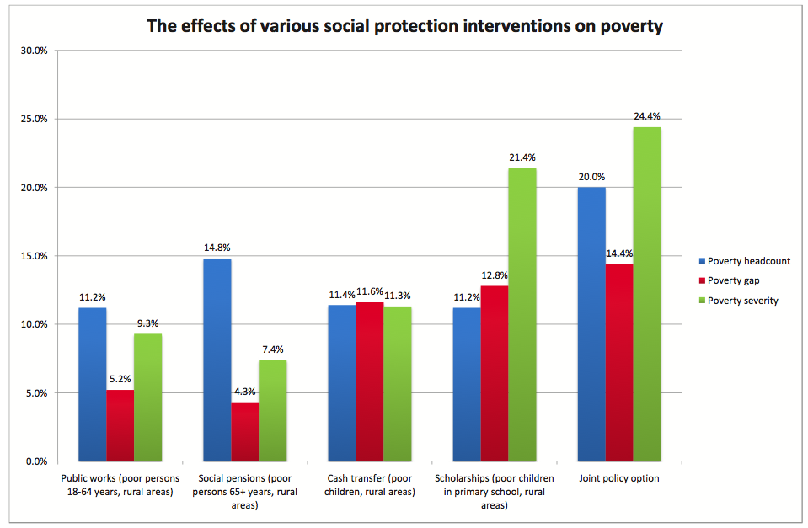

While social protection interventions generate immediate positive effects, by reducing poverty and inequality, overall economic performance would improve later. As households are able to allocate social transfers to immediately improve the education, health, and overall livelihood of children, human capital accumulation is able to occur, meaning that improvements to the future labour productivity would have immense, positive long-term returns on economic performance.

8. The policy priority for social protection in moving to social security
The Royal Government remains committed to developing and implementing a comprehensive and sustainable social safety net and social protection system through the provision and expansion of social protection floor aimed at protecting the livelihoods of the poor and most vulnerable segments of the population. The Council for Agriculture and Rural Development (CARD) has taken some important steps to build consensus on the key concepts and broad direction for policy development on social protection floor for the poor and vulnerable segments of the population in collaboration with implementing line ministries.

- Test, implement and scale-up programs proposed under the NSPS to start putting in place a comprehensive, effective and affordable social protection system.
  - Scaling up cash transfers program to poor pregnant women and young children and strengthening early-childhood development, health, and nutrition service delivery
  - Scaling up public works programs would help address vulnerability to shocks and seasonal unemployment.
  - Scaling up school feeding meals (including for pre-schools) to improve educational outcomes, especially among poor children.
  - Scaling up poverty-targeted scholarship programs to improve food security and nutrition and education outcomes, especially among poor children
  - Scaling up health equity funds as a means to improve health protection for the poor.
- Building an efficient and effective Social Protection (SP) system requires harmonizing across the existing and new programs and strengthening delivery systems.
  - Strengthening the existing national targeting mechanism (ID-Poor) is a priority in the coming years.
  - Incorporating climate vulnerability in the existing targeting system so that the most vulnerable to climate hazards can get social assistance.
  - Localizing Social Protection planning and delivery so that assistance could be tailored to local needs. This should include building capacity of the sub-national authorities in design and implementation of social protection measures.
  - Mechanisms for efficient and timely social protection service delivery need to be put in place.
  - Effective systems for social protection outcome monitoring need to be developed to allow harmonized program implementation. Evidence-based decisions on social protection provision will be developed through a common monitoring framework for the NSPS.
- Strengthening and expanding the coverage of the existing contributory social security programs and developing a strategic framework for expansion to the informal sector. The dynamic of the demographic pattern and urban ID-Poor can provide a solid basis for expansion of the social security system to the informal sector.

9. Conclusion : Beyond the investment in social protection
Social protection should be seen as an instrumental investment in the social peace that is an indispensable condition for sustainable economic development and, furthermore, as one that is essential to unlocking the full productive capacity of individuals. Social security is a social and economic necessity.

With the significant alleviation of the poor people out of poverty in the last decades, the majority of them are being concentrated just above the poverty line. With the lost of 30 cent of their daily income, 3 millions of them will fall back under the poverty line and double the current poverty rate. The development of more comprehensive social safety nets to prevent them from falling into the poverty trap is the most important policy decision. However, beyond designing the safety nets, by investing only 3 cent a day (equal to 166 millions per year or 1.6% of GDP) in social protection, all Cambodian will be leveraged from being the receiver of social safety nets into the more productive tax-payers and contributors of social security system.

Cambodia had explored the last 35 years of modern history to move the public service adequately and sufficiently to the people. With the new investment of social protection, the people will move and utilize the available public service and exercise their rights as the owners of those services and remain part of the development process. By exercising the demands for better public and social service and the right to entitle the social protection floor, Cambodian people are defining the democratic context at sub-national level. By responding to those demand and acknowledge the right of entitlement, the Sub-National Administration will localize the democracy through the participatory local development plan. Through this, Cambodia will re-define the path of securing the survival of democracy.

Reference documents

SNEC (2014) The Analysis of Fiscal Space for Social Protection for Cambodia Vision 2030. forthcoming
ILO (2013). Cambodia: Financial assessment of the National Social Protection Strategy for the Poor and Vulnerable. ILO/EU/Cambodia/R.6. Geneva
ILO (2013). Cambodia: Social Protection Expenditure and Performance Review. ILO/EU/Cambodia/R.4. Geneva
ILO (2013). Cambodia: Social security for the formal economy - Outlook and challenges ahead. ILO/EU/Cambodia/R.7. Geneva
Maastricht Graduate School of Governance Maastricht University, CARD and UNICEF. (2012). Estimation of Rates of Return of Social Protection Instruments in Cambodia: A Case for Non-Contributory Social Transfers. Phnom Penh, Cambodia
Ngy Chanphal. 2012. Realizing a More Integrated, Competitive, Equitable, and Resilient ASEAN Community. A CARD policy paper



By Social Protection Coordination Unit
of Council for Agricultural and Rural Development

For further information, please contact:
H.E Dr. Sann Vathana
Deputy Secretary General of Council for Agricultural and Rural Development
Tel : +855(0)12 950410
Email : vathana20@yahoo.com

National Institute of Statistics, Directorate General for Health, and ICF Macro, 2011. Cambodia Demographic and Health Survey 2010.
Based on finding of 15% RNI for WR in: Pfanner, S Nurtrient Content of Cambodian Diet Based on Food Balance Sheet, unpublished, 2013
Laillou A, Pham TV, Tran NT, Le HT, Wieringa F, et al. (2012) Micronutrient Deficits Are Still Public Health Issues among Women and Young Children in Vietnam. PLoS ONE 7(4): e34906. doi:10.1371/journal.pone.0034906
Based on ratio of male to female anemia found in Vietnam survey
Tax buoyancy for domestic revenue is 1.26 (Revenue Mobilization Strategy Draft Paper, MEF 2011).

